Lesson 33: Applying the Laws of Sines and Cosines

Student Outcomes
- Students understand that the law of sines can be used to find missing side lengths in a triangle when the measures of the angles and one side length are known.
- Students understand that the law of cosines can be used to find a missing side length in a triangle when the angle opposite the side and the other two side lengths are known.
- Students solve triangle problems using the laws of sines and cosines.

Lesson Notes
In this lesson, students will apply the laws of sines and cosines learned in the previous lesson to find missing side lengths of triangles. The goal of this lesson is to clarify when students can apply the law of sines and when they can apply the law of cosines. Students are not prompted to use one law or the other; they must determine that on their own.
Scaffolding:
- Consider having students make a graphic organizer to clearly distinguish between the law of sines and the law of cosines.
- Ask advanced students to write a letter to a younger student that explains the law of sines and the law of cosines and how to apply them to solve problems.
Classwork
Opening Exercise (10 minutes)
Once students have made their decisions, have them turn to a partner and compare their choices. Pairs that disagree should discuss why and, if necessary, bring their arguments to the whole class so they may be critiqued. Ask students to provide justification for their choice.
MP.3
Opening Exercise
For each triangle shown below, identify the method (Pythagorean theorem, law of sines, law of cosines) you would use to find each length$x$.
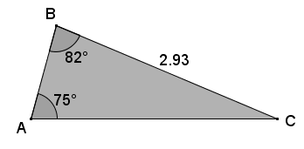 | law of sines

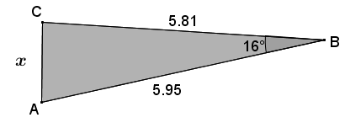 | law of cosines
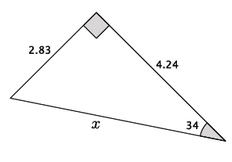 | Pythagorean theorem
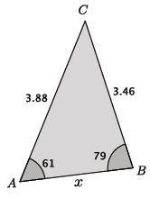 | law of sines  or  law of cosines
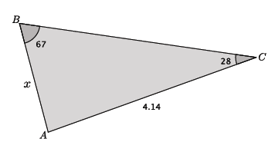 | law of sines

Example 1 (5 minutes)
Students use the law of sines to find missing side lengths in a triangle.
Example 1
Find the missing side length in $△ABC$.

- Which method should we use to find length $AB$ in the triangle shown below? Explain.

Provide a minute for students to discuss in pairs.
  - Yes, the law of sines can be used because we are given information about two of the angles and one side. We can use the triangle sum theorem to find the measure of $∠C$, and then we can use that information about the value of the pair of ratios $\frac{\sin{A}}{a}=\frac{\sin{C}}{c}.$ Since the values are equivalent, we can solve to find the missing length.
- Why can’t we use the Pythagorean theorem with this problem?
  - We can only use the Pythagorean theorem with right triangles. The triangle in this problem is not a right triangle.
- Why can’t we use the law of cosines with this problem?
  - The law of cosines requires that we know the lengths of two sides of the triangle. We are only given information about the length of one side.
- Write the equation that allows us to find the length of $AB.$
  - Let $x$ represent the length of $AB.$
$$\frac{\sin{75}}{2.93}=\frac{\sin{23}}{x} \\ cx=\frac{2.93\sin{23}}{\sin{75}}$$
- We want to perform one calculation to determine the answer so that it is most accurate and rounding errors are avoided. In other words, we do not want to make approximations at each step. Perform the calculation and round the length to the tenths place.
  - The length of $AB$ is approximately $1.2.$

Example 2 (5 minutes)
Students use the law of cosines to find missing side lengths in a triangle.
Example 2
Find the missing side length in $△ABC$.

- Which method should we use to find side $AC$ in the triangle shown below? Explain.

Provide a minute for students to discuss in pairs.
  - We do not have enough information to use the law of sines because we do not have enough information to write any of the ratios related to the law of sines. However, we can use $b^{2}=a^{2}+c^{2}-2ac\cos{B}$ because we are given the lengths of sides $a$ and $c$ and we know the angle measure for $∠B.$

- Write the equation that can be used to find the length of $AC$, and determine the length using one calculation. Round your answer to the tenths place.
Scaffolding:
It may be necessary to demonstrate to students how to use a calculator to determine the answer in one step.

$$x^{2}={5.81}^{2}+{5.95}^{2}-2\left(5.81\right)\left(5.95\right)\cos{16} \\ x=\sqrt{{5.81}^{2}+{5.95}^{2}-2\left(5.81\right)\left(5.95\right)\cos{16}} \\ x≈1.6$$

Exercises 1–6 (16 minutes)
All students should be able to complete Exercises 1 and 2 independently. These exercises can be used to informally assess students’ understanding in how to apply the laws of sines and cosines. Information gathered from these problems can inform you how to present the next two exercises. Exercises 3–4 are challenging, and students should be allowed to work in pairs or small groups to discuss strategies to solve them. These problems can be simplified by having students remove the triangle from the context of the problem. For some groups of students, they may need to see a model of how to simplify the problem before being able to do it on their own. It may also be necessary to guide students to finding the necessary pieces of information, e.g., angle measures, from the context or the diagram. Students that need a challenge should have the opportunity to make sense of the problems and persevere in solving them. The last two exercises are debriefed as part of the closing.

Exercises 1–6
Use the laws of sines and cosines to find all missing side lengths for each of the triangles in the Exercises below. Round your answers to the tenths place.
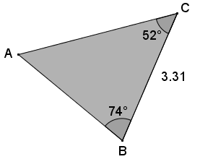
- Use the triangle below to complete this exercise.
  - Identify the method (Pythagorean theorem, law of sines, law of cosines) you would use to find each of the missing lengths of the triangle. Explain why the other methods cannot be used.
Law of sines. The Pythagorean theorem requires a right angle, which is not applicable to this problem. The law of cosines requires information about two side lengths, which is not given. Applying the law of sines requires knowing the measure of two angles and the length of one side.

  - Find the lengths of $\overline{AC}$ and $\overline{AB}.$
By the triangle sum theorem $m∠A=54°$.  Let $b$ represent the length of side $\overline{AC}.$  $$\frac{sin 54}{3.31}=\frac{sin 74}{b} \\ b=\frac{3.31 sin74}{sin54} \\ b≈3.9$$ | Let $c$ represent the length of side $\overline{AB}.$  $$\frac{sin 54}{3.31}=\frac{sin 52}{c} \\ c=\frac{3.31 sin 52}{sin 54} \\ c≈3.2$$
- Your school is challenging classes to compete in a triathlon. The race begins with a swim along the shore, then continues with a bike ride for $4$ miles. School officials want the race to end at the place it began, so after the $4$-mile bike ride, racers must turn $30˚$ and run $3.5$ mi. directly back to the starting point. What is the total length of the race? Round your answer to the tenths place.
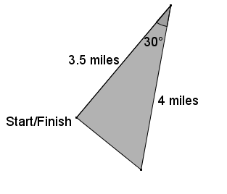
  - Identify the method (Pythagorean theorem, law of sines, law of cosines) you would use to find the total length of the race. Explain why the other methods cannot be used.
Law of cosines. The Pythagorean theorem requires a right angle, which is not applicable to this problem because we do not know if we have a right triangle. The law of sines requires information about two angle measures, which is not given. Applying the law of cosines requires knowing the measure of two sides and the included angle measure.

  - Determine the total length of the race. Round your answer to the tenths place.
Let $a$ represent the length of the swim portion of the triathalon.
$$a^{2}=4^{2}+3.5^{2}-2\left(4\right)\left(3.5\right)\cos{30} \\ a=\sqrt{4^{2}+3.5^{2}-2\left(4\right)\left(3.5\right)\cos{30}} \\ a=2.000322148… \\ a≈2$$
The total length of the race is $4+3.5+2=9.5$ miles.

- Two lighthouses are $30$ mi. apart on each side of shorelines running north and south, as shown. Each lighthouse keeper spots a boat in the distance. One lighthouse keeper notes the location of the boat as $40˚$ east of south, and the other lighthouse keeper marks the boat as $32˚$ west of south. What is the distance from the boat to each of the lighthouses at the time it was spotted? Round your answers to the nearest mile.
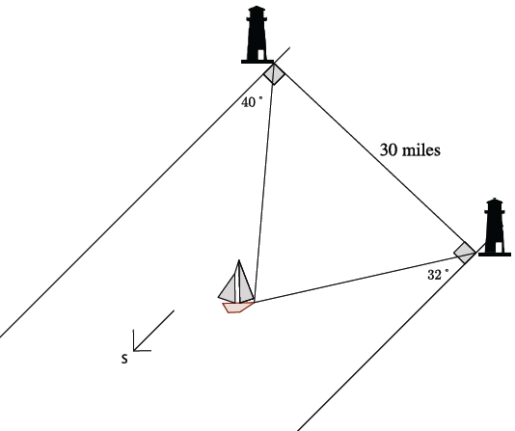

Students must begin by identifying the angle formed by one lighthouse, the boat, and the other lighthouse. This may be accomplished by drawing auxiliary lines and using facts about parallel lines cut by a transversal and triangle sum theorem (or knowledge of exterior angles of a triangle). Once students know the angle is $72˚$, then the other angles in the triangle formed by the lighthouses and the boat can be found. The following calculations lead to the solution.
Let $x$ be the distance from the southern lighthouse to the boat.
$$\frac{\sin{72}}{30}=\frac{\sin{50}}{x} \\ x=\frac{30\sin{50}}{\sin{72}} \\ x=24.16400382…$$
The southern lighthouse is approximately $24$ mi. from the boat.

With this information, students may choose to use the law of sines or the law of cosines to find the other distance. Shown below are both options.

Let $y$ be the distance from the northern lighthouse to the boat.
$$\frac{\sin{72}}{30}=\frac{\sin{58}}{y} \\ y=\frac{30\sin{58}}{\sin{72}} \\ y=26.75071612…$$
The northern lighthouse is approximately $27$ mi. from the boat.
Let $a$ be the distance from the northern lighthouse to the boat.
$$a^{2}={30}^{2}+{24}^{2}-2\left(30)\left(24\right)⋅\cos{58}\right. \\ a=\sqrt{{30}^{2}+{24}^{2}-2\left(30)\left(24\right)⋅\cos{58}\right.} \\ a=26.70049175…$$
The northern lighthouse is approximately $27$ mi. from the boat.

If groups of students work the problem both ways, using law of sines and law of cosines, it may be a good place to have a discussion about why the answers were close but not exactly the same. When rounded to the nearest mile, the answers are the same, but if asked to round to the nearest tenths place, the results would be slightly different. The reason for the difference is that in the solution using law of cosines, one of the values had already been approximated ($24$), leading to an even more approximated and less precise answer.

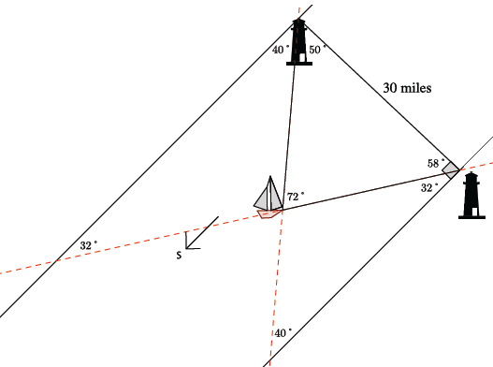

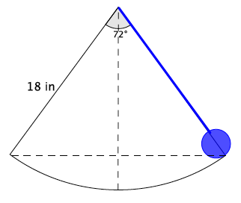
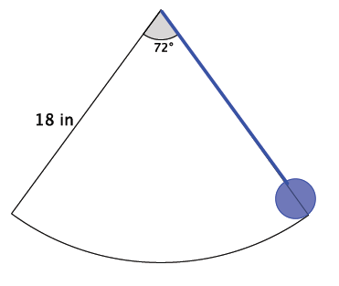
- A pendulum $18$ in. in length swings $72˚$from right to left. What is the difference between the highest and lowest point of the pendulum? Round your answer to the hundredths place, and explain how you found it.
Scaffolding:
Allow students time to struggle with the problem and, if necessary, guide them to drawing the horizontal and vertical dashed lines shown below.

At the bottom of a swing, the pendulum is perpendicular to the ground, and it bisects the $72˚$ angle; therefore the pendulum currently forms an angle of $36°$ with the vertical. By the Triangle Sum Theorem, the angle formed by the pendulum and the horizontal is $54˚$. The $\sin{54}$ will give us the length from the top of the pendulum to where the horizontal and vertical lines intersect, $x$, which happens to be the highest point of the pendulum.
$\sin{54}=\frac{x}{18}$$$18\sin{54}=x \\ 14.5623059…=x$$
$$x$$
The lowest point would be when the pendulum is perpendicular to the ground, which would be exactly $18$ in. Then the difference between those two points is approximately $3.44$ in.
$$54°$$

- What appears to be the minimum amount of information about a triangle that must be given in order to use the Law of Sines to find an unknown length?
To use the law of sines, you must know the measures of two angles and at least the length of one side.

- What appears to be the minimum amount of information about a triangle that must be given in order to use the law of cosines to find an unknown length?
To use the law of cosines, you must know at least the lengths of two sides and the angle measure of the included angle.

Closing (4 minutes)
Ask students to summarize the key points of the lesson. Additionally, consider asking students the following questions. You may choose to have students respond in writing, to a partner, or to the whole class.
- What is the minimum amount of information that must be given about a triangle in order to use the law of sines to find missing lengths? Explain.
- What is the minimum amount of information that must be given about a triangle in order to use the law of cosines to find missing lengths? Explain.
Exit Ticket (5 minutes)
Name Date
Lesson 33: Applying the Laws of Sines and Cosines

Exit Ticket

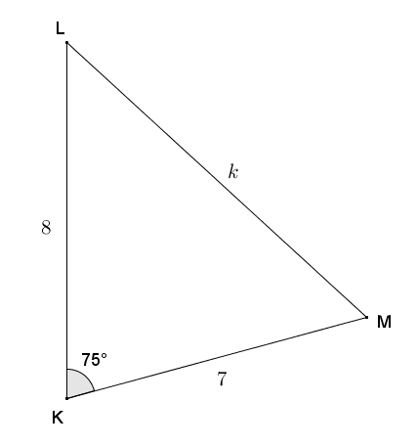
- Given triangle $MLK$, $KL=8$, $KM=7$, and $m∠K=75°$, find the length of the unknown side to the nearest tenth. Justify your method.

- Given triangle $ABC$, $m∠A=36°$, $m∠B=79°$, and $AC=9$, find the lengths of the unknown sides to the nearest tenth.
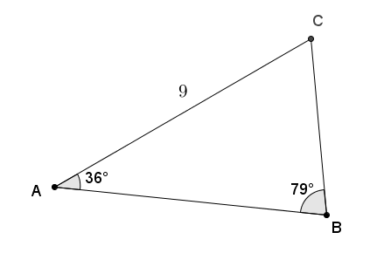
Exit Ticket Sample Solutions

- Given triangle $MLK$, $KL=8$, $KM=7$, and $∠K=75°$, find the length of the unknown side to the nearest tenth. Justify your method.
The triangle provides the lengths of two sides and their included angles, so using the law of cosines:
$$k^{2}=8^{2}+7^{2}-2(8)(7)(\cos{75}) \\ k^{2}=64+49-112(\cos{75}) \\ k^{2}=113-112(\cos{75}) \\ k=\sqrt{113-112(\cos{75})} \\ k≈9.2$$

- Given triangle $ABC$, $∠A=36°$, $∠B=79°$, and $AC=9$, find the lengths of the unknown sides to the nearest tenth.
By the angle sum of a triangle, $∠C=65°$.
Using the law of sines:
$$\frac{\sin{A}}{a}=\frac{\sin{B}}{b}=\frac{\sin{C}}{c}$$
$$\frac{\sin{36}}{a}=\frac{\sin{79}}{9}=\frac{\sin{65}}{c}$$
$$a=\frac{9\sin{36}}{\sin{79}} \\ a≈5.4$$ | $$c=\frac{9\sin{65}}{\sin{79}} \\ c≈8.3$$
$AB≈8.3$ and $BC≈5.4$.

Problem Set Sample Solutions

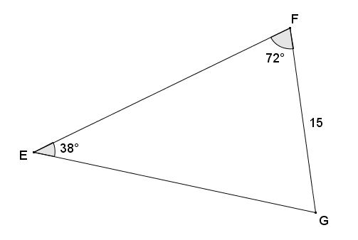
- Given triangle $EFG$, $FG=15$, angle $E$ has measure of $38°$, and angle $F$ has measure $72°$, find the measures of the remaining sides and angle to the nearest tenth. Justify your method.
Using the angle sum of a triangle, the remaining angle $G$ has a measure of $70°$.
The given triangle provides two angles and one side opposite a given angle, so it is appropriate to apply the law of sines.
$$\frac{\sin{38}}{15}=\frac{\sin{72}}{EG}=\frac{\sin{70}}{EF}$$

$$\frac{\sin{38}}{15}=\frac{\sin{72}}{EG} \\ EG=\frac{15\sin{72}}{\sin{38}} \\ EG≈23.2$$ | $$\frac{\sin{38}}{15}=\frac{\sin{70}}{EF} \\ EF=\frac{15\sin{70}}{\sin{38}} \\ EF≈22.9$$
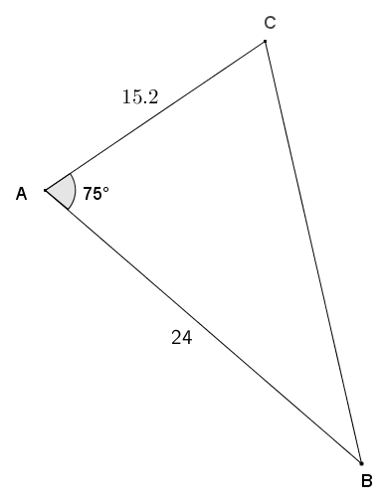
- Given triangle $ABC$, angle $A$ has measure of $75°$, $AC=15.2$, and $AB=24$, find $BC$ to the nearest tenth. Justify your method.
The given information provides the lengths of the sides of the triangle and an included angle, so it is appropriate to use the law of cosines.
$$BC^{2}=24^{2}+15.2^{2}-2(24)(15.2)(\cos{75}) \\ BC^{2}=576+231.04-729.6\cos{75} \\ BC^{2}=807.04-729.6\cos{75} \\ BC=\sqrt{807.04-729.6\cos{75}} \\ BC≈24.9$$

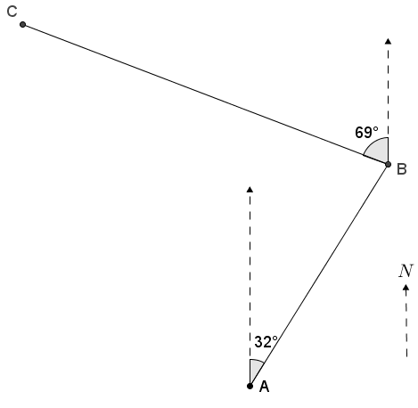
- James flies his plane from point $A$ at a bearing of $32°$ east of north, averaging speed of $143$ miles per hour for $3$ hours, to get to an airfield at point $B$. He next flies $69°$ west of north at an average speed of $129$ miles per hour for $4.5$ hours to a different airfield at point $C$.
  - Find the distance from $A$ to $B$.
$$distance=rate⋅time \\ d=143⋅3 \\ d=429$$
The distance from $A$ to $B$ is $429 mi.$

  - Find the distance from $B$ to $C$.
$$distance=rate⋅time \\ d=129⋅4.5 \\ d=580.5$$
The distance from $B$ to $C$ is $580.5 mi.$

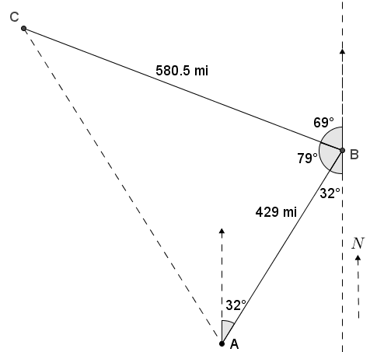
  - Find the measure of angle $ABC$.
All lines pointing to the north/south are parallel; therefore, by alt. int. $∠$'s, the return path from $B$ to $A$ is $32°$ west of south. Using angles on a line, this mentioned angle, the angle formed by the path from $B$ to $C$ with north ($69°$) and angle $ABC$ sum to $180$; thus, $m∠ABC=79°$.

  - Find the distance from $C$ to $A$.
The triangle shown provides two sides and the included angle, so using the law of cosines,
$$b^{2}=a^{2}+c^{2}-2ac(\cos{B}) \\ b^{2}={\left(580.5\right)}^{2}+(42{9)}^{2}-2(580.5)(429)(\cos{79}) \\ b^{2}=336980.25+184041-498069(\cos{79}) \\ b^{2}=521021.25-498069(\cos{79}) \\ b=\sqrt{521021.25-498069(\cos{79})} \\ b≈652.7$$
The distance from $C$ to $A$ is approximately $652.7 mi$.
  - What length of time can James expect the return trip from $C$ to $A$ to take?
$$distance=rate⋅time \\ 652.7=129⋅t_{1} \\ 5.1≈t_{1}$$ | $$distance=rate⋅time \\ 652.7=143t_{2} \\ 4.6≈t_{2}$$
James can expect the trip from $C$ to $A$ to take between $4.6$ and $5.1$ hours.

- Mark is deciding on the best way to get from point $A$ to point $B$ as shown on the map of Crooked Creek to go fishing. He sees that if he stays on the north side of the creek, he would have to walk around a triangular piece of private property (bounded by $\overline{AC}$ and $\overline{BC}$). His other option is to cross the creek at $A$ and take a straight path to $B$, which he knows to be a distance of $1.2 mi$. The second option requires crossing the water, which is too deep for his boots and very cold. Find the difference in distances to help Mark decide which path is his better choice.
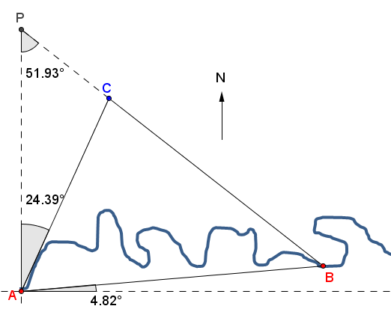
$\overline{AB}$ is $4.82°$ north of east, and $\overline{AC}$ is $24.39°$ east of north. The directions north and east are perpendicular, so the angles at point $A$ form a right angle. Therefore, $∠CAB=60.79°$.
By the angle sum of a triangle, $∠PCA=103.68°$.
$∠PCA$ and $∠BCA$ are angles on a line with a sum of $180°$, so $∠BCA=76.32°$.
Also by the angle sum of a triangle, $∠ABC=42.89°$.
Using the Law of Sines:
$$\frac{\sin{A}}{a}=\frac{\sin{B}}{b}=\frac{\sin{C}}{c}$$
$$\frac{\sin{60.79}}{a}=\frac{\sin{42.89}}{b}=\frac{\sin{76.32}}{1.2}$$
$$b=\frac{1.2\left(\sin{42.89}\right)}{\sin{76.32}} \\ b≈0.8406$$ | $$a=\frac{1.2\left(\sin{60.79}\right)}{\sin{76.32}} \\ a≈1.0780$$
Let $d$ represent the distance from point $A$ to $B$ through point $C$ in miles.
$d=AC+BC$
$d≈0.8406+1.0780$
$d≈1.9$
The distance from point $A$ to $B$ through point $C$ is approximately $1.9$ mi. This distance is approximately $0.7$ mi. longer than walking a straight line from $A$ to $B$.

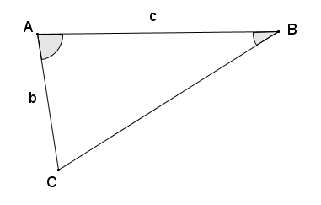
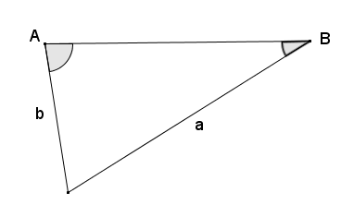
- If you are given triangle $ABC$, the measures of two of its angles, and two of its sides, would it be appropriate to apply the Law of Sines or the Law of Cosines to find the remaining side? Explain.
Case 1:  Given two angles and two sides, one of the angles being an included angle, it is appropriate to use either the Law of Sines or the Law of Cosines.  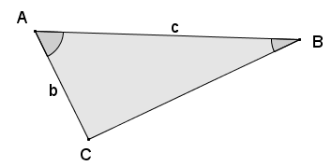 | Case 2:  Given two angles and the sides opposite those angles, the Law of Sines can be applied as the remaining angle can be calculated using the angle sum of a triangle.  The Law of Cosines then can also be applied as the previous calculation provides an included angle.  