Lesson 33: Applying Laws of Sines and Cosines

Classwork
Opening Exercise
For each triangle shown below, identify the method (Pythagorean theorem, law of sines, law of cosines) you would use to find each length$x$.

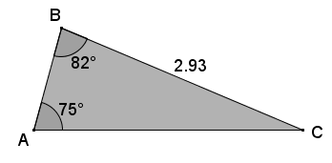
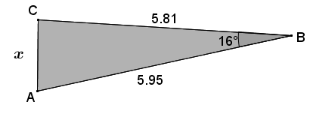
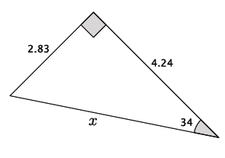
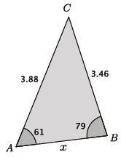
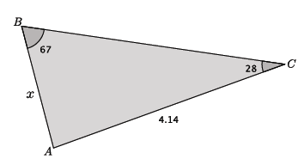

Example 1
Find the missing side length in $△ABC$.
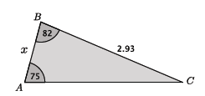

Example 2
Find the missing side length in $△ABC$.
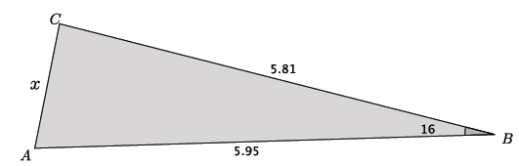

Exercises 1–6
Use the Laws of sines and cosines to find all missing side lengths for each of the triangles in the Exercises below. Round your answers to the tenths place.
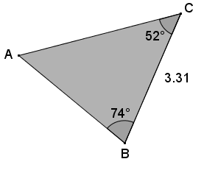
- Use the triangle below to complete this exercise.
  - Identify the method (Pythagorean theorem, law of sines, law of cosines) you would use to find each of the missing lengths of the triangle. Explain why the other methods cannot be used.

  - Find the lengths of $\overline{AC}$ and $\overline{AB}.$

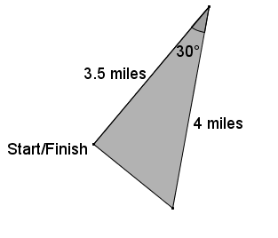
- Your school is challenging classes to compete in a triathlon. The race begins with a swim along the shore, then continues with a bike ride for $4$ miles. School officials want the race to end at the place it began so after the $4$-mile bike ride racers must turn $30˚$ and run $3.5$ mi. directly back to the starting point.
  - Identify the method (Pythagorean theorem, law of sines, law of cosines) you would use to find the total length of the race. Explain why the other methods cannot be used.

  - Determine the total length of the race. Round your answer to the tenths place.

- Two lighthouses are $30$ mi. apart on each side of shorelines running north and south, as shown. Each lighthouse keeper spots a boat in the distance. One lighthouse keeper notes the location of the boat as $40˚$ east of south, and the other lighthouse keeper marks the boat as $32˚$ west of south. What is the distance from the boat to each of the lighthouses at the time it was spotted? Round your answers to the nearest mile.

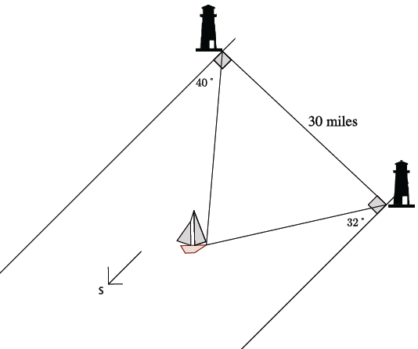

- A pendulum $18$ in. in length swings $72˚$from right to left. What is the difference between the highest and lowest point of the pendulum? Round your answer to the hundredths place, and explain how you found it.

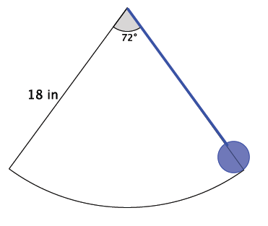

- What appears to be the minimum amount of information about a triangle that must be given in order to use the law of sines to find an unknown length?

- What appears to be the minimum amount of information about a triangle that must be given in order to use the law of cosines to find an unknown length?

Problem Set

- Given triangle $EFG$, $FG=15$, angle $E$ has measure of $38°$, and angle $F$ has measure $72°$, find the measures of the remaining sides and angle to the nearest tenth. Justify your method.
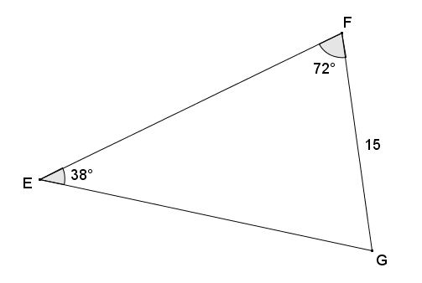

- Given triangle $ABC$, angle $A$ has measure of $75°$, $AC=15.2$, and $AB=24$, find $BC$ to the nearest tenth. Justify your method.

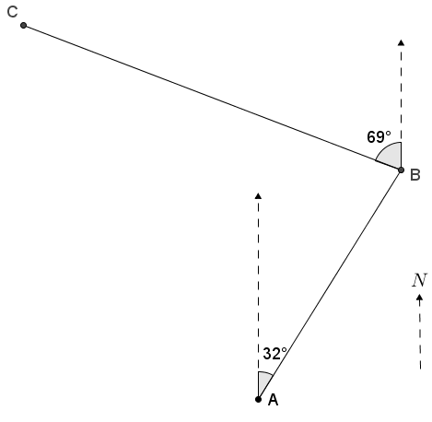
- James flies his plane from point $A$ at a bearing of $32°$ east of north, averaging speed of $143$ miles per hour for $3$ hours, to get to an airfield at point $B$. He next flies $69°$ west of north at an average speed of $129$ miles per hour for $4.5$ hours to a different airfield at point $C$.
  - Find the distance from $A$ to $B$.
  - Find the distance from $B$ to $C$,
  - Find the measure of angle $ABC$.
  - Find the distance from $C$ to $A$.
  - What length of time can James expect the return trip from $C$ to $A$ to take?

- Mark is deciding on the best way to get from point $A$ to point $B$ as shown on the map of Crooked Creek to go fishing. He sees that if he stays on the north side of the creek, he would have to walk around a triangular piece of private property (bounded by $\overline{AC}$ and $\overline{BC}$). His other option is to cross the creek at $A$ and take a straight path to $B$, which he knows to be a distance of $1.2 mi$. The second option requires crossing the water, which is too deep for his boots and very cold. Find the difference in distances to help Mark decide which path is his better choice.
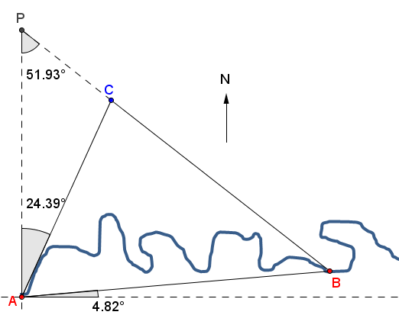

- If you are given triangle $XYZ$, and the measures of two of its angles, and two of its sides, would it be appropriate to apply the law of sines or the law of cosines to find the remaining side? Explain.

