Lesson 31: Using Trigonometry to Determine Area

Student Outcomes
- Students prove that the area of a triangle is one-half times the product of two side lengths times the sine of the included angle and solve problems using this formula.
- Students find the area of an isosceles triangle given the base length and the measure of one angle.

Lesson Notes
Students discover how trigonometric ratios can help with area calculations in cases where the measurement of the height is not provided. In order to determine the height in these cases, students must draw an altitude to create right triangles within the larger triangle. With the creation of the right triangles, students can then set up the necessary trigonometric ratios to express the height of the triangle (G.SRT.8). Students carefully connect the meanings of formulas to the diagrams they represent (MP.2 and 7). In addition, this lesson introduces the formula $Area=\frac{1}{2}ab\sin{C}$ as described by G-SRT.D.9.

Classwork
Opening Exercise (5 minutes)
Opening Exercise
Three triangles are presented below. Determine the areas for each triangle, if possible. If it is not possible to find the area with the provided information, describe what is needed in order to determine the area.
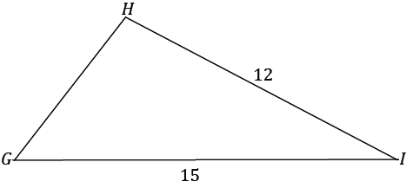
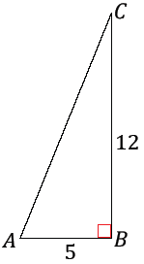
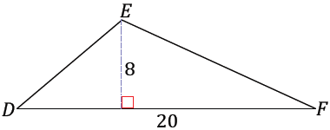

The area of $△ABC$ is $\frac{1}{2}\left(5\right)\left(12\right)=30$ square units, and the area of $△DEF$ is $\frac{1}{2}\left(8\right)\left(20\right)=80$. There is not enough information to find the height of $△GHI$ and, therefore, the area of the triangle.

Is there a way to find the missing information?
Without further information, there is no way to calculate the area.

Example 1 (13 minutes)
- What if the third side length of the triangle were provided? Is it possible to determine the area of the triangle now?
Example 1
Find the area of $△GHI$.
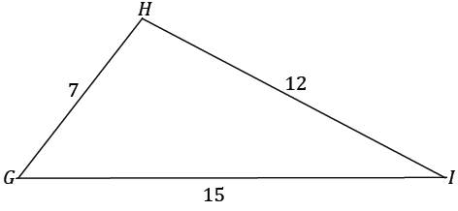
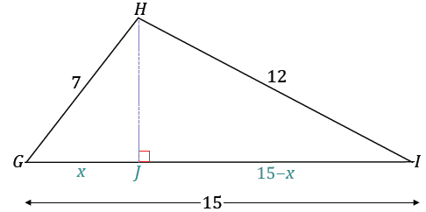

Allow students the opportunity and the time to determine what they must find (the height) and how to locate it (one option is to drop an altitude from vertex $H$ to side $GI$). For students who are struggling, consider showing just the altitude and allowing them to label the newly divided segment lengths and the height.
MP.13
- How can the height be calculated?
  - By applying the Pythagorean theorem to both of the created right triangles to find $x$,
$$h^{2}=49-x^{2}$$ | $$h^{2}=144-{(15-x)}^{2}$$
$$49-x^{2}=144-{(15-x)}^{2} \\ 49-x^{2}=144-225+30x-x^{2} \\ 130=30x \\ x=\frac{13}{3}.$$
$HJ=\frac{13}{3}$ , $IJ=\frac{32}{3}$
  - The value of $x$ can then be substituted into either of the expressions equivalent to $h^{2}$ to find $h$.
$$h^{2}=49-{\left(\frac{13}{3}\right)}^{2} \\ h^{2}=49-\frac{169}{9} \\ h=\frac{4\sqrt{17}}{3}$$
- What is the area of the triangle?
$$Area=\left(\frac{1}{2}\right)\left(15\right)\left(\frac{4\sqrt{17}}{3}\right) \\ Area=10\sqrt{17}$$
Discussion (10 minutes)
Scaffolding:
- For students that are ready for a challenge, pose the unstructured question, “How could you write a formula for area that uses trigonometry, if we didn’t know $h$?”
- For students that are struggling, use a numerical example, such as the $6$–$8$ –$10$ triangle in Lesson 24 to demonstrate how $h c$an be found using $\sin{θ}$.
Now consider $△ABC$ which is set up similarly to the triangle in Example 1:
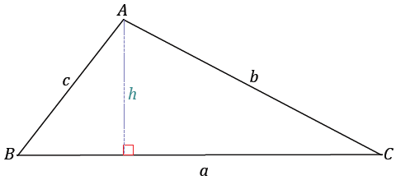
$$a$$

- Write an equation that describes the area of this triangle.
  - $Area=\frac{1}{2}ah$
Write the left-hand column on the board, and elicit the anticipated student response on the right-hand side after writing the second line; then elicit the anticipated student response after writing the third line.
- We will rewrite this equation. Describe what you see.
MP.2
&
MP.7
$$Area=\frac{1}{2}ah$$  $$Area=\frac{1}{2}ah\left(\frac{b}{b}\right)$$  $$Area=\frac{1}{2}ab\left(\frac{h}{b}\right)$$ | The statement is multiplied by $1$.  The last statement is rearranged, but the value remains the same.
Create a discussion around the third line of the newly written formula. Modify $△ABC$: Add in an arc mark at vertex $C,$ and label it $θ$.
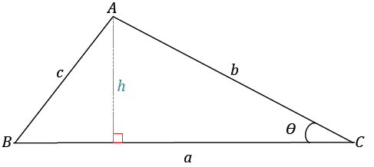
- What do you notice about the structure of $\frac{h}{b}$? Can we think of this newly written area formula in a different way using trigonometry?
  - The value of $\frac{h}{b}$ is equivalent to $\sin{θ}$; the newly written formula can be written as $area=\frac{1}{2}ab\sin{θ}$.
- If the area can be expressed as $\frac{1}{2}ab\sin{θ}$, which part of the expression represents the height?
  - $h=b\sin{θ}$.
- Compare the information provided to find the area of $△GHI$ in the Opening Exercise, how the information changed in Example 1, and then changed again in the triangle above, $△ABC$.
  - Only two side lengths were provided in the Opening Exercise, and the area could not be found because there was not enough information to determine the height. In Example 1, all three side lengths were provided, and then the area could be determined because the height could be determined by applying the Pythagorean theorem in two layers. In the most recent figure, we only needed two sides and the included angle to find the area.
If you had to determine the area of a triangle, and were given the option to have three side lengths of a triangle or two side lengths and the included measure, which set of measurements would you rather have? Why?
The response to this question is a matter of opinion. Considering the amount of work needed to find the area when provided three side lengths, our guess is they will opt for the briefer, trigonometric solution!

Example 3 (5 minutes)
Example 3
A farmer is planning how to divide his land for planting next year’s crops. A triangular plot of land is left with two known side lengths measuring $500 m$ and $1,700 m$.
What could the farmer do next in order to find the area of the plot?

- With just two side lengths known of the plot of land, what are the farmer’s options to determine the area of his plot of land?
  - He can either measure the third side length, apply the Pythagorean theorem to find the height of the triangle, and then calculate the area, or he can find the measure of the included angle between the known side lengths and use trigonometry to express the height of the triangle and then determine the area of the triangle.
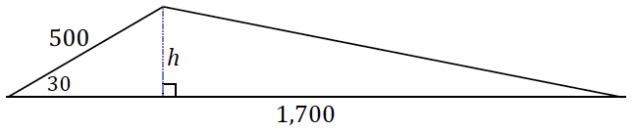
- Suppose the included angle measure between the known side lengths is $30˚$. What is the area of the plot of land? Sketch a diagram of the plot of land.
  - $Area=\frac{1}{2}(1,700)(500)\sin{30}$
  - $Area=212,500$
  - The area of the plot of land is $212,500$square meters.

Exercise 1 (5 minutes)
Exercise 1
- A real estate developer and her surveyor are searching for their next piece of land to build on. They each examine a plot of land in the shape of $△ABC$. The real estate developer measures the length of $AB$ and $AC$ and finds them to both be approximately $4,000$ feet, and the included angle has a measure of approximately $50˚$. The surveyor measures the length of $AC$ and $BC$ and finds the lengths to be approximately $4,000$ feet and $3,400$ feet, respectively, and measures the angle between the two sides to be approximately $65°$.
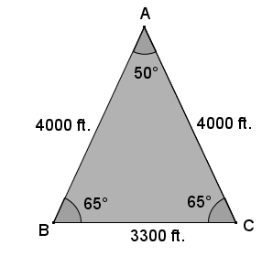
- Draw a diagram that models the situation, labeling all lengths and angle measures.

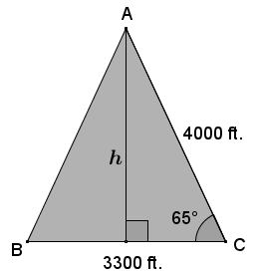
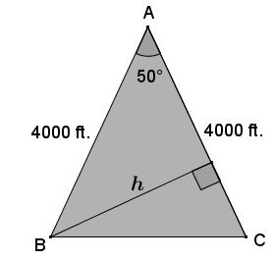
- The real estate developer and surveyor each calculate the area of the plot of land and both find roughly the same area. Show how each person calculated the area; round to the nearest hundred. Redraw the diagram with only the relevant labels for both the real estate agent and surveyor.

$$A=\frac{1}{2}(4000)(4000)\sin{50} \\ A≈6,128,356$$  The area is approximately $6,128,356$ square feet. | $$A=\frac{1}{2}(3400)(4000)\sin{65} \\ A≈6,162,893$$  The area is approximately $6,162,983$ square feet.

- What could possibly explain the difference between the real estate agent and surveyor’s calculated areas?
The difference in the area of measurements can be accounted for by the approximations of the measurements taken, instead of exact measurements.

Closing (2 minutes)
Ask students to summarize the key points of the lesson. Additionally, consider asking students to respond to the following questions independently in writing, to a partner, or to the whole class.
- For a triangle with side lengths $a$ and $b$ and included angle of measure $θ$, when will we need to use the area formula $Area=\frac{1}{2}ab\sin{θ}$ ?
  - We will need it when we are determining the area of a triangle and are not provided a height.
- Recall how to transform the equation $Area=\frac{1}{2}bh$ to $Area=\frac{1}{2}ab\sin{θ}$.

Exit Ticket (5 minutes)

Name Date
Lesson 31: Using Trigonometry to Determine Area

Exit Ticket

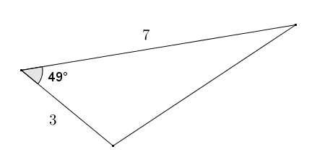
- Given two sides of the triangle shown, having lengths of $3$ and $7$, and their included angle of $49°$, find the area of the triangle to the nearest tenth.

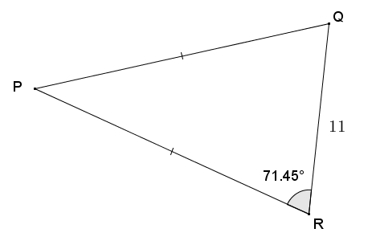
- In isosceles triangle $PQR$, the base $QR=11$, and the base angles have measures of $71.45°$. Find the area of $△PQR$.
Exit Ticket Sample Solutions

- Given two sides of the triangle shown, having lengths of $3$ and $7$, and their included angle of $49°$, find the area of the triangle to the nearest tenth.
$$Area=\frac{1}{2}(3)(7)(\sin{49}) \\ Area=10.5\left(\sin{49}\right)≈7.9$$
The area of the triangle is approximately $7.9$ square units.

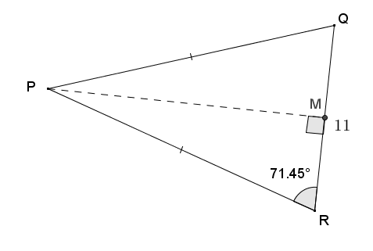
- In isosceles triangle $PQR$, the base $QR=11$, and the base angles have measures of $71.45°$. Find the area of $△PQR$ to the nearest tenth.
Drawing an altitude from $P$ to midpoint $M$ on $\overline{QR}$ cuts the isosceles triangle into two right triangles with $QM=MR=5.5$. Using tangent solve the following:
$$\tan{71.45}=\frac{PM}{5.5} \\ PM=5.5(\tan{71.45})$$
$$Area=\frac{1}{2}bh \\ Area=\frac{1}{2}\left(11\right)\left(5.5\left(\tan{71.45}\right)\right) \\ Area=30.25\left(\tan{71.45}\right)≈90.1$$
The area of the isosceles triangle is approximately $90.1$ square units.

Problem Set Sample Solutions

Find the area of each triangle. Round each answer to the nearest tenth.
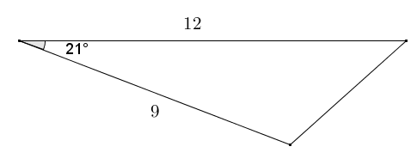
$$Area=\frac{1}{2}(12)(9)(sin{21}) \\ Area=54\left(\sin{21}\right)≈19.4$$
The area of the triangle is approximately $19.4$ square units.

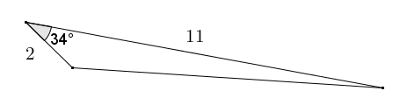
$$Area=\frac{1}{2}(2)(11)(\sin{34}) \\ Area=11\left(\sin{34}\right)≈6.2$$
The area of the triangle is approximately $6.2$ square units.

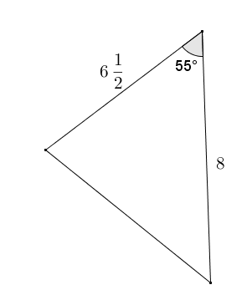
$$Area=\frac{1}{2}\left(8\right)\left(6\frac{1}{2}\right)(\sin{55}) \\ Area=26\left(\sin{55}\right)≈21.3$$
The area of the triangle is approximately $21.3$ square units.

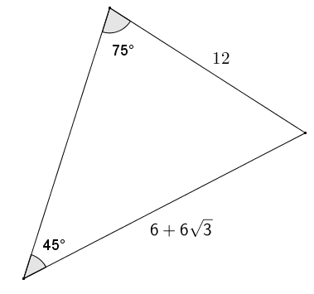
The included angle is $60°$ by the angle sum of a triangle.
$$Area=\frac{1}{2}\left(12\right)\left(6+6\sqrt{3}\right)\sin{60} \\ Area=6\left(6+6\sqrt{3}\right)\left(\frac{\sqrt{3}}{2}\right) \\ Area=\left(36+36\sqrt{3}\right)\left(\frac{\sqrt{3}}{2}\right) \\ Area=18\sqrt{3}+18(3) \\ Area=18\sqrt{3}+54≈85.2$$
The area of the triangle is approximately $85.2$ square units.

- In $△DEF, EF=15, DF=20, and ∠F=63$. Determine the area of the triangle. Round to the nearest tenth.
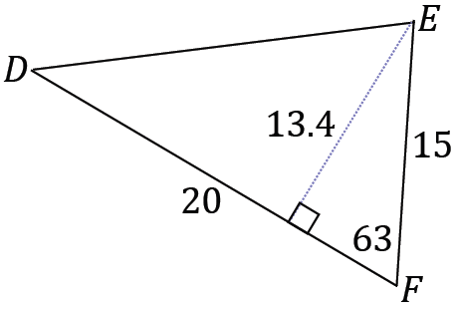
$Area=\frac{1}{2}\left(20\right)\left(15\right)sin\left(63\right)≈133.7 units^{2}$

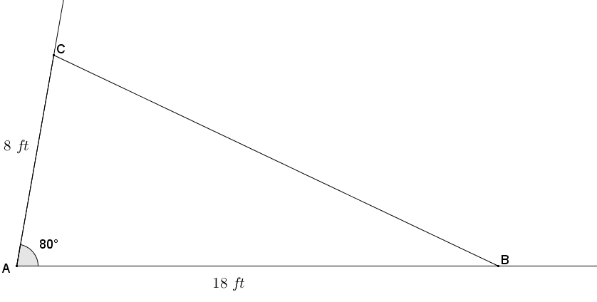
- A landscape designer is designing a flower garden for a triangular area that is bounded on two sides by the client’s house and driveway. The length of the edges of the garden along the house and driveway are $18 ft.$ and $8 ft.$ respectively, and the edges come together at an angle of $80°$. Draw a diagram, and then find the area of the garden to the nearest square foot.

The garden is in the shape of a triangle in which the lengths of two sides and the included angle have been provided.
$$Area\left(ABC\right)=\frac{1}{2}(8 ft.)(18 ft.)\sin{80} \\ Area\left(ABC\right)=\left(72 \sin{80}\right) f{t.}^{2} \\ Area\left(ABC\right)≈71 f{t.}^{2}$$

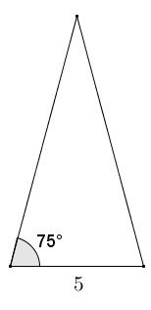
- A right rectangular pyramid has a square base with sides of length $5$. Each lateral face of the pyramid is an isosceles triangle. The angle on each lateral face between the base of the triangle and the adjacent edge is $75°$. Find the surface area of the pyramid to the nearest tenth.
Using tangent, the altitude of the triangle to the base of length $5$ is equal to $2.5\tan{75}$.
$$Area=\frac{1}{2}bh \\ Area=\frac{1}{2}(5)(2.5\sin{75}) \\ Area=6.25\left(\sin{75}\right)$$
The total surface area of the pyramid is the sum of the four lateral faces and the area of the square base:
$$SA=4\left(6.25\left(\sin{75}\right)\right)+5^{2} \\ SA=25\sin{75}+25 \\ SA≈49.1$$
The surface area of the right rectangular pyramid is approximately $49.1$ square units.

- The Pentagon Building in Washington D.C. is built in the shape of a regular pentagon. Each side of the pentagon measures $921 ft.$ in length. The building has a pentagonal courtyard with the same center. Each wall of the center courtyard has a length of $356 ft$. What is the approximate area of the roof of the Pentagon Building?
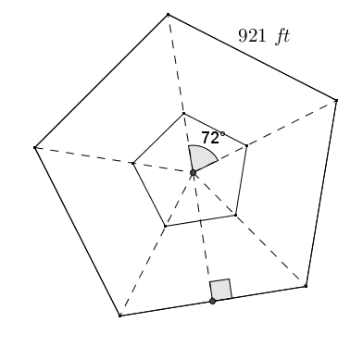
Let $A_{1}$ represent the area within the outer perimeter of the Pentagon Building in square feet.
$$A_{1}=\frac{nb^{2}}{4\tan\left(\frac{180}{n}\right)} \\ A_{1}=\frac{5⋅{\left(921\right)}^{2}}{4\tan\left(\frac{180}{5}\right)} \\ A_{1}=\frac{4,241,205}{4\tan\left(36\right)}≈1,459,379$$
The area within the outer perimeter of the Pentagon Building is approximately $1,459,379 ft^{2}$.
Let $A_{2}$ represent the area within the perimeter of the courtyard of the Pentagon Building in square feet.  $$A_{2}=\frac{nb^{2}}{4\tan{36}} \\ A_{2}=\frac{5{\left(356\right)}^{2}}{4\tan{36}} \\ A_{2}=\frac{633680}{4\tan{36}} \\ A_{2}=\frac{158420}{\tan{36}}≈218,046$$ | Let $A_{T}$ represent the total area of the roof of the Pentagon Building in square feet.  $$A_{T}=A_{1}-A_{2} \\ A_{T}=\frac{4241205}{4\tan\left(36\right)}-\frac{158420}{\tan{36}} \\ A_{T}=\frac{4241205}{4\tan{36}}-\frac{633680}{4\tan{36}} \\ A_{T}=\frac{3607525}{4\tan{36}}≈1,241,333$$
The area of the roof of the Pentagon Building is approximately $1,241,333 ft^{2}$.

- A regular hexagon is inscribed in a circle with a radius of $7$. Find the perimeter and area of the hexagon.
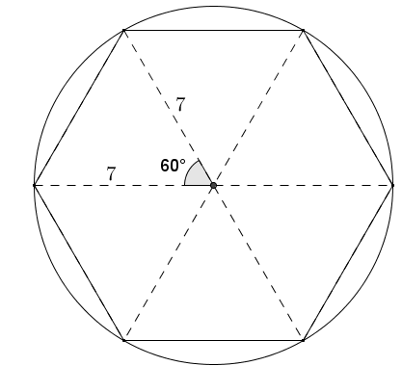
The regular hexagon can be divided into six equilateral triangular regions, with each side of the triangles having a length of $7$. To find the perimeter of the hexagon, solve the following:
$6⋅7=42$ , so the perimeter of the hexagon is $42$units.
To find the area of one equilateral triangle:
$$Area=\frac{1}{2}(7)(7)\sin{60} \\ Area=\frac{49}{2}\left(\frac{\sqrt{3}}{2}\right) \\ Area=\frac{49\sqrt{3}}{4}$$
The area of the hexagon is six times the area of the equilateral triangle.
$$Total area=6\left(\frac{49\sqrt{3}}{4}\right) \\ Total Area=\frac{147\sqrt{3}}{2}≈127.3$$
The total area of the regular hexagon is approximately $127.3$ square units.

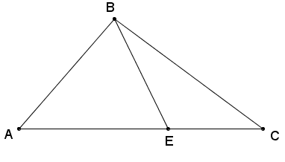
- In the figure below, $∠AEB$ is acute. Show that $Area \left(△ABC\right)=\frac{1}{2}AC⋅BE⋅\sin{∠AEB}$.

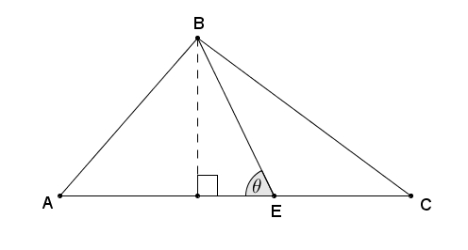
Let $θ$ represent the degree measure of angle $AEB$, and let $h$ represent the altitude of $△ABC$ (and $△ABE$).
$Area\left(△ABC\right)=\frac{1}{2}⋅AC⋅h$
$\sin{θ}=\frac{h}{BE}$, which implies that $h=BE⋅\sin{θ}$.

Therefore, by substitution:
$Area\left(△ABC\right)=\frac{1}{2}AC⋅BE⋅\sin{∠AEB}$.

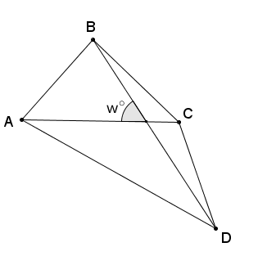
- Let $ABCD$ be a quadrilateral. Let $w$ be the measure of the acute angle formed by diagonals $\overline{AC}$ and $\overline{BD}$. Show that $Area\left(ABCD\right)=\frac{1}{2}AC⋅BD⋅\sin{w}$.
(Hint: Apply the result from Problem 10 to $△ABC$ and $△ACD$.)
Let the intersection of $\overline{AC}$ and $\overline{BD}$ be called point $P$.
Using the results from Problem 10, solve the following:
$Area\left(△ABC\right)=\frac{1}{2}AC⋅BP⋅\sin{w}$ and
$Area\left(△ADC\right)=\frac{1}{2}AC⋅PD⋅\sin{w}$
$Area\left(ABCD\right)=\left[\frac{1}{2}AC⋅BP⋅\sin{w}\right]+\left[\frac{1}{2}AC⋅PD⋅\sin{w}\right]$ Area is additive;
$Area\left(ABCD\right)=\left[\frac{1}{2}AC⋅\sin{w}\right]⋅\left[BP+PD\right]$ Distributive property;
$Area\left(ABCD\right)=\left[\frac{1}{2}AC⋅\sin{w}\right]⋅\left[BD\right]$ Distance is additive;
And commutative addition gives us$Area\left(ABCD\right)=\frac{1}{2}⋅AC⋅BD⋅\sin{w}$.

