Lesson 31: Using Trigonometry to Determine Area

Classwork
Opening Exercise
Three triangles are presented below. Determine the areas for each triangle, if possible. If it is not possible to find the area with the provided information, describe what is needed in order to determine the area.
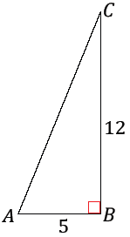
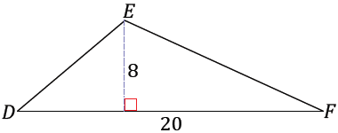
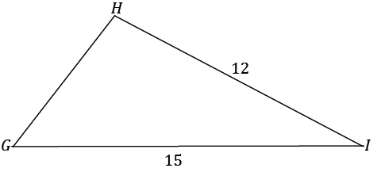

Is there a way to find the missing information?

Example 1
What if the third side length of the triangle were provided? Is it possible to determine the area of the triangle now? Find the area of $△GHI$.
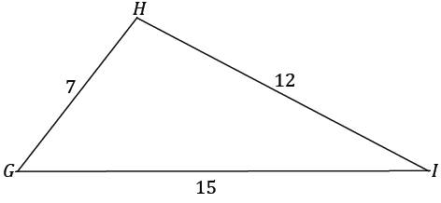

Example 2
A farmer is planning how to divide his land for planting next year’s crops. A triangular plot of land is left with two known side lengths measuring $500 m$ and $1,700 m$.
What could the farmer do next in order to find the area of the plot?

Exercises 1
A real estate developer and her surveyor are searching for their next piece of land to build on. They each examine a plot of land in the shape of $△ABC$. The real estate developer measures the length of $AB$ and $AC$ and finds them to both be approximately $4,000$ feet, and the included angle has a measure of approximately $50˚$. The surveyor measures the length of $AC$ and $BC$ and finds the lengths to be approximately $4,000$ feet and $3,400$ feet, respectively, and measures the angle between the two sides to be approximately $65°$.
  - Draw a diagram that models the situation, labeling all lengths and angle measures.

  - The real estate developer and surveyor each calculate the area of the plot of land and both find roughly the same area. Show how each person calculated the area; round to the nearest hundred. Redraw the diagram with only the relevant labels for both the real estate agent and surveyor.

  - What could possibly explain the difference between the real estate agent and surveyor’s calculated areas?
Problem Set

Find the area of each triangle. Round each answer to the nearest tenth.
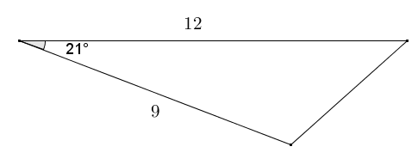

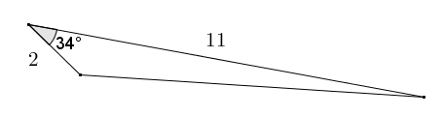

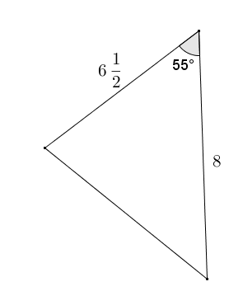

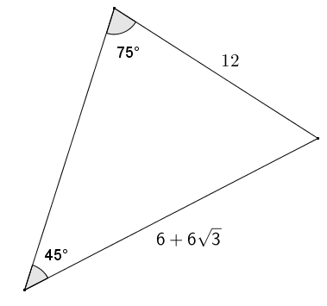

- In $△DEF$, $EF=15$,$DF=20$, and $∠F=63$. Determine the area of the triangle. Round to the nearest tenth.

- A landscape designer is designing a flower garden for a triangular area that is bounded on two sides by the client’s house and driveway. The length of the edges of the garden along the house and driveway are $18 ft.$ and $8 ft.$ respectively, and the edges come together at an angle of $80°$. Draw a diagram, and then find the area of the garden to the nearest square foot.
- A right rectangular pyramid has a square base with sides of length $5$. Each lateral face of the pyramid is an isosceles triangle. The angle on each lateral face between the base of the triangle and the adjacent edge is $75°$. Find the surface area of the pyramid to the nearest tenth.

- The Pentagon Building in Washington D.C. is built in the shape of a regular pentagon. Each side of the pentagon measures $921 ft.$ in length. The building has a pentagonal courtyard with the same center. Each wall of the center courtyard has a length of $356 ft$. What is the approximate area of the roof of the Pentagon Building?

- A regular hexagon is inscribed in a circle with a radius of $7$. Find the perimeter and area of the hexagon.

- In the figure below, $∠AEB$ is acute. Show that $Area\left(△ABC\right)=\frac{1}{2}AC⋅BE⋅\sin{∠AEB}$.
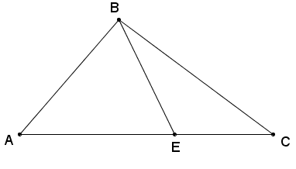

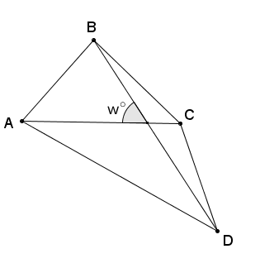
- Let $ABCD$ be a quadrilateral. Let $w$ be the measure of the acute angle formed by diagonals $\overline{AC}$ and $\overline{BD}$. Show that $Area\left(ABCD\right)=\frac{1}{2}AC⋅BD⋅\sin{w}$.
(Hint: Apply the result from Problem 10 to $△ABC$ and $△ACD$.)

