Lesson 30: Trigonometry and the Pythagorean Theorem

Student Outcomes
- Students rewrite the Pythagorean theorem in terms of sine and cosine ratios and use it in this form to solve problems.
- Students write tangent as an identity in terms of sine and cosine and use it in this form to solve problems.

Lesson Notes
Students discover the Pythagorean theorem in terms of sine and cosine ratios and demonstrate why $\tan{θ}=\frac{\sin{θ}}{\cos{θ}}$. They begin solving problems where any one of the values of $\sin{θ}$, $\cos{θ}$, $\tan{θ}$ are provided.
In this Geometry course, trigonometry is anchored in right triangle trigonometry as evidenced by standards G.SRT.6–8 in the cluster that states: Define trigonometric ratios and solve problems involving right triangles. We focus on the values of ratios for a given right triangle. This is an important distinction from trigonometry studied in Algebra II, which is studied from the perspective of functions; sine, cosine, and tangent are functions of any real number, not just those of right triangles. The language in G.SRT.8 juxtaposes trigonometric ratios and the Pythagorean theorem in the same standard, which leads directly to the Pythagorean identity for right triangles. In Algebra II, students will prove that the identity holds for all real numbers. Presently, this lesson offers an opportunity for students to develop deep understanding of the relationship between the trigonometric ratios and the Pythagorean theorem.

Classwork
Exercises 1–2 (4 minutes)
- In this lesson, we will use a fact well known to us, the Pythagorean theorem, and tie it to trigonometry.
Exercises 1–2
Scaffolding:
For students who are struggling, begin with an image of a right triangle with one acute angle marked and the $opp$, $adj$, and $hyp$ sides labeled. Then ask: If the value of $opp:hypotenuse$ ratio is $3:5$, what is the value of $adj:hypotenuse$? ($4:5$).

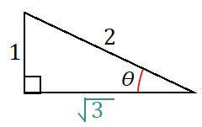
- In a right triangle, with acute angle of measure $θ$, $\sin{θ=\frac{1}{2}}$. What is the value of $\cos{θ}$? Draw a diagram as part of your response.
$$\cos{θ}=\frac{\sqrt{3}}{2}$$

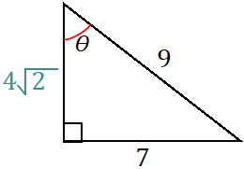
- In a right triangle, with acute angle of measure $θ$, $\sin{θ=\frac{7}{9}}$. What is the value of $\tan{θ}$? Draw a diagram as part of your response.
$$\tan{θ}=\frac{7}{4\sqrt{2}}=\frac{7\sqrt{2}}{8}$$
- How did you apply the Pythagorean theorem to answer Exercises 1–2?
MP.3
  - Since the triangles are right triangles, we used the relationship between side lengths, $a^{2}+b^{2}=c^{2}$, to solve for the missing side length and then used the missing side length to determine the value of the appropriate ratio.

Example 1 (13 minutes)
- The Great Pyramid of Giza in Egypt was constructed around $2600$ B.C. out of limestone blocks weighing several tons each. The angle measure between the base and each of the four triangular faces of the pyramid is roughly $53˚$.
- Observe Figure 1, a model of the Great Pyramid and Figure 2, which isolates the right triangle formed by the height, slant height, and the segment that joins the center of the base to the bottom of the slant height.
Example 1
  - What common right triangle was probably modeled in the construction of the triangle in Figure 2? Use $\sin{53}≈0.8$.
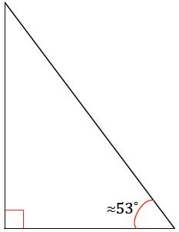
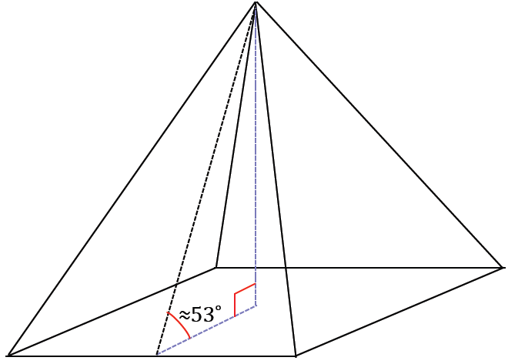
Figure 2
Figure 1

Right triangle with side lengths $3$, $4$, and $5$, since $0.8=\frac{4}{5}$.

- What common right triangle was probably modeled in the construction of the triangle in Figure 2?
Though it may not be immediately obvious to students, part (a) is the same type of question as they completed in Exercises 1–2. The difference is the visual appearance of the value of $\sin{53}$ in decimal form versus in fraction form. Allow students time to sort through what they must do to answer part (a). Offer guiding questions and comments as needed such as the following:
- Revisit Exercises 1–2. What similarities and differences do you notice between Example 1, part (a), and Exercises 1–2?
- What other representation of $0.8$ may be useful in this question?

Alternatively, students should also see that the value of $\sin{53}$ can be thought of as $\frac{opp}{hyp}=\frac{0.8}{1}$. We proceed to answer part (a) using this fraction. If students have responses to share, share them as a whole class, or proceed to share the following solution.
- To determine the common right triangle that was probably modeled in the construction of the triangle in Figure 2, using the approximation $\sin{53}≈0.8$ means we are looking for a right triangle with side-length relationships that are well known.
- Label the triangle with given acute angle measure of approximately $53˚$ as is labeled in the following figure. The hypotenuse has length 1, the opposite side has length $0.8$, and the side adjacent to the marked angle is labeled as $x$.
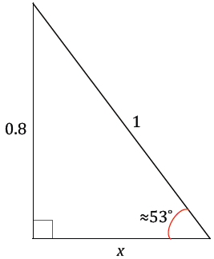
- How can we determine the value of $x$?
  - We can apply the Pythagorean theorem.
- Solve for $x$.
  - ${(0.8)}^{2}+{(x)}^{2}{=(1)}^{2}$
  - $0.64+{\left(x\right)}^{2}=1$
  - ${\left(x\right)}^{2}=0.36$
  - $x=0.6$
- The side lengths of this triangle are $0.6$,$0.8$, and $1$. What well-known right triangle matches these lengths?
Even though the calculations to determine the lengths of the triangle have been made, determining that this triangle is a $3–4$–$5$ triangle is still a jump. Allow time for students to persevere after the answer. Offer guiding questions and comments as needed such as the following:
- Sketch a right triangle with side lengths $6$, $8$, and $10$ and ask how that triangle is related to the one in the problem.
- List other triangle side lengths that are in the same ratio as a $6$–$8$–$10$ triangle.
Students should conclude part (a) with the understanding that a triangle with an acute angle measure of $≈53˚$ is a $3$–$4$–$5$ triangle.

  - The actual angle between the base and lateral faces of the pyramid is actually closer to $52˚$. Considering the age of the pyramid, what could account for the difference between the angle measure in part (a) and the actual measure?
The Great Pyramid is approximately $4,500$ years old, and the weight of each block is several tons. It is conceivable that over time, the great weight of the blocks caused the pyramids to settle and shift the lateral faces enough so that the angle is closer to $52˚$ than to $53˚$.

  - Why do you think the architects chose to use a $3$–$4$–$5$ as a model for the triangle?
Answers may vary. Perhaps they used it (1) because it is the right triangle with the shortest whole-number side lengths to satisfy the converse of the Pythagorean theorem and (2) because of the aesthetic it offers.

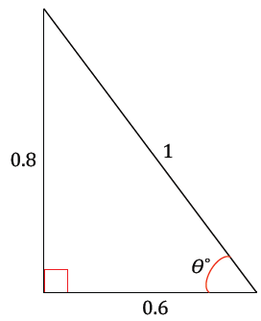
Discussion (10 minutes)
Lead students through a discussion.
- Let $θ$ be the angle such that $\sin{θ}=0.8$. Before we were using an approximation. We don’t know exactly what the angle measure is, but we will assign the angle measure that results in the sine of the angle as $0.8$ the label $θ$. Then we know (draw the following image):
- In the diagram, rewrite the leg lengths in terms of $\sin{θ}$ and $\cos{θ}$.
Allow students a few moments to struggle with this connection. If needed, prompt them and ask what the values of $\sin{θ}$ and $\cos{θ}$ are in this right triangle.
  - Since the value of $\sin{θ}$ is $0.8$ and the value of $\cos{θ}=0.6$, the leg lengths can be rewritten as:
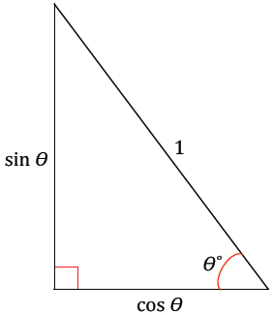

- The Pythagorean theorem states that for a right triangle with lengths $a$, $b$, and $c$, where $c$ is the hypotenuse, the relationship between the side lengths is $a^{2}+b^{2}=c^{2}$. Apply the Pythagorean Theorem to this triangle.
  - ${(\sin{θ)}}^{2}+{(\cos{θ)}}^{2}=1$
- This statement is called the Pythagorean Identity. This relationship is easy to show in general.
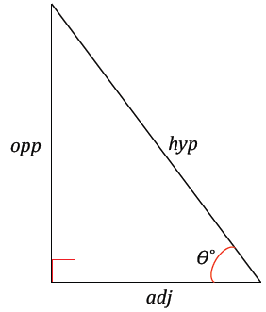

- Referencing the diagram above, we can say
$${opp}^{2}+{adj}^{2}={hyp}^{2}.$$

- Divide both sides by ${hyp}^{2}$.
$${\frac{opp}{{hyp}^{2}}}^{2}+\frac{{adj}^{2}}{{hyp}^{2}}=\frac{{hyp}^{2}}{{hyp}^{2}}$$
$${(\sin{θ)}}^{2}+{(\cos{θ)}}^{2}=1$$
Explain to your students that they might see the Pythagorean Identity written in the following way on the web and in other texts:
$$\sin^{2}{θ}+\cos^{2}{θ}=1.$$
Let them know that in Precalculus they will use this notation but not to worry about such notation now.

Example 2 (7 minutes)
Students discover a second trigonometric identity; this identity describes a relationship between sine, cosine, and tangent.
- Recall Opening Exercise part (b) from Lesson 29. We found that the tangent values of the listed angle measurements were equal to dividing sine by cosine for the same angle measurements. We discover why this is true in this example.
- Use the provided diagram to reason why the trigonometric identity $\tan{θ}=\frac{sinθ}{cosθ}$.
MP.7
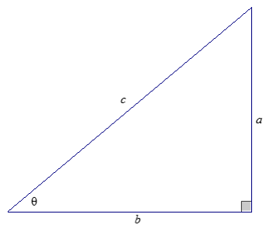
Example 2
Show why $\tan{θ}=\frac{sinθ}{cosθ}$.

Allow students time to work through the reasoning independently before guiding them through an explanation. To provide more support, consider having the diagram on the board and then writing the following to start students off:
$$\sin{θ}=$$ | $$\sin{θ}=\frac{a}{c}$$
$$\cos{θ}=$$ | $$\cos{θ}=\frac{b}{c}$$
$$\tan{θ}=$$ | $$\tan{θ}=\frac{a}{b}$$

  - $\tan{θ}=\frac{sinθ}{cosθ}$ because
MP.7
$\sin{θ}=\frac{a}{c}$ and $\cos{θ}=\frac{b}{c}$.
Then
$\tan{θ}=\frac{\sin{θ}}{\cos{θ}}$
$\tan{θ}=\frac{a}{b}$, which is what we found earlier.
- If you are given one of the values $\sin{θ}$, $\cos{θ}$, or $\tan{θ}$, we can find the other two values using the identities $\sin^{2}{θ}+\cos^{2}{θ}=1$ and $\tan{θ}=\frac{\sin{θ}}{\cos{θ}}$or by using the Pythagorean theorem.

Exercises 3–4 (5 minutes)
Exercises 3–4 are the same as Exercise 1–2, however, students answer them now by applying the Pythagorean identity.
Exercises 3–4
- In a right triangle, with acute angle of measure $θ$, $\sin{θ=\frac{1}{2}}$, use the Pythagorean identity to determine the value of $\cos{θ}$.
$$\sin^{2}{θ}+\cos^{2}{θ}=1 \\ {\left(\frac{1}{2}\right)}^{2}+\cos^{2}{θ}=1 \\ \frac{1}{4}+\cos^{2}{θ}=1 \\ \cos^{2}{θ}=\frac{3}{4} \\ \cos{θ}=\frac{\sqrt{3}}{2}$$

- Given a right triangle, with acute angle of measure $θ$, $\sin{θ=\frac{7}{9}}$, use the Pythagorean identity to determine the value of $\tan{θ}$.
$$\sin^{2}{θ}+\cos^{2}{θ}=1 \\ {\left(\frac{7}{9}\right)}^{2}+\cos^{2}{θ}=1 \\ \frac{49}{81}+\cos^{2}{θ}=1 \\ \cos^{2}{θ}=\frac{32}{81} \\ \cos{θ}=\frac{4\sqrt{2}}{9} \\ \tan{θ}=\frac{\sin{θ}}{\cos{θ}}=\frac{\frac{7}{9}}{\frac{4\sqrt{2}}{9}}=\frac{7}{4\sqrt{2}} \\ tan θ=\frac{7\sqrt{2}}{8}$$

Closing (1 minute)
Ask students to summarize the key points of the lesson. Additionally, consider asking students the following questions independently in writing, to a partner, or to the whole class.
- What is the Pythagorean Identity?
  - $\sin^{2}{θ}+\cos^{2}{θ}=1$.
- What are the ways the tangent can be represented?
  - $\tan{θ}=\frac{opp}{adj}$
  - $\tan{θ}=\frac{sinθ}{cosθ}$
- If one of the values $\sin{θ}$, $\cos{θ}$, or $\tan{θ}$ is provided to us, we can find the other two values by using the identities $\sin^{2}{θ}+\cos^{2}{θ}=1$, $\tan{θ}=\frac{sinθ}{cosθ}$, or the Pythagorean theorem.

Exit Ticket (5 minutes)
Name Date
Lesson 30: Trigonometry and the Pythagorean Theorem

Exit Ticket

- If $\sin{β}=\frac{4\sqrt{29}}{29}$, use trigonometric identities to find $\sin{β}$ and $\tan{β}$.

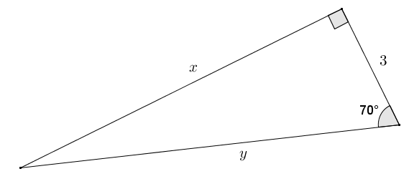
- Find the missing side lengths of the following triangle using sine, cosine, and/or tangent. Round your answer to four decimal places.
Exit Ticket Sample Solutions

- If $\sin{β}=\frac{4\sqrt{29}}{29}$, use trigonometric identities to find $\sin{β}$ and $\tan{β}$.
$$sin^{2}{β}+cos^{2}{β}=1 \\ {\left(\frac{4\sqrt{29}}{29}\right)}^{2}+cos^{2}{β}=1 \\ \frac{16}{29}+cos^{2}{β}=1 \\ cos^{2}{β}=\frac{13}{29} \\ \cos{β}=\sqrt{\frac{13}{29}} \\ \cos{β}=\frac{\sqrt{13}}{\sqrt{29}}=\frac{\sqrt{377}}{29}$$ | $$\tan{β}=\frac{\sin{β}}{\cos{β}} \\ \tan{β}=\frac{\frac{4\sqrt{29}}{29}}{\frac{\sqrt{377}}{29}} \\ \tan{β}=\frac{4\sqrt{29}}{\sqrt{377}} \\ \tan{β}=\frac{4}{\sqrt{13}} \\ \tan{β}=\frac{4\sqrt{13}}{13}$$

- Find the missing side lengths of the following triangle using sine, cosine, and/or tangent. Round your answer to four decimal places.
$$\cos{70}=\frac{3}{y} \\ y=\frac{3}{\cos{70}}≈8.7714$$
$$\tan{70}=\frac{x}{3} \\ x=3\left(\tan{70}\right)≈8.2424$$

Problem Set Sample Solutions

- If $\cos{θ}=\frac{4}{5}$, find $\sin{θ}$ and $\tan{θ}$.
Using the identity $sin^{2}{θ}+cos^{2}{θ}=1$:  $$sin^{2}{θ}+{\left(\frac{4}{5}\right)}^{2}=1 \\ sin^{2}{θ}=1-{\left(\frac{4}{5}\right)}^{2} \\ sin^{2}{θ}=1-\left(\frac{16}{25}\right) \\ sin^{2}{θ}=\frac{9}{25} \\ \sin{θ}=\sqrt{\frac{9}{25}} \\ \sin{θ}=\frac{3}{5}$$ | Using the identity $\tan{θ}=\frac{\sin{θ}}{\cos{θ}}$:  $$\tan{θ}=\frac{\frac{3}{5}}{\frac{4}{5}}=\frac{3}{4}$$

- If $\sin{θ}=\frac{44}{125}$, find $\cos{θ}$ and $\tan{θ}$.
$$\sin^{2}{θ}+\cos^{2}{θ}=1 \\ {\left(\frac{44}{125}\right)}^{2}+\cos^{2}{θ}=1 \\ \cos^{2}{θ}=1-\frac{1936}{15625}=\frac{13689}{15625} \\ \cos{θ}=\sqrt{\frac{13689}{15625}}=\frac{117}{125}$$ | $$\tan{θ}=\frac{44}{125}÷\frac{117}{125}=\frac{44}{117}$$

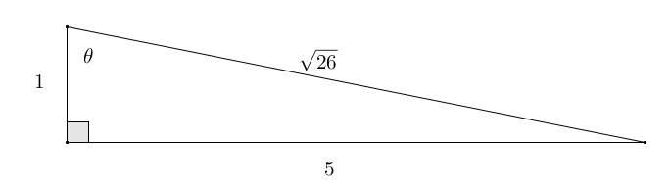
- If $\tan{θ}=5$, find $\sin{θ}$ and $\cos{θ}$.
$\tan{θ}=5=\frac{5}{1}$, so the legs of a right triangle can be considered to have lengths of $5$ and $1$. Using the Pythagorean theorem:
$$5^{2}+1^{2}=hyp^{2} \\ 26=hyp^{2} \\ \sqrt{26}=hyp$$
$$sin θ=\frac{5}{\sqrt{26}}=\frac{5\sqrt{26}}{26}; \cos{θ}=\frac{1}{\sqrt{26}}=\frac{\sqrt{26}}{26}$$

- If $\sin{θ}=\frac{\sqrt{5}}{5}$, find $\cos{θ}$ and $\tan{θ}$.
Using the identity $sin^{2}{θ}+\cos^{2}{θ}=1$:  $${\left(\frac{\sqrt{5}}{5}\right)}^{2}+cos^{2}{θ}=1 \\ cos^{2}{θ}=1-{\left(\frac{\sqrt{5}}{5}\right)}^{2} \\ cos^{2}{θ=1-\left(\frac{5}{25}\right)} \\ cos^{2}{θ}=1-\frac{1}{5}=\frac{4}{5} \\ \cos{θ}=\sqrt{\frac{4}{5}}=\frac{\sqrt{4}}{\sqrt{5}}=\frac{2}{\sqrt{5}} \\ \cos{θ}=\frac{2\sqrt{5}}{5}$$ | Using the identity $\tan{θ}=\frac{\sin{θ}}{\cos{θ}}$:  $$\tan{θ}=\frac{\frac{\sqrt{5}}{5}}{\frac{2\sqrt{5}}{5}}=\frac{\sqrt{5}}{2\sqrt{5}}=\frac{1}{2}$$
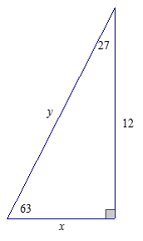
- Find the missing side lengths of the following triangle using sine, cosine, and/or tangent. Round your answer to four decimal places.
$$\frac{x}{12}=\tan{27} \\ x=12\tan{27}≈6.114$$
$$\frac{12}{y}=\sin{63} \\ y=\frac{12}{\sin{63}}≈13.4679$$
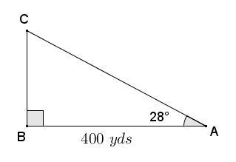
- A surveying crew has two points $A$ and $B$ marked along a roadside at a distance of $400$ yd. A third point $C$ is marked at the back corner of a property along a perpendicular to the road at $B$. A straight path joining $C$ to $A$ forms a $28°$ angle with the road. Find the distance from the road to point $C$ at the back of the property and the distance from $A$ to $C$ using sine, cosine, and/or tangent. Round your answer to three decimal places.
$$\tan{28}=\frac{BC}{400} \\ BC=400\left(\tan{28}\right) \\ BC≈212.684$$
The distance from the road to the back of the property is approximately $212.684 yds$.
$$\cos{28}=\frac{400}{AC} \\ AC=\frac{400}{\cos{28}} \\ AC≈453.028$$
The distance from point $C$ to point $A$ is approximately $453.028 yd$.

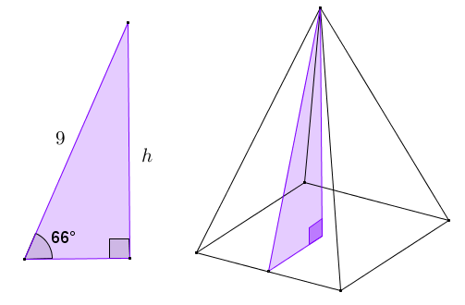
- The right triangle shown is taken from a slice of a right rectangular pyramid with a square base.
  - Find the height of the pyramid (to the nearest tenth).
$$\sin{66}=\frac{h}{9} \\ h=9\left(\sin{66}\right) \\ h≈8.2$$
The height of the prism is approximately $8.2$.

  - Find the lengths of the sides of the base of the pyramid (to the nearest tenth).
The lengths of the sides of the base of the pyramid are twice the length of the short leg of the right triangle shown.
$$\cos{66}=\frac{n}{9} \\ n=9\left(\cos{66}\right) \\ length=2(9\cos{66}) \\ length=18\cos{66} \\ length≈7.3$$
The lengths of the sides of the base are approximately $7.3$.

  - Find the lateral surface area of the right rectangular pyramid.
The faces of the prism are congruent isosceles triangles having bases of $18\cos{66}$ and height of $9$.
$$Area=\frac{1}{2}bh \\ Area=\frac{1}{2}(18\cos{66})(9) \\ Area=81\cos{66} \\ Area≈32.9$$
The lateral surface area of the right rectangular pyramid is approximately $32.9$ square units.
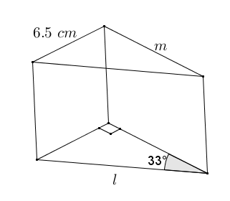
- A machinist is fabricating a wedge in the shape of a right triangular prism. One acute angle of the right triangular base is $33°$, and the opposite side is $6.5 cm$. Find the length of the edges labeled $l$ and $m$ using sine, cosine, and/or tangent. Round your answer to the nearest thousandth of a centimeter.
$$\sin{33}=\frac{6.5}{l} \\ l=\frac{6.5}{\sin{33}}$$
$l≈11.935$
Distance$l$ is approximately $11.935 cm$.

$$\tan{33}=\frac{6.5}{m} \\ m=\frac{6.5}{\tan{33}} \\ m≈10.009$$
Distance $m$ is approximately $10.009 cm$.

- Let $\sin{θ}=\frac{l}{m}$, where $l$, $m>0$. Express $\tan{θ}$ and $\cos{θ}$ in terms of $l$ and $m$.
$$sin^{2}{θ}+cos^{2}{θ}=1 \\ {\left(\frac{l}{m}\right)}^{2}+cos^{2}{θ}=1 \\ cos^{2}{θ}=1-{\left(\frac{l}{m}\right)}^{2} \\ cos^{2}{θ}=\frac{m^{2}}{m^{2}}-\frac{l^{2}}{m^{2}} \\ cos^{2}{θ}=\frac{m^{2}-l^{2}}{m^{2}} \\ \cos{θ}=\sqrt{\frac{m^{2}-l^{2}}{m^{2}}} \\ \cos{θ}=\frac{\sqrt{m^{2}-l^{2}}}{m}$$ | $$\tan{θ}=\frac{\sin{θ}}{\cos{θ}}$$  By substituting the previous result for $\cos{θ}$,$$\tan{θ}=\frac{\frac{l}{m}}{\frac{\sqrt{m^{2}-l^{2}}}{m}} \\ \tan{θ}=\frac{l}{\sqrt{m^{2}-l^{2}}}.$$

