Lesson 30: Trigonometry and the Pythagorean Theorem

Classwork
Exercises 1–2
- In a right triangle, with acute angle of measure $θ$, $\sin{θ=\frac{1}{2}}$. What is the value of $\cos{θ}$? Draw a diagram as part of your response.

- In a right triangle, with acute angle of measure $θ$, $\sin{θ=\frac{7}{9}}$. What is the value of $\tan{θ}$? Draw a diagram as part of your response.

Example 1
  - What common right triangle was probably modeled in the construction of the triangle in Figure 2? Use $\sin{53}≈0.8$.
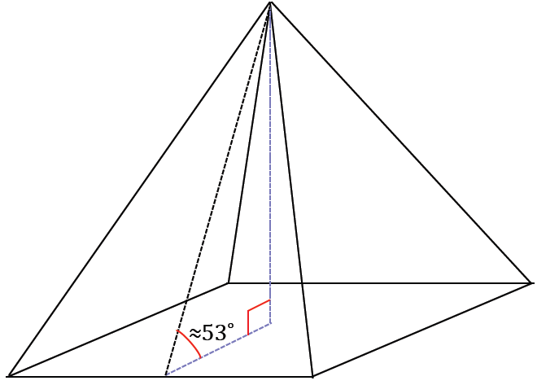
Figure 1

  - The actual angle between the base and lateral faces of the pyramid is actually closer to $52˚$. Considering the age of the pyramid, what could account for the difference between the angle measure in part (a) and the actual measure?

  - Why do you think the architects chose to use a $3$–$4$–$5$ as a model for the triangle?

Example 2
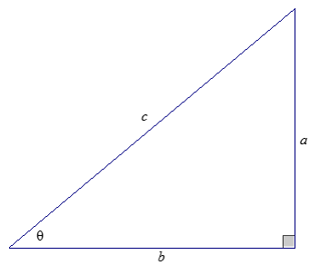
Show why $\tan{θ}=\frac{sinθ}{cosθ}$.

Exercises 3–4
- In a right triangle, with acute angle of measure $θ$, $\sin{θ=\frac{1}{2}}$, use the Pythagorean identity to determine the value of $\cos{θ}$.

- Given a right triangle, with acute angle of measure $θ$, $\sin{θ=\frac{7}{9}}$, use the Pythagorean identity to determine the value of $\tan{θ}$.

Problem Set

- If $\cos{θ}=\frac{4}{5}$, find $\sin{θ}$ and $\tan{θ}$.

- If $\sin{θ}=\frac{44}{125}$, find $\cos{θ}$ and $\tan{θ}$.

- If $\tan{θ}=5$, find $\sin{θ}$ and $\cos{θ}$.

- If $\sin{θ}=\frac{\sqrt{5}}{5}$, find $\cos{θ}$ and $\tan{θ}$.

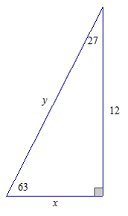
- Find the missing side lengths of the following triangle using sine, cosine, and/or tangent. Round your answer to four decimal places.

- A surveying crew has two points $A$ and $B$ marked along a roadside at a distance of $400$ yd. A third point $C$ is marked at the back corner of a property along a perpendicular to the road at $B$. A straight path joining $C$ to $A$ forms a $28°$ angle with the road. Find the distance from the road to point $C$ at the back of the property and the distance from $A$ to $C$ using sine, cosine, and/or tangent. Round your answer to three decimal places.
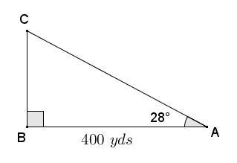

- The right triangle shown is taken from a slice of a right rectangular pyramid with a square base.
  - Find the height of the pyramid (to the nearest tenth).
  - Find the lengths of the sides of the base of the pyramid (to the nearest tenth).
  - Find the lateral surface area of the right rectangular pyramid.
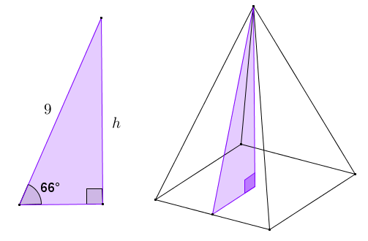

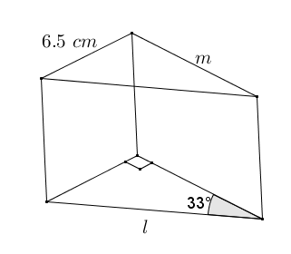
- A machinist is fabricating a wedge in the shape of a right triangular prism. One acute angle of the right triangular base is $33°$, and the opposite side is $6.5 cm$. Find the length of the edges labeled $l$ and $m$ using sine, cosine, and/or tangent. Round your answer to the nearest thousandth of a centimeter.

- Let $\sin{θ}=\frac{l}{m}$, where $l$, $m>0$. Express $\tan{θ}$ and $\cos{θ}$ in terms of $l$ and $m$.

