Lesson 28: Solving Problems Using Sine and Cosine

Student Outcomes
- Students use graphing calculators to find the values of $\sin{θ}$ and $cos⁡θ$ for $θ$ between $0°$ and $90°$.
- Students solve for missing sides of a right triangle given the length of one side and the measure of one of the acute angles.
- Students find the length of the base of a triangle with acute base angles given the lengths of the other two sides and the measure of each of the base angles.

Lesson Notes
Students will need access to a graphing calculator to calculate the sine and cosine of given angle measures. It will likely be necessary to show students how to set the calculator in degree mode and to perform these operations. Encourage students to make one computation on the calculator and then approximate their answer as opposed to making intermediate approximations throughout the solution process. Intermediate approximations lead to a less accurate answer than doing the approximation once.

Classwork
Exercises 1–4 (12 minutes)
Allow students to work in pairs to complete Exercise 1. You may need to demonstrate how to use a graphing calculator to perform the following calculations. Ensure that all calculators are in degree mode, not radian. Consider telling students that radian is a measure they will encounter in Module 5 and use in Algebra II. For now, our unit of angle measure is degree. After completing the exercises, debrief by having students share their explanations in Exercise 4.

Exercises 1–4

  - The bus drops you off at the corner of H Street and 1st Street, approximately $300$ ft. from school. You plan to walk to your friend Janneth’s house after school to work on a project. Approximately how many feet will you have to walk from school to Janneth’s house? Round your answer to the nearest foot. (Hint: Use the ratios you developed in Lesson 25.)
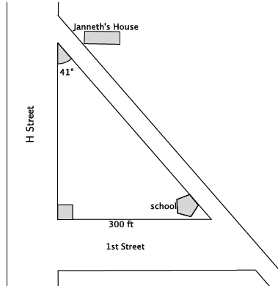

Let $x$ represent the distance from school to Janneth’s house. The $sin⁡41=\frac{opp}{hyp}=\frac{5.3}{8}.$ Then $\frac{300}{x}=\frac{5.3}{8}$ and $x=452.8301887…$
The distance I will have to walk from school to Janneth’s house is approximately $453$ ft.

  - In real life, it is unlikely that you would calculate the distance between school and Janneth’s house in this manner. Describe a similar situation in which you might actually want to determine the distance between two points using a trigonometric ratio.
Accept any reasonable responses. Some may include needing to calculate the distance to determine if a vehicle has enough fuel to make the trip or the need to determine the length prior to attempting the walk because a friend is on crutches and cannot easily get from one location to the next when the distance is too long.

- Use a calculator to find the sine and cosine of $θ$. Give your answer rounded to the ten-thousandth place.
$$θ$$ | $$0$$ | $$10$$ | $$20$$ | $$30$$ | $$40$$ | $$50$$ | $$60$$ | $$70$$ | $$80$$ | $$90$$
$$\sin{θ}$$ | $$0$$ | $$0.1736$$ | $$0.3420$$ | $$\frac{1}{2}=0.5$$ | $$0.6428$$ | $$0.7660$$ | $$0.8660$$ | $$0.9397$$ | $$0.9848$$ | $$1$$
$$\cos{θ}$$ | $$1$$ | $$0.9848$$ | $$0.9397$$ | $$0.8660$$ | $$0.7660$$ | $$0.6428$$ | $$\frac{1}{2}=0.5$$ | $$0.3420$$ | $$0.1736$$ | $$0$$

- What do you notice about the numbers in the row $sin θ$compared with the numbers in the row $\cos{θ}$?
MP.8
The numbers are the same but reversed in order.

- Provide an explanation for what you noticed in Exercise 2.
The pattern exists because the sine and cosine of complementary angles are equal.

Example 1 (8 minutes)
Students find the missing side length of a right triangle using sine and cosine.
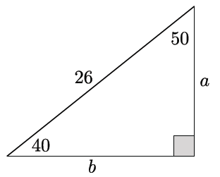
Example 1
Find the values of $a$ and $b$.

- Now that we can calculate the sine and cosine of a given angle using a calculator, we can use the decimal value of the ratio to determine the unknown side length of a triangle.
Consider the following triangle.
- What can we do to find the length of side $a$?
  - We can find the $\sin{40}$ or $\cos{50}.$
- Let’s begin by using the $\sin{40.}$We expect $\sin{40=\frac{a}{26}}.$ Why?
  - By definition of sine; $\sin{θ=\frac{opp}{hyp}.}$
- To calculate the length of $a$ we must determine the value of $26\sin{40}$ because $a=26\sin{40}.$ We will round our answer to two decimal places.
- Using the decimal approximation of $\sin{40}≈0.6428$, we can write
$$26\left(0.6428\right)≈a \\ 16.71≈a$$
- Now let’s use $\cos{50}$ which is approximately $0.6428.$ What do you expect the result to be? Explain.
  - I expect the result to be the same. Since the approximation of $\sin{40}$ is equal to the approximation of $\cos{50}$ the computation should be the same.
Note that students may say that $\sin{40=\cos{50}}.$ Ensure that students know that once decimal approximations are used in place of the functions, we are no longer looking at two quantities that are equal because the decimals are approximations. To this end, ask students to recall that in Exercise 1 we were only taking the first four decimal digits of the number; that is, we are using approximations of those values. Therefore, we cannot explicitly claim that $\sin{40=\cos{50}},$ rather that their approximations are extremely close in value to one another.
If necessary, show the computation below that verifies the claim made above.
$$\cos{50}=\frac{a}{26} \\ 26\cos{50=a} \\ 26\left(0.6428\right)≈a \\ 16.71≈a$$
- Now calculate the length of side $b$.
  - Side $b$ can be determined using $\sin{50}$or $\cos{40}.$
$$26\left(0.7660\right)≈b \\ 19.92≈b$$
- Could we have used another method to determine the length of side $b?$
  - Yes, because this is a right triangle and two sides are known, we could use the Pythagorean theorem to determine the length of the third side.

The points below are to make clear that the calculator gives approximations of the ratios we desire when using trigonometric functions.
- When we use a calculator to compute, what we get is a decimal approximation of the ratio $\frac{a}{26}$. Our calculators are programmed to know which number $a$ is needed, relative to $26$, so that the value of the ratio $\frac{a}{26}$ is equal to the value of $\sin{40}.$ For example, $\sin{40}=\frac{a}{26}$ and $\sin{40}≈0.6428.$ Our calculators give us the number $a$ that, when divided by $26$, is closest to the actual value of $\sin{40}.$
- Here is a simpler example illustrating this fact. Consider a right triangle with an acute angle of $30˚$ and hypotenuse length of $9$ units. Then, $\sin{30}=\frac{a}{9}$. We know that $\sin{30}=\frac{1}{2}=0.5$. What our calculators do is find the number $a$ so that $\frac{a}{9}=\frac{1}{2}=0.5,$ which is $a=4.5.$

Exercise 5 (5 minutes)
Students complete Exercise 5 independently. All students should be able to complete part (a) in the allotted time. Consider assigning part (b) to only those students who finish part (a) quickly. Once completed, have students share their solutions with the class.
Scaffolding:
- Read the problem aloud and ask students to summarize the situation with a partner.
- English language learners may benefit from labeling the horizontal distance E for east and the vertical distance S for south.
- Consider simplifying the problem by drawing only the triangle and labeling the measures of the angle and the hypotenuse and then asking students to find the unknown lengths.
Exercise 5
- A shipmate set a boat to sail exactly $27˚$ NE from the dock. After traveling $120$miles, the shipmate realized he had misunderstood the instructions from the captain; he was supposed to set sail going directly east!
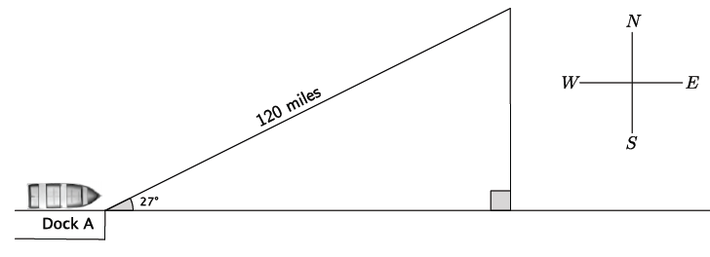

  - How many miles will the shipmate have to travel directly south before he is directly east of the dock? Round your answer to the nearest mile.
Let $S$ represent the distance they traveled directly south.
$$\sin{27=\frac{S}{120}} \\ 120\sin{27}=S \\ 54.47885997 ... =S$$
He traveled approximately $54$ mi. south.

  - How many extra miles does the shipmate travel by going the wrong direction compared to going directly east? Round your answer to the nearest mile.
Solutions may vary. Some students may use the Pythagorean theorem while others may use the cosine function. Both are acceptable strategies. If students use different strategies make sure to share them with the class and discuss the benefits of each.
Let $E$ represent the distance the boat is when it is directly east of the dock.
$$\cos{27}=\frac{E}{120} \\ 120\cos{27=E} \\ 106.9207829…=E \\ 107≈E$$
The total distance traveled by the boat is $120+54=174$. They ended up exactly $107$ miles east of the dock so they traveled an extra $174-107=67$ miles.

Example 2 (8 minutes)
Students find the missing side length of a triangle using sine and cosine.
Johanna borrowed some tools from a friend so that she could precisely, but not exactly, measure the corner space in her backyard to plant some vegetables. She wants to build a fence to prevent her dog from digging up the seeds that she plants. Johanna returned the tools to her friend before making the most important measurement: the one that would give the length of the fence!
MP.1
Johanna decided that she could just use the Pythagorean theorem to find the length of the fence she’d need. Is the Pythagorean theorem applicable in this situation? Explain.
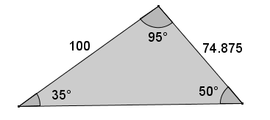
No, the corner of her backyard is not a $90˚$ angle; therefore, the Pythagorean theorem cannot be applied in this situation. The Pythagorean theorem will, however, provide an approximation since the given angle has a measure that is close to $90°$.
- What can we do to help Johanna figure out the length of fence she needs?
MP.1
Provide time for students to discuss this in pairs or small groups. Allow them to make sense of the problem and persevere in solving it. It may be necessary to guide their thinking using the prompts below.
- If we dropped an altitude from the angle with measure $95˚$, could that help? How?
- Would we be able to use the Pythagorean theorem now? Explain.
- If we denote the side opposite the $95˚$ angle as $x$ and $y$, as shown, can we use what we know about sine and cosine? Explain.
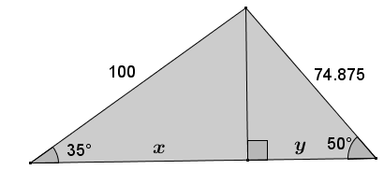
  - The missing side length is equal to $x+y.$ The length $x$ is equal to $100\cos{35}$ and the length $y$ is equal to $74.875\cos{50}.$ Therefore, the length of $x+y=100\cos{35}+74.875\cos{50}≈81.92+48.12872≈130.05.$
  - Note: The Pythagorean theorem provides a reasonable approximation of $124.93$.

Exercise 6 (4 minutes)
Students complete Exercise 6 independently.
Exercise 6
- The measurements of the triangle shown below are rounded to the nearest hundredth. Calculate the missing side length to the nearest hundredth.
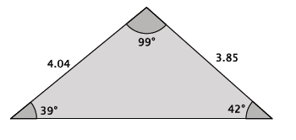
Drop an altitude from the angle that measures $99˚$.
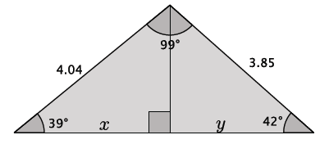
Then the length of the missing side is $x+y$, which can be found by $4.04\cos{39+3.85\cos{42}≈3.139669+2.861107=6.000776≈6.}00$.

Closing (3 minutes)
Ask students to discuss the answers to the following questions with a partner, and then select students to share with the class. For the first question, elicit as many acceptable responses as possible.
- Explain how to find the unknown length of a side of a right triangle.
  - If two sides are known, then the Pythagorean theorem can be used to determine the length of the third side.
  - If one side is known and the measure of one of the acute angles is known, then sine, cosine, or tangent can be used.
  - If the triangle is known to be similar to another triangle where the side lengths are given, then corresponding ratios or knowledge of the scale factor can be used to determine the unknown length.
  - Direct measurement can be used.
- Explain when and how you can find the unknown length of a side of a triangle that does not have a right angle.
  - You can find the length of an unknown side length of a triangle when you know two of the side lengths and the missing side is between two acute angles. Split the triangle into two right triangles, and find the lengths of two pieces of the missing side.

Exit Ticket (5 minutes)

Name Date
Lesson 28: Solving Problems Using Sine and Cosine

Exit Ticket

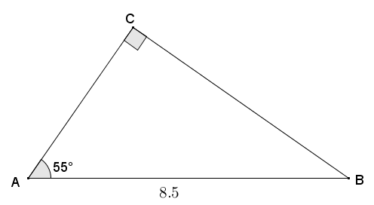
- Given right triangle$ABC$ with hypotenuse $AB=8.5$ and $∠A=55°$, find $AC$ and $BC$ to the nearest hundredth.

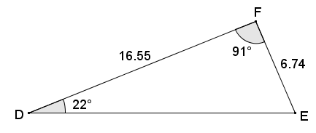
- Given triangle $DEF$, $∠D=22°$, $∠F=91°$, $DF=16.55$, and $EF=6.74$, find $DE$ to the nearest hundredth.
Exit Ticket Sample Solutions

- Given right triangle $ABC$ with hypotenuse $AB=8.5$ and $∠A=55°$, find $AC$ and $BC$ to the nearest hundredth.
$$BC=8.5\left(\sin{55}\right) \\ BC≈6.96$$

$$AC=8.5(cos{55}) \\ A≈4.88$$

- Given triangle $DEF$, $∠D=22°$, $∠F=91°$, $DF=16.55$, and $EF=6.74$, find $DE$ to the nearest hundredth.
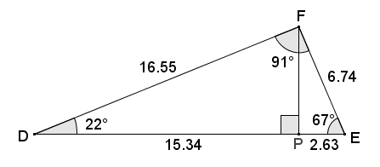
Draw altitude from $F$ to $\overline{DE}$ at point $P$. Cosines can be used on angles $D$ and $E$ to determine the lengths of $DP$ and $PE$, which together compose $\overline{DE}$.
$$PE=6.74\left(\cos{67}\right) \\ PE≈2.6335$$
$$DP=16.55\left(\cos{22}\right) \\ DP≈15.3449$$
$$DE=DP+PE \\ DE≈15.3449+2.6335 \\ DE≈17.98$$

Note to teacher: Answers of $DE≈17.97$ result from rounding to the nearest hundredth too early in the problem.

Problem Set Sample Solutions

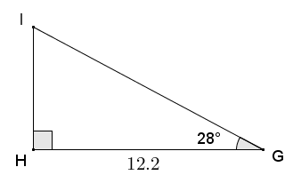
- Given right triangle $GHI$, with right angle at $H$, $GH=12.2$ and $m∠G=28°$, find the measures of the remaining sides and angle to the nearest tenth.
$$\cos{28}=\frac{12.2}{GI} \\ GI=\frac{12.2}{\cos{28}} \\ GI≈13.8$$
$$\tan{28}=\frac{IH}{12.2} \\ IH=12.2\tan{28} \\ IH≈6.5$$
$$28°+∠I=90° \\ ∠I=62°$$

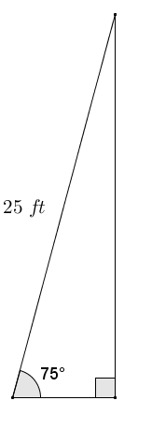
- The Occupational Safety and Health Administration (OSHA) provides standards for safety at the work place. A ladder is leaned against a vertical wall according to OSHA standards and forms an angle of approximately $75°$ with the floor.
  - If the ladder is $25 ft.$ long, what is the distance from the base of the ladder to the base of the wall?
Let $b$ represent the distance of the base of the ladder from the wall in feet.
$$b=25\left(\cos{75}\right) \\ b≈6.5$$
The base of the ladder is approximately $6 ft. 6 in.$ from the wall.

  - How high on the wall does the ladder make contact?
Let $h$ represent the height on the wall where the ladder makes contact in feet.
$$h=25(\sin{75)} \\ h≈24.1$$
The ladder contacts the wall just over $24 f$t. above the ground.

  - Describe how to safely set a ladder according to OSHA standards without using a protractor.
Answers will vary. Possible description:
The horizontal distance of the base of the ladder to the point of contact of the ladder should be approximately $\frac{1}{4}$ of the length of the ladder.

- A regular pentagon with side lengths of $14 cm$ is inscribed in a circle. What is the radius of the circle?
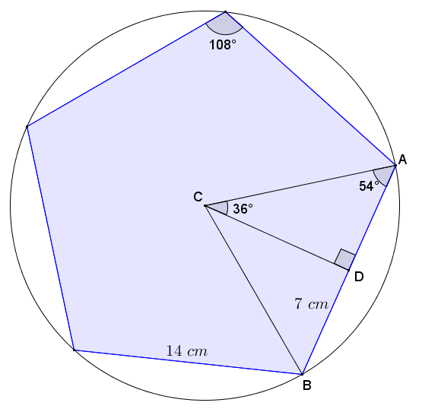
Draw radii from center $C$ of the circle to two consecutive vertices of the pentagon, $A$ and $B$, and draw an altitude from the center $C$ to $D$ on $\overline{AB}$.
The interior angles of a regular pentagon have measure of $108°$, and $\overline{AC}$ and $\overline{BC}$ bisect the interior angles at $A$ and $B$.
$AD=BD=7 cm$
Let $x$ represent the lengths of $AC$ in $cm$.

Using cosine, $\cos{54}=\frac{7}{x}$, and thus:
$$x=\frac{7}{\cos{54}} \\ x≈11.9.$$
$AC$ is a radius of the circle and has a length of approximately $11.9 cm$.

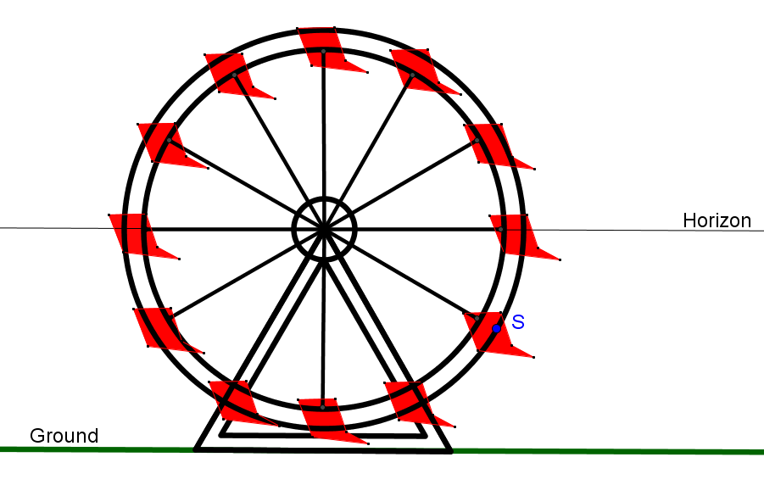
- The circular frame of a Ferris wheel is suspended so that it sits $4 ft.$ above the ground and has a radius of $30 ft.$ A segment joins center $C$ to point $S$ on the circle. If $\overline{CS}$ makes an angle of $48°$ with the horizon, what is the distance of point $S$ to the ground?
Horizontal Center Line
Note to teacher: There are two correct answers to this problem since the segment can make an angle of $48°$ above or below the horizon in four distinct locations, providing two different heights above the ground.
There are four locations at which the segment makes an angle of $48°$ with the horizon. In each case, $\overline{CS}$ is the hypotenuse of a right triangle with acute angles with measures of $48°$ and $42°$.

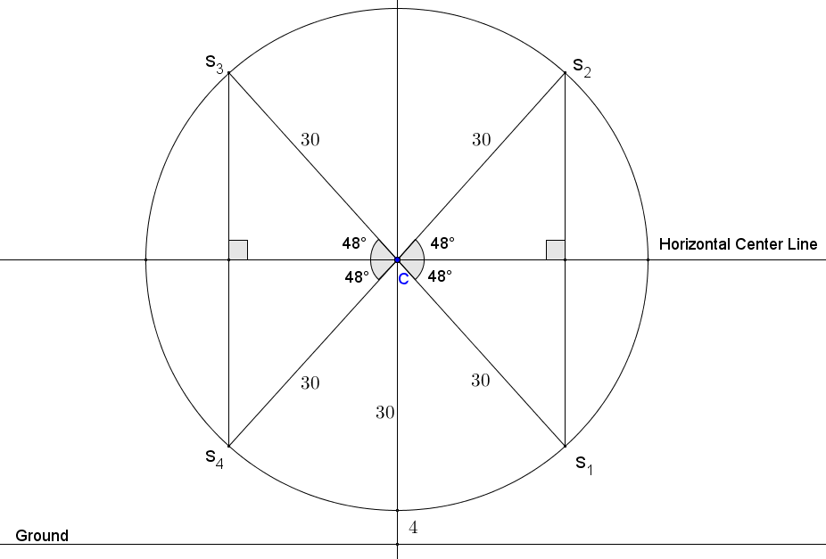

Let $d$ represent the distance in feet from point $S$ to the horizon (applies to each case):
$$\sin{48}=\frac{d}{30} \\ 30 \left(\sin{48}\right)=d \\ 22.3≈d.$$
The center of the Ferris wheel is $34 ft.$ above the ground; therefore, the distance from points $S_{1}$ and $S_{4}$ to the ground in feet is
$34-22.3=11.7$.
Points $S_{2}$ and $S_{3}$ are approximately $22.3 ft.$ above the center of the Ferris wheel, so the distance from $S_{2}$ and $S_{3}$ to the ground in feet is
$34+22.3=56.3$.
When $\overline{CS}$ forms a $48°$ angle with the horizon, point $S$ is either approximately $11.7 ft.$ above the ground or approximately $56.3 ft.$ above the ground.

- Tim is a contractor who is designing a wheelchair ramp for handicapped access to a business. According to the Americans with Disabilities Act (ADA), the maximum slope allowed for a public wheelchair ramp forms an angle of approximately $4.76°$ to level ground. The length of a ramp’s surface cannot exceed $30 ft.$ without including a flat $5 ft.×5 ft.$ platform (minimum dimensions) on which a person can rest, and such a platform must be included at the bottom and top of any ramp.
Tim designs a ramp that forms an angle of $4°$ to the level ground to reach the entrance of the building. The entrance of the building is $2 ft. 9 in.$ above the ground. Let $x$ and $y$ as shown in Tim’s initial design below be the indicated distances in feet.
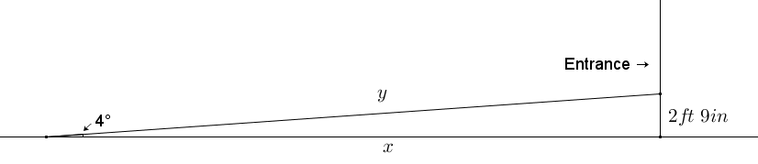
  - Assuming that the ground in front of the building’s entrance is flat, use Tim’s measurements and the ADA requirements to complete and/or revise his wheelchair ramp design.
(For more information, see section 405 of the 2010 ADA Standards for Accessible Design at the following link: http://www.ada.gov/regs2010/2010ADAStandards/2010ADAstandards.htm#pgfId-1006877.)
Note to Teacher: Student designs will vary; however, the length of the ramp’s surface is greater than $30 ft.$, which requires at least one resting platform along the ramp. Furthermore, Tim’s design does not include a platform at the top of the ramp as required by the guidelines, rendering his design incorrect.
Possible Student Solution:
$2 ft. 9 in.=2.75 ft.$
Using tangent, $\tan{4}=\frac{2.75}{x}$, and thus
$$x=\frac{2.75}{\tan{4}} \\ x≈39.33.$$
The ramp begins approximately $39 ft. 4 in.$ from the building; thus, the ramp’s surface is greater than $30$ feet in length. The hypotenuse of the triangle represents the sloped surface of the ramp and must be longer than the legs. Tim’s design will not meet the ADA Guidelines because it does not include a flat resting section along the ramp‘s slope, nor does it include a platform at the top of the ramp. (The bottom of the ramp is flat ground. The student’s design may or may not include a platform at the bottom.)
The vertical distance from the ground to the entrance is $2.75 ft.$ Using sine, $\sin{4}=\frac{2.75}{y}$, and thus
$$y=\frac{2.75}{\sin{4}}$$
$$y≈39.42.$$
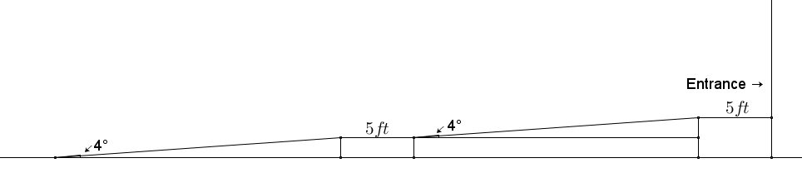
The total length of the ramp surface is approximately $39 ft. 5 in.$; however, because of its length, it requires a resting platform somewhere in the first $30$ feet and another platform at the top.
Resting Platform 1

Resting Platform 2

  - What is the total distance from the start of the ramp to the entrance of the building in your design?
If each platform is $5 ft.$ in length, then the total distance along the ramp from the ground to the building is approximately $49 ft. 5 in.$

- Tim is designing a roof truss in the shape of an isosceles triangle. The design shows the base angles of the truss to have measures of $18.5°$. If the horizontal base of the roof truss is $36 ft.$ across, what is the height of the truss?
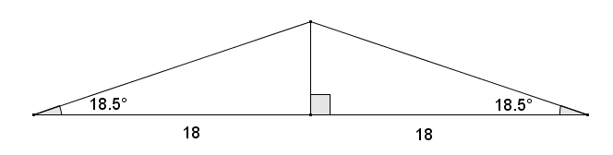
Let $h$ represent the height of the truss in feet. Using tangent, $\tan{18.5}=\frac{h}{18}$, and thus
$$h=18(\tan{18.5}) \\ h≈6.$$
The height of the truss is approximately $6 ft.$

