Lesson 28: Solving Problems Using Sine and Cosine

Classwork
Exercise 1–4

  - The bus drops you off at the corner of H Street and 1st Street, approximately $300$ ft. from school. You plan to walk to your friend Janneth’s house after school to work on a project. Approximately how many feet will you have to walk from school to Janneth’s house? Round your answer to the nearest foot. (Hint: Use the ratios you developed in Lesson 25.)

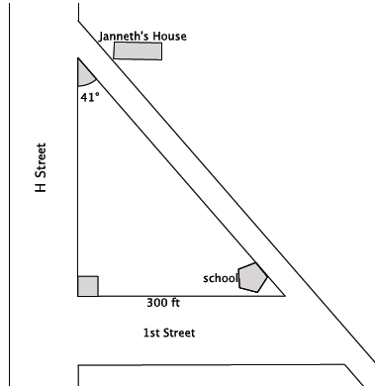

  - In real life, it is unlikely that you would calculate the distance between school and Janneth’s house in this manner. Describe a similar situation in which you might actually want to determine the distance between two points using a trigonometric ratio.

- Use a calculator to find the sine and cosine of $θ$. Give your answer rounded to the ten-thousandth place.
$$θ$$ | $$0$$ | $$10$$ | $$20$$ | $$30$$ | $$40$$ | $$50$$ | $$60$$ | $$70$$ | $$80$$ | $$90$$
$$\sin{θ}$$
$$\cos{θ}$$
- What do you notice about the numbers in the row $sin θ$compared with the numbers in the row $\cos{θ}$?

- Provide an explanation for what you noticed in Exercise 2.

Example 1
Find the values of $a$ and $b$.

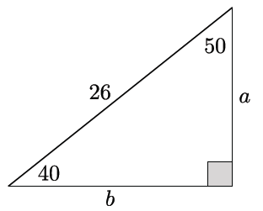

Exercise 5
- A shipmate set a boat to sail exactly $27˚$ NE from the dock. After traveling $120$miles, the shipmate realized he had misunderstood the instructions from the captain; he was supposed to set sail going directly east!
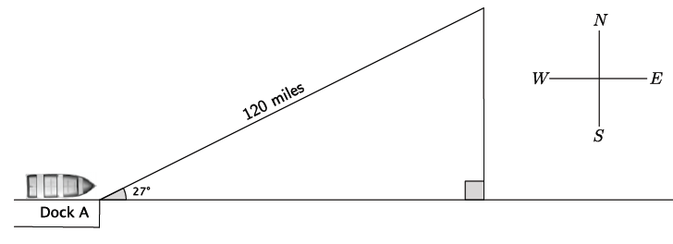
  - How many miles will the shipmate have to travel directly south before he is directly east of the dock? Round your answer to the nearest mile.

  - How many extra miles does the shipmate travel by going the wrong direction compared to going directly east? Round your answer to the nearest mile.

Example 2
Johanna borrowed some tools from a friend so that she could precisely, but not exactly, measure the corner space in her backyard to plant some vegetables. She wants to build a fence to prevent her dog from digging up the seeds that she plants. Johanna returned the tools to her friend before making the most important measurement: the one that would give the length of the fence!
Johanna decided that she could just use the Pythagorean theorem to find the length of the fence she’d need. Is the Pythagorean theorem applicable in this situation? Explain.
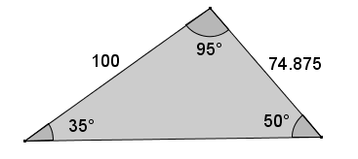

Exercise 6
- The measurements of the triangle shown below are rounded to the nearest hundredth. Calculate the missing side length to the nearest hundredth.
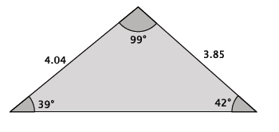

Problem Set

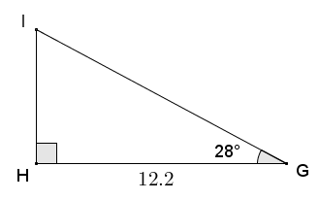
- Given right triangle $GHI$, with right angle at $H$, $GH=12.2$, and $m∠G=28°$, find the measures of the remaining sides and angle to the nearest tenth.

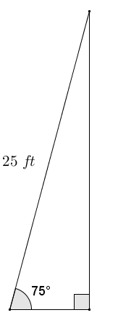
- The Occupational Safety and Health Administration (OSHA) provides standards for safety at the workplace. A ladder is leaned against a vertical wall according to OSHA standards and forms an angle of approximately $75°$ with the floor.
  - If the ladder is $25 ft.$ long, what is the distance from the base of the ladder to the base of the wall?
  - How high on the wall does the ladder make contact?
  - Describe how to safely set a ladder according to OSHA standards without using a protractor.

- A regular pentagon with side lengths of $14 cm$ is inscribed in a circle. What is the radius of the circle?
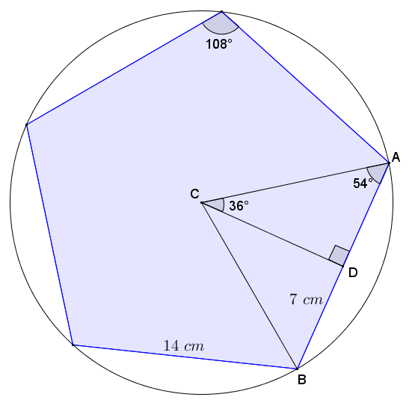

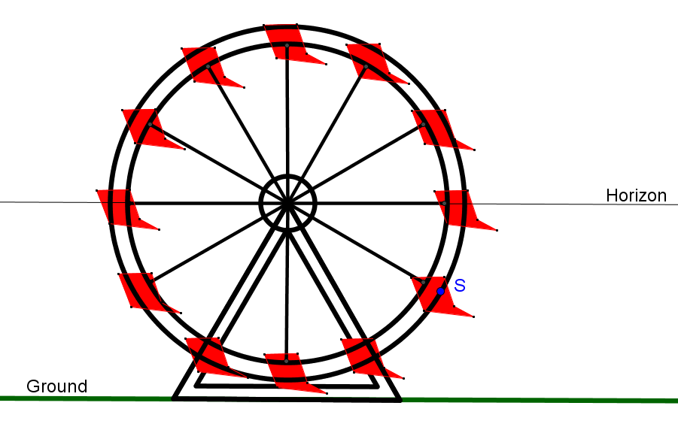
- The circular frame of a Ferris wheel is suspended so that it sits $4 ft.$ above the ground and has a radius of $30 ft.$ A segment joins center $C$ to point $S$ on the circle. If $\overline{CS}$ makes an angle of $48°$ with the horizon, what is the distance of point $S$ to the ground?
Horizontal Center Line

- Tim is a contractor who is designing a wheelchair ramp for handicapped access to a business. According to the Americans with Disabilities Act (ADA), the maximum slope allowed for a public wheelchair ramp forms an angle of approximately $4.76°$ to level ground. The length of a ramp’s surface cannot exceed $30 ft.$ without including a flat $5 ft.$ $×5 ft.$ platform (minimum dimensions) on which a person can rest, and such a platform must be included at the bottom and top of any ramp.
Tim designs a ramp that forms an angle of $4°$ to the level ground to reach the entrance of the building. The entrance of the building is $2 ft. 9 in.$ above the ground. Let $x$ and $y$ as shown in Tim’s initial design below be the indicated distances in feet.
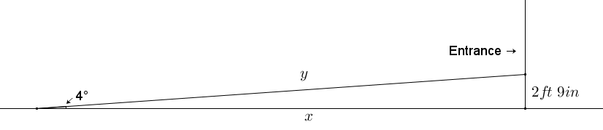
  - Assuming that the ground in front of the building’s entrance is flat, use Tim’s measurements and the ADA requirements to complete and/or revise his wheelchair ramp design.

(For more information, see section 405 of the 2010 ADA Standards for Accessible Design at the following link: http://www.ada.gov/regs2010/2010ADAStandards/2010ADAstandards.htm#pgfId-1006877.)

  - What is the total distance from the start of the ramp to the entrance of the building in your design?

- Tim is designing a roof truss in the shape of an isosceles triangle. The design shows the base angles of the truss to have measures of $18.5°$. If the horizontal base of the roof truss is $36 ft.$ across, what is the height of the truss?

