Lesson 27: Sine and Cosine of Complementary Angles and Special Angles

Student Outcomes
- Students understand that if $α$ and $β$ are the measurements of complementary angles, then $\sin{α=\cos{β}}$.
- Students solve triangle problems using special angles.
Scaffolding:
- If students are struggling to see the connection, use a right triangle with side lengths 3, 4, and 5 to help make the values of the ratios more apparent.
- Use the cutouts from Lesson 21.
- Ask students to calculate values of sine and cosine for the acute angles (by measuring) and then ask them, "What do you notice?"
- As an extension, ask students to write a letter to a middle school student explaining why the sine of an angle is equal to the cosine of its complementary angle.

Lesson Notes
Students examine the sine and cosine relationship more closely and find that the sine and cosine of complementary angles are equal. Students become familiar with the values associated with sine and cosine of special angles. Once familiar with these common values, students use them to find unknown values in problems.

Classwork
Example 1 (8 minutes)
Students discover why cosine has the prefix “co-”. It may be necessary to remind students why we know alpha and beta are complementary.
Example 1
If $α$ and $β$ are the measurements of complementary angles, then we are going to show that $sin α=cos β$.
In right triangle $ABC$, the measurement of acute angle $∠A$ is denoted by $α$, and the measurement of acute angle $∠B$ is denoted by $β$.
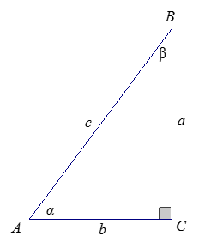
Determine the following values in the table:
MP.2
$$sin α$$ | $$sin β$$ | $$cos α$$ | $$cos β$$
$$sin α=\frac{opp}{hyp}=\frac{a}{c}$$ | $$sin β=\frac{opp}{hyp}=\frac{b}{c}$$ | $$cos α=\frac{adj}{hyp}=\frac{b}{c}$$ | $$cos β=\frac{adj}{hyp}=\frac{a}{c}$$
What can you conclude from the results?
Since the ratios for $sin α$ and $cos β$ are the same, $sin α=cos β$ and ratios for $cos α$ and $sin β$ are the same; additionally, $cos α=sin β$. The sine of an angle is equal to the cosine of its complementary angle, and the cosine of an angle is equal to the sine of its complementary angle.

- Therefore, we conclude for complementary angles $α$ and $β$ that $sin α=cos β,$ or, in other words, when $0<θ<90$ that $sin\left(90-θ\right)=cos θ,$ and $sin θ=cos (90-θ)$. Any two angles that are complementary can be realized as the acute angles in a right triangle. Hence, the “co-” prefix in cosine is a reference to the fact that the cosine of an angle is the sine of its complement.

Exercises 1–3 (7 minutes)
Students apply what they know about the sine and cosine of complementary angles to solve for unknown angle values.
Exercises 1–3
- Consider the right triangle $ABC$ so that $∠C$ is a right angle, and the degree measures of $∠A$ and $∠B$ are $α$ and $β$, respectively.
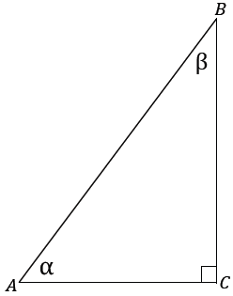
  - Find $α+β$.
$$90˚$$

  - Use trigonometric ratios to describe $\frac{BC}{AB}$ two different ways.
$\sin{∠A}{=}\frac{BC}{AB}$, $\cos{∠B}{=}\frac{BC}{AB}$

  - Use trigonometric ratios to describe $\frac{AC}{AB}$ two different ways.
$\sin{∠B}{=}\frac{AC}{AB}$, $\cos{∠A}{=}\frac{AC}{AB}$

  - What can you conclude about $sin α$ and $cos β$?
$$\sin{α}=\cos{β}$$

  - What can you conclude about $cos α$ and $sin β$?
$$\cos{α}=\sin{β}$$

- Find values for $θ$ that make each statement true.
  - $sin θ=cos (25)$
$$θ=65$$

  - $sin 80=cos θ$
$$θ=10$$

  - $sin θ=cos (θ+10)$
$$θ=40$$

  - $sin (θ-45)=cos (θ)$
$$θ=67.5$$

- For what angle measurement must sine and cosine have the same value? Explain how you know.
Sine and cosine have the same value for $θ=45$. The sine of an angle is equal to the cosine of its complement. Since the complement of $45$ is $45$, $sin 45=cos 45$.
Example 2 (8 minutes)
Students begin to examine special angles associated with sine and cosine, starting with the angle measurements of $0˚$ and $90˚$. Consider modeling this on the board by drawing a sketch of the following figure and using a meter stick to represent $c$.
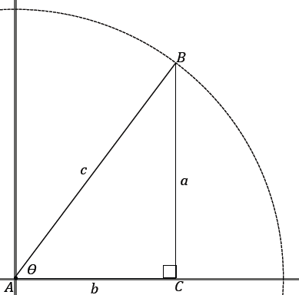
Example 2
What is happening to $a$ and $b$ as $θ$ changes? What happens to $\sin{θ}$ and $\cos{θ}$?

- There are values for sine and cosine commonly known for certain angle measurements. Two such angle measurements are when $θ=0˚$ and $θ=90˚$.
- To better understand sine and cosine values, imagine a right triangle whose hypotenuse has a fixed length $c$ of $1$ unit. We illustrate this by imagining the hypotenuse as the radius of a circle, as in the image.
- What happens to the value of the sine ratio as $θ$ approaches $0˚$? Consider what is happening to the opposite side, $a$.
With one end of the meter stick fixed at $A$, rotate it like the hands of a clock and show how $a$ decreases as $θ$ decreases. Demonstrate the change in the triangle for each case.
  - As $θ$ gets closer to $0°$, $a$ decreases. Since $\sin{θ}=\frac{a}{1}$, the value of $\sin{θ}$ is also approaching $0$.
- Similarly, what happens to the value of the cosine ratio as $θ$ approaches $0˚$? Consider what is happening to the adjacent side, $b$.
  - As $θ$ gets closer to $0°$, $b$ increases and becomes closer to $1$. Since $\cos{θ}=\frac{b}{1}$, the value of $\cos{θ}$ is approaching $1$.
- Now, consider what happens to the value of the sine ratio as $θ$ approaches $90°.$ Consider what is happening to the opposite side, $a$.
  - As $θ$ gets closer to $90°$, $a$ increases and becomes closer to $1$. Since $\sin{θ}=\frac{a}{1}$, the value of $\sin{θ}$ is also approaching $1$.
- What happens to the value of the cosine ratio as $θ$ approaches $90˚$? Consider what is happening to the adjacent side, $b$.
  - As $θ$ gets closer to $90°$, $b$ decreases and becomes closer to $0$. Since $\cos{θ}=\frac{b}{1}$, the value of $\cos{θ}$ is approaching $0$.
- Remember, because there are no right triangles with an acute angle of $0˚$ or of $90˚$, in the above thought experiment, we are really defining $\sin{0}=0$ and $\cos{0}=1$.

- Similarly, we define $\sin{90=1}$ and $\cos{90=0}$; notice that this falls in line with our conclusion that the sine of an angle is equal to the cosine of its complementary angle.

Example 3 (10 minutes)
Students examine the remaining special angles associated with sine and cosine in Example 3. Consider assigning parts (b) and (c) to two halves of the class and having students present a share out of their findings.

Example 3
There are certain special angles where it is possible to give the exact value of sine and cosine. These are the angles that measure $0˚$, $30˚$, $45˚$, $60˚$, and $90˚$; these angle measures are frequently seen.
You should memorize the sine and cosine of these angles with quick recall just as you did your arithmetic facts.
  - Learn the following sine and cosine values of the key angle measurements.
$$θ$$ | $$0˚$$ | $$30˚$$ | $$45˚$$ | $$60˚$$ | $$90˚$$
Sine | $$0$$ | $$\frac{1}{2}$$ | $$\frac{\sqrt{2}}{2}$$ | $$\frac{\sqrt{3}}{2}$$ | $$1$$
Cosine | $$1$$ | $$\frac{\sqrt{3}}{2}$$ | $$\frac{\sqrt{2}}{2}$$ | $$\frac{1}{2}$$ | $$0$$

We focus on an easy way to remember the entries in the table. What do you notice about the table values?
MP.7
The entries for cosine are the same as the entries for sine but in the reverse order.

This is easily explained because the pairs $(0,90)$, $(30,60)$, and $(45,45)$ are the measures of complementary angles. So, for instance, $\sin{30=\cos{60}}$.
The sequence $0,\frac{1}{2}, \frac{\sqrt{2}}{2}, \frac{\sqrt{3}}{2},1$ may be easier to remember as the sequence $\frac{\sqrt{0}}{2},\frac{\sqrt{1}}{2},\frac{\sqrt{2}}{2},\frac{\sqrt{3}}{2},\frac{\sqrt{4}}{2}$.

  - $△ABC$ is equilateral, with side length $2$; $D$ is the midpoint of side $AC$. Label all side lengths and angle measurements for $△ABD$. Use your figure to determine the sine and cosine of $30$ and $60$.

Provide students with a hint, if necessary, by suggesting they construct the angle bisector of $∠B$, which is also the altitude to $AC$.

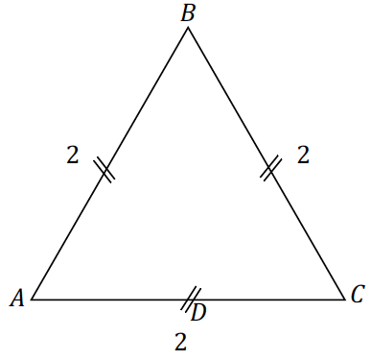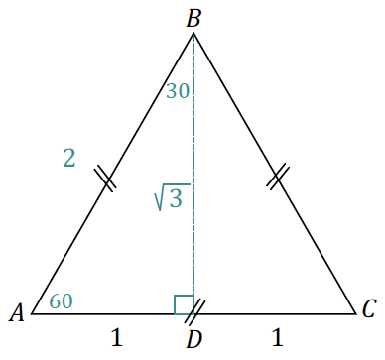

$$sin \left(30\right)=\frac{AD}{AB}=\frac{1}{2}\text{,} cos \left(30\right)=\frac{BD}{AB}=\frac{\sqrt{3}}{2}\text{,} sin \left(60\right)=\frac{BD}{AB}=\frac{\sqrt{3}}{2}\text{,} cos \left(60\right)=\frac{AD}{AB}=\frac{1}{2}$$
  - Draw an isosceles right triangle with legs of length $1$. What are the measures of the acute angles of the triangle? What is the length of the hypotenuse? Use your triangle to determine sine and cosine of the acute angles.
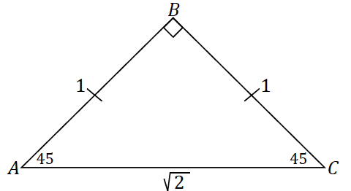
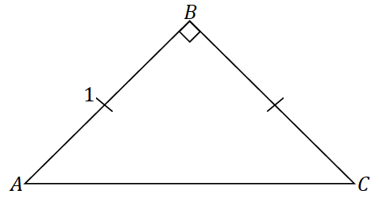
$$sin \left(45\right)=\frac{AB}{AC}=\frac{1}{\sqrt{2}}\text{,} cos \left(45\right)=\frac{BC}{AC}=\frac{1}{\sqrt{2}}$$

Parts (b) and (c) demonstrate how the sine and cosine values of the mentioned special angles can be found. These triangles are common to trigonometry; we refer to the triangle in part (b) as a $30$–$60$–$90$ triangle and the triangle in part (c) as a $45$–$45$–$90$ triangle.
Scaffolding:
- For the $1:2:\sqrt{3}$ triangle, students may develop the misconception that the last value is the length of the hypotenuse; the longest side of the right triangle. Help students correct this misconception by comparing $\sqrt{3}$ and $\sqrt{4}$ to show that $\sqrt{4}>\sqrt{3}$, and $\sqrt{4}=2$, so $2>\sqrt{3}$.
- The ratio $1:2:\sqrt{3}$ is easier to remember because of the numbers $1, 2, 3$.

- Remind students that the values of the sine and cosine ratios of triangles similar to each of these will be the same.
Highlight the length ratios for $30$–$60$–$90$ and $45$–$45$–$90$ triangles. Consider using a set up like the table below to begin the conversation. Ask students to determine side lengths of three different triangles similar to each of the triangles provided above. Remind them that the scale factor will determine side length. Then, have them generalize the length relationships.

$30$–$60$–$90$ Triangle,  side length ratio $1:2:\sqrt{3}$ | $45$–$45$–$90$ Triangle,  side length ratio $1:1:\sqrt{2}$
$$2:4:2\sqrt{3}$$ | $$2:2:2\sqrt{2}$$
$$3:6:3\sqrt{3}$$ | $$3:3:3\sqrt{2}$$
$$4:8:4\sqrt{3}$$ | $$4:4:4\sqrt{2}$$
$$x:2x:x\sqrt{3}$$ | $$x:x:x\sqrt{2}$$
Exercises 4–5 (5 minutes)

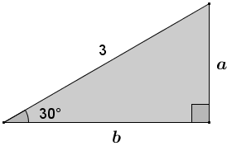
- Find the missing side lengths in the triangle.
$$\sin{30}=\frac{a}{3}=\frac{1}{2}\text{, }a=\frac{3}{2}$$
$$\cos{30}=\frac{b}{3}=\frac{\sqrt{3}}{2}\text{, }b=\frac{3\sqrt{3}}{2}$$
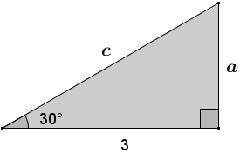

- Find the missing side lengths in the triangle.
$$\cos{30}=\frac{3}{c}=\frac{\sqrt{3}}{2}\text{,} c=\frac{6}{\sqrt{3}}=2\sqrt{3}$$
$$\sin{30}=\frac{a}{2\sqrt{3}}=\frac{1}{2}\text{,} a=\sqrt{3}$$

Closing (2 minutes)
Ask students to respond to these questions about the key ideas of the lesson independently in writing, with a partner, or as a class.
- What is remarkable about the sine and cosine of a pair of angles that are complementary?
  - The sine of an angle is equal to the cosine of its complementary angle, and the cosine of an angle is equal to the sine of its complementary angle.
- Why is $\sin{90}=1$? Similarly, why is $\sin{0}=0$, $\cos{90}=0$, and $\cos{0}=1$?
  - We can see that $\sin{θ}$ approaches $1$ as $θ$ approaches $90$. The same is true for the other sine and cosine values for $0$ and $90$.
- What do you notice about the sine and cosine of the following special angle values?
  - The entries for cosine are the same as the entries for sine, but values are in reverse order. This is explained by the fact the special angles can be paired up as complements, and we already know that the sine and cosine values of complementary angles are equal.

$$θ$$ | $$0˚$$ | $$30˚$$ | $$45˚$$ | $$60˚$$ | $$90˚$$
Sine | $$0$$ | $$\frac{1}{2}$$ | $$\frac{\sqrt{2}}{2}$$ | $$\frac{\sqrt{3}}{2}$$ | $$1$$
Cosine | $$1$$ | $$\frac{\sqrt{3}}{2}$$ | $$\frac{\sqrt{2}}{2}$$ | $$\frac{1}{2}$$ | $$0$$

Exit Ticket (5 minutes)

Name Date
Lesson 27: Sine and Cosine of Complementary Angles and Special Angles

Exit Ticket

- Find the values for $θ$ that make each statement true.
  - $\sin{θ}=\cos{32}$

  - $\cos{θ}=\sin{(θ+20)}$

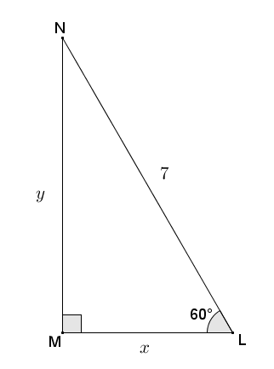
- $△LMN$ is a $30$–$60$–$90$ right triangle. Find the unknown lengths $x$ and $y$.
Exit Ticket Sample Solutions

- Find the values for $θ$ that make each statement true.
  - $\sin{θ}=\cos{32}$
$θ=90-32$
$θ=58$

  - $\cos{θ}=\sin{(θ+20)}$
$$\sin\left(90-θ\right)=\sin\left(θ+20\right) \\ 90-θ=θ+20 \\ 70=2θ \\ 35=θ$$

- Triangle $LMN$ is a $30$–$60$–$90$ right triangle. Find the unknown lengths $x$ and $y$.
$$\sin{60=}\frac{\sqrt{3}}{2} \\ \frac{\sqrt{3}}{2}=\frac{y}{7} \\ 7\sqrt{3}=2y \\ y=\frac{7\sqrt{3}}{2}$$ | $$\cos{60}=\frac{1}{2} \\ \frac{1}{2}=\frac{x}{7} \\ 7=2x \\ \frac{7}{2}=x$$

Problem Set Sample Solutions

- Find the value of $θ$ that makes each statement true.
  - $\sin{θ}=\cos\left(θ+38\right)$
$$\cos{(90-θ)}=\cos{(θ+38)} \\ 90-θ=θ+38 \\ 52=2θ \\ 26=θ$$

  - $\cos{θ}=\sin{(θ-30)}$
$$\sin\left(90-θ\right)=\sin{(θ-30)} \\ 90-θ=θ-30 \\ 120=2θ \\ 60=θ$$

  - $\sin{θ}=\cos\left(3θ+20\right)$
$$\cos{(90-θ)}=\cos{(3θ+20)} \\ 90-θ=3θ+20 \\ 70=4θ \\ 17.5=θ$$

  - $\sin\left(\frac{θ}{3}+10\right)=\cos{θ}$
$$\sin\left(\frac{θ}{3}+10\right)=\sin\left(90-θ\right) \\ \frac{θ}{3}+10=90-θ \\ \frac{4θ}{3}=80 \\ θ=60$$

  - Make a prediction about how the sum $\sin{30}+\cos{60}$ will relate to the sum $\sin{60}+\cos{30}$.
Answers will vary; however, some students may believe that the sums will be equal. This is explored in problems (3) through (5).

  - Use the sine and cosine values of special angles to find the sum: $\sin{30}+\cos{60}$.
$\sin{30}=\frac{1}{2}$ and $\cos{60}=\frac{1}{2}$; therefore, $\sin{30}+\cos{60}=\frac{1}{2}+\frac{1}{2}=1$.
Alternative strategy:
$cos 60°=sin \left(90-60\right)°=sin 30°$
$sin 30°+cos 60°=sin 30°+sin 30°=2\left(sin 30°\right)=2\left(\frac{1}{2}\right)=1$

  - Find the sum: $\sin{60}+\cos{30}$.
$\sin{60}=\frac{\sqrt{3}}{2}$ and $\cos{30}=\frac{\sqrt{3}}{2}$; therefore, $\sin{60}+\cos{30}=\frac{\sqrt{3}}{2}+\frac{\sqrt{3}}{2}=\sqrt{3}$.

  - Was your prediction a valid prediction? Explain why or why not.
Answers will vary.

- Langdon thinks that the sum $\sin{30}+\sin{30}$ is equal to $\sin{60}$. Do you agree with Langdon? Explain what this means about the sum of the sines of angles.
I disagree. Explanations may vary. It was shown in the solution to Problem 3 that $\sin{30}+\sin{30}=1$, and it is known that $\sin{60}=\frac{\sqrt{3}}{2}≠1$. This shows that the sum of the sines of angles is not equal to the sine of the sum of the angles.

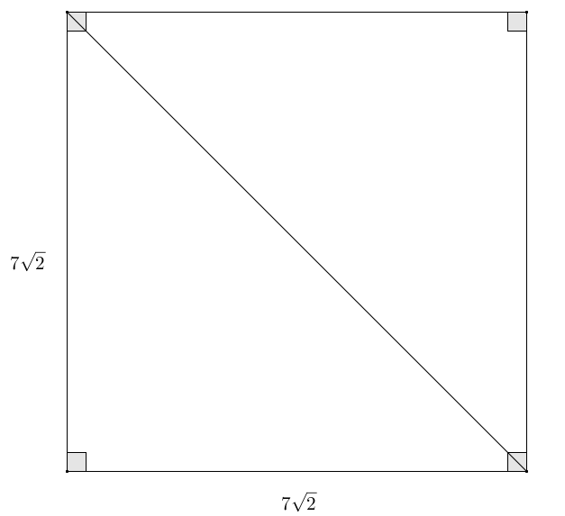
- A square has side lengths of $7\sqrt{2}$. Use sine or cosine to find the length of the diagonal of the square. Confirm your answer using the Pythagorean theorem.
The diagonal of a square cuts the square into two congruent $45$–$45$–$90$ right triangles. Let $d$ represent the length of the diagonal of the square:
$$\cos{45}=\frac{\sqrt{2}}{2} \\ \frac{\sqrt{2}}{2}=\frac{7\sqrt{2}}{d} \\ d\sqrt{2}=14\sqrt{2} \\ d=14$$
Confirmation using Pythagorean theorem:
$${\left(7\sqrt{2}\right)}^{2}+{\left(7\sqrt{2}\right)}^{2}=hyp^{2} \\ 98+98=hyp^{2} \\ 196=hyp^{2} \\ \sqrt{196}=hyp \\ 14=hyp$$

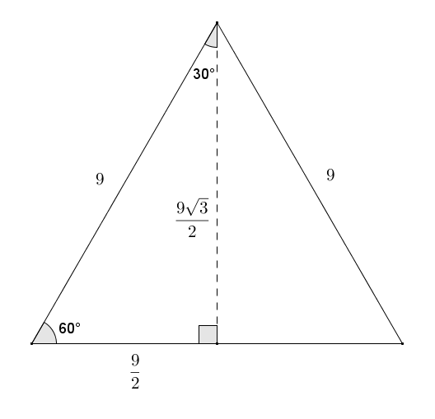
- Given an equilateral triangle with sides of length $9$, find the length of the altitude. Confirm your answer using the Pythagorean theorem.
An altitude drawn within an equilateral triangle cuts the equilateral triangle into two congruent $30$–$60$–$90$ right triangles. Let $h$ represent the length of the altitude:
$$\sin{60}=\frac{\sqrt{3}}{2} \\ \frac{\sqrt{3}}{2}=\frac{h}{9} \\ 9\sqrt{3}=2h \\ \frac{9\sqrt{3}}{2}=h$$
The altitude of the triangle has a length of $\frac{9\sqrt{3}}{2}$.
Confirmation using Pythagorean Theorem:
$${\left(\frac{9}{2}\right)}^{2}+leg^{2}=9^{2} \\ \frac{81}{4}+leg^{2}=81 \\ leg^{2}=\frac{243}{4} \\ leg=\sqrt{\frac{243}{4}} \\ leg=\frac{\sqrt{243}}{2} \\ leg=\frac{9\sqrt{3}}{2}$$

