Lesson 27: Sine and Cosine of Complementary and Special Angles

Classwork
Example 1
If $α$ and $β$ are the measurements of complementary angles, then we are going to show that $sin α=cos β$.
In right triangle $ABC$, the measurement of acute angle $∠A$ is denoted by $α,$ and the measurement of acute angle $∠B$ is denoted by $β$.
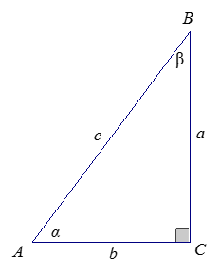
Determine the following values in the table:
$$sin α$$ | $$sin β$$ | $$cos α$$ | $$cos β$$
What can you conclude from the results?

Exercises 1–3
- Consider the right triangle $ABC$ so that $∠C$ is a right angle, and the degree measures of $∠A$ and $∠B$ are $α$ and $β$, respectively.
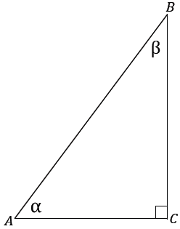
  - Find $α+β$.

  - Use trigonometric ratios to describe $\frac{BC}{AB}$ two different ways.

  - Use trigonometric ratios to describe $\frac{AC}{AB}$ two different ways.

  - What can you conclude about $sin α$ and $cos β$?

  - What can you conclude about $cos α$ and $sin β$?

- Find values for $θ$ that make each statement true.
  - $sin θ=cos (25)$

  - $sin 80=cos θ$

  - $sin θ=cos (θ+10)$

  - $sin (θ-45)=cos (θ)$

- For what angle measurement must sine and cosine have the same value? Explain how you know.

Example 2
What is happening to $a$ and $b$ as $θ$ changes? What happens to $\sin{θ}$ and $\cos{θ}$?
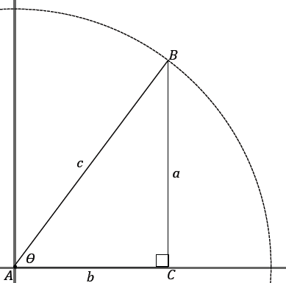

Example 3
There are certain special angles where it is possible to give the exact value of sine and cosine. These are the angles that measure $0˚$, $30˚$, $45˚$, $60˚$, and $90˚$; these angle measures are frequently seen.
You should memorize the sine and cosine of these angles with quick recall just as you did your arithmetic facts.

  - Learn the following sine and cosine values of the key angle measurements.

$$θ$$ | $$0˚$$ | $$30˚$$ | $$45˚$$ | $$60˚$$ | $$90˚$$
Sine | $$0$$ | $$\frac{1}{2}$$ | $$\frac{\sqrt{2}}{2}$$ | $$\frac{\sqrt{3}}{2}$$ | $$1$$
Cosine | $$1$$ | $$\frac{\sqrt{3}}{2}$$ | $$\frac{\sqrt{2}}{2}$$ | $$\frac{1}{2}$$ | $$0$$

We focus on an easy way to remember the entries in the table. What do you notice about the table values?

This is easily explained because the pairs $(0,90)$, $(30,60)$, and $(45,45)$ are the measures of complementary angles. So, for instance, $\sin{30=\cos{60}}$.
The sequence $0,\frac{1}{2}, \frac{\sqrt{2}}{2}, \frac{\sqrt{3}}{2},1$ may be easier to remember as the sequence $\frac{\sqrt{0}}{2},\frac{\sqrt{1}}{2},\frac{\sqrt{2}}{2},\frac{\sqrt{3}}{2},\frac{\sqrt{4}}{2}$.
  - $△ABC$ is equilateral, with side length $2$; $D$ is the midpoint of side $AC$. Label all side lengths and angle measurements for $△ABD$. Use your figure to determine the sine and cosine of $30$ and $60$.
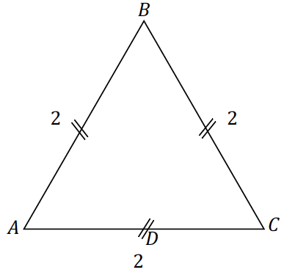

  - Draw an isosceles right triangle with legs of length $1$. What are the measures of the acute angles of the triangle? What is the length of the hypotenuse? Use your triangle to determine sine and cosine of the acute angles.
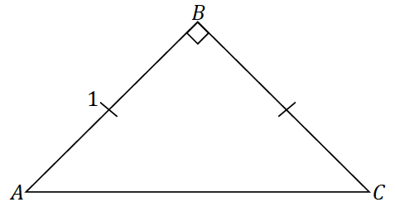

Parts (b) and (c) demonstrate how the sine and cosine values of the mentioned special angles can be found. These triangles are common to trigonometry; we refer to the triangle in part (b) as a $30$–$60$–$90$ triangle and the triangle in part (c) as a $45$–$45$–$90$ triangle.
$30$–$60$–$90$ Triangle, side length ratio $1:2:\sqrt{3}$ | $45$–$45$–$90$ Triangle, side length ratio $1:1:\sqrt{2}$
$$2:4:2\sqrt{3}$$ | $$2:2:2\sqrt{2}$$
$$3:6:3\sqrt{3}$$ | $$3:3:3\sqrt{2}$$
$$4:8:4\sqrt{3}$$ | $$4:4:4\sqrt{2}$$
$$x:2x:x\sqrt{3}$$ | $$x:x:x\sqrt{2}$$

Exercises 4–5
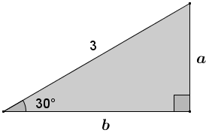
- Find the missing side lengths in the triangle.

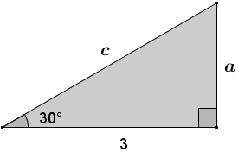
- Find the missing side lengths in the triangle.

Problem Set

- Find the value of $θ$ that makes each statement true.
  - $\sin{θ}=\cos\left(θ+38\right)$
  - $\cos{θ}=\sin{(θ-30)}$
  - $\sin{θ}=\cos\left(3θ+20\right)$
  - $\sin\left(\frac{θ}{3}+10\right)=\cos{θ}$

- a. Make a prediction about how the sum $\sin{30}+\cos{60}$ will relate to the sum $\sin{60}+\cos{30}$.
  - Use the sine and cosine values of special angles to find the sum: $\sin{30}+\cos{60}$.
  - Find the sum $\sin{60}+\cos{30}$.
  - Was your prediction a valid prediction? Explain why or why not.

- Langdon thinks that the sum $\sin{30}+\sin{30}$ is equal to $\sin{60}$. Do you agree with Langdon? Explain what this means about the sum of the sines of angles.

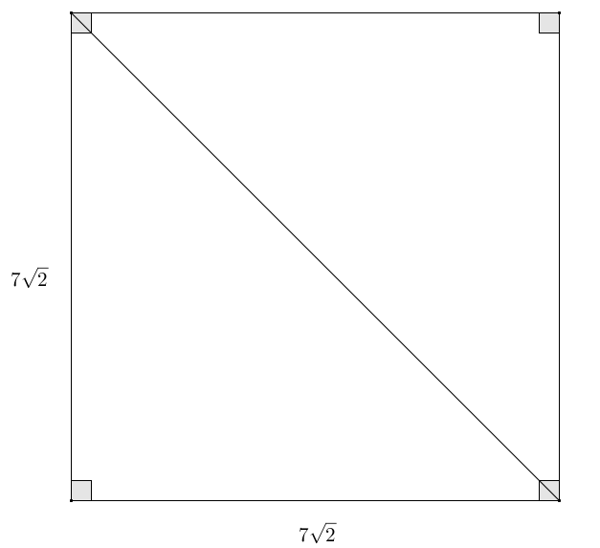
- A square has side lengths of $7\sqrt{2}$. Use sine or cosine to find the length of the diagonal of the square. Confirm your answer using the Pythagorean theorem.

- Given an equilateral triangle with sides of length $9$, find the length of the altitude. Confirm your answer using the Pythagorean theorem.

