Lesson 26: The Definition of Sine, Cosine, and Tangent

Student Outcomes
- Students define sine, cosine, and tangent of $θ,$ where $θ$ is the angle measure of an acute angle of a right triangle. Students denote sine, cosine, and tangent as $sin$, $cos$, and $tan$, respectively.
- If $∠A$ is an acute angle whose measure in degrees is $θ,$ then we also say: $\sin{∠A}=sinθ$,$\cos{∠A}=cosθ$, and$\tan{∠A}=tanθ$.
- Given the side lengths of a right triangle with acute angles, students find sine, cosine, and tangent of each acute angle.

Lesson Notes
It is convenient, as adults, to use the notation “$\sin^{2}{x}$” to refer to the value of the square of the sine function. However, rushing too fast to this abbreviated notation for trigonometric functions leads to incorrect understandings of how functions are manipulated, which can lead students to think that $\sin{x}$ is short for “$sin⋅x$” and to incorrectly divide out the variable, “$\frac{\sin{x}}{x}=sin$.”
To reduce these types of common notation-driven errors later, this curriculum is very deliberate about how and when we use abbreviated function notation for sine, cosine, and tangent:
- In geometry, sine, cosine, and tangent are thought of as the value of ratios of triangles, not as functions. No attempt is made to describe the trigonometric ratios as functions of the real number line. Therefore, the notation is just an abbreviation for the “sine of an angle” ($\sin{∠A}$) or “sine of an angle measure” ($\sin{θ}$). Parentheses are used more for grouping and clarity reasons than as symbols used to represent a function.

- In Algebra II, to distinguish between the ratio version of sine in geometry, all sine functions are notated as functions: $\sin{(x)}$ is the value of the sine function for the real number $x$, just like $f(x)$ is the value of the function $f$ for the real number $x$. In this grade, we maintain function notation integrity and strictly maintain parentheses as part of function notation, writing, for example, $\sin\left(\frac{π}{2}-θ\right)=\cos{(θ)}$, instead of $\sin{\frac{π}{2}-θ=\cos{θ}}$.

- By pre-calculus, students have had two full years of working with sine, cosine, and tangent as both ratios and functions. It is finally in this year that we begin to blur the distinction between ratio and function notations and write, for example, $\sin^{2}{θ}$ as the value of the square of the sine function for the real number $θ$, which is how most calculus textbooks notate these functions.

Classwork
Exercises 1–3 (6 minutes)
The following exercises provide students with practice identifying specific ratios of sides based on the labels learned in Lesson 25. The third exercise leads into an understanding of the relationship between sine and cosine, which is observed in this lesson and formalized in Lesson 27.
Exercises 1–3
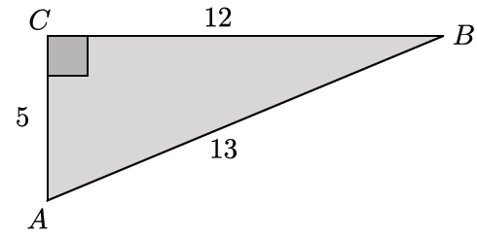
- Identify the $\frac{opp}{hyp}$ ratios for angles $∠A$ and $∠B$.
For $∠A:$ $\frac{12}{13}$
For $∠B: \frac{5}{ 13}$
Scaffolding:
- For students who are struggling, model labeling opp, hyp, and adj for $∠A.$
- Allow students to use the reference chart provided with Lesson 25.
- For advanced students, include an extension: Draw another triangle $ABC$ with different side lengths that will have the same ratios for $∠A$ and $∠B$. Explain how you know the ratios will be the same, and justify your answer.

- Identify the $\frac{adj}{hyp}$ ratios for angles $∠A$ and $∠B$.
For $∠A:$ $\frac{5}{13}$
For $∠B: \frac{12}{13}$

- Describe the relationship between the ratios for angles $∠A$ and $∠B$.
The $\frac{opp}{hyp}$ ratio for $∠A$ is equal to the $\frac{adj}{hyp}$ ratio for $∠B$.
The $\frac{opp}{hyp}$ ratio for $∠B$ is equal to the $\frac{adj}{hyp}$ ratio for $∠A$.

Discussion (6 minutes)
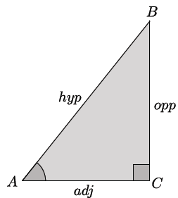
The Discussion defines sine, cosine, and tangent. As the names $opp$, $adj,$ and $hyp$ are relatively new to students, it is important that students have a visual of the triangle to reference throughout the discussion. Following the discussion is an exercise that can be used to informally assess students’ understanding of these definitions.
- In everyday life, we reference objects and people by name, especially when we use the object or see the person frequently. Imagine always calling your friend “hey” or “him/her” or “friend”! We want to be able to easily distinguish and identify a person, so we use a name. The same reasoning can be applied to the fractional expressions that we have been investigating: $\frac{opp}{hyp},\frac{adj}{hyp},$ and $\frac{opp}{adj}$ need names.
Normally, we would say that these fractional expressions are values of the ratios. However, to avoid saying “value of the ratio $opp:hyp$ as $\frac{opp}{hyp}$” all of the time, we agree to call these fractional expressions, collectively, the “trigonometric ratios,” based upon historical precedence, even though they really are not defined as ratios in the CCSS standards. Consider sharing this fact with students.
- These incredibly useful ratios were discovered long ago and have had several names. The names we currently use are translations of Latin words. You will learn more about the history behind these ratios in Algebra II.
- Presently, mathematicians have agreed upon the names sine, cosine, and tangent.
- If $θ$ is the angle measure of $∠A$, as shown, then we define:
The sine of $θ$ is the value of the ratio of the length of the opposite side to the length of the hypotenuse. As a formula,
$$\sin{θ}=\frac{opp}{hyp}.$$
We also say $\sin{∠A=\sin{θ.}}$ Then, $\sin{∠A=\frac{BC}{AB}}$.

The cosine of $θ$ is the value of the ratio of the length of the adjacent side to the length of the hypotenuse. As a formula,
$$\cos{θ}=\frac{adj}{hyp}.$$
We also say $\cos{∠A=\cos{θ.}}$ Then, $\cos{∠A=\frac{AC}{AB}.}$

The tangent of $θ$ is the value of the ratio of the length of the opposite side to the length of the adjacent side. As a formula,
$$\tan{θ}=\frac{opp}{adj}.$$
We also say $\tan{∠A=\tan{θ}.}$ Then, $\tan{∠A=\frac{BC}{AC}.}$

- There are still three possible combinations of quotients of the side lengths; we briefly introduce them here.

The secant of $θ$ is the value of the ratio of the length of the hypotenuse to the length of the adjacent side. As a formula,
$$\sec{θ}=\frac{hyp}{adj}.$$
The cosecant of $θ$ is the value of the ratio of the length of the hypotenuse to the length of the opposite side. As a formula,
$$\csc{θ}=\frac{hyp}{opp}.$$
The cotangent of $θ$ is the value of the ratio of the length of the adjacent side to the length of the opposite side. As a formula,
$$\cot{θ}=\frac{adj}{opp}.$$
- We have little need in this course for secant, cosecant, and cotangent because, given any two sides, it is possible to write the quotient so as to get sine, cosine, and tangent. In more advanced courses, secant, cosecant, and cotangent are more useful.
Exercises 4–9 (15 minutes)
You can choose to have students complete Exercises 4–6 independently, or divide the work among the students and have them share their results. Once Exercises 4–6 have been completed, encourage students to discuss in small groups the relationships they notice between the sine of the angle and the cosine of its complement. Also, encourage them to discuss the relationship they notice about the tangent of both angles. Finally, have students share their observations with the whole class and then complete Exercises 7–8. Note that because we are not asking students to rationalize denominators, the relationships are clearer.
Scaffolding:
- Consider having students draw two right triangles and then color-code and/or label each with opp, adj, and hyp, relative to the angle they are looking at.
- Consider having advanced students draw two right triangles, $△DEF$ and $△GHI,$ such that they are not congruent, but so that $\sin{E=\sin{H}.}$Then, have students explain how they know.
Exercises 4–9
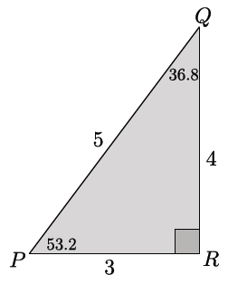
- In $△PQR$, $m∠P=53.2°$ and $m∠Q=36.8°$. Complete the following table.

Measure of Angle | Sine $\left(\frac{opp}{hyp}\right)$ | Cosine $\left(\frac{adj}{hyp}\right)$ | Tangent $\left(\frac{opp}{adj}\right)$
$$53.2$$ | $$\sin{53.2=\frac{4}{5}}$$ | $$\cos{53.2=\frac{3}{5}}$$ | $$\tan{53.2}=\frac{4}{3}$$
$$36.8$$ | $$\sin{36.8=\frac{3}{5}}$$ | $$\cos{36.8}=\frac{4}{5}$$ | $$\tan{36.8}=\frac{3}{4}$$

- In the triangle below, $m∠A=33.7°$ and $m∠B=56.3°$. Complete the following table.
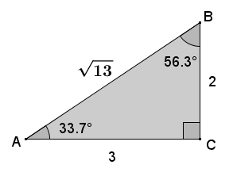
Measure of Angle | Sine | Cosine | Tangent
$$33.7$$ | $$\sin{33.7=\frac{2}{\sqrt{13}}}$$ | $$\cos{33.7=\frac{3}{\sqrt{13}}}$$ | $$tan 33.7=\frac{2}{3}$$
$$56.3$$ | $$\sin{56.3=\frac{3}{\sqrt{13}}}$$ | $$\cos{56.3}=\frac{2}{\sqrt{13}}$$ | $$\tan{56.3}=\frac{3}{2}$$

- In the triangle below, let $e$ be the measure of $∠E$ and $d$ be the measure of $∠D$. Complete the following table.
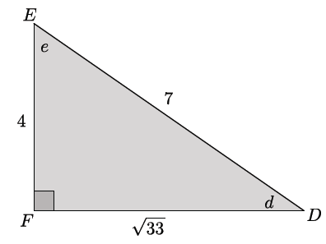
Measure of Angle | Sine | Cosine | Tangent
$$d$$ | $$\sin{d=\frac{4}{7}}$$ | $$\cos{d=\frac{\sqrt{33}}{7}}$$ | $$\tan{d}=\frac{4}{\sqrt{33}}$$
$$e$$ | $$\sin{e=\frac{\sqrt{33}}{7}}$$ | $$\cos{e}=\frac{4}{7}$$ | $$\tan{e}=\frac{\sqrt{33}}{4}$$

- In the triangle below, let $x$ be the measure of $∠X$ and $y$ be the measure of $∠Y$. Complete the following table.
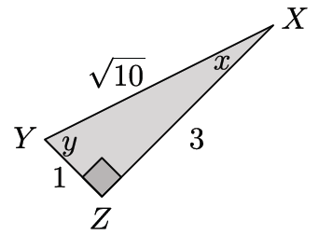
Measure of Angle | Sine | Cosine | Tangent
$$x$$ | $$\sin{x=\frac{1}{\sqrt{10}}}$$ | $$\cos{x=\frac{3}{\sqrt{10}}}$$ | $$\tan{x}=\frac{1}{3}$$
$$y$$ | $$\sin{y=\frac{3}{\sqrt{10}}}$$ | $$\cos{y}=\frac{1}{\sqrt{10}}$$ | $$\tan{y}=\frac{3}{1}$$

- Tamer did not finish completing the table below for a diagram similar to the previous problems that the teacher had on the board where $p$ was the measure of $∠P$ and $q$ was the measure of $∠Q$. Use any patterns you notice from Exercises 1–4 to complete the table for Tamer.
MP.8

Measure of Angle | Sine | Cosine | Tangent
$$p$$ | $$\sin{p=\frac{11}{\sqrt{157}}}$$ | $$\cos{p=\frac{6}{\sqrt{157}}}$$ | $$\tan{p}=\frac{11}{6}$$
$$q$$ | $$\sin{q=\frac{6}{\sqrt{157}}}$$ | $$\cos{q}=\frac{11}{\sqrt{157}}$$ | $$tan q=\frac{6}{11}$$

- Explain how you were able to determine the sine, cosine, and tangent of $∠Q$ in Exercise 7.
I was able to complete the table for Tamer by observing the patterns of previous problems. For example, I noticed that the sine of one angle was always equal to the ratio that represented the cosine of the other angle. Since I was given $\sin{p}$, I knew the ratio $\frac{11}{\sqrt{157}}$ would be the $\cos{q}$. Similarly, $\cos{p}=\sin{q=\frac{6}{\sqrt{157}}}$. Finally, I noticed that the tangents of the angles were always reciprocals of each other. Since I was given the $\tan{p=\frac{11}{6}}$, I knew that the $\tan{q}$ must be equal to $\frac{6}{11}$.

Discussion (8 minutes)
The sine, cosine, and tangent of an angle can be used to find unknown lengths of other triangles using within-figure ratios of similar triangles. The discussion that follows begins by posing a question to students. Provide time for students to discuss the answer in pairs or small groups, and then have them share their thoughts with the class.
- If $0<θ<90$, we can define sine, cosine, and tangent of $θ:$ take a right triangle that has an acute angle with angle degree measure $θ$, and use the appropriate side lengths.
- If we use different right triangles, why will we get the same value for $\sin{θ}$, $\cos{θ}$, and $\tan{θ}$?

Provide time for students to talk to a partner or small group. If necessary, use the questions and diagrams below to guide students’ thinking. The decimal values for the side lengths are used to make less obvious the fact that the ratios of the side lengths are equal.
MP.3
- For example, consider the following two triangles.
The triangles below contain approximations for all lengths. If the Pythagorean theorem is used to verify that the triangles are right triangles, then you will notice that the values are slightly off. For example, the length of the hypotenuse of $△DEF$ contains $11$decimal digits, not the $5$ shown.
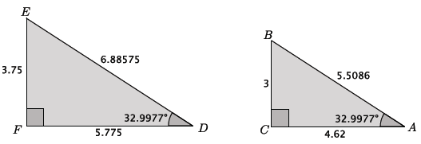

- Find the $\sin{A}$,$\cos{A}$, and $\tan{A.}$Compare those ratios to the $\sin{D}$,$\cos{D}$, and $\tan{D.}$ What do you notice?
The task of finding the ratios can be divided among the students and shared with the group.
  - Students should notice that $\sin{A}=\sin{D}$, $\cos{A=\cos{D}}$, and$\tan{A=\tan{D}.}$
- Under what circumstances have we observed ratios within one figure being equal to ratios within another figure?
  - Within-figure ratios are equal when the figures are similar.

- Two right triangles, each having an acute angle of angle measure $θ,$ are similar by the AA criterion. So, we know that the values of corresponding ratios of side lengths will be equal. That means $\sin{θ}$,$\cos{θ}$, and $\tan{θ}$do not depend on which right triangle we use.
- The ratios we write for the sine, cosine, and tangent of an angle are useful because they allow us to solve for two sides of a triangle when we know only the length of one side.

Closing (5 minutes)
Ask students the following questions. You may choose to have students respond in writing, to a partner, or to the whole class.
- Describe the ratios that we used to calculate sine, cosine, and tangent.
  - Given an angle, $θ,$ $\sin{θ}=\frac{opp}{hyp}$, $\cos{θ}=\frac{adj}{hyp}$, and $\tan{θ}=\frac{opp}{adj}.$
- Given any two right triangles that each have an acute angle with measure $θ,$ why would we get the same value for $\sin{θ}$, $\cos{θ}$, and $\tan{θ}$ using either triangle?

  - Since the two right triangles each have an acute angle with measure $θ$, they are similar by the AA criterion. Similar triangles will have corresponding side lengths that are equal in ratio. Additionally, based on our investigations in Lesson 25, we know that the value of the ratios of corresponding sides for a particular angle size will be equal to the same constant.
- Given a right triangle, describe the relationship between the sine of one acute angle and the cosine of the other acute angle.
  - The sine of one acute angle of a right triangle is equal to the cosine of the other acute angle in the triangle.

Exit Ticket (5 minutes)

Name Date
Lesson 26: The Definition of Sine, Cosine, and Tangent

Exit Ticket

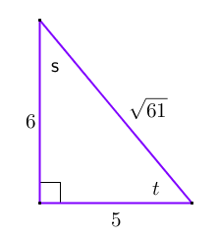
- Given the diagram of the triangle, complete the following table.
Angle Measure | $$sin θ$$ | $$cos θ$$ | $$tan θ$$
$$s$$
$$t$$

  - Which values are equal?

  - How are $tan s$ and $tan t$ related?

- If $u$ and $v$ are the measures of complementary angles such that $\sin{u}=\frac{2}{5}$ and $\tan{v}=\frac{\sqrt{21}}{2}$, label the sides and angles of the right triangle in the diagram below with possible side lengths.
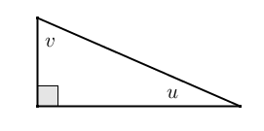
Exit Ticket Sample Solutions

- Given the diagram of the triangle, complete the following table.
Angle | $$sin θ$$ | $$cos θ$$ | $$tan θ$$
$$s$$ | $$\frac{5}{\sqrt{61}}=\frac{5\sqrt{61}}{61}$$ | $$\frac{6}{\sqrt{61}}=\frac{6\sqrt{61}}{61}$$ | $$\frac{5}{6}$$
$$t$$ | $$\frac{6}{\sqrt{61}}=\frac{6\sqrt{61}}{61}$$ | $$\frac{5}{\sqrt{61}}=\frac{5\sqrt{61}}{61}$$ | $$\frac{6}{5}$$

  - Which values are equal?
$sin s=cos t$ and $cos s=sin t$

  - How are $tan s$ and $tan t$ related?
They are reciprocals; $\frac{5}{6}⋅\frac{6}{5}=1$.

- If $u$ and $v$ are the measures of complementary angles such that $\sin{u}=\frac{2}{5}$ and $\tan{v}=\frac{\sqrt{21}}{2}$, label the sides and angles of the right triangle in the diagram below with possible side lengths:
A possible solution is shown below; however, any similar triangle having a shorter leg with length of $2x$, longer leg with length of $x\sqrt{21}$, and hypotenuse with length of $5x$, for some positive number $x$, is also correct.
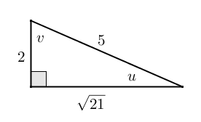

Problem Set Sample Solutions

- Given the triangle in the diagram, complete the following table.
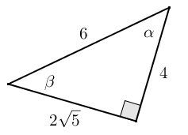
Angle Measure | $$sin$$ | $$cos$$ | $$tan$$
$$α$$ | $$\frac{2\sqrt{5}}{6}$$ | $$\frac{4}{6}=\frac{2}{3}$$ | $$\frac{2\sqrt{5}}{4}=\frac{\sqrt{5}}{2}$$
$$β$$ | $$\frac{4}{6}=\frac{2}{3}$$ | $$\frac{2\sqrt{5}}{6}$$ | $$\frac{4}{2\sqrt{5}}=\frac{2}{\sqrt{5}}$$

- Given the table of values below (not in simplest radical form), label the sides and angles in the right triangle.
Angle Measure | $$sin$$ | $$cos$$ | $$tan$$
$$α$$ | $$\frac{4}{2\sqrt{10}}$$ | $$\frac{2\sqrt{6}}{2\sqrt{10}}$$ | $$\frac{4}{2\sqrt{6}}$$
$$β$$ | $$\frac{2\sqrt{6}}{2\sqrt{10}}$$ | $$\frac{4}{2\sqrt{10}}$$ | $$\frac{2\sqrt{6}}{4}$$
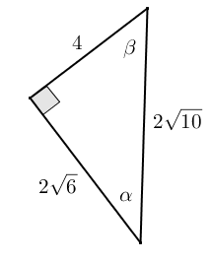
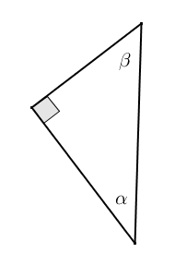

- Given $sin α$ and $sin β$, complete the missing values in the table. You may draw a diagram to help you.
Angle Measure | $$sin$$ | $$cos$$ | $$tan$$
$$α$$ | $$\frac{\sqrt{2}}{3\sqrt{3}}$$ | $$\frac{5}{3\sqrt{3}}$$ | $$\frac{\sqrt{2}}{5}$$
$$β$$ | $$\frac{5}{3\sqrt{3}}$$ | $$\frac{\sqrt{2}}{3\sqrt{3}}$$ | $$\frac{5}{\sqrt{2}}$$

- Given the triangle shown to the right, fill in the missing values in the table.
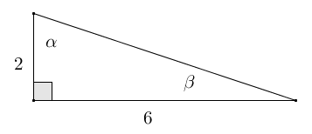
Using the Pythagorean theorem:
$$hyp^{2}=2^{2}+6^{2}$$
$$hyp^{2}=4+36$$
$$hyp^{2}=40$$
$$hyp=\sqrt{40}$$
$$hyp=2\sqrt{10}$$

Angle Measure | $$sin$$ | $$cos$$ | $$tan$$
$$α$$ | $$\frac{6}{2\sqrt{10}}=\frac{3\sqrt{10}}{10}$$ | $$\frac{2}{2\sqrt{10}}=\frac{\sqrt{10}}{10}$$ | $$\frac{6}{2}=3$$
$$β$$ | $$\frac{2}{2\sqrt{10}}=\frac{\sqrt{10}}{10}$$ | $$\frac{6}{2\sqrt{10}}=\frac{3\sqrt{10}}{10}$$ | $$\frac{2}{6}=\frac{1}{3}$$

- Jules thinks that if $α$ and $β$ are two different acute angle measures, then $\sin{α}≠\sin{β}$. Do you agree or disagree? Explain.
I agree. If $α$ and $β$ are different acute angle measures, then either $α>β$or$β>α$. A right triangle with acute angle $α$ cannot be similar to a right triangle with acute angle $β$ (unless $α+β=90$) because the triangles fail the AA criterion. If the triangles are not similar, then their corresponding sides are not in proportion, meaning their within-figure ratios are not in proportion; therefore, $\sin{α}≠\sin{β}$. In the case where $α+β=90$, the given right triangles are similar; however, $α$ and $β$ must be alternate acute angles, meaning $\sin{α}=\cos{β}$, and $\sin{β}=\cos{α}$, but $\sin{α}≠\sin{β}$.
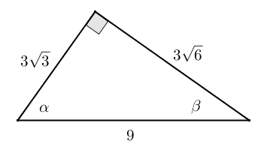
- Given the triangle in the diagram, complete the following table.
Angle Measure | $$sin$$ | $$cos$$ | $$tan$$
$$α$$ | $$\frac{3\sqrt{6}}{9}$$ | $$\frac{3\sqrt{3}}{9}$$ | $$\frac{3\sqrt{6}}{3\sqrt{3}}$$
$$β$$ | $$\frac{3\sqrt{3}}{9}$$ | $$\frac{3\sqrt{6}}{9}$$ | $$\frac{3\sqrt{3}}{3\sqrt{6}}$$

Rewrite the values from the table in simplest terms.
Angle Measure | $$sin$$ | $$cos$$ | $$tan$$
$$α$$ | $$\frac{\sqrt{6}}{3}$$ | $$\frac{\sqrt{3}}{3}$$ | $$\frac{\sqrt{6}}{\sqrt{3}}=\sqrt{2}$$
$$β$$ | $$\frac{\sqrt{3}}{3}$$ | $$\frac{\sqrt{6}}{3}$$ | $$\frac{\sqrt{3}}{\sqrt{6}}=\frac{\sqrt{2}}{2}$$

Draw and label the sides and angles of a right triangle using the simplified values of the ratios $sin$ and $cos$. How is the new triangle related to the original triangle?
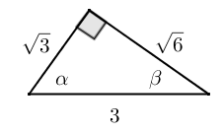
The triangles are similar by SSS criterion because the new triangle has sides that are $\frac{1}{3}$ of the length of their corresponding sides in the original triangle.

- Given $tan α$ and $cos β$, in simplest terms, find the missing side lengths of the right triangle if one leg of the triangle has a length of $4$. Draw and label the sides and angles of the right triangle.
Angle Measure | $$sin θ$$ | $$cos θ$$ | $$tan θ$$
$$α$$ | $$\frac{\sqrt{3}}{2}$$ | $$\frac{1}{2}$$ | $$\sqrt{3}$$
$$β$$ | $$\frac{1}{2}$$ | $$\frac{\sqrt{3}}{2}$$ | $$\frac{\sqrt{3}}{3}$$

The problem does not specify which leg is $4$, so there are two possible solutions to this problem. The values given in the table do not represent the actual lengths of the sides of the triangles; however, they do represent the lengths of the sides of a similar triangle, which is a 30–60–90 right triangle with side lengths $1$,$2$, and$\sqrt{3}$.
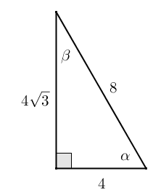
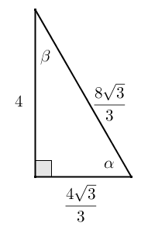
Case 1: The short leg of the right triangle is $4$: Case 2: The long leg of the right triangle is $4$:

- Eric wants to hang a rope bridge over a small ravine so that it is easier to cross. To hang the bridge, he needs to know how much rope is needed to span the distance between two trees that are directly across from each other on either side of the ravine. Help Eric devise a plan using sine, cosine, and tangent to determine the approximate distance from tree A to tree B without having to cross the ravine.
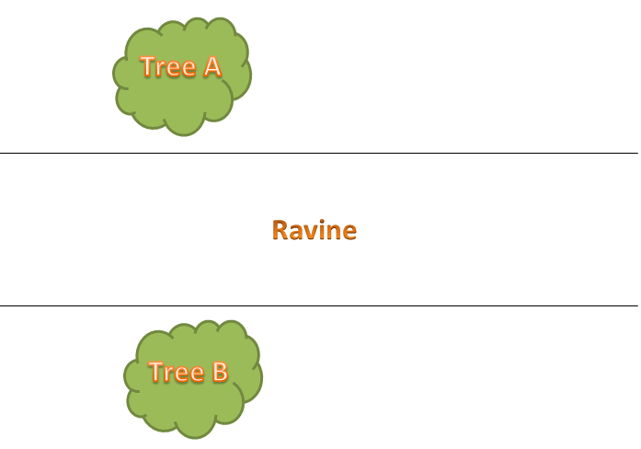
Student solutions will vary. Possible solution:
If Eric walks a path parallel to the ravine to a point $P$ at a convenient distance from $A$, he could measure the angle formed by his line of sight to both trees. Using the measured angle and distance, he could use the value of the tangent ratio of the angle to determine the length of the opposite leg of the triangle. The length of the opposite leg of the triangle represents the distance between the two trees.

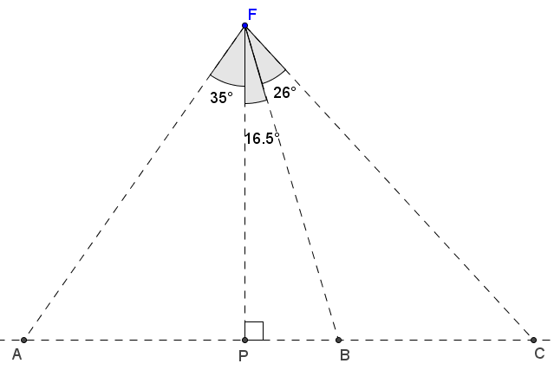
- A fisherman is at point $F$ on the open sea and has three favorite fishing locations. The locations are indicated by points $A, B,$ and $C$. The fisherman plans to sail from $F$ to $A,$ then to $B$, then to $C$, then back to $F$. If the fisherman is $14$ miles from $\overline{AC}$, find the total distance that he will sail.
$FP=14$ and can be considered the adjacent side to the $35°$ angle shown in triangle $APF$.
Using cosine:
$$\cos{35=\frac{14}{AF}}$$
$$AF=\frac{14}{\cos{35}}$$
$$AF≈17.09$$
Using tangent:
$\tan{35}=\frac{AP}{14}$
$AP=14\tan{35}$
$AP≈9.8029$
$\overline{PC}$ is the leg opposite angle $PFC$ in triangle $PFC$ and has a degree measure of $42.5$.
Using tangent:
$\tan{42.5}=\frac{PC}{14}$
$PC=14\tan{42.5}$
$PC≈12.8286$ The total distance that the fisherman will sail:
$distance=AF+AP+PC+FC$
Using cosine: $distance=\frac{14}{\cos{35}}+14\tan{35}+14\tan{42.5}+\frac{14}{\cos{42.5}}$
$\cos{42.5}=\frac{14}{FC}$ $distance≈58.7$
$FC=\frac{14}{\cos{42.5}}$
$FC≈18.9888$
The total distance that the fisherman will sail is approximately $58.7$ miles.

