Lesson 26: Definition of Sine, Cosine, and Tangent

Classwork
Exercises 1–3
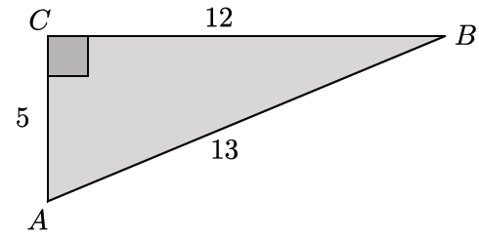
- Identify the $\frac{opp}{hyp}$ ratios for angles $∠A$ and $∠B.$

- Identify the $\frac{adj}{hyp}$ ratios for angles $∠A$ and $∠B.$

- Describe the relationship between the ratios for angles $∠A$ and $∠B.$

Exercises 4–9
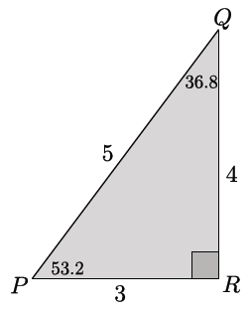
- In $△PQR$, $m∠P=53.2°$ and $m∠Q=36.8°.$ Complete the following table.

Measure of Angle | Sine $\left(\frac{opp}{hyp}\right)$ | Cosine $\left(\frac{adj}{hyp}\right)$ | Tangent $\left(\frac{opp}{adj}\right)$
$$53.2$$
$$36.8$$
- In the triangle below, $m∠A=33.7°$ and $m∠B=56.3°$. Complete the following table.
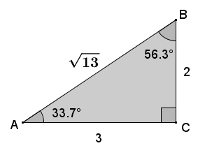
Measure of Angle | Sine | Cosine | Tangent
$$33.7$$
$$56.3$$

- In the triangle below, let $e$ be the measure of $∠E$ and $d$ be the measure of $∠D$. Complete the following table.
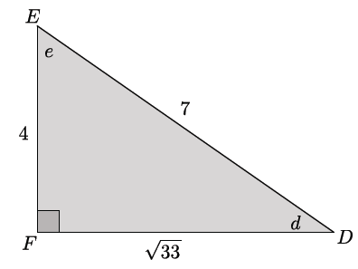
Measure of Angle | Sine | Cosine | Tangent
$$d$$
$$e$$

- In the triangle below, let $x$ be the measure of $∠X$ and $y$ be the measure of $∠Y$. Complete the following table.
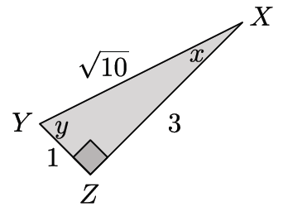
Measure of Angle | Sine | Cosine | Tangent
$$x$$
$$y$$

- Tamer did not finish completing the table below for a diagram similar to the previous problems that the teacher had on the board where $p$ was the measure of $∠P$ and $q$ was the measure of $∠Q$. Use any patterns you notice from Exercises 1–4 to complete the table for Tamer.

Measure of Angle | Sine | Cosine | Tangent
$$p$$ | $$\sin{p=\frac{11}{\sqrt{157}}}$$ | $$\cos{p=\frac{6}{\sqrt{157}}}$$ | $$\tan{p}=\frac{11}{6}$$
$$q$$

- Explain how you were able to determine the sine, cosine, and tangent of $∠Q$ in Exercise 7.

Problem Set

- Given the triangle in the diagram, complete the following table.

Angle Measure | $$sin$$ | $$cos$$ | $$tan$$
$$α$$
$$β$$

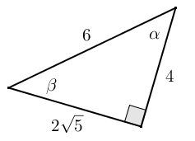

- Given the table of values below (not in simplest radical form), label the sides and angles in the right triangle.

Angle Measure | $$sin$$ | $$cos$$ | $$tan$$
$$α$$ | $$\frac{4}{2\sqrt{10}}$$ | $$\frac{2\sqrt{6}}{2\sqrt{10}}$$ | $$\frac{4}{2\sqrt{6}}$$
$$β$$ | $$\frac{2\sqrt{6}}{2\sqrt{10}}$$ | $$\frac{4}{2\sqrt{10}}$$ | $$\frac{2\sqrt{6}}{4}$$

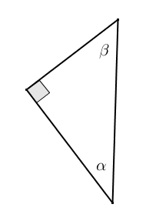

- Given $sin α$ and $sin β$, complete the missing values in the table. You may draw a diagram to help you.

Angle Measure | $$sin$$ | $$cos$$ | $$tan$$
$$α$$ | $$\frac{\sqrt{2}}{3\sqrt{3}}$$ | $$\frac{5}{3\sqrt{3}}$$
$$β$$

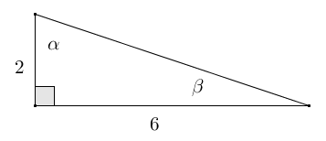
- Given the triangle shown to the right, fill in the missing values in the table.

Angle Measure | $$sin$$ | $$cos$$ | $$tan$$
$$α$$
$$β$$

- Jules thinks that if $α$ and $β$ are two different acute angle measures, then $\sin{α}≠\sin{β}$. Do you agree or disagree? Explain.

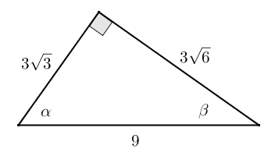
- Given the triangle in the diagram, complete the following table.

Angle Measure | $$sin$$ | $$cos$$ | $$tan$$
$$α$$
$$β$$

Rewrite the values from the table in simplest terms.

Angle Measure | $$sin$$ | $$cos$$ | $$tan$$
$$α$$
$$β$$

Draw and label the sides and angles of a right triangle using the values of the ratios $sin$ and $cos$. How is the new triangle related to the original triangle?

- Given $tan α$ and $cos β$, in simplest terms, find the missing side lengths of the right triangle if one leg of the triangle has a length of $4$. Draw and label the sides and angles of the right triangle.

Angle | $$sin θ$$ | $$cos θ$$ | $$tan θ$$
$$α$$
$$β$$

- Eric wants to hang a rope bridge over a small ravine so that it is easier to cross. To hang the bridge, he needs to know how much rope is needed to span the distance between two trees that are directly across from each other on either side of the ravine. Help Eric devise a plan using sine, cosine, and tangent to determine the approximate distance from tree A to tree B without having to cross the ravine.
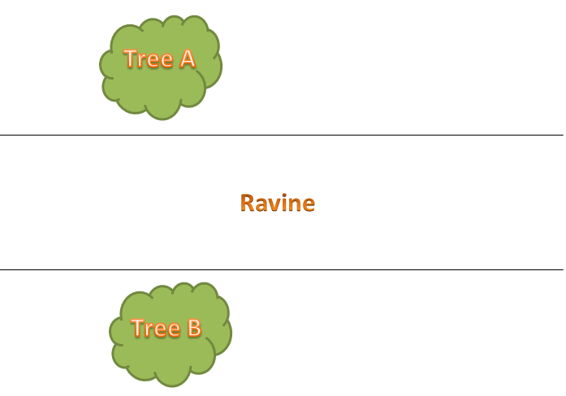

- A fisherman is at point $F$ on the open sea and has three favorite fishing locations. The locations are indicated by points $A, B,$ and $C$. The fisherman plans to sail from $F$ to $A,$ then to $B$, then to $C$, then back to $F$. If the fisherman is $14$ miles from $\overline{AC}$, find the total distance that he will sail.
