Lesson 24: Prove the Pythagorean Theorem Using Similarity

Student Outcomes
- Students prove the Pythagorean theorem using similarity.
- Students use similarity and the Pythagorean theorem to find the unknown side lengths of a right triangle.
- Students are familiar with the ratios of the sides of special right triangles with angle measures $45–45–90$ and $30–60–90$.

Lesson Notes
In Grade 8, students proved the Pythagorean theorem using what they knew about similar triangles. The base of this proof is the same, but students are better prepared to understand the proof because of their work in Lesson 23. This proof differs from what students did in Grade 8 because it uses knowledge of ratios within similar triangles and more advanced algebraic skills.
The proof of the Pythagorean theorem and the Exploratory Challenge addressing special right triangles are the essential components of this lesson. Exercises 1–3 and the bullet points in the discussion between the exercises can be moved to the problem set if necessary.

Classwork
Opening (5 minutes)
Show the diagram below and then ask the three questions that follow, which increase in difficulty. Have students respond using a white board. Ask advanced students to attempt to show that $a^{2}+b^{2}=c^{2}$, without the scaffolded questions. Discuss methods used as a class.
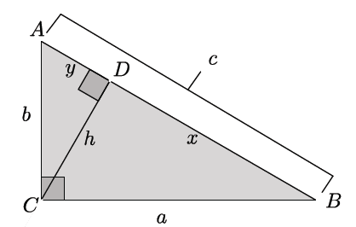
Scaffolding:
Some groups of students may respond better to a triangle with numeric values.
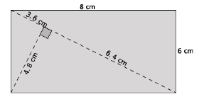
- Write an expression in terms of $c$ for $x$ and $y$.
  - $x+y=c.$
- Write a similarity statement for the three right triangles in the image.
  - $△ACB\sim △ADC\sim △CDB.$

- Write a ratio based on the similarity statement from the previous question.
  - Several answers are acceptable. Ensure that students are writing ratios as they did in Lesson 21. That is, ratios that compare $shorter leg:hypotenuse$, $longer leg:hypotenuse$, or $shorter leg:longer leg.$

Discussion (10 minutes)
In the discussion that follows, students prove the Pythagorean theorem using similarity and the converse of the Pythagorean Theorem using SSS for congruent triangles.
- Our goal is to prove the Pythagorean theorem using what we know about similar triangles. Consider the right triangle $△ABC$ so that $∠C$ is a right angle. We label the side lengths $a, b,$ and $c$ so that side length $a$ is opposite $∠A$, side length $b$ is opposite $∠B$, and hypotenuse $c$ is opposite $∠C$, as shown.
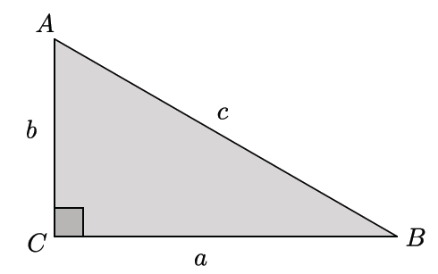
- Next, we draw the altitude, $h$, from the right angle to the hypotenuse so that it splits the hypotenuse, at point $D$, into lengths $x$ and $y$ so that $x+y=c$, as shown.
Scaffolding:
Students may want to use the cutouts that they created in Lesson 21.
- What do we know about the original triangle and the two sub-triangles?
  - The three triangles are similar.
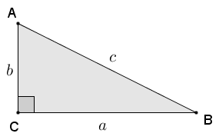
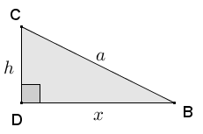
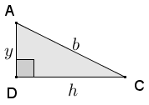
If necessary, show students the set of three triangles in the diagram below. The original triangle and the two triangles formed by the altitude $h$ have been moved via rigid motions that make their corresponding sides and angles easier to see.

- We want to prove the Pythagorean theorem using what we know about similar triangles and the ratios we wrote in Lesson 23, i.e., $shorter leg:hypotenuse$, $longer leg:hypotenuse$, or $shorter leg:longer leg$.
- We begin by identifying the two triangles that each have $∠B$ as one of their angles. Which are they?
  - The two triangles are $△ABC$ and $△CBD$.
- Since they are similar, we can write equivalent ratios of the two similar triangles we just named in terms of $longer leg:hypotenuse$.
$$\frac{a}{c}=\frac{x}{a} \\ a^{2}=xc$$
- Now identify two right triangles in the figure that each have $∠A$ as an acute angle.
  - The two triangles are $△ABC$ and $△ACD$.
- Write equivalent ratios in terms of $shorter leg:hypotenuse$ and simplify as we just did:
$$\frac{b}{c}=\frac{y}{b} \\ b^{2}=yc.$$
- Our goal is to show that $a^{2}+b^{2}=c^{2}.$ We know that $a^{2}=xc$ and $b^{2}=yc.$ By substitution,
$$a^{2}+b^{2}=xc+yc \\ =\left(x+y\right)c \\ =cc (\text{because} x+y=c) \\ =c^{2}.$$
Therefore, $a^{2}+b^{2}=c^{2},$ and we have proven the Pythagorean theorem using similarity.
MP.6
Ask students to summarize the steps of the proof in writing or with a partner.
- We next show that the converse of the Pythagorean theorem is true.
Converse of the Pythagorean theorem: If a triangle has side lengths $a$, $b$, and $c$ so that $a^{2}+b^{2}=c^{2}$, then the triangle is a right triangle with $c$ as the length of the hypotenuse (side opposite the right angle).
In the diagram below, we have a triangle with side lengths $a$,$b$, and $c$.
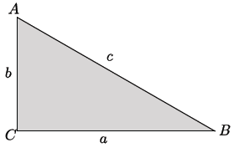
In this diagram, we have constructed a right triangle with side lengths $a$ and $b.$
If time permits, actually show the construction. Draw a segment of length $a$, construct a line through one of the endpoints of segment $a$ that is perpendicular to $a$, mark a point along the perpendicular line that is equal to the length of $b$, and draw the hypotenuse c.

- Consider the right triangle with leg lengths of $a$ and $b.$ By the Pythagorean theorem, we know that $a^{2}+b^{2}=c^{2}.$ Taking the square root of both sides gives the length of the hypotenuse as $\sqrt{a^{2}+b^{2}}=c.$ Then, by SSS, the two triangles are congruent because both triangles have side lengths of $a$,$b$, and $c$. Therefore, the given triangle is a right triangle with a right angle that is opposite the side of length $c.$

Exercises 1–2 (5 minutes)
Students complete Exercise 1 independently. Exercise 2 is designed so that early finishers of Exercise 1 can begin thinking about the topic of the next discussion. If time allows, consider asking students why we do not need to consider the negative solution for $c^{2}=12,500$, which is $c=±50\sqrt{5}$; we only consider $50\sqrt{5}$ in our solution. The desired response is that the context is length; therefore, there is no need to consider a negative length.
Exercises 1–3
- Find the length of the hypotenuse of a right triangle whose legs have lengths $50$ and $100$.
Scaffolding:
Guide students’ thinking by asking, “How might similar triangles make the work in Exercise 1 easier?”
$$c^{2}=50^{2}+100^{2} \\ c^{2}=2,500+10,000 \\ c^{2}=12,500 \\ \sqrt{c^{2}}=\sqrt{12,500} \\ c=\sqrt{2^{2}⋅5^{5}} \\ c=2⋅5^{2}\sqrt{5} \\ c=50\sqrt{5}$$

- Can you think of a simpler method for finding the length of the hypotenuse in Exercise 1? Explain.
Accept any reasonable methods. Students may recall from Grade 8 that they can use what they know about similar triangles and scale factors to make their computations easier.

Discussion (4 minutes)
In the discussion that follows, students use what they know about similar triangles to simplify their work from Exercise 1.
- To simplify our work with large numbers, as in the leg lengths of $50$ and $100$ from Exercise 1, we can find the greatest common factor (GCF) of $50$ and $100$ and then consider a similar triangle with those smaller side lengths. Since $GCF\left(50,100\right)=50$, we can use that GCF to determine the side lengths of a dilated triangle.
- Specifically, we can consider a triangle that has been dilated by a scale factor of $\frac{1}{50}$, which produces a similar triangle with leg lengths $1$ and $2$.
- A triangle with leg lengths $1$ and $2$ has a hypotenuse length of $\sqrt{5}$. The original triangle has side lengths that are $50$ times longer than this one; therefore, the length of the hypotenuse of the original triangle is $50\sqrt{5}$.

Exercise 3 (2 minutes)
Students complete Exercise 3 independently.

- Find the length of the hypotenuse of a right triangle whose legs have lengths $75$ and $225$.
A right triangle with leg lengths $75$ and $225$ has leg lengths that are $75$ times longer than a triangle with leg lengths $1$ and $3$. A triangle with leg lengths $1$ and $3$ has a hypotenuse of length $\sqrt{10}$. Therefore, the length of the hypotenuse of a triangle with leg lengths $75$ and $225$ is $75\sqrt{10}$.

Exploratory Challenge/Exercises 4–5 (10 minutes)
This challenge reveals the relationships of special right triangles with angle measures $30$-$60$-$90$ and $45$-$45$-$90.$ Divide the class so that one half investigates the $30$-$60$-$90$ triangle, and the other half investigates the $45$-$45$-$90$ triangle. Consider having pairs of students from each half become one small group to share their results. Another option is to discuss the results as a whole class using the closing questions below.
Exploratory Challenge/Exercises 4–5
- An equilateral triangle has sides of length $2$ and angle measures of $60$, as shown below. The altitude from one vertex to the opposite side divides the triangle into two right triangles.
  - Are those triangles congruent? Explain.
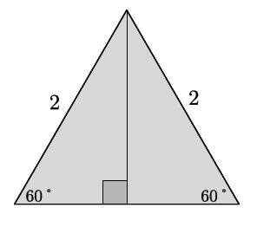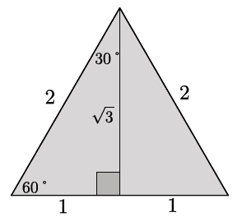
Yes, the two right triangles are congruent by ASA. Since the altitude is perpendicular to the base, then each of the right triangles has angles of measure $90$ and $60$. By the triangle sum theorem, the third angle has a measure of $30$. Then, each of the right triangles has corresponding angle measures of $30$ and $60$, and the included side length is $2$.

  - What is the length of the shorter leg of each of the right triangles? Explain.
Since the total length of the base of the equilateral triangle is $2,$ and the two right triangles formed are congruent, then the bases of each must be equal in length. Therefore, the length of the base of one right triangle is $1$.

  - Use the Pythagorean theorem to determine the length of the altitude.
Let $h$ represent the length of the altitude.
$$1^{2}+h^{2}=2^{2} \\ h^{2}=2^{2}-1^{2} \\ h^{2}=3 \\ h=\sqrt{3}$$

  - Write the ratio that represents $shorter leg:hypotenuse$.
$$1:2$$

  - Write the ratio that represents $longer leg:hypotenuse$.
$$\sqrt{3}:2$$

  - Write the ratio that represents $shorter leg:longer leg$.
$$1:\sqrt{3}$$

  - By the AA criterion, any triangles with measures $30$–$60$–$90$ will be similar to this triangle. If a $30$–$60$–$90$ triangle has a hypotenuse of length $16$, what are the lengths of the legs?
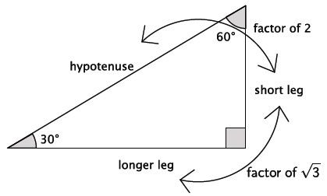
Consider providing the following picture for students:

Let $a$ represent the length of the shorter leg.
$$\frac{a}{16}=\frac{1}{2} \\ a=8$$
Let $b$ represent the length of the longer leg.
$$\frac{b}{16}=\frac{\sqrt{3}}{2} \\ 2b=16\sqrt{3} \\ b=8\sqrt{3}$$
The length $a=8$and the length $b=8\sqrt{3}.$
Note: After finding the length of one of the legs, some students may have used the ratio $shorter leg:longer leg$ to determine the length of the other leg.

- An isosceles right triangle has leg lengths of $1$, as shown.
  - What are the measures of the other two angles? Explain.
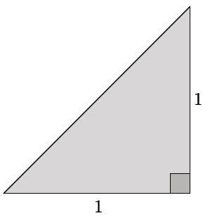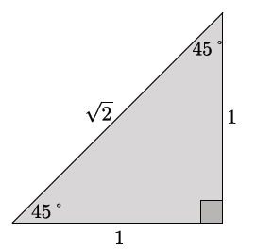

Base angles of an isosceles triangle are equal; therefore, the other two angles have a measure of $45.$

  - Use the Pythagorean Theorem to determine the length of the hypotenuse of the right triangle.
Let $c$ represent the length of the hypotenuse.
$$1^{2}+1^{2}=c^{2} \\ 2=c^{2} \\ \sqrt{2}=c$$

  - Is it necessary to write all three ratios: $shorter leg:hypotenuse$, $longer leg:hypotenuse$, and $shorter leg:longer leg$? Explain.
No, it is not necessary to write all three ratios. The reason is that the shorter leg and the longer leg are the same length. Therefore, the ratios $shorter leg:hypotenus$e and $longer leg:hypotenuse$ will be the same. Additionally, the $shorter leg:longer leg$ ratio would be $1:1$, which is not useful since we are given that the right triangle is an isosceles right triangle.

  - Write the ratio that represents $leg:hypotenuse$.
$$1:\sqrt{2}$$

  - By the AA criterion, any triangles with measures $45$–$45$–$90$ will be similar to this triangle. If a $45$–$45$–$90$ triangle has a hypotenuse of length $20$, what are the lengths of the legs?
Let $a$ represent the length of the leg.
$$\frac{a}{20}=\frac{1}{\sqrt{2}} \\ a\sqrt{2}=20 \\ a=\frac{20}{\sqrt{2}} \\ a=\frac{20}{\sqrt{2}}\left(\frac{\sqrt{2}}{\sqrt{2}}\right) \\ a=\frac{20\sqrt{2}}{2} \\ a=10\sqrt{2}$$

Closing (4 minutes)
Ask students to summarize the key points of the lesson. Additionally, consider asking students the following questions. You may choose to have students respond in writing, to a partner, or to the whole class.
- Explain in your own words the proof of the Pythagorean theorem using similarity.
- Triangles with angle measures $30$–$60$–$90$ are a result of drawing an altitude from one angle of an equilateral triangle to the opposite side. Explain how to use ratios of legs and the hypotenuse to find the lengths of any $30$–$60$–$90$ triangle. Why does it work?
- Triangles with angle measures $45$–$45$–$90$ are isosceles right triangles. Explain how to use ratios of legs and the hypotenuse to find the lengths of any $45$–$45$–$90$ triangle. Why does it work?

Exit Ticket (5 minutes)

Name Date
Lesson 24: Prove the Pythagorean Theorem Using Similarity
Exit Ticket

A right triangle has a leg with a length of $18$ and a hypotenuse with a length of $36$. Bernie notices that the hypotenuse is twice the length of the given leg, which means it is a $30$–$60$–$90$ triangle. If Bernie is right, what should the length of the remaining leg be? Explain your answer. Confirm your answer using the Pythagorean theorem.

Exit Ticket Sample Solutions

A right triangle has a leg with a length of $18$ and a hypotenuse with a length of $36$. Bernie notices that the hypotenuse is twice the length of the given leg, which means it is a $30$–$60$–$90$ triangle. If Bernie is right, what should the length of the remaining leg be? Explain your answer. Confirm your answer using the Pythagorean theorem.
A right angle and two given sides of a triangle determine a unique triangle. All $30$-$60$-$90$ triangles are similar by $AA$ criterion, and the lengths of their sides are $1c$, $2c$, and $c\sqrt{3}$, for some positive number $c$. The given hypotenuse is twice the length of the given leg of the right triangle, so Bernie’s conclusion is accurate. The ratio of the length of the short leg to the length of the longer leg of any $30$–$60$–$90$ triangle is $1:\sqrt{3}$. The given leg has a length of $18$, which is $\frac{1}{2}$ of the hypotenuse and, therefore, must be the shorter leg of the triangle.
$$\frac{1}{\sqrt{3}}=\frac{18}{leg_{2}} \\ leg_{2}=18\sqrt{3}$$ | $$18^{2}+leg^{2}=36^{2} \\ 324+leg^{2}=1296 \\ leg^{2}=972 \\ leg=\sqrt{972} \\ leg=\sqrt{324}\sqrt{3} \\ leg=18\sqrt{3}$$

Problem Set Sample Solutions

- In each row of the table below are the lengths of the legs and hypotenuses of different right triangles. Find the missing side lengths in each row, in simplest radical form.
$$Leg_{1}$$ | $$Leg_{2}$$ | $$Hypotenuse$$
$$15$$ | $$20$$ | $$25$$
$$15$$ | $$36$$ | $$39$$
$$3$$ | $$2\sqrt{10}$$ | $$7$$
$$100$$ | $$200$$ | $$100\sqrt{5}$$
Answers provided in table.
By the Pythagorean Theorem:
$$leg_{1}^{2}+leg_{1}^{2}=hyp^{2} \\ 15^{2}+y^{2}=25^{2} \\ 225+y^{2}=625 \\ y^{2}=400 \\ y=20 or y=-20$$
The case where $y=-20$ does not make sense since it represents a length of a side of a triangle and is, therefore, disregarded.
Alternative Strategy:
Divide each side length by the greatest common factor to get the side lengths of a similar right triangle. Find the missing side length for the similar triangle, and multiply by the GCF.
$Leg: 15$, $Hypotenuse: 25$, $GCF(15,25)=5$
Consider the triangle with $Leg: 3$ and $Hypotenuse: 5$. This is a 3–4–5 right triangle. The missing leg length is $5⋅4=20$.
$Legs: 100$ and $200$: $GCF(100,200)=100$
Consider the right triangle with $Legs: 1$ and $2$. $Hypotenuse =$ $\sqrt{5}$. The missing hypotenuse length is $100\sqrt{5}$.
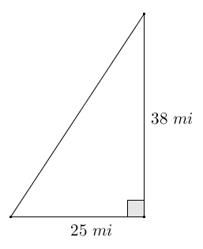
- Claude sailed his boat due south for $38$ miles, then due west for $25$ miles. Approximately how far is Claude from where he began?
Claude’s path forms a right triangle since south and west are perpendicular to each other. His distance from where he began is a straight line segment represented by the hypotenuse of the triangle.
$$38^{2}+25^{2}=hyp^{2} \\ 1444+625=hyp^{2} \\ 2069=hyp^{2} \\ \sqrt{2069}=hyp$$
Claude is approximately $45.5$ miles from where he began.

- Find the lengths of the legs in the triangle given the hypotenuse with length $100$.
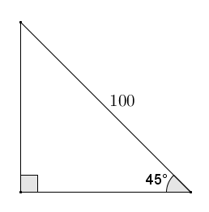
By the Pythagorean theorem:
$$leg^{2}+leg^{2}=100^{2} \\ 2leg^{2}=10000 \\ leg^{2}=5000 \\ leg=\sqrt{5000} \\ leg=\sqrt{2500}\sqrt{2} \\ leg=50\sqrt{2}$$
Alternative strategy:
The right triangle is an isosceles right triangle, so the leg lengths are equal. The hypotenuse of an isosceles right triangle can be calculated as follows:
$$hyp=leg⋅\sqrt{2} \\ 100=l\sqrt{2} \\ \frac{100}{\sqrt{2}}=l \\ \frac{100\sqrt{2}}{2}=50\sqrt{2}=l.$$
The legs of the 45–45–90 right triangle with a hypotenuse of $100$ are $50\sqrt{2}$.

- Find the length of the hypotenuse in the right triangle given that the legs have lengths of $100$.
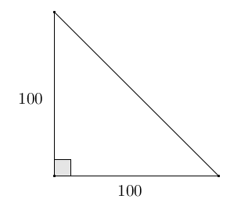
By the Pythagorean theorem:
$$100^{2}+100^{2}=hyp^{2} \\ 10000+10000=hyp^{2} \\ 20000=hyp^{2} \\ \sqrt{20000}=hyp \\ \sqrt{10000}\sqrt{2}=hyp^{2} \\ 100\sqrt{2}=hyp$$
Alternative strategy:
The given right triangle is a $45$-$45$-$90$ triangle. Therefore, the ratio of the length of its legs to the length of its hypotenuse is $1:\sqrt{2}$.
$$hyp=leg⋅\sqrt{2} \\ hyp=100\sqrt{2}$$
The hypotenuse of the right triangle with legs of length $100$ is $100\sqrt{2}$.
- Each row in the table below shows the side lengths of a different $30$–$60$–$90$ right triangle. Complete the table with the missing side lengths in simplest radical form. Use the relationships of the values in the first three rows to complete the last row. How could the expressions in the last row be used?

Shorter Leg | Longer Leg | Hypotenuse
$$25$$ | $$25\sqrt{3}$$ | $$50$$
$$15$$ | $$15\sqrt{3}$$ | $$30$$
$$\sqrt{3}$$ | $$3$$ | $$2\sqrt{3}$$
$$x$$ | $x\sqrt{3}$ | $$2x$$

The last row of the table shows that the sides of a $30$–$60$–$90$ right triangle are multiples of $1$,$2$, and $\sqrt{3}$ by some constant $x$, with $2x$ being the longest and, therefore, the hypotenuse. The expressions could be used to find two unknown sides of a $30$–$60$–$90$ triangle where only one of the sides is known.

- In right triangle $ABC$ with $∠C$ a right angle, an altitude of length $h$ is dropped to side $AB$ that splits the side $AB$ into segments of length $x$ and $y$. Use the Pythagorean Theorem to show $h^{2}=xy$.
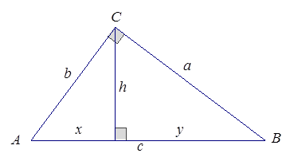
By the Pythagorean theorem $a^{2}+b^{2}=c^{2}$ .
Since $c=x+y$, we have
$$a^{2}+b^{2}={\left(x+y\right)}^{2}$$
$a^{2}+b^{2}=x^{2}+2xy+y^{2}$
Also by the Pythagorean theorem,
$a^{2}=h^{2}+y^{2}$, and $b^{2}=h^{2}+x^{2}$, so
$a^{2}+b^{2}=h^{2}+y^{2}+h^{2}+x^{2}$
$a^{2}+b^{2}=2h^{2}+x^{2}+y^{2}$.
Thus by substitution,
$$x^{2}+2xy+y^{2}=2h^{2}+x^{2}+y^{2}$$
$$2xy=2h^{2}$$
$$xy=h^{2}$$

- In triangle $ABC$, the altitude from $∠C$splits side $AB$ into two segments of lengths $x$ and $y$. If $h$ denotes the length of the altitude and $h^{2}=xy$, use the Pythagorean theorem and its converse to show that triangle $ABC$ is a right triangle with $∠C$ a right angle.
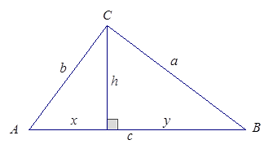
Let $a$, $b$, and$c$ be the lengths of the sides of the triangle opposite
$∠A$,$∠B$, and$∠C$, respectively. By the Pythagorean theorem:
$a^{2}=h^{2}+y^{2}$ and $b^{2}=h^{2}+x^{2}$, so
$a^{2}+b^{2}=h^{2}+y^{2}+h^{2}+x^{2}$
$$a^{2}+b^{2}=x^{2}+2h^{2}+y^{2}$$
$$a^{2}+b^{2}=x^{2}+2xy+y^{2}$$
$$a^{2}+b^{2}={\left(x+y\right)}^{2}$$
$$a^{2}+b^{2}=c^{2}$$
So, by the converse of the Pythagorean theorem, $△ABC$ is a right triangle, $a$ and $b$ are the lengths of legs of the triangle, and $c$ is the hypotenuse which lies opposite the right angle. Therefore, $∠C$ is the right angle of the right triangle.

