Lesson 24: Prove the Pythagorean Theorem Using Similarity

Classwork
Exercises 1–3
- Find the length of the hypotenuse of a right triangle whose legs have lengths $50$ and $100.$

- Can you think of a simpler method for finding the length of the hypotenuse in Exercise 1? Explain.

- Find the length of the hypotenuse of a right triangle whose legs have lengths $75$ and $225.$

Exploratory Challenge/Exercises 4–5
- An equilateral triangle has sides of length $2$ and angle measures of $60$, as shown below. The altitude from one vertex to the opposite side divides the triangle into two right triangles.
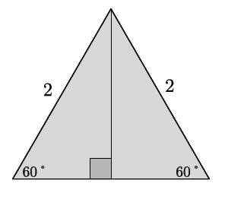

  - Are those triangles congruent? Explain.

  - What is the length of the shorter leg of each of the right triangles? Explain.

  - Use the Pythagorean theorem to determine the length of the altitude.

  - Write the ratio that represents $shorter leg:hypotenuse$.

  - Write the ratio that represents $longer leg:hypotenuse$.

  - Write the ratio that represents $shorter leg:longer leg$.

  - By the AA criterion, any triangles with measures $30$–$60$–$90$ will be similar to this triangle. If a $30$–$60$–$90$ triangle has a hypotenuse of length $16$, what are the lengths of the legs?

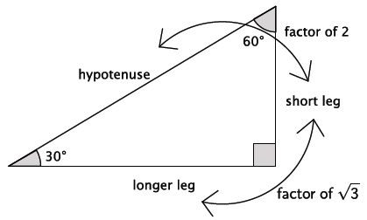

- An isosceles right triangle has leg lengths of $1,$ as shown.
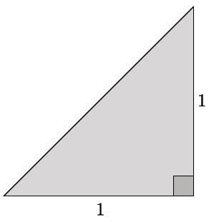
  - What are the measures of the other two angles? Explain.

  - Use the Pythagorean theorem to determine the length of the hypotenuse of the right triangle.

  - Is it necessary to write all three ratios: $shorter leg:hypotenuse$, $longer leg:hypotenuse,$ and $shorter leg:longer leg$? Explain.

  - Write the ratio that represents $leg:hypotenuse$.

  - By the AA criterion, any triangles with measures $45$–$45$–$90$ will be similar to this triangle. If a $45$–$45$–$90$ triangle has a hypotenuse of length $20$, what are the lengths of the legs?

Problem Set

- In each row of the table below are the lengths of the legs and hypotenuses of different right triangles. Find the missing side lengths in each row, in simplest radical form.
Leg₁ | Leg₂ | Hypotenuse
$$15$$ |  | $$25$$
$$15$$ | $$36$$
$$3$$ |  | $$7$$
$$100$$ | $$200$$

- Claude sailed his boat due south for $38$ miles, then due west for $25$ miles. Approximately how far is Claude from where he began?
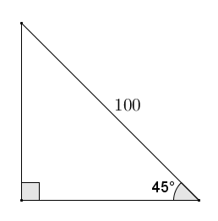
- Find the lengths of the legs in the triangle given the hypotenuse with length $100$.

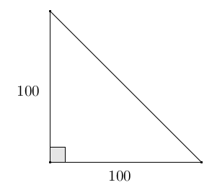
- Find the length of the hypotenuse in the right triangle given that the legs have lengths of $100$.

- Each row in the table below shows the side lengths of a different $30$–$60$–$90$ right triangle. Complete the table with the missing side lengths in simplest radical form. Use the relationships of the values in the first three rows to complete the last row. How could the expressions in the last row be used?
Shorter Leg | Longer Leg | Hypotenuse
$$25$$ |  | $$50$$
$$15$$
 | $$3$$ | $$2\sqrt{3}$$
$$x$$
- In right triangle $ABC$ with $∠C$ a right angle, an altitude of length $h$ is dropped to side $AB$ that splits the side $AB$ into segments of length $x$ and $y$. Use the Pythagorean theorem to show $h^{2}=xy$.
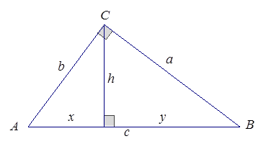

- In triangle $ABC$, the altitude from $∠C$splits side $AB$ into two segments of lengths $x$ and $y$. If $h$ denotes the length of the altitude and $h^{2}=xy$, use the Pythagorean theorem and its converse to show that triangle $ABC$ is a right triangle with $∠C$ a right angle.



