Lesson 23: Adding and Subtracting Expressions with Radicals

Student Outcomes
- Students use the distributive property to simplify expressions that contain radicals.

Lesson Notes
In this lesson, students will add and subtract expressions with radicals, continuing their work from the previous lesson. Again, the overarching goal is for students to rewrite expressions involving radical and rational exponents using the properties of exponents (N.RN.A.2), which will be mastered in Algebra II. To achieve this goal, we provide practice adding and subtracting expressions in a geometric setting.

Classwork
Exercises 1–5 (8 minutes)
The first three exercises are designed to informally assess students’ ability to simplify square root expressions, a skill that is necessary for the topic of this lesson. The last two exercises provide a springboard for discussing how to add expressions that contain radicals. Encourage students to discuss their conjectures with a partner. The discussion that follows debriefs Exercises 1-5.
Exercises 1–5
Simplify each expression as much as possible.
- $\sqrt{32}=$  $$\sqrt{32}=\sqrt{16}\sqrt{2} \\ =4\sqrt{2}$$ | - $\sqrt{45}=$  $$\sqrt{45}=\sqrt{9}\sqrt{5} \\ =3\sqrt{5}$$
- $\sqrt{300}=$
$$\sqrt{300}=\sqrt{100}\sqrt{3} \\ =10\sqrt{3}$$

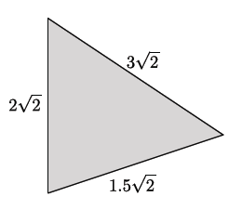
- The triangle shown below has a perimeter of $6.5\sqrt{2}$ units. Make a conjecture about how this answer was reached.
It appears that when all three sides of the triangle were added, the numbers that preceded the square roots were the only numbers that were added:
$3+2+1.5=6.5$. The $\sqrt{2}$ shown as part of each length remained $\sqrt{2}$.
MP.3

- The sides of a triangle are $4\sqrt{3}$, $\sqrt{12}$, and $\sqrt{75}$. Make a conjecture about how to determine the perimeter of this triangle.
Answers will vary. The goal is for students to realize that $\sqrt{12}$ and $\sqrt{75}$ can be rewritten so that each has a factor of $\sqrt{3}$, which then strongly resembles Exercise 4. By rewriting each side length as a multiple of $\sqrt{3}$, we get
$4\sqrt{3}+2\sqrt{3}+5\sqrt{3}=11\sqrt{3}.$
Some students may answer incorrectly by adding $3+12+75$. Show that this is incorrect using a simpler example:
$\sqrt{9}+\sqrt{16}≠\sqrt{25}$.

Discussion (6 minutes)
Scaffolding:
It may be necessary to show students that $\sqrt{2}$ is a number between $1$ and $2$ on the number line. If we consider a unit square on the number line with a diagonal, $s$, as shown, then we can use a compass with a radius equal in length to the diagonal and center at $0$ to show that the length of the diagonal of the square ($\sqrt{2}$) is a number.
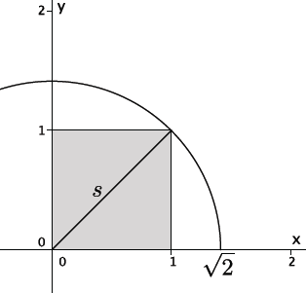
Ensure that students are correctly simplifying the expressions in Exercises 1–3 because it is a skill that is required to add and subtract the expressions in this lesson. Then, continue with the discussion that follows.
- Share your conjecture for Exercise 4. How can we explain that $1.5\sqrt{2}+2\sqrt{2}+3\sqrt{2}=6.5\sqrt{2}$?
Select students to share their conjectures. The expectation is that students will recognize that the rational parts of each length were added.
- Does this remind you of anything else you’ve done before? Give an example.
MP.7
  - It is reminiscent of combining like terms using the distributive property. For example, $1.5x+2x+3x=\left(1.5+2+3\right)x=6.5x.$
- The distributive property is true for all real numbers. Is $\sqrt{2}$a real number?
  - Yes, $\sqrt{2}$ is a real number. It is irrational, but it is a real number.
- For this reason, we can apply the distributive property to radical expressions.
- Share your conjecture for Exercise 5. How might we add $4\sqrt{3}$, $\sqrt{12},$and $\sqrt{75}$?
Now that students know that we can apply the distributive property to radical expressions, they may need another minute or two to evaluate the conjectures they developed while working on Exercise 5. Select students to share their conjectures. The expectation is that students will apply their knowledge from the previous lesson to determine a strategy for finding the perimeter of the triangle. This strategy should include simplifying each expression and combining those with the same irrational factor. Now would be a good time to point out that the $\sqrt{p}$ for any prime number $p$ is an irrational number. This explains why many of the simplifications tend to have radicands that are either prime or a product of prime numbers.

Exercise 6 (10 minutes)
To complete Exercise 6, students will need to circle the expressions on the list that they think can be simplified. As students complete the task, pair them so that they can compare their lists and discuss any discrepancies. Have students who are ready for a challenge generate their own examples, possibly including expressions that contain variables.

Exercise 6
Circle the expressions that can be simplified using the distributive property. Be prepared to explain your choices.
$$8.3\sqrt{2}+7.9\sqrt{2}$$
$$\sqrt{13}-\sqrt{6}$$
$$-15\sqrt{5}+\sqrt{45}$$
$$11\sqrt{7}-6\sqrt{7}+3\sqrt{2}$$
$$19\sqrt{2}+2\sqrt{8}$$
$$4+\sqrt{11}$$
$$\sqrt{7}+2\sqrt{10}$$
$$\sqrt{12}-\sqrt{75}$$
$$\sqrt{32}+\sqrt{2}$$
$$6\sqrt{13}+\sqrt{26}$$
The expressions that can be simplified using the distributive property are noted in red.

Example 1 (5 minutes)
The expressions in this example have been taken from the list that students completed in Exercise 6. Ask students who circled this expression to explain why.
Explain how the expression $8.3\sqrt{2}+7.9\sqrt{2}$can be simplified using the distributive property.
Each term of the expression has a common factor, $\sqrt{2}.$ For that reason, the distributive property can be applied.
$$8.3\sqrt{2}+7.9\sqrt{2}=\left(8.3+7.9\right)\sqrt{2} \text{By the distributive property} \\ =16.2\sqrt{2}$$

Explain how the expression $11\sqrt{7}-6\sqrt{7}+3\sqrt{2}$ can be simplified using the distributive property.
The expression can be simplified because the first two terms contain the expression $\sqrt{7}.$ Using the distributive property, we get
$$11\sqrt{7}-6\sqrt{7}+3\sqrt{2}=\left(11-6\right)\sqrt{7} +3\sqrt{2} \text{By the distributive property} \\ =5\sqrt{7}+3\sqrt{2.}$$

Example 2 (4 minutes)
The expression in this example has been taken from the list that students completed in Exercise 6. Ask students, “Who circled this expression?” Have those students explain to small groups why they believe the expression can be simplified. Then, allow students who had not selected the expression to circle it if they have been convinced that it can be simplified. Finally, ask one of the students who changed his answer to explain how the expression can be simplified.
MP.3

Explain how the expression $19\sqrt{2}+2\sqrt{8}$ can be simplified using the distributive property.
The expression can be simplified, but first the term $2\sqrt{8}$ must be rewritten.
$$19\sqrt{2}+2\sqrt{8}=19\sqrt{2}+2\sqrt{4}⋅\sqrt{2} \text{By Rule 1} \\ =19\sqrt{2}+2⋅2\sqrt{2} \\ =19\sqrt{2}+4\sqrt{2} \\ =\left(19+4\right)\sqrt{2} \text{By the distributive property} \\ =23\sqrt{2}$$

Example 3 (6 minutes)
The expressions in this example have been taken from the list that students completed in Exercise 6. Ask students who circled this expression to explain why.
Can the expression $\sqrt{7}+2\sqrt{10}$ be simplified using the distributive property?
No, the expression cannot be simplified because neither term can be rewritten in a way that the distributive property could be applied.

To determine if an expression can be simplified, you must first simplify each of the terms within the expression. Then, apply the distributive property, or other properties as needed, to simplify the expression.

Have students return to Exercise 6 and discuss the remaining expressions in small groups. Any groups that cannot agree on an expression should present their arguments to the class.
MP.3

Closing (3 minutes)
Working in pairs, have students describe to a partner how to simplify the expressions below. Once students have partner shared, ask the class how the work completed today is related to the structure of rational numbers they have observed in the past. The expected response is that the distributive property can be applied to square roots because they are numbers, too.
- Describe how to simplify the expression $3\sqrt{18}+10\sqrt{2}$.
  - To simplify the expression, we must first rewrite $3\sqrt{18}$ so that is has a factor of $\sqrt{2}$.
$$3\sqrt{18}=3\sqrt{9}\sqrt{2} \\ =3\left(3\right)\sqrt{2} \\ =9\sqrt{2}$$
Now that both terms have a factor of $\sqrt{2},$ the distributive property can be applied to simplify.
$$9\sqrt{2}+10\sqrt{2}=\left(9+10\right)\sqrt{2} \\ =19\sqrt{2}$$

- Describe how to simplify the expression $5\sqrt{3}+\sqrt{12}$.
  - To simplify the expression, we must first rewrite $\sqrt{12}$ so that is has a factor of $\sqrt{3}$.
$$\sqrt{12}=\sqrt{4}\sqrt{3} \\ =2\sqrt{3}$$
Now that both terms have a factor of $\sqrt{3}$, the distributive property can be applied to simplify.
$$5\sqrt{3}+2\sqrt{3}=\left(5+2\right)\sqrt{3} \\ =7\sqrt{3}$$

Exit Ticket (3 minutes)

Name Date
Lesson 23: Adding and Subtracting Expressions with Radicals

Exit Ticket

- Simplify $5\sqrt{11}-17\sqrt{11}$.

- Simplify $\sqrt{8}+5\sqrt{2}$.

- Write a radical addition or subtraction problem that cannot be simplified, and explain why it cannot be simplified.

Exit Ticket Sample Solutions

- Simplify $5\sqrt{11}-17\sqrt{11}$.
$$5\sqrt{11}-17\sqrt{11}=\left(5-17\right)\sqrt{11} \\ =-12\sqrt{11}$$

- Simplify $\sqrt{8}+5\sqrt{2}$.
$$\sqrt{8}+5\sqrt{2}=\sqrt{4}\sqrt{2}+5\sqrt{2} \\ =2\sqrt{2}+5\sqrt{2} \\ =\left(2+5\right)\sqrt{2} \\ =7\sqrt{2}$$

- Write a radical addition or subtraction problem that cannot be simplified, and explain why it cannot be simplified.
Answers will vary. Students should state that their expression cannot be simplified because one or both terms cannot be rewritten so that each has a common factor. Therefore, the distributive property cannot be applied.

Problem Set Sample Solutions

Express each answer in simplified radical form.
- $18\sqrt{5}-12\sqrt{5}=$  $$18\sqrt{5}-12\sqrt{5}=\left(18-12\right)\sqrt{5} \\ =6\sqrt{5}$$ | - $\sqrt{24}+4\sqrt{54}=$  $$\sqrt{24}+4\sqrt{54}=\sqrt{4}⋅\sqrt{6}+4⋅\sqrt{9}⋅\sqrt{6} \\ =2\sqrt{6}+4⋅3\sqrt{6} \\ =\left(2+12\right)\sqrt{6} \\ =14\sqrt{6}$$
- $2\sqrt{7}+4\sqrt{63}$
$$2\sqrt{7}+4\sqrt{63}=2\sqrt{7}+4\sqrt{9}\sqrt{7} \\ =2\sqrt{7}+4\left(3\right)\sqrt{7} \\ =\left(2+12\right)\sqrt{7} \\ =14\sqrt{7}$$

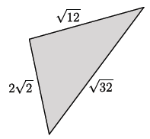
- What is the perimeter of the triangle shown below?
$$2\sqrt{2}+\sqrt{12}+\sqrt{32}=2\sqrt{2}+\sqrt{4}⋅\sqrt{3}+\sqrt{16}⋅\sqrt{2} \\ =2\sqrt{2}+2\sqrt{3}+4\sqrt{2} \\ =\left(2+4\right)\sqrt{2}+2\sqrt{3} \\ =6\sqrt{2}+2\sqrt{3}$$
The perimeter of the triangle is $6\sqrt{2}+2\sqrt{3}$ units.
- Determine the area and perimeter of the triangle shown. Simplify as much as possible.
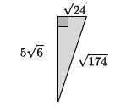
The perimeter of the triangle is
$$\sqrt{24}+5\sqrt{6}+\sqrt{174}=\sqrt{4}\sqrt{6}+5\sqrt{6}+\sqrt{174} \\ =2\sqrt{6}+5\sqrt{6}+\sqrt{174} \\ =\left(2+5\right)\sqrt{6}+\sqrt{174} \\ =7\sqrt{6}+\sqrt{174.}$$The area of the triangle is
$$\frac{\sqrt{24}\left(5\sqrt{6}\right)}{2}=\frac{2\sqrt{6}\left(5\sqrt{6}\right)}{2}=\frac{60}{2}=30.$$
The perimeter is $7\sqrt{6}+\sqrt{174}$units, and the area is $30$square units.

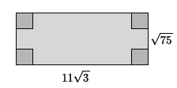
- Determine the area and perimeter of the rectangle shown. Simplify as much as possible.
The perimeter of the rectangle is
$$11\sqrt{3}+11\sqrt{3}+\sqrt{75}+\sqrt{75}=2\left(11\sqrt{3}\right)+2\left(\sqrt{25}\sqrt{3}\right) \\ =22\sqrt{3}+10\sqrt{3} \\ =\left(22+10\right)\sqrt{3} \\ =32\sqrt{3}.$$
The area of the rectangle is
$$11\sqrt{3}\left(5\sqrt{3}\right)=55\left(3\right) \\ =165.$$
The perimeter is $32\sqrt{3}$units, and the area is $165$square units.

- Determine the area and perimeter of the triangle shown. Simplify as much as possible.
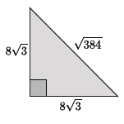
The perimeter of the triangle is
$$8\sqrt{3}+8\sqrt{3}+\sqrt{384}=\left(8+8\right)\sqrt{3}+\sqrt{384} \\ =16\sqrt{3}+\sqrt{384} \\ =16\sqrt{3}+\sqrt{64}\sqrt{6} \\ =16\sqrt{3}+8\sqrt{6.}$$
The area of the triangle is
$$\frac{{\left(8\sqrt{3}\right)}^{2}}{2}=\frac{8^{2}{\left(\sqrt{3}\right)}^{2}}{2} \\ =\frac{64\left(3\right)}{2} \\ =32\left(3\right) \\ =96.$$
The perimeter of the triangle is $16\sqrt{3}+8\sqrt{6}$units, and the area of the triangle is $96$square units.

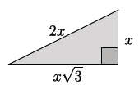
- Determine the area and perimeter of the triangle shown. Simplify as much as possible.
The perimeter of the triangle is
$$2x+x+x\sqrt{3}=3x+x\sqrt{3.}$$
The area of the triangle is
$$\frac{x(x\sqrt{3})}{2}=\frac{x^{2}\sqrt{3}}{2}.$$
The perimeter is $3x+x\sqrt{3}$units, and the area is $\frac{x^{2}\sqrt{3}}{2}$square units.

- The area of the rectangle shown in the diagram below is $160$ square units. Determine the area and perimeter of the shaded triangle. Write your answers in simplest radical form, and then approximate to the nearest tenth.
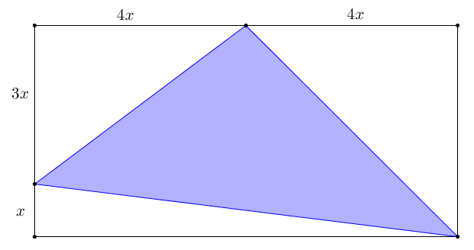
The length of the rectangle is $8x,$ and the width is $4x$. Using the given area of the rectangle:
1
2
3
4
$\text{Area}=\text{length}×\text{width}$
$$160=8x⋅4x \\ 160=32x^{2} \\ 5=x^{2} \\ \sqrt{5}=x$$

$Area{}_{rectangle}=A_{1}+A_{2}+A_{3}+A_{4}$

$Area_{1}=\frac{1}{2}bh$ $Area_{2}=\frac{1}{2}bh$ $Area_{3}=\frac{1}{2}bh$
$Area_{1}=\frac{1}{2}⋅3x⋅4x$ $Area_{2}=\frac{1}{2}⋅4x⋅4x$ $Area_{3}=\frac{1}{2}⋅8x⋅x$
$Area_{1}=6x^{2}$ $Area_{2}=8x^{2}$ $Area_{3}=4x^{2}$
$Area_{1}=6{\left(\sqrt{5}\right)}^{2}$ $Area_{2}=8{\left(\sqrt{5}\right)}^{2}$ $Area_{3}=4{\left(\sqrt{5}\right)}^{2}$
$Area_{1}=30$ $Area_{2}=40$ $Area_{3}=20$

$$160=30+40+20+A_{4} \\ A_{4}=70$$
The area of the shaded triangle in the diagram is $70$ square units .
The perimeter of the shaded triangle requires use of the Pythagorean theorem to find the hypotenuses of right triangles 1, 2, and 3. Let $h_{1}$, $h_{2}$, and $h_{3}$ represent the lengths of the hypotenuses of triangles 1, 2, and 3, respectively.
$${\left(3\sqrt{5}\right)}^{2}+{\left(4\sqrt{5}\right)}^{2}={\left(c_{1}\right)}^{2} \\ 45+80={\left(c_{1}\right)}^{2} \\ 125={\left(c_{1}\right)}^{2} \\ 5\sqrt{5}=c_{1}$$ | $${\left(4\sqrt{5}\right)}^{2}+{\left(4\sqrt{5}\right)}^{2}={\left(c_{2}\right)}^{2} \\ 80+80={\left(c_{2}\right)}^{2} \\ 160={\left(c_{2}\right)}^{2} \\ 4\sqrt{10}=c_{2}$$ | $${\left(\sqrt{5}\right)}^{2}+{\left(8\sqrt{5}\right)}^{2}={\left(c_{3}\right)}^{2} \\ 5+320={\left(c_{3}\right)}^{2} \\ 325={\left(c_{3}\right)}^{2} \\ 5\sqrt{13}=c_{3}$$
Perimeter $=c_{1}+c_{2}+c_{3}$
Perimeter$=5\sqrt{5}+4\sqrt{10}+5\sqrt{13}$
The perimeter of the shaded triangle is approximately $41.9$ units.

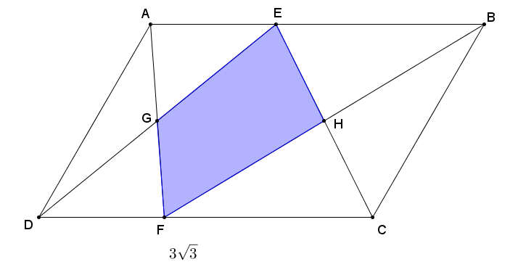
- Parallelogram $ABCD$ has an area of $9\sqrt{3}$ square units. $DC=3\sqrt{3}$, and $G$ and $H$ are midpoints of $\overline{DE}$ and $\overline{CE}$, respectively. Find the area of the shaded region. Write your answer in simplest radical form.
Using the area of a parallelogram:
$Area\left(ABCD\right)=bh$
$$9\sqrt{3}=3\sqrt{3}⋅h \\ 3=h$$
The height of the parallelogram is $3$.
The area of the shaded region is the sum of the areas of $△EGH$ and $△FGH$.
The given points $G$ and $H$ are midpoints of $\overline{DE}$ and $\overline{CE}$; therefore, by the Triangle Side Splitter Theorem, $\overline{GH}$ must be parallel to $\overline{DC}$, and thus, also parallel to $\overline{AB}$. Furthermore, $GH=\frac{1}{2}CD=\frac{1}{2}AB=\frac{3}{2}\sqrt{3}$.
$△EGH\sim △EDC$ by AA$\sim$ criterion with a scale factor of $\frac{1}{2}$. The areas of scale drawings are related by the square of the scale factor; therefore, $Area\left(△EGH\right)={\left(\frac{1}{2}\right)}^{2}⋅Area\left(△EDC\right)$.
$Area\left(△EDC\right)=\frac{1}{2}⋅3\sqrt{3}⋅3$
$Area\left(△EDC\right)=\frac{9}{2}\sqrt{3}$
By a similar argument:
$Area\left(△EGH\right)={\left(\frac{1}{2}\right)}^{2}⋅\frac{9}{2}\sqrt{3}$ $Area\left(△FGH\right)=\frac{9}{8}\sqrt{3}$
$Area\left(△EGH\right)=\frac{1}{4}⋅\frac{9}{2}\sqrt{3}$
$Area\left(△EGH\right)=\frac{9}{8}\sqrt{3}$

$Area\left(EHFG\right)=Area\left(△EGH\right)+Area\left(△FGH\right)$
$Area\left(EHFG\right)=\frac{9}{8}\sqrt{3}+\frac{9}{8}\sqrt{3}$
$Area\left(EHFG\right)=\frac{9}{4}\sqrt{3}$
The area of the shaded region is $\frac{9}{4}\sqrt{3}$ square units.

