Lesson 23: Adding and Subtracting Expressions with Radicals

Classwork
Exercises 1–5
Simplify each expression as much as possible.
- $\sqrt{32}=$ | - $\sqrt{45}=$
- $\sqrt{300}=$

- The triangle shown below has a perimeter of $6.5\sqrt{2}$ units. Make a conjecture about how this answer was reached.
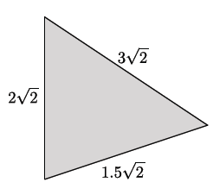

- The sides of a triangle are $4\sqrt{3}$, $\sqrt{12}$, and $\sqrt{75}$. Make a conjecture about how to determine the perimeter of this triangle.

Exercise 6
- Circle the expressions that can be simplified using the distributive property. Be prepared to explain your choices.

$$8.3\sqrt{2}+7.9\sqrt{2}$$
$$\sqrt{13}-\sqrt{6}$$
$$-15\sqrt{5}+\sqrt{45}$$
$$11\sqrt{7}-6\sqrt{7}+3\sqrt{2}$$
$$19\sqrt{2}+2\sqrt{8}$$
$$4+\sqrt{11}$$
$$\sqrt{7}+2\sqrt{10}$$
$$\sqrt{12}-\sqrt{75}$$
$$\sqrt{32}+\sqrt{2}$$
$$6\sqrt{13}+\sqrt{26}$$

Example 1
Explain how the expression $8.3\sqrt{2}+7.9\sqrt{2}$can be simplified using the distributive property.

Explain how the expression $11\sqrt{7}-6\sqrt{7}+3\sqrt{2}$ can be simplified using the distributive property.

Example 2
Explain how the expression $19\sqrt{2}+2\sqrt{8}$ can be simplified using the distributive property.

Example 3
Can the expression $\sqrt{7}+2\sqrt{10}$ be simplified using the distributive property?

To determine if an expression can be simplified, you must first simplify each of the terms within the expression. Then, apply the distributive property, or other properties as needed, to simplify the expression.

Problem Set

Express each answer in simplified radical form.
- $18\sqrt{5}-12\sqrt{5}=$ | - $\sqrt{24}+4\sqrt{54}=$
- $2\sqrt{7}+4\sqrt{63}=$

- What is the perimeter of the triangle shown below?
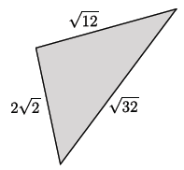

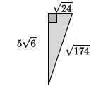
- Determine the area and perimeter of the triangle shown. Simplify as much as possible.

- Determine the area and perimeter of the rectangle shown. Simplify as much as possible.
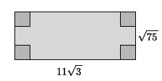

- Determine the area and perimeter of the triangle shown. Simplify as much as possible.
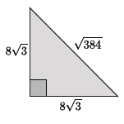

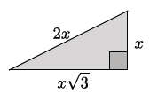
- Determine the area and perimeter of the triangle shown. Simplify as much as possible.

- The area of the rectangle shown in the diagram below is $160$ square units. Determine the area and perimeter of the shaded triangle. Write your answers in simplest radical form, and then approximate to the nearest tenth.
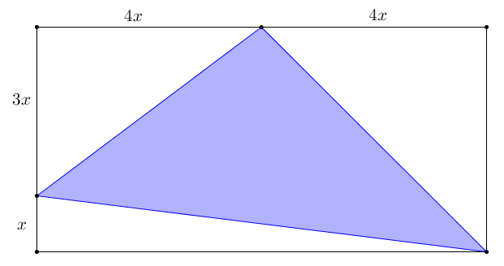

- Parallelogram $ABCD$ has an area of $9\sqrt{3}$. $DC=3\sqrt{3}$, and $G$ and $H$ are midpoints of $\overline{DE}$ and $\overline{CE}$, respectively. Find the area of the shaded region. Write your answer in simplest radical form.

