Lesson 22: Multiplying and Dividing Expressions with Radicals

Classwork
Exercises 1–5
Simplify as much as possible.
- $\sqrt{17^{2}}=$

- $\sqrt{5^{10}}=$

- $\sqrt{4x^{4}}=$

- Complete parts (a) through (c).
  - Compare the value of $\sqrt{36}$ to the value of $\sqrt{9}×\sqrt{4}.$

  - Make a conjecture about the validity of the following statement. For nonnegative real numbers $a$ and $b$, $\sqrt{ab}=\sqrt{a}∙\sqrt{b}$. Explain.

  - Does your conjecture hold true for $a=-4$ and $b=-9$?

- Complete parts (a) through (c).
  - Compare the value of $\sqrt{\frac{100}{25}}$ to the value of $\frac{\sqrt{100}}{\sqrt{25}}$.

  - Make a conjecture about the validity of the following statement. For nonnegative real numbers $a$ and $b$, when $b≠0$, $\sqrt{\frac{a}{b}}=\frac{\sqrt{a}}{\sqrt{b}}$. Explain.

  - Does your conjecture hold true for $a=-100$ and $b=-25$?

Exercises 6–17
Simplify each expression as much as possible and rationalize denominators when applicable.
- $\sqrt{72}=$ | - $\sqrt{\frac{17}{25}}=$
- $\sqrt{32x}=$ | - $\sqrt{\frac{1}{3}}=$
- $\sqrt{54x^{2}}=$ | - $\frac{\sqrt{36}}{\sqrt{18}}=$
- $\sqrt{\frac{4}{x^{4}}}=$ | - $\frac{4x}{\sqrt{64x^{2}}}=$
- $\frac{5}{\sqrt{x^{7}}}=$ | - $\sqrt{\frac{x^{5}}{2}}=$
- $\frac{\sqrt{18x}}{3\sqrt{x^{5}}}=$

- The captain of a ship recorded the ship’s coordinates, then sailed north and then west, and then recorded the new coordinates. The coordinates were used to calculate the distance they traveled, $\sqrt{578}$km. When the captain asked how far they traveled, the navigator said, “About $24$ km.” Is the navigator correct? Under what conditions might he need to be more precise in his answer?

Problem Set

Express each number in its simplest radical form.
- $\sqrt{6}⋅\sqrt{60}=$ | - $\sqrt{108}=$
- Pablo found the length of the hypotenuse of a right triangle to be $\sqrt{45}$. Can the length be simplified? Explain.

- $\sqrt{12x^{4}}=$

- Sarahi found the distance between two points on a coordinate plane to be $\sqrt{74}$. Can this answer be simplified? Explain.

- $\sqrt{16x^{3}}=$

- $\frac{\sqrt{27}}{\sqrt{3}}=$

- Nazem and Joffrey are arguing about who got the right answer. Nazem says the answer is $\frac{1}{\sqrt{3}}$, and Joffrey says the answer is $\frac{\sqrt{3}}{3}$. Show and explain that their answers are equivalent.

- $\sqrt{\frac{5}{8}}=$

- Determine the area of a square with side length $2\sqrt{7}$ in.

- Determine the exact area of the shaded region shown below.
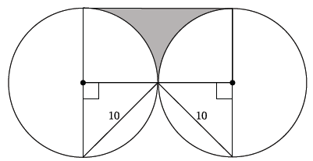

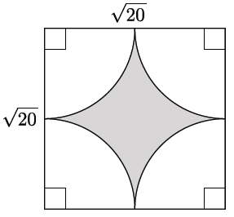
- Determine the exact area of the shaded region shown to the right.

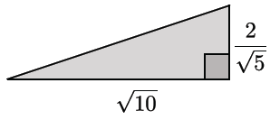
- Calculate the area of the triangle to the right.

- $\frac{\sqrt{2x^{3}}⋅\sqrt{8x}}{\sqrt{x^{3}}}=$

- Prove Rule 2 for square roots: $\sqrt{\frac{a}{b}}=\frac{\sqrt{a}}{\sqrt{b}}$ ($a≥0, b>0)$.
Let $p$ be the nonnegative number so that $p^{2}=a$, and let $q$ be the nonnegative number so that $q^{2}=b$.

