Lesson 21: Special Relationships Within Right Triangles—Dividing into Two Similar Sub-Triangles

Student Outcomes
- Students understand that the altitude of a right triangle from the vertex of the right angle to the hypotenuse divides the triangle into two similar right triangles that are also similar to the original right triangle.
- Students complete a table of ratios for the corresponding sides of the similar triangles that are the result of dividing a right triangle into two similar sub-triangles.

Lesson Notes
This lesson serves as a foundational piece for understanding trigonometric ratios related to right triangles. The goal of the lesson is to show students how ratios within figures can be used to find lengths of sides in another triangle when those triangles are known to be similar.

Classwork
Opening Exercise (5 minutes)
Opening Exercise
Use the diagram below to complete parts (a)–(c).
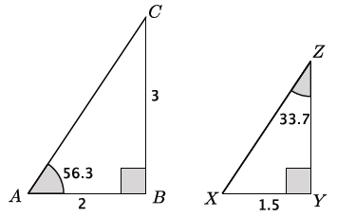

  - Are the triangles shown above similar? Explain.
Yes, the triangles are similar by the AA criterion. Both triangles have a right angle, and $m∠A=m∠X$ and $m∠C=m∠Z$.

  - Determine the unknown lengths of the triangles.
Let $x$ represent the length of $\overline{YZ}$. | $$\frac{3}{2}=\frac{x}{1.5} \\ 2x=4.5 \\ x=2.25$$
Let $y$ be the length of the hypotenuse of $△ABC$. | $$2^{2}+3^{2}=y^{2} \\ 4+9=y^{2} \\ 13=y^{2} \\ \sqrt{13}=y$$
Let $z$ be the length of the hypotenuse of $△XYZ$. | $$1.5^{2}+2.25^{2}=z^{2} \\ 2.25+5.0625=z^{2} \\ 7.3125=z^{2} \\ \sqrt{7.3125}=z$$

  - Explain how you found the lengths in part (a).
Since the triangles are similar, I used the values of the ratios of the corresponding side lengths to determine the length of $\overline{YZ}$. To determine the lengths of $\overline{AC}$and $\overline{XZ}$, I used the Pythagorean theorem.
Scaffolding:
- A good hands-on visual that can be used here requires a $3×5$ notecard. Have students draw the diagonal, then draw the perpendicular line from $B$ to side $AC$.
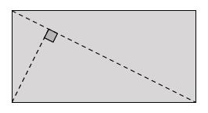
- Make sure students label all of the parts to match the triangles before they make the cuts. Next, have students cut out the three triangles. Students will then have a notecard version of the three triangles shown and will be better able to see the relationships among them.

Example 1 (15 minutes)
In Example 1, students learn that when a perpendicular is drawn from the right angle to the hypotenuse of a right triangle, the triangle is divided into two sub-triangles. Further, students show that all three of the triangles, the original one and the two formed by the perpendicular, are similar.
Example 1
Recall that an altitude of a triangle is a perpendicular line segment from a vertex to the line determined by the opposite side. In triangle $△ABC$ below, $\overline{BD}$ is the altitude from vertex $B$ to the line containing $\overline{AC}.$
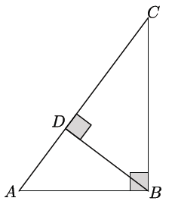
How many triangles do you see in the figure?
There are three triangles in the figure.

Identify the three triangles by name.
Note that there are many ways to name the three triangles. Ensure that the names students show corresponding angles.
$△ABC$, $△ADB$, and $△BDC$.
We want to consider the altitude of a right triangle from the right angle to the hypotenuse. The altitude of a right triangle splits the triangle into two right triangles, each of which shares a common acute angle with the original triangle. In $△ABC$, the altitude $\overline{BD}$ divides the right triangle into two sub-triangles, $△BDC$ and $△ADB$.
Is $△ABC \sim △BDC$? Is $△ABC \sim △ADB$? Explain.
Triangles $△ABC$ and $△BDC$ are similar by the AA criterion. Each has a right angle and each share $∠C.$ Triangles $△ABC$ and $△ADB$ are similar because each has a right angle and each share $∠A$, so, again, these triangles are similar by the AA criterion.

Is $△ABC\sim △DBC$? Explain.
Triangles $△ABC$ and $△DBC$ are not similar because their corresponding angles, under the given correspondence of vertices, do not have equal measure.

Since $△ABC \sim △BDC$ and $△ABC\sim △ADB$, can we conclude that $△BDC\sim △ADB$? Explain.
Since similarity is transitive, $△ABC\sim △BDC$ and $△ABC\sim △ADB$ implies that $△ABC\sim △BDC\sim △ADB$.

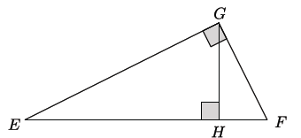
Identify the altitude drawn in triangle $△EFG.$
$\overline{GH}$ is the altitude from vertex $G$ to the line containing $\overline{EF}.$

As before, the altitude divides the triangle into three triangles. Identify them by name so that the corresponding angles match up.
$△EFG$, $△GFH$, and $△EGH$.

Does the altitude divide$△EFG$ into three similar sub-triangles as the altitude did with $△ABC$?

Allow students time to investigate whether the triangles are similar. Students should conclude that $△EFG\sim$ $△GFH\sim △EGH$ using the same reasoning as before, i.e., the AA criterion and the fact that similarity is transitive.

The fact that the altitude drawn from the right angle of a right triangle divides the triangle into two similar sub-triangles, which are also similar to the original triangle, allows us to determine the unknown lengths of right triangles.

Example 2 (15 minutes)
In this example, students use ratios within figures to determine unknown side lengths of triangles.
Example 2
Consider the right triangle $△ABC$ below.
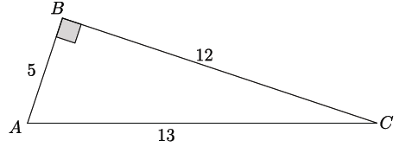
Scaffolding:
It may be helpful for students to use the cutouts from Example 1. Have students label the side lengths on the front and back of the notecard according to this diagram and then use the cutouts to complete the table of ratios.

Draw the altitude $\overline{BD}$ from vertex $B$ to the line containing $\overline{AC}.$ Label the segment $\overline{AD}$as $x$, the segment $\overline{DC}$ as $y$, and the segment $\overline{BD}$ as $z.$
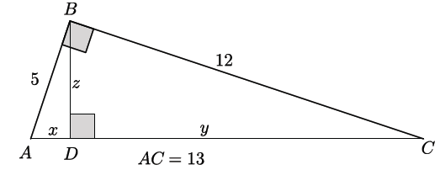
Find the values of $x, y,$ and $z.$

Provide students time to find the values of $x$, $y$, and $z$. Allow students to use any reasonable strategy to complete the task. Suggested time allotment for this part of the example is 5 minutes. Next, have students briefly share their solutions and explanations for finding the lengths $x=1\frac{12}{13}$, $y=11\frac{1}{13}$, and $z=4\frac{8}{13}$. For example, students may first use what they know about similar triangles and corresponding side lengths having equal ratios to determine $x$, then use the equation $x+y=13$ to determine the value of $y$, and finally use the Pythagorean Theorem to determine the length of $z.$
MP.1
Now we will look at a different strategy for determining the lengths of $x, y,$ and $z.$ The strategy requires that we complete a table of ratios that compares different parts of each triangle.

Students may struggle with the initial task of finding the values of $x$,$y$, and $z$. Encourage them by letting them know that they have all the necessary tools to find these values. When transitioning to the use of ratios to find values, explain any method that yields acceptable answers. We are simply looking to add another tool to the toolbox of strategies that apply in this situation.
Provide students a moment to complete the ratios related to $△ABC.$

Make a table of ratios for each triangle that relates the sides listed in the column headers.
MP.2
&
MP.7
 | $$shorter leg:hypotenuse$$ | $$longer leg:hypotenuse$$ | $$shorter leg:longer leg$$
$$△ABC$$ | $$5:13$$ | $$12:13$$ | $$5:12$$

Ensure that students have written the correct ratios before moving on to complete the table of ratios for $△ADB$ and $△CDB.$

 | $$shorter leg:hypotenuse$$ | $$longer leg:hypotenuse$$ | $$shorter leg:longer leg$$
$$△ADB$$ | $$x:5$$ | $$z:5$$ | $$x:z$$
$$△CDB$$ | $$z:12$$ | $$y:12$$ | $$z:y$$

Our work in Example 1 showed us that $△ABC\sim △ADB\sim △CDB$. Since the triangles are similar, the ratios of their corresponding sides will be equal. For example, we can find the length of $x$ by equating the values of $shorter leg:hypotenuse$ ratios of triangles $△ABC$ and $△ADB.$
$$\frac{x}{5}=\frac{5}{13} \\ 13x=25 \\ x=\frac{25}{13}=1\frac{12}{13}$$
Why can we use these ratios to determine the length of $x$?
We can use these ratios because the triangles are similar. Similar triangles have ratios of corresponding sides that are equal. We also know that we can use ratios between-figures or within-figures. The ratios used were within-figure ratios.

Which ratios can we use to determine the length of $y$?
To determine the value of $y$, we can equate the values $longer leg:hypotenuse$ratios for $△CDB$ and $△ABC$.
$$\frac{y}{12}=\frac{12}{13} \\ 13y=144 \\ y=\frac{144}{13}=11\frac{1}{13}$$

Use ratios to determine the length of $z.$

Students have several options of ratios to determine the length of $z.$ As students work, identify those students using different ratios and ask them to share their work with the class.

To determine the value of $z$, we can equate the values of $longer leg:hypotenuse$ ratios for $△ADB$ and $△ABC$.
$$\frac{z}{5}=\frac{12}{13} \\ 13z=60 \\ z=\frac{60}{13}=4\frac{8}{13}$$

To determine the value of $z$, we can equate the values of $shorter leg:hypotenuse$ ratios for $△CDB$ and $△ABC$.
$$\frac{z}{12}=\frac{5}{13} \\ 13z=60 \\ z=\frac{60}{13}=4\frac{8}{13}$$

To determine the value of $z$, we can equate the values of $shorter leg:longer leg$ ratios for $△ADB$ and $△ABC:$
$$\frac{ \frac{25}{13} }{z}=\frac{5}{12} \\ 5z=\frac{25}{13}\left(12\right) \\ z=\frac{25}{13}\left(\frac{12}{5}\right) \\ z=\frac{60}{13}=4\frac{8}{13}$$

To determine the value of $z,$ we can equate the values of $shorter leg:longer leg$ ratios for $△CDB$ and $△ABC:$
$$\frac{ z }{\frac{144}{13}}=\frac{5}{12} \\ 12z=\frac{144}{13}(5) \\ z=\frac{144}{13}\left(\frac{5}{12}\right) \\ z=\frac{60}{13}=4\frac{8}{13}$$
Since corresponding ratios within similar triangles are equal, we can solve for any unknown side length by equating the values of the corresponding ratios. In the coming lessons, we will learn about more useful ratios for determining unknown side lengths of right triangles.

Closing (5 minutes)
Ask students the following questions. Students may respond in writing, to a partner, or to the whole class.
- What is an altitude, and what happens when an altitude is drawn from the right angle of a right triangle?
  - An altitude is the perpendicular line segment from a vertex of a triangle to the line containing the opposite side. When an altitude is drawn from the right angle of a right triangle, then the triangle is divided into two similar sub-triangles.
- What is the relationship between the original right triangle and the two similar sub-triangles?
  - By the AA criterion and transitive property, we can show that all three triangles are similar.
- Explain how to use the ratios of the similar right triangles to determine the unknown lengths of a triangle.
Note that we have used “shorter leg” and “longer leg” in the lesson and would expect students to do the same in responding to this prompt. It may be valuable to point out to students that an isosceles right triangle would not have a shorter or longer leg.
  - Ratios of side lengths can be written using “shorter leg,” “longer leg,” and hypotenuse. The ratios of corresponding sides of similar triangles are equivalent and can be used to find unknown lengths of a triangle.

Exit Ticket (5 minutes)

Name Date
Lesson 21: Special Relationships Within Right Triangles— Dividing into Two Similar Sub-Triangles

Exit Ticket

Given $△RST$, with altitude $\overline{SU}$ drawn to its hypotenuse, $ST=15$, $RS=36$, and $RT=39$, answer the questions below.
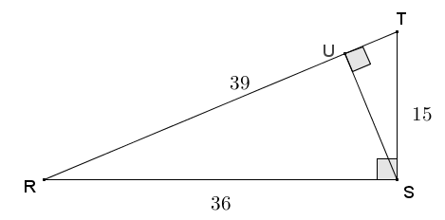
- Complete the similarity statement relating the three triangles in the diagram.

$△RST\sim △$ __________$\sim △$ ____________

- Complete the table of ratios specified below.
 | $$shorter leg:hypotenuse$$ | $$longer leg:hypotenuse$$ | $$shorter leg:longer leg$$
$$△RST$$
$$△RSU$$
$$△STU$$

- Use the values of the ratios you calculated to find the length of $SU$.

Exit Ticket Sample Solutions

Given $△RST$, with altitude $\overline{SU}$ drawn to its hypotenuse, $ST=15$, $RS=36$, and $RT=39$, answer the questions below.
- Complete the similarity statement relating the three triangles in the diagram.
$$△RST\sim △ RUS \sim △ SUT$$
Using the right angles and shared angles, the triangles are similar by $AA$ criterion. The transitive property may also be used.

- Complete the table of ratios specified below.
 | $$shorter leg:hypotenuse$$ | $$longer leg:hypotenuse$$ | $$shorter leg:longer leg$$
$$△RST$$ | $$\frac{15}{39}$$ | $$\frac{36}{39}$$ | $$\frac{15}{36}$$
$$△RSU$$ | $$\frac{SU}{36}$$ | $$\frac{RU}{36}$$ | $$\frac{SU}{RU}$$
$$△STU$$ | $$\frac{TU}{15}$$ | $$\frac{SU}{15}$$ | $$\frac{TU}{SU}$$

- Use the values of the ratios you calculated to find the length of $SU$.
$$\frac{15}{39}=\frac{SU}{36} \\ 540=39(SU) \\ \frac{540}{39}=SU \\ 13\frac{11}{13}=SU$$

Problem Set Sample Solutions

- Use similar triangles to find the length of the altitudes labeled with variables in each triangle below.
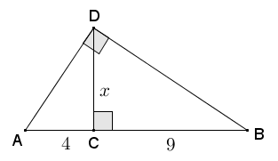
$△ACD\sim △DCB$ by AA criterion, so corresponding sides are proportional.
$$\frac{x}{4}=\frac{9}{x} \\ x^{2}=36 \\ x=\sqrt{36}=6$$
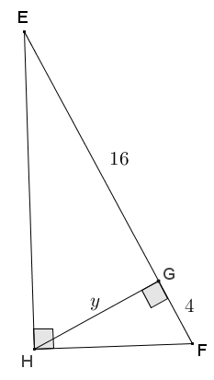
$△GHE\sim △GFH$ by AA criterion, so corresponding sides are proportional.
$$\frac{y}{4}=\frac{16}{y} \\ y^{2}=64 \\ y=\sqrt{64}=8$$

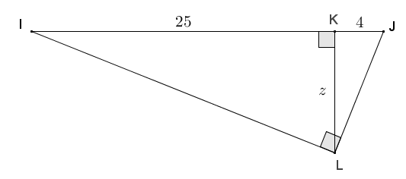

$△LKI\sim △JKL$ by $AA$ criterion, so corresponding sides are proportional:
$$\frac{z}{25}=\frac{4}{z} \\ z^{2}=100 \\ z=\sqrt{100}=10$$

  - Describe the pattern that you see in your calculations for parts (a) through (c).
For each of the given right triangles, the length of the altitude drawn to its hypotenuse is equal to the square root of the product of the lengths of the pieces of the hypotenuse that it cuts.

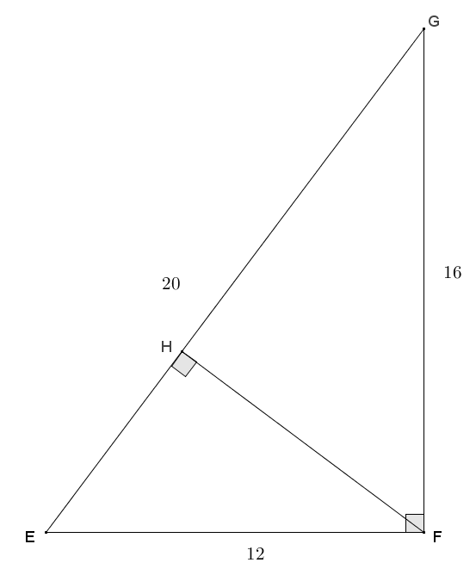
- Given right triangle $EFG$ with altitude $\overline{FH}$ drawn to the hypotenuse, find the lengths of $EH$, $FH$, and $GH$.
The altitude drawn from $F$ to $H$ cuts triangle $EFG$ into two similar sub-triangles providing the following correspondence:
$△EFG\sim △EHF\sim △FHG$.
Using the ratio $shorter leg:hypotenuse$ for the similar triangles:
$$\frac{12}{20}=\frac{HF}{16} \\ 192=20(HF) \\ \frac{192}{20}=HF \\ 9\frac{12}{20}=9\frac{3}{5}=HF$$ | $$\frac{12}{20}=\frac{HE}{12} \\ 144=20\left(HE\right) \\ \frac{144}{20}=HE \\ 7\frac{4}{20}=7\frac{1}{5}=HE$$
By addition:
$$EH+GH=EG \\ 7\frac{1}{5}+GH=20 \\ GH=12\frac{4}{5}$$
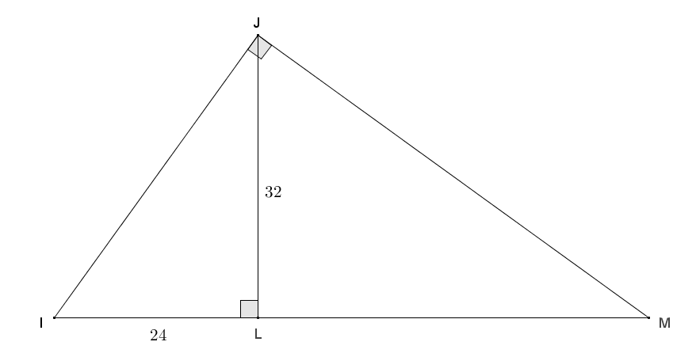
- Given triangle $IMJ$ with altitude $\overline{JL}$, $JL=32$, and $IL=24$, find $IJ$, $JM$, $LM$, and $IM$.

Altitude $\overline{JL}$ cuts $△IMJ$ into two similar sub-triangles such that $△IMJ\sim △JML\sim △IJL$.
By the Pythagorean theorem:
$$24^{2}+32^{2}=IJ^{2} \\ 576+1024=IJ^{2} \\ 1600=IJ^{2} \\ \sqrt{1600}=IJ \\ 40=IJ$$

Using the ratio $shorter leg:longer leg$:  $$\frac{24}{32}=\frac{40}{JM} \\ 24\left(JM\right)=1280 \\ JM=\frac{1280}{24} \\ JM=53\frac{1}{3}$$ | Using the ratio $shorter leg:hypotenuse$:  $$\frac{24}{40}=\frac{40}{IM} \\ 24\left(IM\right)=1600 \\ IM=\frac{1600}{24} \\ IM=66\frac{2}{3}$$ | Using addition:  $$IL+LM=IM \\ 24+LM=66\frac{2}{3} \\ LM=42\frac{2}{3}$$

- Given right triangle $RST$ with altitude $\overline{RU}$ to its hypotenuse, $TU=1\frac{24}{25}$, and $RU=6\frac{18}{25}$, find the lengths of the sides of $△RST$.
Altitude $\overline{RU}$ cuts $△RST$ into similar sub-triangles, $△URT\sim △USR$.
Using the Pythagorean theorem:  $$TU^{2}+RU^{2}=TR^{2} \\ {\left(1\frac{24}{25}\right)}^{2}+{\left(6\frac{18}{25}\right)}^{2}=TR^{2} \\ {\left(\frac{49}{25}\right)}^{2}+{\left(\frac{168}{25}\right)}^{2}=TR^{2} \\ \frac{2401}{625}+\frac{28224}{625}=TR^{2} \\ \frac{30625}{625}=TR^{2} \\ 49=TR^{2} \\ \sqrt{49}=7=TR$$ | Using the ratio $shorter leg:hypotenuse$:  $$\frac{\frac{49}{25}}{7}=\frac{7}{ST} \\ \frac{49}{25}\left(ST\right)=49 \\ ST=25$$
Using the Pythagorean theorem:
$$RS^{2}+RT^{2}=ST^{2} \\ RS^{2}+7^{2}=25^{2} \\ RS^{2}+49=625 \\ RS^{2}=576 \\ RS=\sqrt{576}=24$$

Note to the teacher: The next problem involves radical values that students have used previously; however, rationalizing is a focus of Lessons 23 and 24, so the solutions provided in this problem involve non-rationalized values.

- Given right triangle $ABC$ with altitude $\overline{CD}$, find $AD$, $BD$, $AB$, and $DC$.
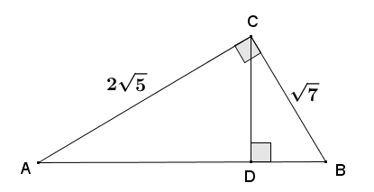

Using the Pythagorean theorem:
$${\left(2\sqrt{5}\right)}^{2}+{\left(\sqrt{7}\right)}^{2}=AB^{2} \\ 20+7=AB^{2} \\ 27=AB^{2} \\ \sqrt{27}=AB \\ 3\sqrt{3}=AB$$
An altitude from the right angle in a right triangle to the hypotenuse cuts the triangle into two similar right triangles: $△ABC\sim △ACD\sim △CBD$.
Using the ratio $shorter leg:hypotenuse$:
$$\frac{\sqrt{7}}{3\sqrt{3}}=\frac{DC}{2\sqrt{5}} \\ 2\sqrt{35}=DC\left(3\sqrt{3}\right) \\ \frac{2\sqrt{35}}{3\sqrt{3}}=DC$$ | $$\frac{\sqrt{7}}{3\sqrt{3}}=\frac{DB}{\sqrt{7}} \\ 7=DB\left(3\sqrt{3}\right) \\ \frac{7}{3\sqrt{3}}=DB$$
Using the Pythagorean Theorem:
$$AD^{2}+DC^{2}=AC^{2} \\ AD^{2}+{\left(\frac{2\sqrt{35}}{3\sqrt{3}}\right)}^{2}={\left(2\sqrt{5}\right)}^{2} \\ AD^{2}+\frac{4⋅35}{9⋅3}=(4⋅5) \\ AD^{2}+\frac{140}{27}=20 \\ AD^{2}=14\frac{22}{27} \\ AD=\sqrt{14\frac{22}{27}}$$
- Right triangle $DEC$ is inscribed in a circle with radius $AC=5$. $\overline{DC}$ is a diameter of the circle, $EF$ is an altitude of $△DEC$, and $DE=6$. Find the lengths $x$ and $y$.
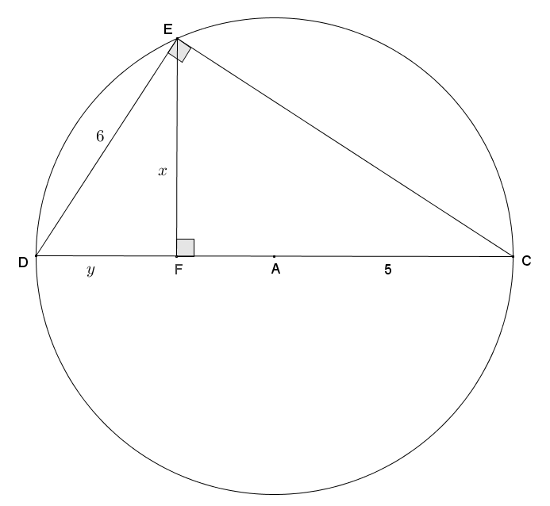
The radius of the circle is $5,$ and $DC=2\left(5\right)=10$.
By the Pythagorean theorem:
$$6^{2}+EC^{2}=10^{2} \\ 36+{EC}^{2}=100 \\ {EC}^{2}=64 \\ EC=8$$
($EC=-8$ is also a solution; however, since $EC$ represents a distance, its value must be positive, so the solution $EC=-8$ is disregarded.)
We showed that an altitude from the right angle of a right triangle to the hypotenuse cuts the triangle into two similar sub-triangles, so
$$△DEC\sim △DFE\sim △EFC.$$
Using the ratio $shorter leg:hypotenuse$ for similar right triangles:
$$\frac{6}{10}=\frac{y}{6} \\ 36=10y \\ 3.6=y$$ | $$\frac{6}{10}=\frac{x}{8} \\ 48=10x \\ 4.8=x$$

- In right triangle $ABD$, $AB=53$, and altitude $DC=14$. Find the lengths of $BC$ and $AC$.
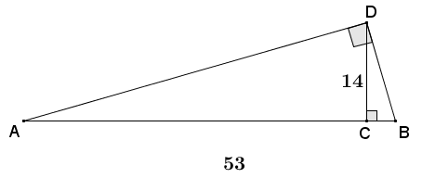
Let the length $BC=x$, then $AC=53-x$.
Using the pattern from Problem 1,
$$14^{2}=x(53-x) \\ 196=53x-x^{2} \\ x^{2}-53x+196=0 \\ \left(x-49\right)\left(x-4\right)=0 \\ x=49 \text{or} x=4.$$
Using the solutions from the equation and the given information, either $BC=4$ and $AC=49$, or $BC=49$ and $AC=4$.

