Lesson 21: Special Relationships Within Right Triangles—Dividing into Two Similar Sub-Triangles

Classwork
Opening Exercise
Use the diagram below to complete parts (a)–(c).
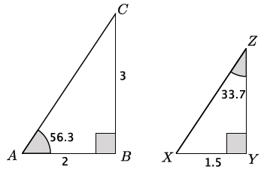

  - Are the triangles shown above similar? Explain.

  - Determine the unknown lengths of the triangles.

  - Explain how you found the lengths in part (a).

Example 1
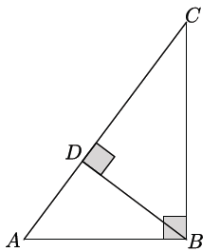
Recall that an altitude of a triangle is a perpendicular line segment from a vertex to the line determined by the opposite side. In triangle $△ABC$ below, $\overline{BD}$ is the altitude from vertex $B$ to the line containing $\overline{AC}.$
How many triangles do you see in the figure?

Identify the three triangles by name.
Note that there are many ways to name the three triangles. Ensure that the names students give show corresponding angles.

We want to consider the altitude of a right triangle from the right angle to the hypotenuse. The altitude of a right triangle splits the triangle into two right triangles, each of which shares a common acute angle with the original triangle. In $△ABC,$ the altitude $\overline{BD}$ divides the right triangle into two sub-triangles, $△BDC$ and $△ADB.$
Is $△ABC\sim △BDC$? Is $△ABC\sim △ADB$? Explain.

Is $△ABC\sim △DBC$? Explain.

Since $△ABC \sim △BDC$ and $△ABC\sim △ADB,$ can we conclude that $△BDC\sim △ADB$? Explain.

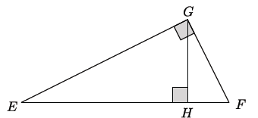
Identify the altitude drawn in triangle $△EFG.$

As before, the altitude divides the triangle into three triangles. Identify them by name so that the corresponding angles match up.

Does the altitude divide$△EFG$ into three similar sub-triangles as the altitude did with $△ABC?$

The fact that the altitude drawn from the right angle of a right triangle divides the triangle into two similar sub-triangles which are also similar to the original triangle allows us to determine the unknown lengths of right triangles.
Example 2
Consider the right triangle $△ABC$ below.

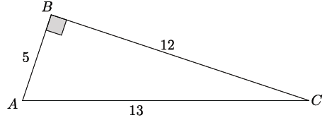

Draw the altitude $\overline{BD}$ from vertex $B$ to the line containing $\overline{AC}.$ Label the segment $\overline{AD}$as $x$, the segment $\overline{DC}$ as $y$, and the segment $\overline{BD}$ as $z.$

Find the values of $x, y,$ and $z.$

Now we will look at a different strategy for determining the lengths of $x, y,$ and $z.$ The strategy requires that we complete a table of ratios that compares different parts of each triangle.

Make a table of ratios for each triangle that relates the sides listed in the column headers.
 | $$shorter leg:hypotenuse$$ | $$longer leg:hypotenuse$$ | $$shorter leg:longer leg$$
$$△ABC$$
$$△ADB$$
$$△CDB$$
Our work in Example 1 showed us that $△ABC\sim △ADB\sim △CDB$. Since the triangles are similar, the ratios of their corresponding sides will be equal. For example, we can find the length of $x$ by equating the values of $shorter leg:hypotenuse$ ratios of triangles $△ABC$ and $△ADB.$
$$\frac{x}{5}=\frac{5}{13} \\ 13x=25 \\ x=\frac{25}{13}=1\frac{12}{13}$$
Why can we use these ratios to determine the length of $x$?

Which ratios can we use to determine the length of $y$?

Use ratios to determine the length of $z.$

Since corresponding ratios within similar triangles are equal, we can solve for any unknown side length by equating the values of the corresponding ratios. In the coming lessons, we will learn about more useful ratios for determining unknown side lengths of right triangles.
Problem Set

- Use similar triangles to find the length of the altitudes labeled with variables in each triangle below.
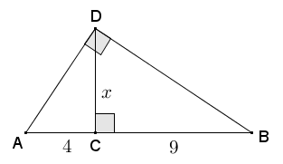
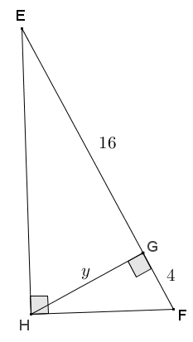
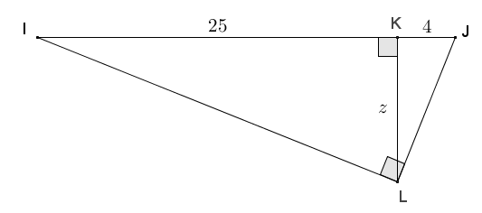

  - Describe the pattern that you see in your calculations for parts (a) through (c).

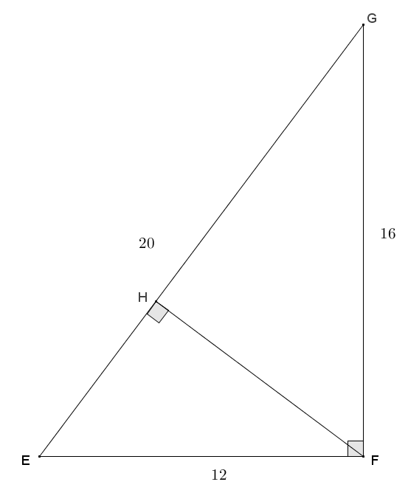
- Given right triangle $EFG$ with altitude $\overline{FH}$ drawn to the hypotenuse, find the lengths of $EH$, $FH$, and $GH$.

- Given triangle $IMJ$ with altitude $\overline{JL}$, $JL=32$, and $IL=24$, find $IJ$, $JM$, $LM$, and $IM$.
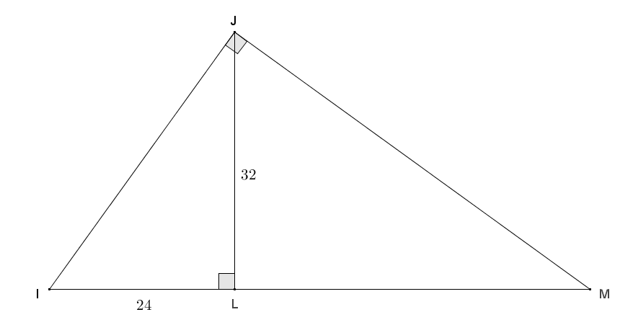

- Given right triangle $RST$ with altitude $\overline{RU}$ to its hypotenuse, $TU=1\frac{24}{25}$, and $RU=6\frac{18}{25}$, find the lengths of the sides of $△RST$.

- Given right triangle $ABC$ with altitude $\overline{CD}$, find $AD$, $BD$, $AB$, and $DC$.
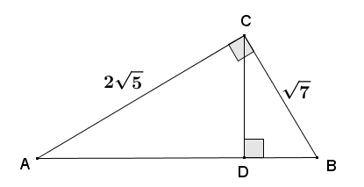

- Right triangle $DEC$ is inscribed in a circle with radius $AC=5$. $\overline{DC}$ is a diameter of the circle, $EF$ is an altitude of $△DEC$, and $DE=6$. Find the lengths $x$ and $y$.
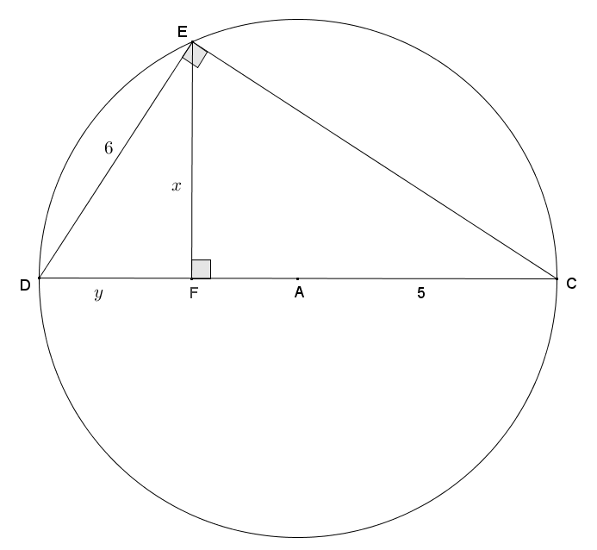

- In right triangle $ABD$, $AB=53$, and altitude $DC=14$. Find the lengths of $BC$ and $AC$.
