|  |
| --- |
|  |

Lesson 19: Families of Parallel Lines and the Circumference of the Earth

Student Outcomes

* Students understand that parallel lines cut transversals into proportional segments. They use ratios between corresponding line segments in different transversals and ratios within line segments on the same transversal.
* Students understand Eratosthenes’ method for measuring the Earth and solve related problems.

Lesson Notes

Students revisit their study of side splitters and the triangle side splitter theorem to understand how parallel lines cut transversals into proportional segments. The theorem is a natural consequence of side splitters; allow students the opportunity to make as many connections of their own while guiding them forward. The second half of the lesson is teacher-led and describes Eratosthenes’ calculation of the Earth’s circumference. The segment lays the foundation for Lesson 20, where students study another application of geometry by the ancient Greeks.

Classwork

Opening (7 minutes)

* Consider below with side splitter .



* Recall we say line segment splits sides and proportionally if or equivalently .
* Using as the lengths of the indicated segments, how can we rewrite ? Simplify as much as possible.
  + *is the same as* .

**MP.7**

* Thus another way to say that segment splits the sides proportionally is to say that the ratios and . are equal.

As scaffolding, consider reviewing a parallel example with numerical values:

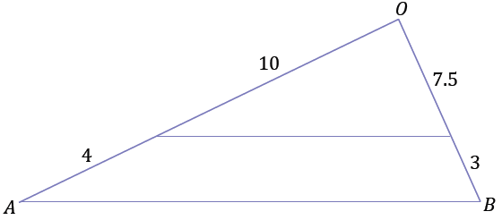

Opening Exercise (4 minutes)

Suggest students use the numerical example from the Opening to help them with the Opening Exercise.

Opening Exercise

Show is equivalent to .

**Discussion (10 minutes)**

Lead students through a discussion to prove that parallel lines cut transversals into proportional segments.

* We will use our understanding of side splitters to prove the following theorem.
* **Theorem**: Parallel lines cut transversals into proportional segments. If parallel lines are intersected by two transversals, then the ratios of the segments determined along each transversal between the parallel lines are equal.
* Draw three parallel lines that are cut by two transversals. Label the following lengths of the line segments as , , , and .



* To prove the theorem, we must show that . Why would this be enough to show that the ratios of the segments along each transversal between the parallel lines are equal?
  + *This would be enough because the relationship implies that .*
* Draw a segment so that two triangles are formed between the parallel lines and between the transversals.



* Label each portion of the segment separated by a pair of parallel lines as and .
* Are there any conclusions we can draw based on the diagram?
  + *We can apply the triangle side splitter theorem twice to see that and .*
  + *So,* *and* . *Thus,* .
* Therefore, we have proved the theorem: Parallel lines cut transversals into proportional segments.
* Notice that the two equations and are equivalent as described above.

Exercises 1–2 (4 minutes)

Students apply their understanding that parallel lines cut transversals into proportional segments to determine the unknown length in each problem.

Exercises 1–2

Lines that appear to be parallel are in fact parallel.

1. 
2. 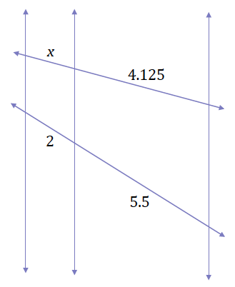

Discussion (13 minutes)

* The word geometry is Greek for geos (earth) and metron (measure). A Greek named Eratosthenes, who lived over years ago, used geometry to measure the circumference of the earth. The Greeks knew the earth was a sphere. They also knew the sun was so far away that rays from the sun (as they met Earth) were, for all practical purposes, parallel to each other. Using these two facts, here is how Eratosthenes calculated the circumference of the earth.
* Eratosthenes lived in Egypt. He calculated the circumference of the earth without ever leaving Egypt. Every summer solstice in the city of Syene, the sun was directly overhead at noon. Eratosthenes knew this because at noon on that day alone, the sun would reflect directly (perpendicularly) off the bottom of a deep well.
* On the same day at noon in Alexandria, a city north of Syene, the angle between a perpendicular to the ground and the rays of the sun was about . We do not have a record of how Eratosthenes found this measurement, but here is one possible explanation.
* Imagine a pole perpendicular to the ground (in Alexandria), as well as its shadow. With a tool such as a protractor, the shadow can be used to determine the measurement of the angle between the ray and the pole, regardless of the height of the pole.
* You might argue that we cannot theorize such a method because we do not know the height of the pole. However, because of the angle the rays make with the ground and the angle of the pole with the ground, the triangle formed by the ray, the pole, and the shadow are all similar triangles, regardless of the height of the pole. Why must the triangles all be similar?
  + *The situation satisfies the AA criterion; therefore, the triangles must be similar.*

Remind students that the discussion points here are similar to the work done in Lesson 16 on indirect measurement.

* Therefore, if the pole had a height of meters, the shadow had a length of meters, or if the pole had a height of meter, the shadow had a length of meters.

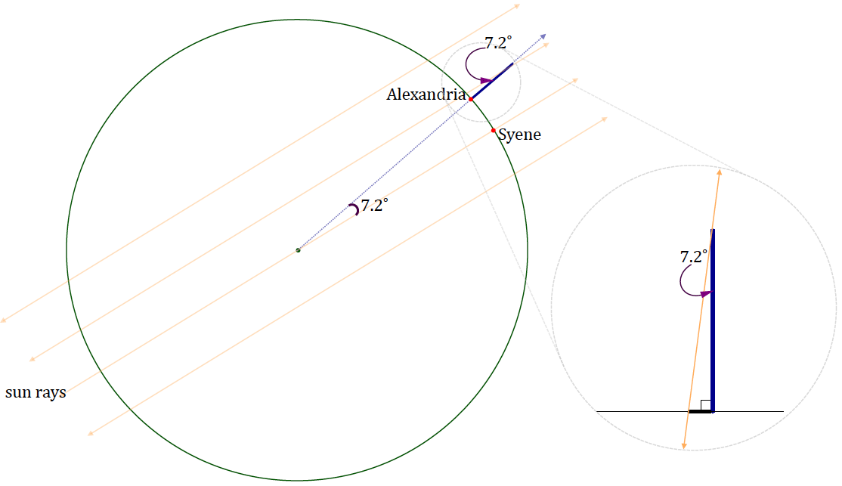

* This measurement of the angle between the sun’s ray and the pole was instrumental to the calculation of the circumference. Eratosthenes used it to calculate the angle between the two cities from the center of the earth.
* You might think it necessary to go to the center of the earth to determine this measurement, but it is not. Eratosthenes extrapolated both the sun’s rays and the ray perpendicular to the ground in Alexandria. Notice that the perpendicular at Alexandria acts as a transversal to the parallel rays of the sun, namely the sun ray that passes through Syene and the center of the earth, and the sun ray that forms the triangle with the top of the pole and the shadow of the pole. Using the alternate interior angles determined by the transversal (the extrapolated pole) that intersects the parallel lines (extrapolated sun rays), Eratosthenes found the angle between the two cities to be .
* How can this measurement be critical to finding the entire circumference?
  + *We can divide into , which gives us a fraction of the circumference, or how many times we have to multiply the distance between Alexandria to Syene to get the whole circumference.*
* Eratosthenes divided by , which yielded . So the distance from Syene to Alexandria is of the circumference of the earth. The only thing that is missing is that distance between Syene and Alexandria, which was known to be about stades; the stade was a Greek unit of measurement and stade feet.
* So Eratosthenes’ estimate was about feet, or about miles. A modern day estimate for the circumference of the earth at the equator is about miles.
* It is remarkable that around B.C., basic geometry helped determine a very close approximation of the circumference of the earth.

Closing (2 minutes)

* Explain how parallel lines cut transversals into proportional segments in your own words.
* What are some assumptions that Eratosthenes must have made as part of his calculation?
  + *The rays of the sun are all parallel.*
  + *The earth is perfectly spherical.*

Share the following link to [a video on Eratosthenes and his calculation of Earth’s circumference](http://www.youtube.com/watch?v=wnElDaV4esg&feature=youtu.be). (The same video was used in Module 1, Lesson 11.)

Exit Ticket (5 minutes)

Name Date Lesson 19: Families of Parallel Lines and the Circumference of the Earth

Exit Ticket

1. Given the diagram to the right, , , , and , find .

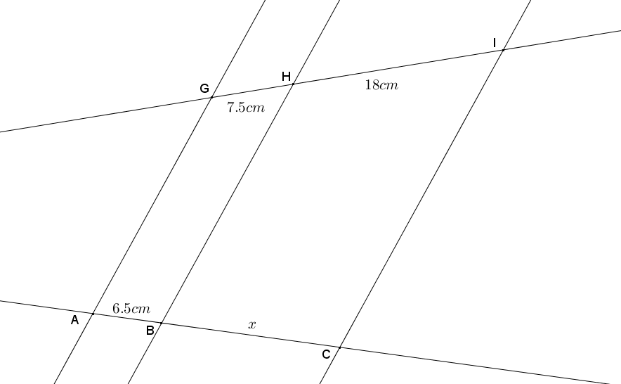

1. Martin the Martian lives on Planet Mart. Martin wants to know the circumference of Planet Mart, but it is too large to measure directly. He uses the same method as Eratosthenes by measuring the angle of the sun’s rays in two locations. The sun shines on a flag pole in Martinsburg, but there is no shadow. At the same time the sun shines on a flag pole in Martville, and a shadow forms a angle with the pole. The distance from Martville to Martinsburg is miles. What is the circumference of Planet Mart?

Exit Ticket Sample Solutions

1. Given the diagram to the right, , , , and , find .



Parallel lines cut transversals proportionally; therefore, , and thus,

*The length of is* .

1. Martin the Martian lives on Planet Mart. Martin wants to know the circumference of Planet Mart, but it is too large to measure directly. He uses the same method as Eratosthenes by measuring the angle of the sun’s rays in two locations. The sun shines on a flag pole in Martinsburg, but there is no shadow. At the same time the sun shines on a flag pole in Martville, and a shadow forms a angle with the pole. The distance from Martville to Martinsburg is miles. What is the circumference of Planet Mart?

The distance from Martinsburg to Martville makes up only of the total rotation about the planet. There are in the complete circumference of the planet, and , so milesmiles.

The circumference of planet Mart is miles.

Problem Set Sample Solutions

1. Given the diagram shown, , and . Use the additional information given in each part below to answer the questions:

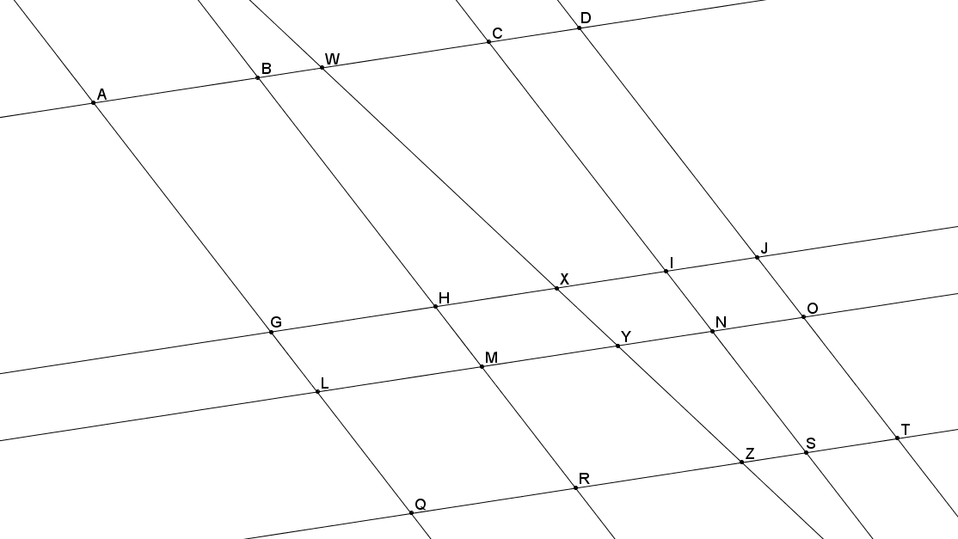

* 1. If , what is ?

forms a parallelogram since opposite sides are parallel, and opposite sides of a parallelogram are equal in length; therefore, .

* 1. If , , and , what is ?

Parallel lines cut transversals proportionally; therefore, it is true that , and likewise .

* 1. Using information from part (b), if , what is ?

By the same argument as in part (a), . Parallel lines cut transversals proportionally; therefore, it is true that , and likewise .

1. Use your knowledge about families of parallel lines to find the coordinates of point on the coordinate plane below.

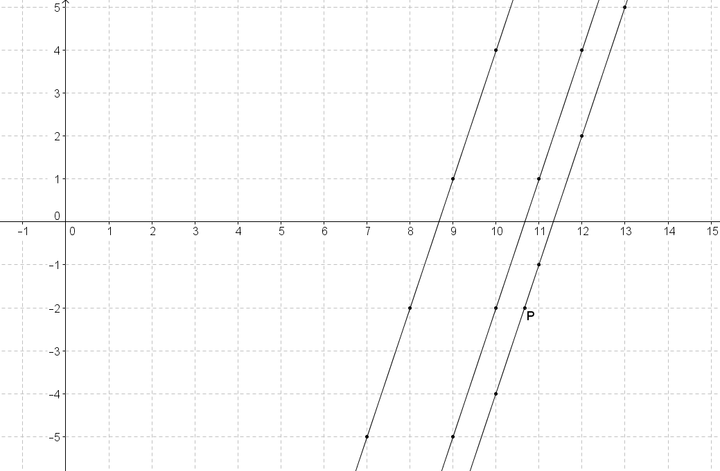

The given lines on the coordinate plane are parallel because they have the same slope . First draw a horizontal transversal through points and , and a second transversal through points and . The transversals intersect at . Parallel lines cut transversals proportionally, so using horizontal and vertical distances, , where represents the distance from point to .

Point is units more than , or , so the coordinates of point are .

1. and are both trapezoids with bases , , and . The perimeter of trapezoid is . If the ratio of is , , and , find , , and .

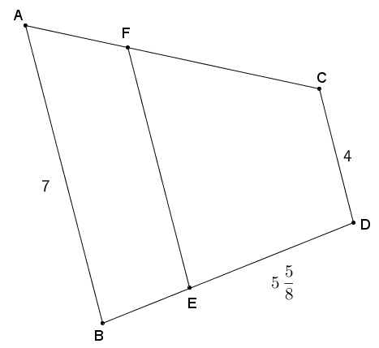

The bases of a trapezoid are parallel and since serves as a base for both trapezoids; it follows that , , and are parallel line segments. Parallel lines cut transversals proportionally, so it must be true that .

By the given information, , it follows that . Also, , so .

**, and by the given ratio, , so .**

By substituting for ,

1. Given the diagram and the ratio of is , answer each question below:

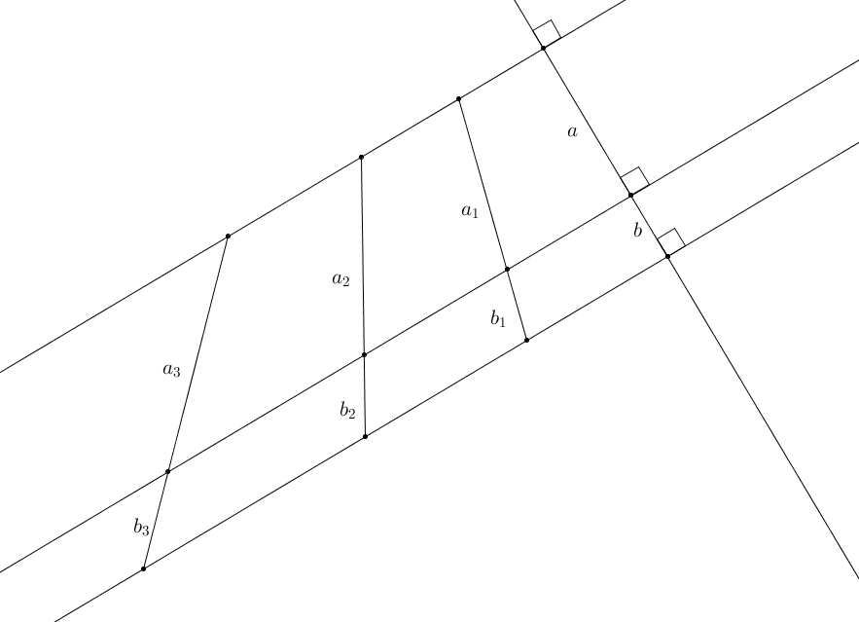

* 1. Write an equation for in terms of .

* 1. Write an equation for in terms of .

* 1. Use one of your equations to find in terms of if .

* 1. What is the relationship between and ?

Using the equation from parts (a) and (c), , so ; thus .

* 1. What constant, , relates and ? Is this surprising? Why or why not?

The constant relating and is the same constant relating to , .

* 1. Using the formula , find in terms of .

* 1. Using the formula , find in terms of .

* 1. Use your answers from parts (f) and (g) to calculate the value of the ratio of ?

1. Julius wants to try to estimate the circumference of the earth based on measurements made near his home. He cannot find a location near his home where the sun is straight overhead. Will he be able to calculate the circumference of the earth? If so, explain and draw a diagram to support your claim.

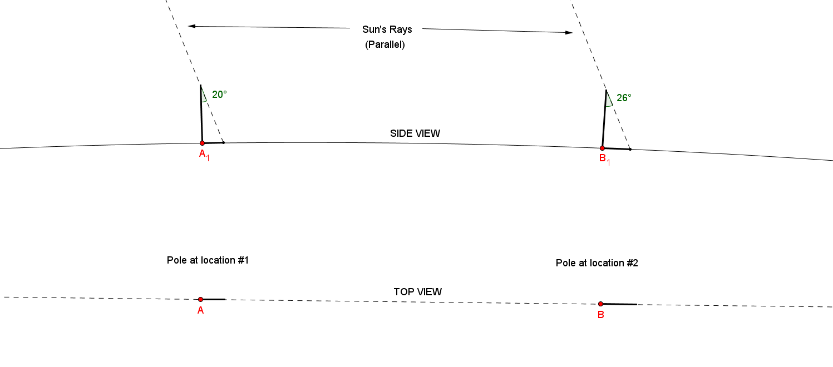Note to the teacher: This problem is very open ended, requires critical thinking, and may not be suitable for all students. You may scaffold this problem by providing a diagram with possible measurements that Julius made based on the description in the student solution below.

Possible solution: If Julius can find two locations such that those locations and their shadows lie in the same straight path, then the difference of the shadows’ angles can be used as part of the in the earth’s circumference. The distance between those two locations corresponds with that difference of angles.