Lesson 19: Families of Parallel Lines and the Circumference of the Earth

Classwork

Opening Exercise

Show is equivalent to .

Exercises 1–2

Lines that appear to be parallel are in fact parallel.

1. 
2. 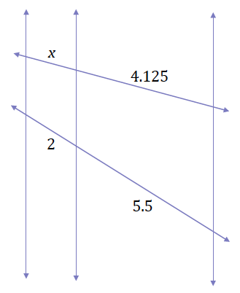

Problem Set

1. Given the diagram shown, , and . Use the additional information given in each part below to answer the questions:

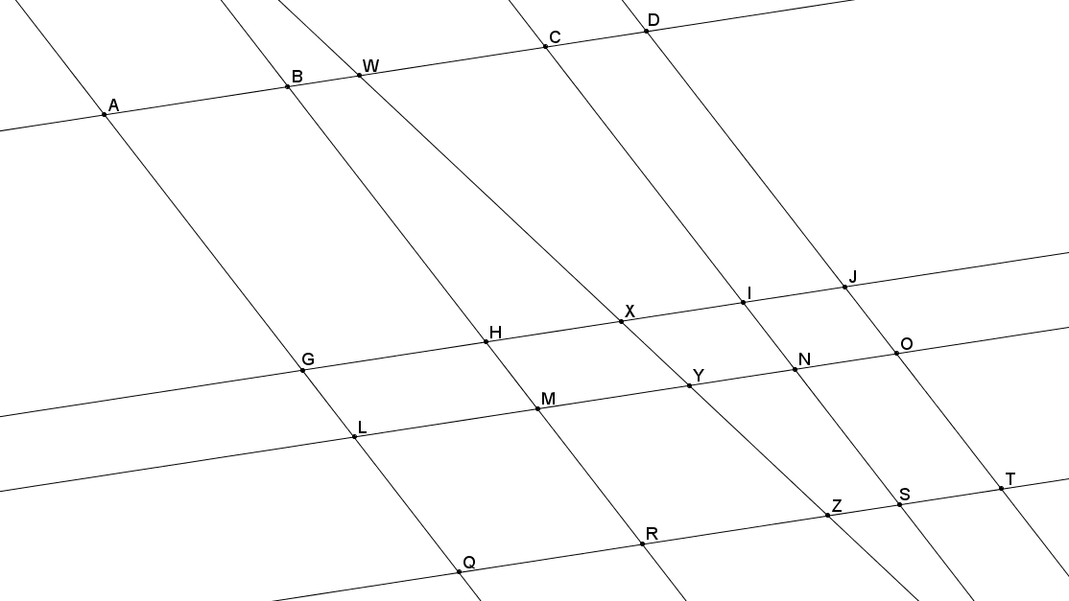

* 1. If , what is ?
  2. If , , and , what is ?
  3. Using information from part (b), if , what is ?

1. Use your knowledge about families of parallel lines to find the coordinates of point on the coordinate plane below.

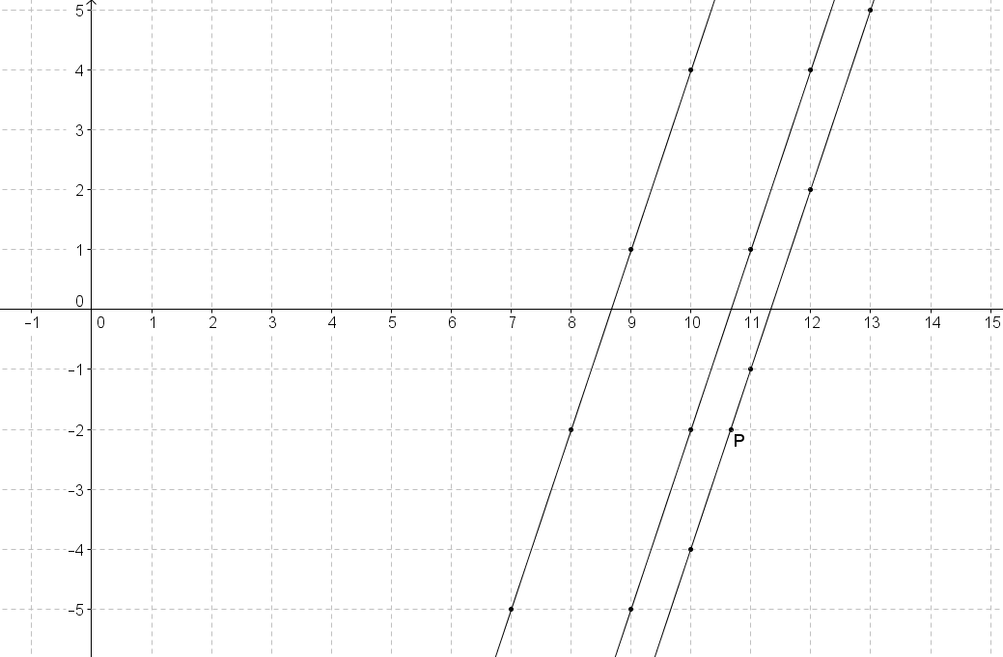

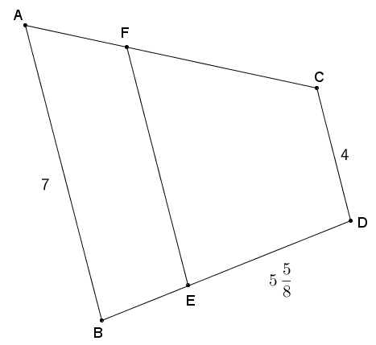

1. and are both trapezoids with bases , , and . The perimeter of trapezoid is . If the ratio of is , and , find , , and .
2. Given the diagram and the ratio of is , answer each question below.

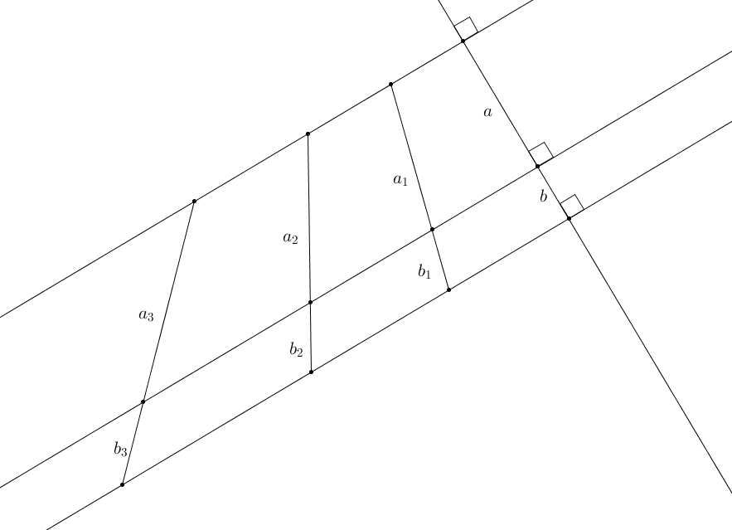

* 1. Write an equation for in terms of .
  2. Write an equation for in terms of .
  3. Use one of your equations to find in terms of if .
  4. What is the relationship between and ?
  5. What constant, , relates and ? Is this surprising? Why or why not?
  6. Using the formula , find in terms of .
  7. Using the formula , find in terms of .
  8. Use your answers from parts (f) and (g) to calculate the value of the ratio of ?

1. Julius wants to try to estimate the circumference of the earth based on measurements made near his home. He cannot find a location near his home where the sun is straight overhead. Will he be able to calculate the circumference of the earth? If so, explain and draw a diagram to support your claim.