Lesson 18: Similarity and the Angle Bisector Theorem

Student Outcomes
- Students state, understand, and prove the angle bisector theorem.
- Students use the angle bisector theorem to solve problems.

Classwork
Opening Exercise (5 minutes)
The Opening Exercise should activate students’ prior knowledge acquired in Module 1 that will be helpful in proving the angle bisector theorem.
Scaffolding:
- If necessary, provide visuals to accompany these questions.
- For part (a):
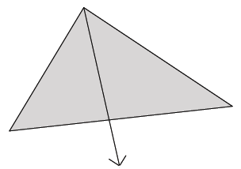
- For part (b):
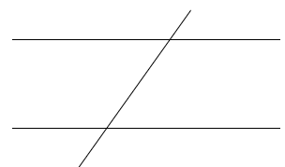
- For part (c):
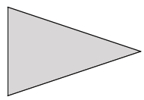
Opening Exercise
  - What is an angle bisector?
The bisector of an angle is a ray in the interior of the angle such that the two adjacent angles formed by it have equal measures.

  - Describe the angle relationships formed when parallel lines are cut by a transversal.
When parallel lines are cut by a transversal, corresponding angles are congruent, alternate interior angles are congruent, and alternate exterior angles are congruent.

  - What are the properties of an isosceles triangle?
An isosceles triangle has at least two congruent sides and its base angles are also congruent.

Discussion (20 minutes)
Prior to proving the angle bisector theorem, students observe the length relationships of the sides of a triangle when one of the angles of the triangle has been bisected.
- In this lesson, we will investigate the length relationships of the sides of a triangle when one angle of the triangle has been bisected.
Provide students time to look for relationships between the side lengths. This will require trial and error on the part of the student and may take several minutes.

Discussion
MP.7
In the diagram below, the angle bisector of $∠A$ in $△ABC$ meets side $BC$ at point $D$. Does the angle bisector create any observable relationships with respect to the side lengths of the triangle?
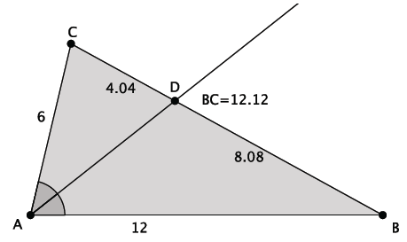

Acknowledge any relationships students may find, but highlight the relationship $BD:CD=BA:CA.$ Then continue the discussion below that proves this relationship.

- The following theorem generalizes our observation:
Theorem: The angle bisector theorem: In $△ABC,$ if the angle bisector of $∠A$ meets side $BC$ at point $D$, then $BD:CD=BA:CA.$
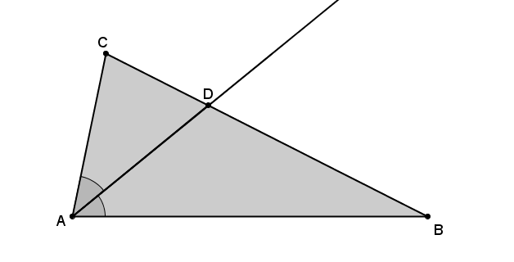
In words, the bisector of an angle of a triangle splits the opposite side into segments that have the same ratio as the adjacent sides.

- Our goal now is to prove this relationship for all triangles. We begin by constructing a line through vertex $C$ that is parallel to side $AB.$ Let $E$ be the point where this parallel line meets the angle bisector, as shown.
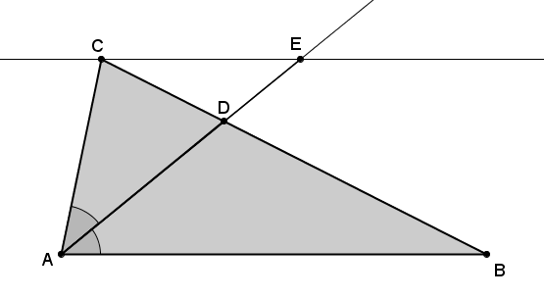
Scaffolding:
In place of the formal proof, students may construct angle bisectors for a series of triangles and take measurements to verify the relationship inductively.
If we can show that $△ABD\sim △ECD$, then we can use what we know about similar triangles to prove the relationship $BD:CD=BA:CA.$
Consider asking students why it is that if we can show$△ABD \sim △ECD,$ we will be closer to our goal of showing $BD:CD=BA:CA.$ Students should respond that similar triangles have proportional length relationships. The triangles $△ABD$ and $△ECD$, if shown similar, would give us $BD:BA=CD:CE$, three out of the four lengths needed in the ratio $BD:CD=BA:CA.$
- How can we show that $△ABD \sim △ECD$?
Provide students time to discuss how to show that the triangles are similar. Elicit student responses; then continue with the discussion below.
- It is true that $△ABD \sim △ECD$ by the AA criterion for similarity. Vertical angles $∠ADB$ and $∠EDC$ are congruent and, therefore, equal. Angles $∠DEC$ and $∠BAD$ are congruent and equal because they are alternate interior angles of parallel lines cut by a transversal. (Show diagram below.)
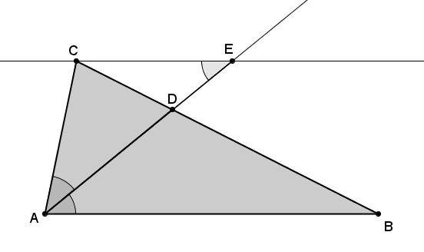
- Since the triangles are similar, we know that $BD:CD=BA:CE.$ This is very close to what we are trying to show, $BD:CD=BA:CA.$ What must we do now to prove the theorem?
  - We have to show that $CE=CA.$
Once students have identified what needs to be done, i.e, show that $CE=CA$, provide them time to discuss how to show it. The prompts below can be used to guide students’ thinking.
- We need to show that $CE=CA.$ Notice that the segments $CE$ and $CA$ are two sides of the triangle $△ACE.$ How might that be useful?
  - If we could show that $△ACE$ is an isosceles triangle, then we would know that $CE=CA.$
- How can we show that $△ACE$ is an isosceles triangle?
  - We were first given that angle $A$ was bisected by $\overline{AD}$, which means that $∠BAD≅∠CAD$. Then by alt.int. $∠'s$, $\overline{CE}∥\overline{AB}$, it follows that $∠CAD=∠CEA$. We can use the converse of the base angles of isosceles triangle theorem, i.e., base $∠$’s converse. Since $∠CAE=∠CEA$, then triangle $△ACE$ must be an isosceles triangle.
- Now that we know $△ACE$ is isosceles, then we can conclude that $CE=CA$ and finish the proof of the angle bisector theorem. All we must do now is substitute $CA$ for $CE$ in$BD:CD=BA:CE.$ Therefore, $BD:CD=BA:CA$ and the theorem is proved.
Consider asking students to restate what was just proved and summarize the steps of the proof. Students should respond that the bisector of an angle of a triangle splits the opposite side into segments that have the same ratio as the adjacent sides.

Exercises 1–4 (10 minutes)
Students complete Exercises 1–4 independently.
Exercises 1–4
- The sides of a triangle are $8$,$12$, and $15$. An angle bisector meets the side of length $15$. Find the lengths $x$ and $y$. Explain how you arrived at your answers.
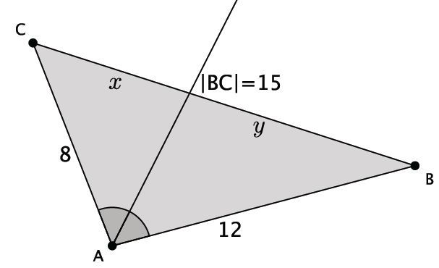
$$\frac{y}{x}=\frac{12}{8} \\ x=15-y \\ 8y=12x$$  $$8y=12(15-y) \\ 8y=180-12y \\ 20y=180 \\ y=9$$ | $$x=15-9 \\ x=6$$
The length $x$ is $6$ and the length $y$ is $9$.
Since I know that $∠A$ is bisected, I applied what I knew about the angle bisector theorem to determine the lengths $x$ and $y$. Specifically, the angle bisector cuts the side that is opposite the bisected angle so that $y:x=12:8$. I set up an equation using the values of the ratios, which could be solved once I rewrote one of the variables $x$ or $y$. I rewrote $x$ as $15-y$, and then solved for $y.$ Once I had a value for $y,$ I could replace it in the equation $x=15-y$ to determine the value of $x$.

- The sides of a triangle are $8$, $12$, and $15$. An angle bisector meets the side of length $12$. Find the lengths $x$ and $y$.
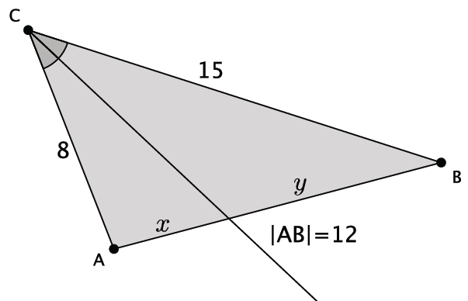
$$y=12-x \\ \frac{x}{12-x}=\frac{8}{15} \\ 15x=8(12-x) \\ 15x=96-8x \\ 23x=96 \\ x=\frac{96}{23}=4\frac{4}{23}$$ | $$y=12-4\frac{4}{23} \\ y=7\frac{19}{23}$$
The length of $x$ is $4\frac{4}{23}$, and the length of $y$ is $7\frac{19}{23}$.

- The sides of a triangle are $8$,$12$, and $15$. An angle bisector meets the side of length $8.$ Find the lengths $x$ and $y$.
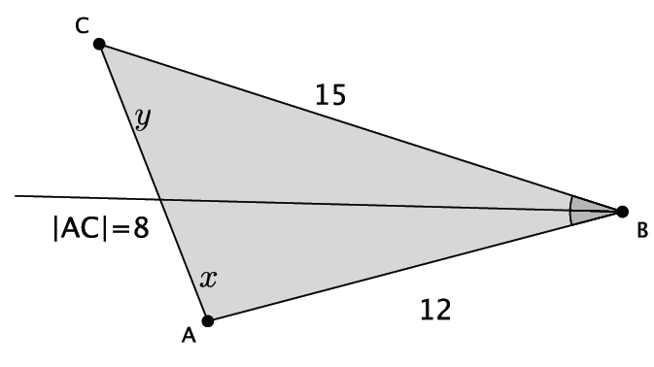
$$\frac{y}{x}=\frac{15}{12} \\ y=8-x \\ 15x=12y$$  $$15x=12\left(8-x\right)$$  $$15x=96-12x \\ 27x=96 \\ x=\frac{96}{27}=3\frac{15}{27}=3\frac{5}{9}$$ | $$y=8-3\frac{5}{9} \\ y=4\frac{4}{9}$$
The length of $x$ is $3\frac{5}{9}$, and the length of $y$ is $4\frac{4}{9}$.

- The angle bisector of an angle splits the opposite side of a triangle into lengths $5$ and $6$. The perimeter of the triangle is $33$. Find the lengths of the other two sides.
Let $z$ be the scale factor of a similarity. By the angle bisector theorem, the side of the triangle adjacent to the segment of length $5$ has length of $5z$, and the side of the triangle adjacent to the segment of length $6$ has length of $6z$. The sum of the sides is equal to the perimeter.
$$5+6+5z+6z=33$$
$$11+11z=33$$
$$11z=22$$
$$z=2$$
$5\left(2\right)=10$ and $6\left(2\right)=12$. The lengths of the other two sides are $10$ and $12$.

Closing (5 minutes)
- Explain the angle bisector theorem in your own words.
- Explain how knowing that one of the angles of a triangle has been bisected allows you to determine unknown side lengths of a triangle.

Exit Ticket (5 minutes)

Name Date
Lesson 18: Similarity and the Angle Bisector Theorem

Exit Ticket

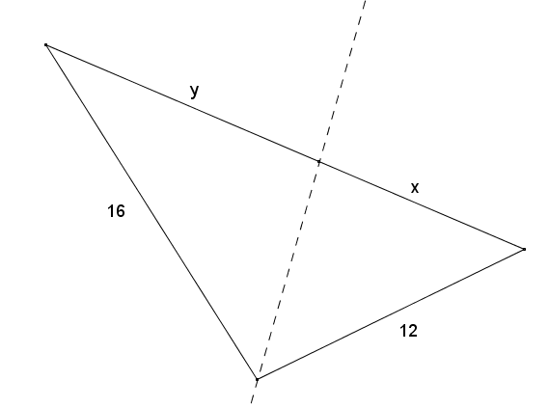
- The sides of a triangle have lengths of $12$,$16$, and $21.$ An angle bisector meets the side of length $21$. Find the lengths $x$ and $y$.

- The perimeter of $∆UVW$ is $22\frac{1}{2}$. $\vec{WZ}$ bisects $∠UWV$, $UZ=2,$ and $VZ=2\frac{1}{2}$. Find $UW$ and $VW$.
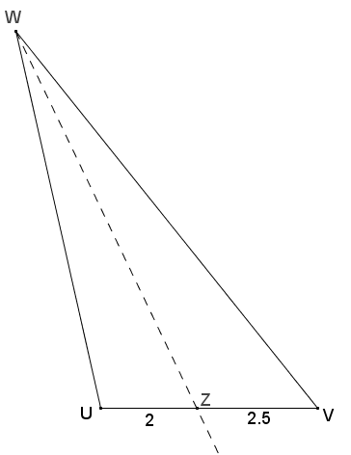
Exit Ticket Sample Solutions

- The sides of a triangle are $12, 16,$ and $21.$ An angle bisector meets the side of length $21.$ Find the lengths $x$ and $y$.
By the angle bisector theorem, $\frac{y}{x}=\frac{16}{12}$, and $y=21-x$, so
$$\frac{21-x}{x}=\frac{16}{12} \\ 12\left(21-x\right)=16x \\ 252-12x=16x \\ 252=28x \\ 9=x$$ | $$y=21-x \\ y=21-9 \\ y=12$$

- The perimeter of $∆UVW$ is $22\frac{1}{2}$. $\vec{WZ}$bisects $∠UWV$, $UZ=2$, and $VZ=2\frac{1}{2}$. Find $UW$ and $VW$.
By the angle bisector theorem, $\frac{2}{2.5}=\frac{UW}{VW}$, so $UW=2x$ and $VW=2.5x$ for some positive number $x$. The perimeter of the triangle is $22\frac{1}{2}$, so
$$2+2.5+2x+2.5x=22.5 \\ 4.5+4.5x=22.5 \\ 4.5x=18 \\ x=4$$
$$UW=2x=2\left(4\right)=8 \\ VW=2.5x=2.5\left(4\right)=10$$

Problem Set Sample Solutions

- The sides of a triangle have lengths of $5, 8,$ and $6\frac{1}{2}.$ An angle bisector meets the side of length $6\frac{1}{2}.$ Find the lengths $x$ and $y$.
Using the Angle Bisector Theorem, $\frac{x}{y}=\frac{5}{8}$, and $y=6\frac{1}{2}-x$, so
$$\frac{x}{6\frac{1}{2}-x}=\frac{5}{8} \\ 5\left(6\frac{1}{2}-x\right)=8x \\ 32\frac{1}{2}-5x=8x \\ 32\frac{1}{2}=13x \\ x=2\frac{1}{2}$$ | $$y=6\frac{1}{2}-x \\ y=6\frac{1}{2}-2\frac{1}{2} \\ y=4$$
- The sides of a triangle are $10\frac{1}{2}$,$16\frac{1}{2}$, and $9.$ An angle bisector meets the side of length $9$. Find the lengths $x$ and $y$.
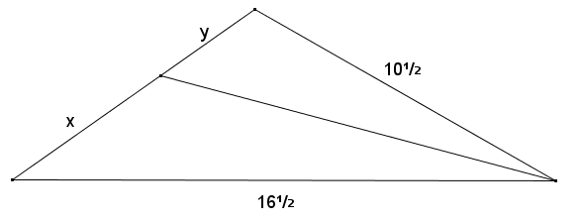

By the angle bisector theorem, $\frac{x}{y}=\frac{16\frac{1}{2}}{10\frac{1}{2}}$ and $y=9-x$, so
$$\frac{x}{9-x}=\frac{16.5}{10.5} \\ 10.5x=16.5\left(9-x\right) \\ 10.5x=148.5-16.5x \\ 27x=148.5 \\ x=5.5$$ | $$y=9-x \\ y=9-5.5 \\ y=3.5$$

- In the diagram of triangle $DEF$ below, $\overline{DG}$ is an angle bisector, $E=8$, $DF=6$, and $EF=8\frac{1}{6}$. Find $FG$ and $EG$.
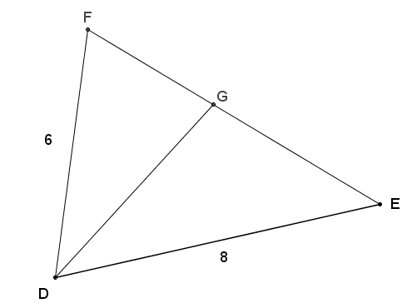

Since $\overline{DG}$ is the angle bisector of angle $D$, $FG:GE=FD:ED$ by the angle bisector theorem. If $EF=8\frac{1}{6}$, then $FG=8\frac{1}{6}-GE$.
$$\frac{\left(8\frac{1}{6}-GE\right)}{GE}=\frac{6}{8} \\ 8\frac{1}{6}-GE=\frac{6}{8}∙GE \\ 8\frac{1}{6}=\frac{14}{8}∙GE \\ \frac{49}{6}∙\frac{8}{14}=GE \\ \frac{28}{6}=GE \\ GE=4\frac{2}{3}$$ | $$FE=GE+FG \\ 8\frac{1}{6}=4\frac{2}{3}+FG \\ FG=3\frac{1}{2}$$
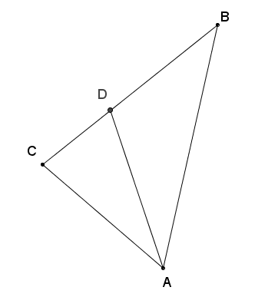
- Given the diagram below and $∠BAD≅∠DAC$, show that $BD:BA=CD:CA$.
Using the given information, $\overline{AD}$ is the angle bisector of angle $A$. By the Angle Bisector Theorem, $BD:CD=BA:CA$, so
$$\frac{BD}{CD}=\frac{BA}{CA}$$
$$BD∙CA=CD∙BA$$
$$\frac{BD}{BA}=\frac{CD}{CA}$$

- The perimeter of triangle $LMN$ is $32 cm$. $\overline{NX}$ is the angle bisector of angle $N$, $LX=3 cm$, and $XM=5 cm$. Find $LN$ and $MN$.
Since $\overline{NX}$ is an angle bisector of angle $N$, by the Angle Bisector Theorem, $XL:XM=LN:MN$; thus $LN:MN=3:5$. Therefore, $LN=3x$ and $MN=5x$ for some positive number $x$. The perimeter of the triangle is $32 cm$, so
$$XL+XM+MN+LN=32 \\ 3+5+3x+5x=32 \\ 8+8x=32 \\ 8x=24 \\ x=3$$
$3x=3\left(3\right)=9$ and $5x=5\left(3\right)=15$
$LN=9 cm$ and $MN=15 cm$.

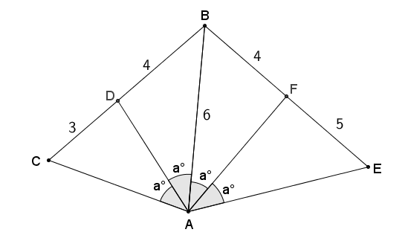
- Given $CD=3$, $DB=4$, $BF=4$, $FE=5$, $AB=6$, and $∠CAD≅∠DAB≅∠BAF≅∠FAE$, find the perimeter of quadrilateral $AEBC$.
$\overline{AD}$ is the angle bisector of angle $CAB$, so by the Angle Bisector Theorem, $CD:BD=CA:BA$.
$$\frac{3}{4}=\frac{CA}{6} \\ 4∙CA=18 \\ CA=4.5$$
$\overline{AF}$ is the angle bisector of angle $BAE$, so by the Angle Bisector Theorem, $BF:EF=BA:EA$
$$\frac{4}{5}=\frac{6}{EA} \\ 4∙EA=30 \\ EA=7.5$$
The perimeter of quadrilateral $AEBC=CD+DB+BF+FE+EA+AC$,
$$AEBC=3+4+4+5+7.5+4.5$$
$$AEBC=28$$

- If $\overline{AE}$ meets $\overline{BC}$ at $D$ such that $CD:BD=CA:BA$, show that $∠CAD≅∠BAD$. Explain how this proof relates to the angle bisector theorem.
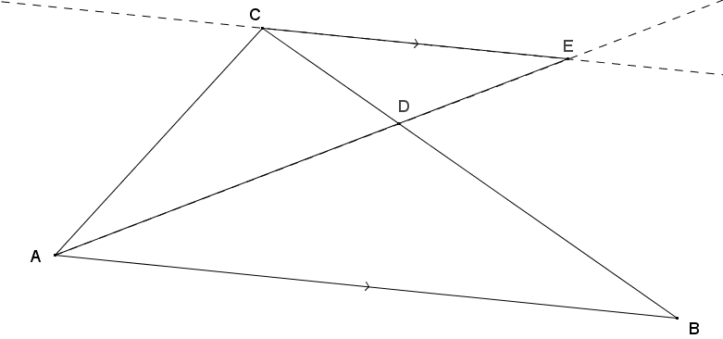

This is a proof of the converse to the angle bisector theorem.
$∠CEA≅∠BAD \left(\text{Alt. Int. }∠s, \overline{CE}∥\overline{AB}\right)$
$∠ADB≅∠EDC (\text{Vert.} \text{∠}\text{'s})$
$∆CDE\sim ∆BDA (\text{AA} \sim )$
$\frac{CD}{DB}=\frac{CE}{BA} (\text{Corr. sides of} \sim ∆\text{'s})$
Given$\frac{CD}{BD}=\frac{CA}{BA}$ implies then that
$CE=CA$, so $∆AEC$ is isosceles.
$∠CAD≅∠CEA (\text{Base} ∠\text{'}\text{s})$
$∠CAD≅∠BAD (\text{Substitution})$

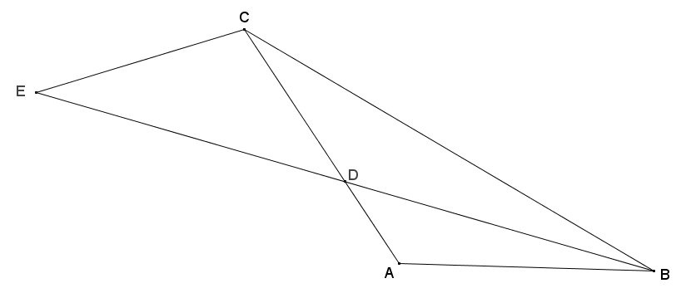
- In the diagram below, $\overline{ED}≅\overline{DB}$, $\overline{BE}$ bisects $∠ABC$, $AD=4$, and $DC=8$. Prove that $∆ADB\sim ∆CEB$.

Using given information, $ED=DB$, so it follows that $EB=2DB$. Since $\overline{BE}$ bisects $∠ABC$, $∠ABD≅∠CBD$. Also by the angle bisector theorem, $\frac{CD}{AD}=\frac{BC}{BA}$, which means $\frac{BC}{BA}=\frac{8}{4}=\frac{2}{1}$.
Since $\frac{EB}{DB}=\frac{CB}{AB}=\frac{2}{1}$, and $∠ABD≅∠CBD$, $∆ADB\sim ∆CEB$ by the SAS criterion for showing similar triangles.

