Lesson 18: Similarity and the Angle Bisector Theorem

Classwork
Opening Exercise
  - What is an angle bisector?

  - Describe the angle relationships formed when parallel lines are cut by a transversal.

  - What are the properties of an isosceles triangle?

Discussion
In the diagram below, the angle bisector of $∠A$ in $△ABC$ meets side $BC$ at point $D$. Does the angle bisector create any observable relationships with respect to the side lengths of the triangle?

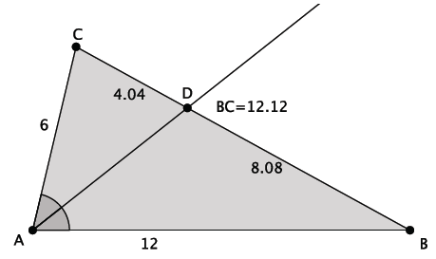

Exercises 1–4
- The sides of a triangle are $8$,$12$, and $15$. An angle bisector meets the side of length $15$. Find the lengths $x$ and $y$. Explain how you arrived at your answers.

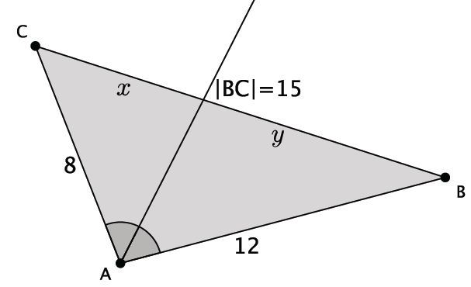

- The sides of a triangle are $8$, $12$, and $15$. An angle bisector meets the side of length $12$. Find the lengths $x$ and $y$.

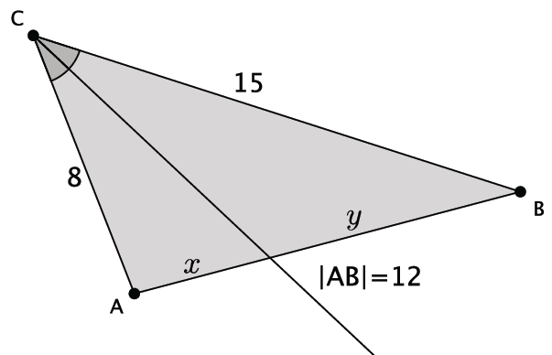

- The sides of a triangle are $8$,$12$, and $15$. An angle bisector meets the side of length $8.$ Find the lengths $x$ and $y$.
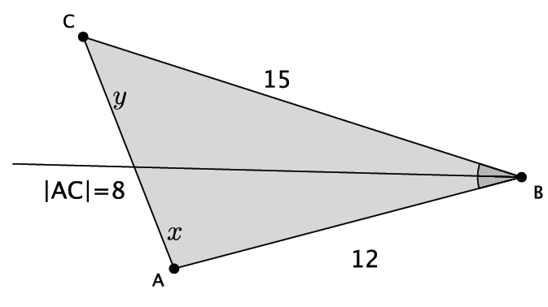

- The angle bisector of an angle splits the opposite side of a triangle into lengths $5$ and $6$. The perimeter of the triangle is $33$. Find the lengths of the other two sides.

Problem Set

- The sides of a triangle have lengths of $5, 8,$ and $6\frac{1}{2}.$ An angle bisector meets the side of length $6\frac{1}{2}.$ Find the lengths $x$ and $y$.

- The sides of a triangle are $10\frac{1}{2}$,$16\frac{1}{2}$, and $9.$ An angle bisector meets the side of length $9$. Find the lengths $x$ and $y$.

- In the diagram of triangle $DEF$ below, $\overline{DG}$ is an angle bisector, $E=8$, $DF=6$, and $EF=8\frac{1}{6}$. Find $FG$ and $EG$.
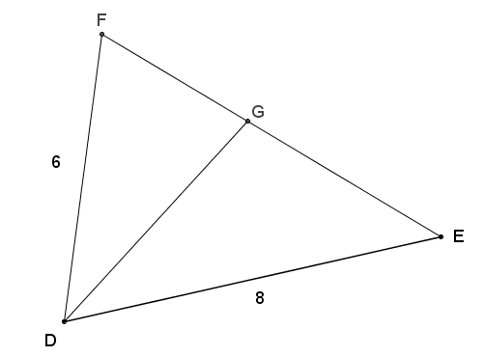

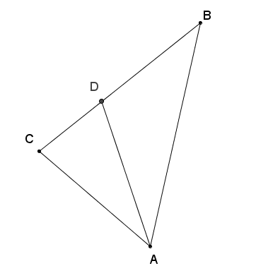
- $∠BAD≅∠DAC$, show that $BD:BA=CD:CA$.

- The perimeter of triangle $LMN$ is $32 cm$. $\overline{NX}$ is the angle bisector of angle $N$, $LX=3 cm$, and $XM=5 cm$. Find $LN$ and $MN$.

- Given $CD=3$, $DB=4$, $BF=4$, $FE=5$, $AB=6$, and $∠CAD≅∠DAB≅∠BAF≅∠FAE$, find the perimeter of quadrilateral $AEBC$

- If $\overline{AE}$ meets $\overline{BC}$ at $D$ such that $CD:BD=CA:BA$, show that $∠CAD≅∠BAD$. Explain how this proof relates to the angle bisector theorem.
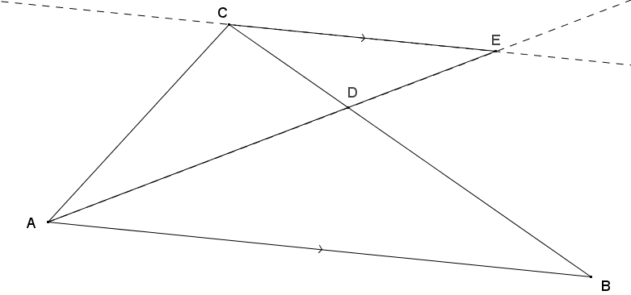

- In the diagram below, $\overline{ED}≅\overline{DB}$, $\overline{BE}$ bisects $∠ABC$, $AD=4$, and $DC=8$. Prove that $∆ADB\sim ∆CEB$.
