Lesson 17: The Side-Angle-Side (SAS) and Side-Side-Side (SSS) Criteria for Two Triangles to be Similar

Student Outcomes
- Students prove the side-angle-side criterion for two triangles to be similar and use it to solve triangle problems.
- Students prove the side-side-side criterion for two triangles to be similar and use it to solve triangle problems.

Lesson Notes
At this point students know that two triangles can be considered similar if they have two pairs of corresponding equal angles. In this lesson students will learn the other conditions that can be used to deem two triangles similar, specifically the SAS and SSS criterion.

Classwork
Opening Exercise (3 minutes)
Opening Exercise
  - Choose three lengths that represent the sides of a triangle. Draw the triangle with your chosen lengths using construction tools.
Answers will vary. Sample response: $6 cm$, $7 cm$, and $8 cm$.

  - Multiply each length in your original triangle by $2$ to get three corresponding lengths of sides for a second triangle. Draw your second triangle using construction tools.
Answers will be twice the lengths given in part (a). Sample response: $12 cm$, $14 cm$, and $16 cm$.

  - Do your constructed triangles appear to be similar? Explain your answer.
MP.3
The triangles appear to be similar. Their corresponding sides are given as having lengths in the ratio $2:1$, and the corresponding angles appear to be equal in measure. (This can be verified using either a protractor or patty paper.)

  - Do you think that the triangles can be shown similar without knowing the angle measures?
Answers will vary.

- We discovered in Lesson 16 that if two triangles have two pairs of angles with equal measures, it is not necessary to check all 6 conditions (3 sides and 3 angles) to show that the two triangles are similar. We called it the AA criterion. In this lesson we will learn that other combinations of conditions can be used to conclude that two triangles are similar.
Exploratory Challenge 1/Exercises 1–2 (8 minutes)
In this challenge students are given the opportunity to discover the SAS criterion for similar triangles. The discussion that follows solidifies this fact. Consider splitting the class into two groups where one group works on Exercise 1 and the other group completes Exercise 2. Then have students share their work with the whole class.
Exploratory Challenge 1/Exercises 1–2
- Examine the figure and answer the questions to determine whether or not the triangles shown are similar.
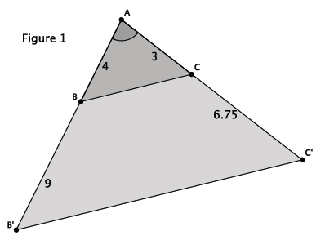
Scaffolding:
- It may be helpful to ask students how many triangles they see in Figure 1, and then have students identify each of the triangles.
- Have students create triangles that meet specific criteria. Given a starting triangle with lengths $3$,$6$,$7$, generate similar triangles by multiplying the sides of the “starting” triangle by a single factor, such as $1$,$1.5$,$2$,$3$, etc.

  - What information is given about the triangles in Figure 1?
We are given that $∠A$ is common to both triangle $△ABC$ and triangle $△AB^{'}C^{'}.$ We are also given information about some of the side lengths.

  - How can the information provided be used to determine whether $△ABC$ is similar to $△AB^{'}C^{'}$?
We know that similar triangles will have ratios of corresponding sides that are proportional; therefore, we can use the side lengths to check for proportionality.

  - Compare the corresponding side lengths of $△ABC$ and $△AB^{'}C^{'}$. What do you notice?
$$\frac{4}{13}=\frac{3}{9.75}$$$39=39$
The cross-products are equal, therefore, the side lengths are proportional.

  - Based on your work in parts (a)–(c), draw a conclusion about the relationship between $△ABC$ and
$△AB^{'}C^{'}$. Explain your reasoning.
The triangles are similar. By the triangle side splitter theorem, I know that when the sides of a triangle are cut proportionally, then $\overline{BC}∥\overline{B^{'}C^{'}}$. Then I can conclude that the triangles are similar because they have two pairs of corresponding angles that are equal.

- Examine the figure, and answer the questions to determine whether or not the triangles shown are similar.
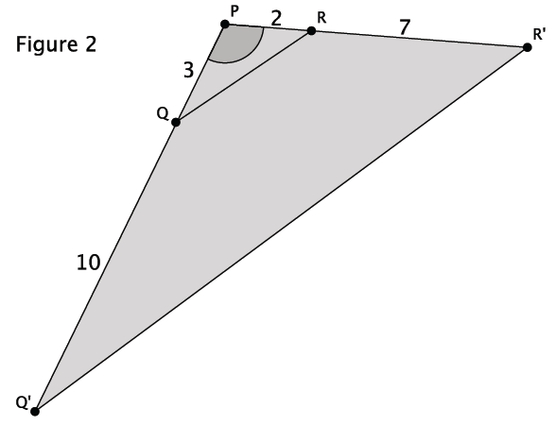
Scaffolding:
It may be helpful to ask students how many triangles they see in Figure 2; then have students identify each of the triangles.
  - What information is given about the triangles in Figure 2?
We are given that $∠P$ is common to both triangle $△PQR$ and triangle $△PQ'R'.$ We are also given information about some of the side lengths.

  - How can the information provided be used to determine whether $△PQR$ is similar to $△PQ'R'$?
We know that similar triangles will have ratios of corresponding sides that are proportional; therefore, we can use the side lengths to check for proportionality.

  - Compare the corresponding side lengths of $△PQR$ and $△PQ'R'$. What do you notice?
$$\frac{3}{13}≠\frac{2}{9} \\ 27≠26$$
The side lengths are not proportional.

  - Based on your work in parts (a)–(c), draw a conclusion about the relationship between $△PQR$ and $△PQ'R'$. Explain your reasoning.
The triangles are not similar. The side lengths are not proportional, which is what I would expect in similar triangles. I know that the triangles have one common angle, but I cannot determine from the information given whether there is another pair of equal angles. Therefore, I conclude that the triangles are not similar.

Discussion (5 minutes)
Have students reference their work in part (d) of Exercises 1 and 2 while leading the discussion below.
- Which figure contained triangles that were similar? How did you know?
  - Figure 1 had the similar triangles. I knew because the triangles had side lengths that were proportional. Since the side lengths are split proportionally by segment $BC$, then $BC||B'C'$ and the triangles are similar by the AA criterion. The same could not be said about Figure 2.
- The triangles in Figure 1 are similar. Take note of the information that was given about the triangles in the diagrams not what you were able to deduce about the angles.
  - The diagram showed information related to the side lengths and the angle between the sides.
Once the information contained in the above two bullets are clear to students, explain the side-angle-side criterion for triangle similarity below.
- Theorem: The side-angle-side criterion for two triangles to be similar is as follows.
Given two triangles $△ABC$ and $△A’B’C’$ so that $\frac{A^{'}B^{'}}{AB}=\frac{A^{'}C^{'}}{AC}$ and $m∠A=m∠A^{'},$ then the triangles are similar, $△ABC \sim △A^{'}B^{'}C^{'}$. In words, two triangles are similar if they have one pair of corresponding angles that are congruent and the sides adjacent to that angle are proportional.

- The proof of this theorem is simply to take any dilation with scale factor $r=\frac{A^{'}B^{'}}{AB}=\frac{A^{'}C^{'}}{AC}$. This dilation maps $△ABC$ to a triangle that is congruent to $△A'B'C'$ by the side-angle-side congruence criterion.
- We refer to the angle between the two sides as the included angle. Or we can say the sides are adjacent to the given angle. When the side lengths adjacent to the angle are in proportion, then we can conclude that the triangles are similar by the side-angle-side criterion.
The question below requires students to apply their new knowledge of the SAS criterion to the triangles in Figure 2. Students should have concluded that they were not similar in part (d) of Exercise 2. The question below pushes students to apply the SAS and AA theorems related to triangle similarity to show definitively that the triangles in Figure 2 are not similar.
- Did Figure 2 have side lengths that were proportional? What can you conclude about the triangles in Figure 2?
  - No. The side lengths were not proportional, so we cannot use the SAS criterion for similarity to say that the triangles are similar. If the side lengths were proportional, we could conclude that the lines containing $PQ$ and $P^{'}Q'$ are parallel, but the side lengths are not proportional; therefore, the lines containing $PQ$ and $P^{'}Q'$ are not parallel. This then means that the corresponding angles are not equal, and the AA criterion cannot be used to say that the triangles are similar.
- We can use the SAS criterion to determine if a pair of triangles are similar. Since the side lengths in Figure 2 were not proportional, we can conclude that the triangles are not similar.

Exploratory Challenge 2/Exercises 3–4 (8 minutes)
In this challenge, students are given the opportunity to discover the SSS criterion for similar triangles. The discussion that follows solidifies this fact. Consider splitting the class into two groups where one group works on Exercise 3 and the other group completes Exercise 4. Then have students share their work with the whole class.
Exploratory Challenge 2/Exercises 3–4
- Examine the figure, and answer the questions to determine whether or not the triangles shown are similar.
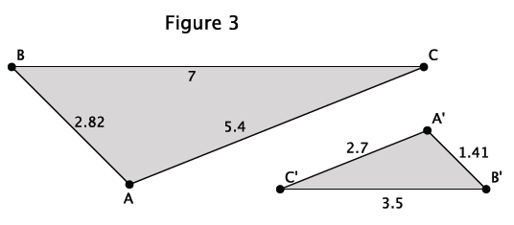
  - What information is given about the triangles in Figure 3?
We are only given information related to the side lengths of the triangles.
  - How can the information provided be used to determine whether $△ABC$ is similar to $△A{'B}^{'}C^{'}$?
We know that similar triangles will have ratios of corresponding sides that are proportional; therefore, we can use the side lengths to check for proportionality.

  - Compare the corresponding side lengths of $△ABC$ and $△A{'B}^{'}C^{'}$. What do you notice?
$$\frac{1.41}{2.82}=\frac{3.5}{7}=\frac{2.7}{5.4}=\frac{1}{2}$$
The side lengths are proportional.

  - Based on your work in parts (a)–(c), make a conjecture about the relationship between $△ABC$ and$△A{'B}^{'}C^{'}$. Explain your reasoning.
I think that the triangles are similar. The side lengths are proportional, which is what I would expect in similar triangles.

- Examine the figure, and answer the questions to determine whether or not the triangles shown are similar.
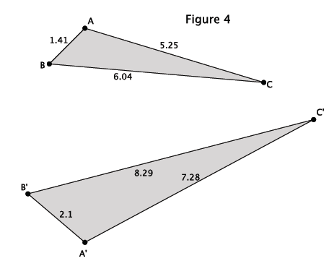
  - What information is given about the triangles in Figure 4?
We are only given information related to the side lengths of the triangles.

  - How can the information provided be used to determine whether $△ABC$ is similar to $△A{'B}^{'}C^{'}$?
We know that similar triangles will have ratios of corresponding sides that are proportional; therefore, we can use the side lengths to check for proportionality.

  - Compare the corresponding side lengths of $△ABC$ and $△A{'B}^{'}C^{'}$. What do you notice?
$$\frac{2.1}{1.41}≠\frac{8.29}{6.04}≠\frac{7.28}{5.25}$$
The side lengths are not proportional.
  - Based on your work in parts (a)–(c), make a conjecture about the relationship between $△ABC$ and
$△A'B^{'}C^{'}$. Explain your reasoning.
I think that the triangles are not similar. I would expect the side lengths to be proportional if the triangles are similar.

Discussion (5 minutes)
- Which figure contained triangles that were similar? What made you think they were similar?
MP.8
  - Figure 3 had the similar triangles. I think Figure 3 had the similar triangles because all three pairs of corresponding sides were in proportion. That was not the case for Figure 4.
- The triangles in Figure 3 are similar. Take note of the information that was given about the triangles in the diagrams.
  - The diagram showed information related only to the side lengths of each of the triangles.

- Theorem: The side-side-side criterion for two triangles to be similar is as follows.
Given two triangles $△ABC$ and $△A’B’C’$ so that $\frac{A^{'}B^{'}}{AB}=\frac{B^{'}C^{'}}{BC}=\frac{A^{'}C^{'}}{AC}$, then the triangles are similar,
$△ABC \sim △A^{'}B^{'}C^{'}$. In other words, two triangles are similar if their corresponding sides are proportional.

- What would the scale factor, $r$, need to be to show that these triangles are similar? Explain.
  - A scale factor $r=\frac{A^{'}B^{'}}{AB}$ or $r=\frac{B^{'}C^{'}}{BC}$ or $r=\frac{A^{'}C^{'}}{AC}$ would show that these triangles are similar. Dilating by one of those scale factors guarantees that the corresponding sides of the triangles will be proportional.
- Then a dilation by scale factor $r=\frac{A^{'}B^{'}}{AB}=\frac{B^{'}C^{'}}{BC}=\frac{A^{'}C^{'}}{AC}$ maps $△ABC$ to a triangle that is congruent to $△A'B'C'$ by the side-side-side congruence criterion.
- When all three pairs of corresponding sides are in proportion, we can conclude that the triangles are similar by side-side-side criterion.
- Did Figure 4 have side lengths that were proportional? What can you conclude about the triangles in Figure 4?
  - No. The side lengths were not proportional; therefore, the triangles are not similar.
- We can use the SSS criterion to determine if a pair of triangles are similar. Since the side lengths in Figure 4 were not proportional, we can conclude that the triangles are not similar.

Exercises 5–10 (8 minutes)
Students identify whether or not the triangles are similar. For pairs of triangles that are similar, students will identify the criterion used: AA, SAS, or SSS.

Exercises 5–10
- Are the triangles shown below similar? Explain. If the triangles are similar, write the similarity statement.
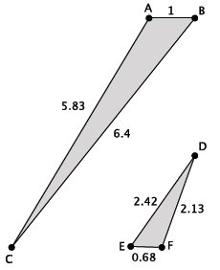

$$\frac{1}{0.68}≠\frac{6.4}{2.42}≠\frac{5.83}{2.13}$$
There is no information about the angle measures, so we cannot use AA or SAS to conclude the triangles are similar. Since the side lengths are not proportional, we cannot use SSS to conclude the triangles are similar. Therefore, the triangles shown are not similar.

- Are the triangles shown below similar? Explain. If the triangles are similar, write the similarity statement.
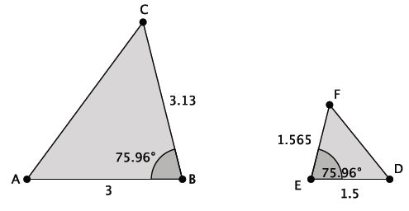
$$\frac{3.13}{1.565}=\frac{3}{1.5}$$
Yes, the triangles shown are similar. $△ABC \sim △DEF$ by SAS because $m∠B=m∠E$, and the adjacent sides are proportional.

- Are the triangles shown below similar? Explain. If the triangles are similar, write the similarity statement.
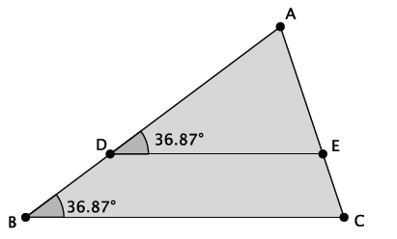

Yes, the triangles shown are similar. $△ABC \sim △ADE$ by AA because $m∠ADE=m∠ABC$, and both triangles share $∠A$.

- Are the triangles shown below similar? Explain. If the triangles are similar, write the similarity statement.
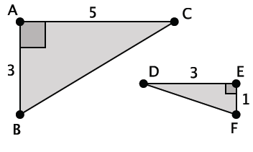
$$\frac{5}{3}≠\frac{3}{1}$$
There is no information about the angle measures other than the right angle, so we cannot use AA to conclude the triangles are similar. We only have information about two of the three side lengths for each triangle, so we cannot use SSS to conclude they are similar. If the triangles are similar, we would have to use the SAS criterion, and since the side lengths are not proportional, the triangles shown are not similar. (Note that students could also utilize the Pythagorean theorem to determine the length of the hypotenuses, and then use $SSS$ similarity criterion to answer the question.)

- Are the triangles shown below similar? Explain. If the triangles are similar, write the similarity statement.
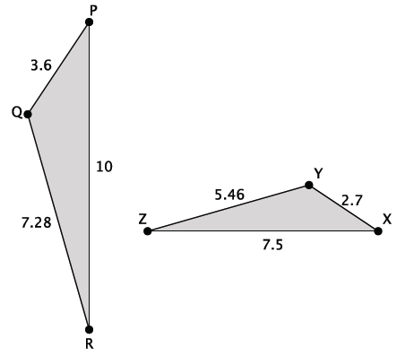
$$\frac{3.6}{2.7}=\frac{7.28}{5.46}=\frac{10}{7.5}$$
Yes, the triangles are similar. $△PQR \sim △XYZ$ by SSS.

- Are the triangles shown below similar? Explain. If the triangles are similar, write the similarity statement.
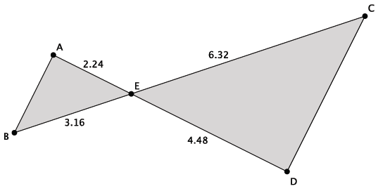

$$\frac{2.24}{4.48}=\frac{3.16}{6.32}$$
Yes, the triangles are similar. $△ABE\sim △DCE$ by SAS because $m∠AEB=m∠DEC$(vertical angles are congruent), and the sides adjacent to those angles are proportional.

Closing (3 minutes)
Ask the following three questions to informally assess students’ understanding of the similarity criterion for triangles.
- Given only information about the angles of a pair of triangles, how can you determine if the given triangles are similar?
  - The AA criteria can be used to determine if two triangles are similar. The triangles must have two pairs of corresponding angles that are equal in measure.
- Given only information about one pair of angles for two triangles, how can you determine if the given triangles are similar?
  - The SAS criteria can be used to determine if two triangles are similar. The triangles must have one pair of corresponding angles that are equal in measure, and the ratios of the corresponding adjacent sides must be in proportion.
- Given no information about the angles of a pair of triangles, how can you determine if the given triangles are similar?
  - The SSS criteria can be used to determine if two triangles are similar. The triangles must have three pairs of corresponding side lengths in proportion.

Exit Ticket (5 minutes)

Name Date
Lesson 17: The Side-Angle-Side (SAS) and Side-Side-Side (SSS) Criteria for Two Triangles to be Similar

Exit Ticket

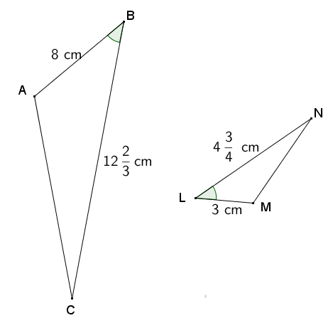
- Given $∆ABC$ and $∆LMN$ in the diagram below, and $∠B≅∠L$, determine if the triangles are similar. If so, write a similarity statement, and state the criterion used to support your claim.

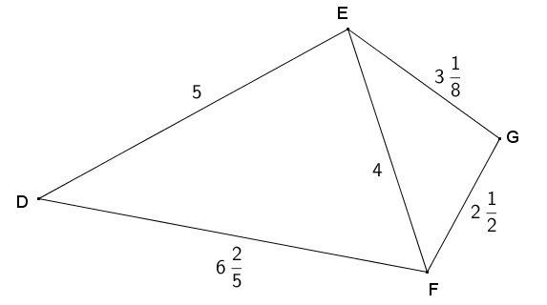
- Given $∆DEF$ and $∆EFG$ in the diagram below, determine if the triangles are similar. If so, write a similarity statement, and state the criterion used to support your claim.

Exit Ticket Sample Solutions

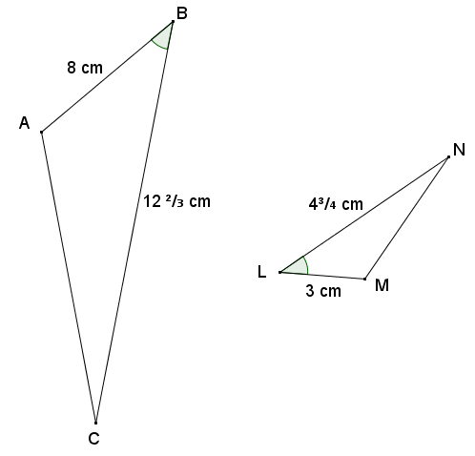
- Given $∆ABC$ and $∆LMN$ in the diagram below, determine if the triangles are similar. If so, write a similarity statement, and state the criterion used to support your claim.
In comparing the ratios of sides between figures, I found that $\frac{AB}{ML}=\frac{CB}{LN}$ because the cross products of the proportion $\frac{8}{3}=\frac{12\frac{2}{3}}{4\frac{3}{4}}$ are both $38$. We are given that $∠L≅∠B$. Therefore, $∆ABC\sim ∆MLN$ by the $SAS$ criterion for proving similar triangles.

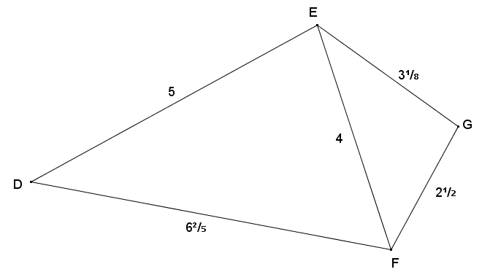
- Given $∆DEF$ and $∆EFG$ in the diagram below, determine if the triangles are similar. If so, write a similarity statement, and state the criterion used to support your claim.
By comparison, if the triangles are in fact similar, then the longest sides of each triangle will correspond, and likewise the shortest sides will correspond. The corresponding sides from each triangle are proportional since $\frac{5}{3\frac{1}{8}}=\frac{4}{2\frac{1}{2}}=\frac{6\frac{2}{5}}{4}=\frac{8}{5}$ , so $\frac{DE}{EG}=\frac{EF}{GF}=\frac{DF}{EF}$. Therefore, by the $SSS$ criterion for showing triangle similarity, $∆DEF\sim ∆EGF$.

Problem Set Sample Solutions

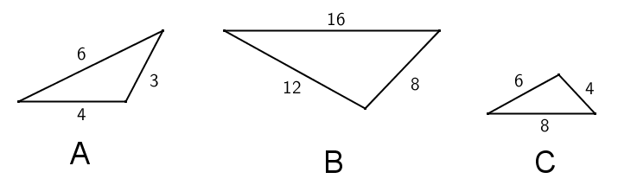
- For each part (a) through (d) below, state which of the three triangles, if any, are similar and why.

Triangles $B$ and $C$ are similar because they share three pairs of corresponding sides that are in the same ratio.
$$\frac{4}{8}=\frac{6}{12}=\frac{8}{16}=\frac{1}{2}$$
Triangles $A$ and $B$ are not similar because the ratios of their corresponding sides are not in the same ratio.
$$\frac{6}{16}≠\frac{4}{12}$$
Further, if triangle $A$ is not similar to triangle $B$, then triangle $A$ is not similar to triangle $C$.
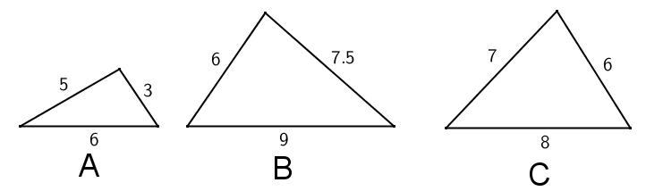

Triangles $A$ and $B$ are not similar because their corresponding sides are not all in the same ratio. Two pairs of corresponding sides are proportional, but the third pair of corresponding sides are not.
$$\frac{3}{6}≠\frac{5}{7.5}=\frac{6}{9}$$
Triangles $B$ and $C$ are not similar because their corresponding sides are not in the same ratio.
$$\frac{6}{6}≠\frac{7}{7.5}≠\frac{8}{9}$$
Triangles $A$ and $C$ are not similar because their corresponding sides are not in the same ratio:
$$\frac{3}{6}≠\frac{5}{7}≠\frac{6}{8}$$
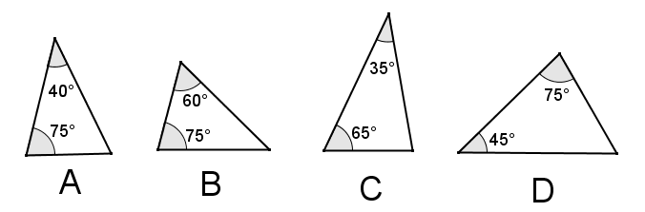

Triangles $B$ and $D$ are the only similar triangles because they have the same angle measures. Using the angle sum of a triangle, each of the triangles $B$ and $D$ have angles of $75°$, $60°$, and $45°$.
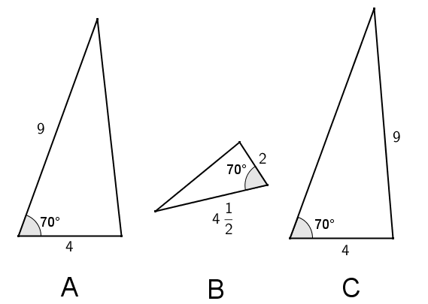

Triangles $A$ and $B$ are similar because they have two pairs of corresponding sides that are in the same ratio and their included angles are equal measures. Triangle $C$ cannot be shown similar because even though it has two sides that are the same length as two sides of triangle $A$, the $70°$ angle in triangle $C$ is not the included angle and, therefore, does not correspond to the $70°$ angle in triangle $A$.

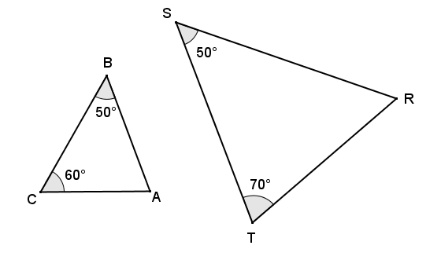
- For each given pair of triangles, determine if the triangles are similar or not, and provide your reasoning. If the triangles are similar, write a similarity statement relating the triangles.

The triangles are similar because, using the angle sum of a triangle, each triangle has angle measures of $50°$, $60°$, and $70°$. Therefore, $∆ABC\sim ∆TSR$.
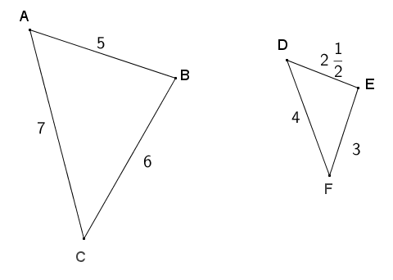

The triangles are not similar because the ratios of corresponding sides are not all in proportion.
$\frac{AB}{DE}=\frac{BC}{EF}=2$; however, $\frac{AC}{DF}=\frac{7}{4}≠2$.
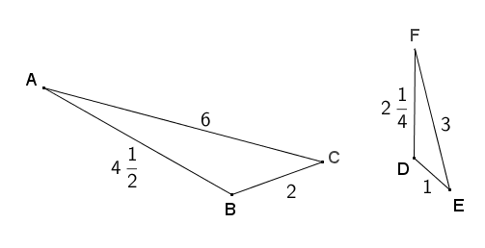

$∆ABC\sim ∆FDE$ by the $SSS$ criterion for showing similar triangles because the ratio of all pairs of corresponding sides $\frac{AC}{FE}=\frac{AB}{FD}=\frac{BC}{DE}=2$.

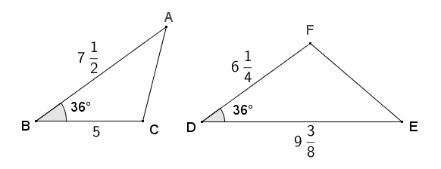

$\frac{AB}{DE}=\frac{BC}{DF}=\frac{4}{5}$, and included angles $B$ and $D$ are both $36°$ and, therefore, congruent, so $∆ABC\sim ∆EDF$ by the SAS criterion for showing similar triangles.

- For each pair of similar triangles below, determine the unknown lengths of the sides labeled with letters.
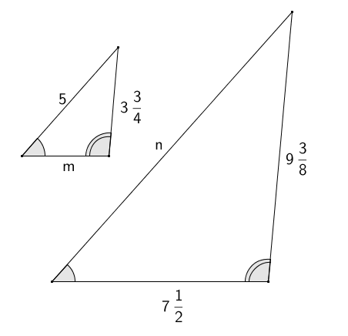
The ratios of corresponding sides must be equal, so $\frac{5}{n}=\frac{3\frac{3}{4}}{9\frac{3}{8}}$ giving $n=12\frac{1}{2}$. Likewise, $\frac{m}{7\frac{1}{2}}=\frac{3\frac{3}{4}}{9\frac{3}{8}}$ giving $m=3$.

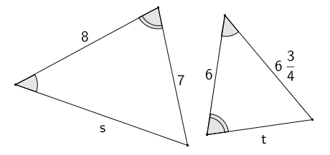
The ratios of corresponding sides must be equal, so $\frac{8}{6}=\frac{s}{6\frac{3}{4}}$ giving $s=9$. Likewise $\frac{8}{6}=\frac{7}{t}$ giving $t=5\frac{1}{4}$.

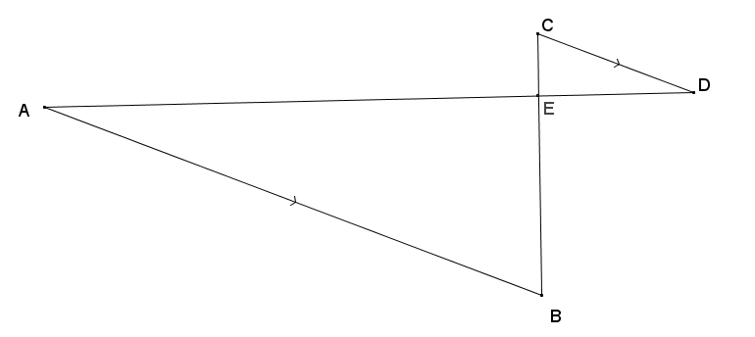
- Given that $\overline{AD}$ and $\overline{BC}$ intersect at $E$, and $\overline{AB}∥\overline{CD}$, show that $∆ABE\sim ∆DCE$.

$∠AEB$ and $∠DEC$ are vertically opposite angles and, therefore, congruent. $∠A≅∠D$by alt. int. $∠$' s,
$\overline{AB}∥\overline{CD}$. Therefore, $∆ABE\sim ∆DCE$ by the AA criterion for showing similar triangles.

- Given $BE=11$, $EA=11$, $BD=7$, and $DC=7$, show that $∆BED\sim ∆BAC$.
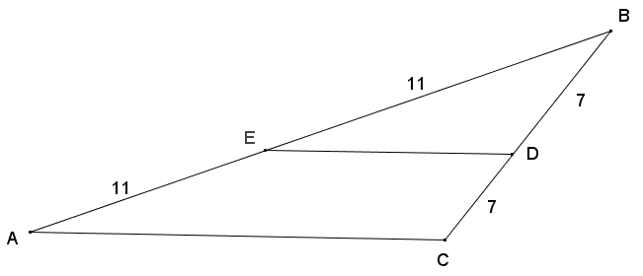

Both triangles share angle $B$, and by the reflexive property, $∠B≅∠B$. $BA=BE+EA$, so $BA=22$, and $BC=BD+DC$, so $BC=14$. The ratios of corresponding sides $\frac{BE}{BA}=\frac{BD}{BC}=\frac{1}{2}$. Therefore, $∆BED\sim ∆BAC$ by the $SAS$ criterion for triangle similarity.

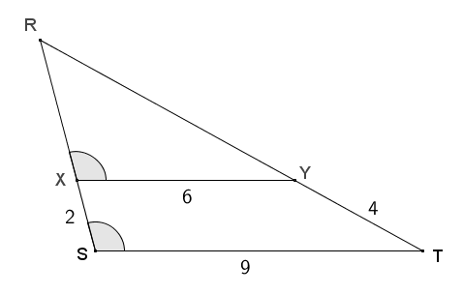
- Given the diagram below, $X$ is on $\overline{RS}$ and $Y$ is on $\overline{RT}$, $XS=2$, $XY=6$, $ST=9$, and $YT=4$.

  - Show that $∆RXY\sim ∆RST$.
The diagram shows $∠RST≅∠RXY$. Both triangle $RXY$ and $RST$ share angle $R$, and by the reflexive property, $∠R≅∠R$, so$∆RXY\sim ∆RST$ by the $AA$ criterion show triangle similarity.

  - Find $RX$ and $RY$.
Since the triangles are similar, their corresponding sides must be in the same ratio.
$$\frac{RX}{RS}=\frac{RY}{RT}=\frac{XY}{ST}=\frac{6}{9}$$
$RS=RX+XS$, so $RS=RX+2$ and $RT=RY+YT$, so $RT=RY+4$.
$$\frac{RX}{RX+2}=\frac{6}{9} \\ 9\left(RX\right)=6\left(RX\right)+12 \\ RX=4$$ | $$\frac{RY}{RY+4}=\frac{6}{9} \\ 9\left(RY\right)=6\left(RY\right)+24 \\ RY=8$$

- One triangle has a $120°$ angle, and a second triangle has a $65°$ angle. Is it possible that the two triangles are similar? Explain why or why not.
No, the triangles cannot be similar because in the first triangle, the sum of the remaining angles is $60°$, which means that it is not possible for the triangle to have a $65°$ angle. For the triangles to be similar, both triangles would have to have angles measuring $120°$ and $65°$, but this is impossible due to the angle sum of a triangle.

- A right triangle has a leg that is $12 cm$ long, and another right triangle has a leg that is $6 cm$ long. Are the two triangles similar or not? If so, explain why. If not, what other information would be needed to show they are similar?
The two triangles may or may not be similar. There is not enough information to make this claim. If the second leg of the first triangle is twice the length of the second leg of the first triangle, then the triangles are similar by SAS criterion for showing similar triangles.

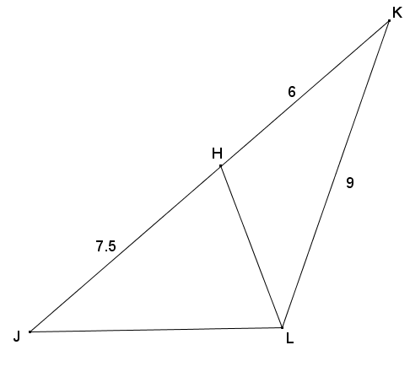
- Given the diagram below, $JH=7.5$, $HK=6$, and $KL=9$, is there a pair of similar triangles? If so, write a similarity statement and explain why. If not, explain your reasoning.
$∆LKJ\sim ∆HKL$ by the SAS criterion for showing triangle similarity. Both triangles share $∠K$, and by the reflexive property, $∠K≅∠K$. Furthermore, $\frac{LK}{JK}=\frac{HK}{LK}=\frac{2}{3}$ , giving two pairs of corresponding sides in the same ratio and included angles of the same size.

