Lesson 17: The Side-Angle-Side (SAS) and Side-Side-Side (SSS) Criteria for Two Triangles to be Similar

Classwork
Opening Exercise
  - Choose three lengths that represent the sides of a triangle. Draw the triangle with your chosen lengths using construction tools.

  - Multiply each length in your original triangle by $2$ to get three corresponding lengths of sides for a second triangle. Draw your second triangle using construction tools.

  - Do your constructed triangles appear to be similar? Explain your answer.

  - Do you think that the triangles can be shown similar without knowing the angle measures?

Exploratory Challenge 1/Exercises 1–2
- Examine the figure and answer the questions to determine whether or not the triangles shown are similar.
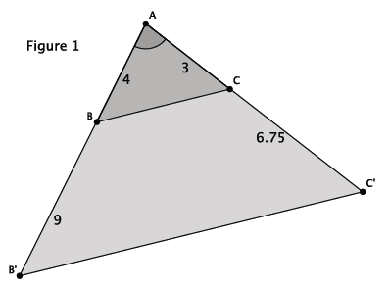

  - What information is given about the triangles in Figure 1?

  - How can the information provided be used to determine whether $△ABC$ is similar to $△AB^{'}C^{'}$?

  - Compare the corresponding side lengths of $△ABC$ and $△AB^{'}C^{'}$. What do you notice?

  - Based on your work in parts (a)–(c), draw a conclusion about the relationship between $△ABC$ and $△AB^{'}C^{'}$. Explain your reasoning.

- Examine the figure, and answer the questions to determine whether or not the triangles shown are similar.

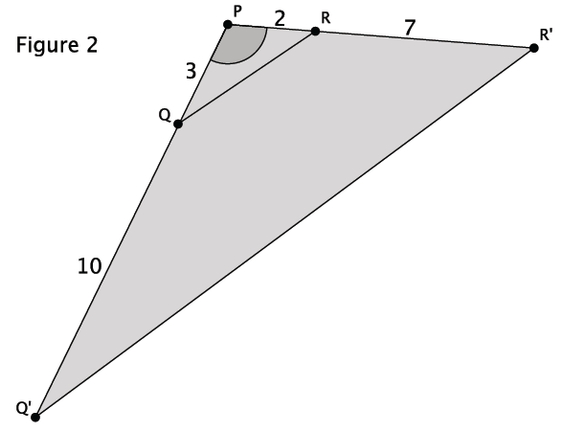

  - What information is given about the triangles in Figure 2?

  - How can the information provided be used to determine whether $△PQR$ is similar to $△PQ'R'$?

  - Compare the corresponding side lengths of $△PQR$ and $△PQ'R'$. What do you notice?

  - Based on your work in parts (a)–(c), draw a conclusion about the relationship between $△PQR$ and $△PQ'R'$. Explain your reasoning.

Exploratory Challenge 2/Exercises 3–4
- Examine the figure and answer the questions to determine whether or not the triangles shown are similar.

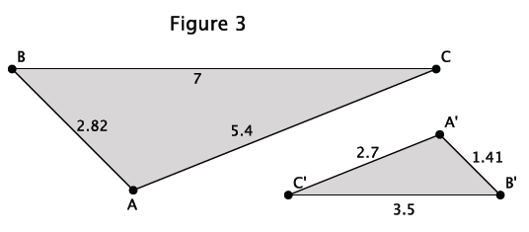

  - What information is given about the triangles in Figure 3?

  - How can the information provided be used to determine whether $△ABC$ is similar to $△AB^{'}C^{'}$?

  - Compare the corresponding side lengths of $△ABC$ and $△AB^{'}C^{'}$. What do you notice?

  - Based on your work in parts (a)–(c), make a conjecture about the relationship between $△ABC$ and$△AB^{'}C^{'}$. Explain your reasoning.

- Examine the figure and answer the questions to determine whether or not the triangles shown are similar.
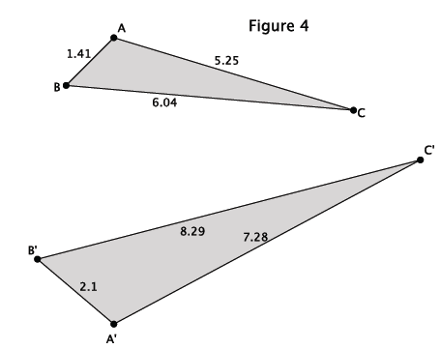
  - What information is given about the triangles in Figure 4?

  - How can the information provided be used to determine whether $△ABC$ is similar to $△AB^{'}C^{'}$?

  - Compare the corresponding side lengths of $△ABC$ and $△AB^{'}C^{'}$. What do you notice?

  - Based on your work in parts (a)–(c), make a conjecture about the relationship between $△ABC$ and $△AB^{'}C^{'}$. Explain your reasoning.

Exercises 5–10
- Are the triangles shown below similar? Explain. If the triangles are similar, write the similarity statement.

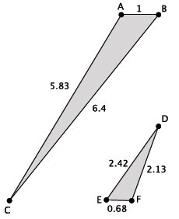

- Are the triangles shown below similar? Explain. If the triangles are similar, write the similarity statement.

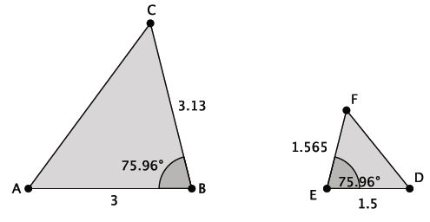

- Are the triangles shown below similar? Explain. If the triangles are similar, write the similarity statement.
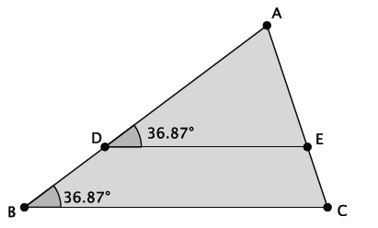

- Are the triangles shown below similar? Explain. If the triangles are similar, write the similarity statement.
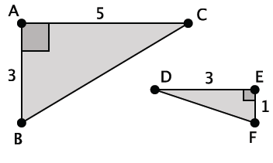

- Are the triangles shown below similar? Explain. If the triangles are similar, write the similarity statement.
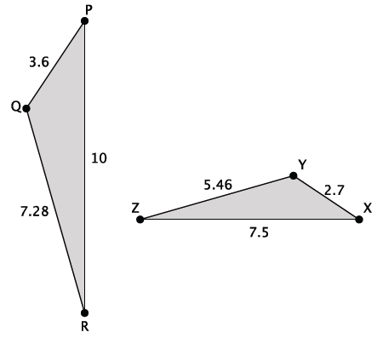

- Are the triangles shown below similar? Explain. If the triangles are similar, write the similarity statement.
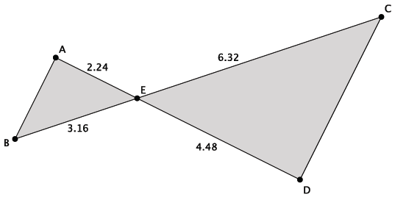

Problem Set

- For each part (a) through (d) below, state which of the three triangles, if any, are similar and why.
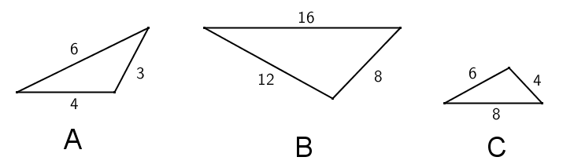

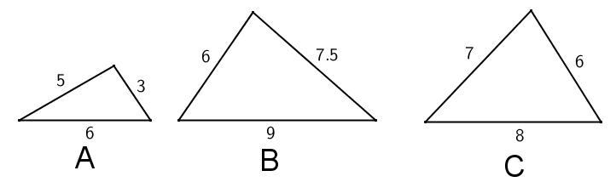

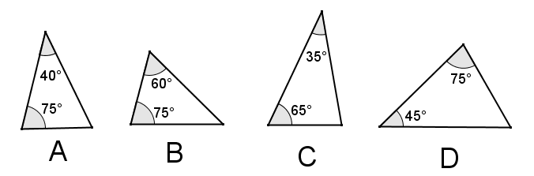

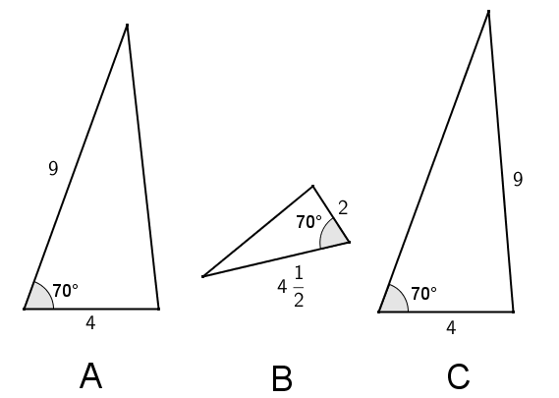

- For each given pair of triangles, determine if the triangles are similar or not, and provide your reasoning. If the triangles are similar, write a similarity statement relating the triangles.
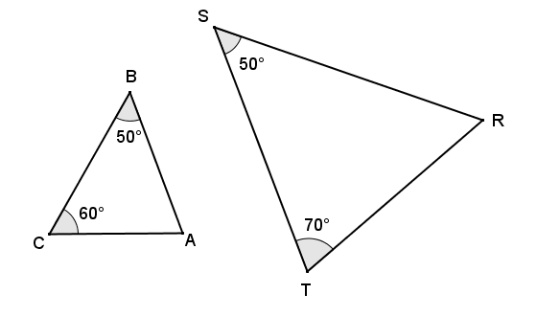

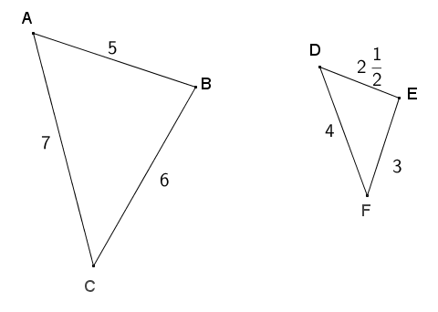

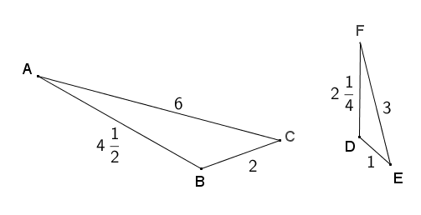

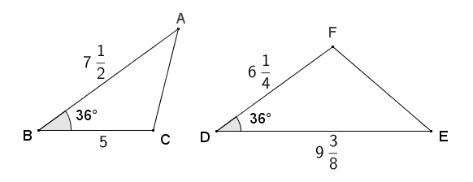

- For each pair of similar triangles below, determine the unknown lengths of the sides labeled with letters.
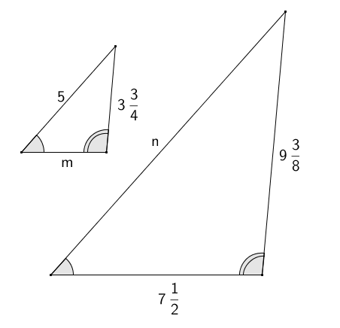

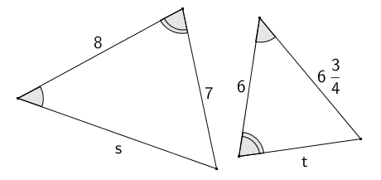

- Given that $\overline{AD}$ and $\overline{BC}$ intersect at $E$, and $\overline{AB}∥\overline{CD}$, show that $∆ABE\sim ∆DCE$.
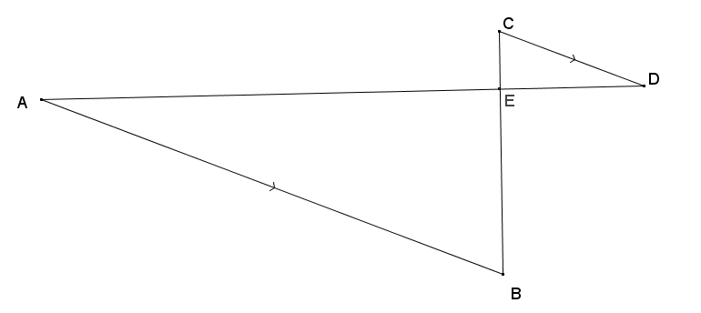

- Given $BE=11$, $EA=11$, $BD=7$, and $DC=7$, show that $∆BED\sim ∆BAC$.
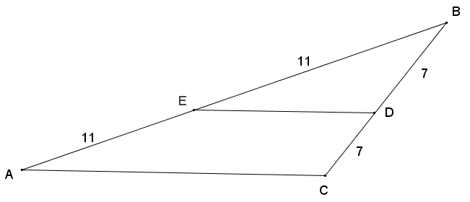

.

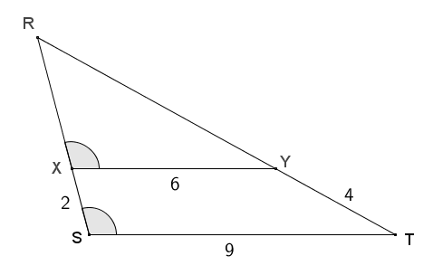
- Given the diagram below, $X$ is on $\overline{RS}$ and $Y$ is on $\overline{RT}$, $XS=2$, $XY=6$, $ST=9$, and $YT=4$.

  - Show that $∆RXY\sim ∆RST$.
  - Find $RX$ and $RY$.

- One triangle has a $120°$ angle, and a second triangle has a $65°$ angle. Is it possible that the two triangles are similar? Explain why or why not.

- A right triangle has a leg that is $12 cm$ long, and another right triangle has a leg that is $6 cm$ long. Are the two triangles similar or not? If so, explain why. If not, what other information would be needed to show they are similar?

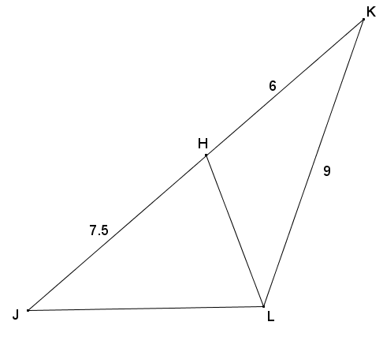
- Given the diagram below, $JH=7.5$, $HK=6$, and $KL=9$, is there a pair of similar triangles? If so, write a similarity statement and explain why. If not, explain your reasoning.

