|  |
| --- |
|  |

Lesson 15: The Angle-Angle (AA) Criterion for Two Triangles to be Similar

Student Outcomes

* Students prove the angle-angle criterion for two triangles to be similar and use it to solve triangle problems.

Lesson Notes

In Lesson 4, we stated that the triangle side splitter theorem was an important theorem because it is the central ingredient in proving the AA criterion for similar triangles. In this lesson, we substantiate this statement by using the theorem (in the form of the dilation theorem) to prove the AA criterion. The AA criterion is arguably one of the most useful theorems for recognizing and proving that two triangles are similar. However, students may not need to accept that this statement is true without justification: they will get plenty of opportunities in the remaining lessons (and modules) to see that the AA criterion is indeed very useful.

Classwork

**Exercises 1–5 (10 minutes)**

Exercises 1–5

1. Draw two triangles of different sizes with two pairs of equal angles. Then measure the lengths of the corresponding sides to verify that the ratio of their lengths is proportional. Use a ruler, compass, or protractor, as necessary.

**MP.5**

Student work will vary. Verify that students have drawn a pair of triangles with two pairs of equal angles and have shown via direct measurement that the ratios of corresponding side lengths are proportional.

1. Are the triangles you drew in Exercise 1 similar? Explain.

**MP.3**

Yes, the triangles are similar. The converse of the theorem on similar triangles states that when we have two triangles and with corresponding angles that are equal and corresponding side lengths that are proportional, then the triangles are similar.

1. Why is it that you only needed to construct triangles where two pairs of angles were equal and not three?

If we are given the measure of two angles of a triangle, then we also know the third measure because of the triangle sum theorem. All three angles must add to , so showing two pairs of angles are equal in measure is just like showing all three pairs of angles are equal in measure.

1. Why were the ratios of the corresponding sides proportional?

Since the triangles are similar, we know that there exists a similarity transformation that maps one triangle onto another. Then, corresponding sides of similar triangles must be in proportion because of what we know about similarity, dilation, and scale factor. Specifically, the length of a dilated segment is equal to the length of the original segment multiplied by the scale factor. For example,

and .

1. Do you think that what you observed will be true when you construct a pair of triangles with two pairs of equal angles? Explain.

Accept any reasonable explanation that students provide. Use student responses to this exercise as a springboard for the Opening discussion and the presentation of the AA criterion for similarity.

**Opening (4 minutes)**

Debrief the work that students completed in Exercises 1–5 by having students share their responses to Exercise 5. Then continue the discussion with the points below and the presentation of the theorem.

* Based on our understanding of similarity transformations, we know that we can show two figures in the plane are similar by describing a sequence of dilations and rigid motions that would map one figure onto another.
* Since a similarity implies the properties observed in Exercises 1–5 about corresponding side lengths and angle measures, will it be necessary to show that all 6 conditions (3 sides and 3 angles) are met before concluding that triangles are similar?

Provide time for students to discuss in small groups and make conjectures about the answers to this question. Consider having students share their conjectures with the class.

* Instead of having to check all 6 conditions, it would be nice to simplify our work by checking just two or three of the conditions. Based on our work in Exercises 1–5, we are led to our next theorem:

**Theorem:** Two triangles with two pairs of equal corresponding angles are similar. (This is known as the AA criterion for similarity.)

Exercise 6 (4 minutes)

This exercise is optional and can be used if students require more time to explore whether two pairs of equal corresponding angles can produce similar triangles.

Exercise 6

1. Draw another two triangles of different sizes with two pairs of equal angles. Then measure the lengths of the corresponding sides to verify that the ratio of their lengths is proportional. Use a ruler, compass, or protractor, as necessary.

**MP.5**

Student work will vary. Verify that students have drawn a pair of triangles with two pairs of equal angles and have shown via direct measurement that the ratios of corresponding side lengths are proportional.

**Discussion (9 minutes)**

*Scaffolding:*

It may be necessary for students to review the congruence criterion learned in Module 1 prior to discussing the relationship between ASA criterion for congruence and AA criterion for similarity.

* To prove the AA criterion, we need to show that two triangles with two pairs of equal corresponding angles are in fact similar. To do so, we will apply our knowledge of both congruence and dilation.
* Recall the ASA criterion for congruent triangles. If two triangles have two pairs of equal angles and an included side equal in length, then the triangles are congruent. The proof of the AA criterion for similarity is related to the ASA criterion for congruence. Can you think of how they are related?

Provide students time to discuss the relationship between ASA and AA in small groups.

* + *The ASA criterion for congruence requires the included side to be equal in length between the two figures. Since AA is for similarity, we would not expect the lengths to be equal in measure but more likely proportional to the scale factor. Both ASA and AA criterion require two pairs of equal angles.*
* Given two triangles, and , where and , show that .

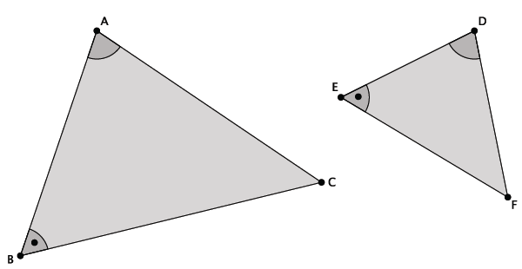

*Scaffolding:*

* Consider using cardboard cutouts (reproducible available at end of lesson) of the triangles as manipulatives to make the discussion of the proof less abstract. Cutouts can be given to small groups of students or used only by the teacher.
* Consider asking students to make their own cutouts. Have students create triangles with the same two angles, and for example and then compare their triangles with their neighbors.
* If we can show that is congruent to a triangle that is a dilated version of , then we can describe the similarity transformation to prove that . To do so, what scale factor should we choose?

**MP.2**

* + *We should let .*
* Since , we will dilate triangle from center by scale factor to produce as shown below.

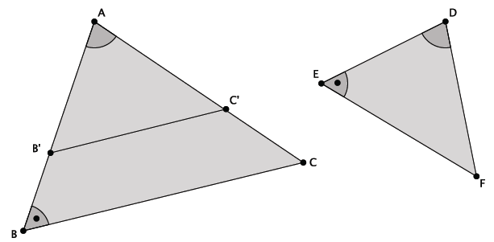

* Have we constructed a triangle so that ? Explain. Hint: Use ASA for congruence.

**MP.5**

Provide students time to discuss this question in small groups.

*Scaffolding:*

Ask a direct question: Why is Then instruct students to prove the triangles are congruent using ASA. If necessary, ask students to explain why why and why

* + Proof using ASA for congruence:
  + Angle: Given.
  + Side: . The first equality is true because is a dilation of by scale factor . The second equality is true because is defined by
  + Angle: By the dilation theorem, Therefore because corresponding angles of parallel lines are equal in measure. Finally, is given.
  + Therefore, by ASA.
* Now we have the following diagram.

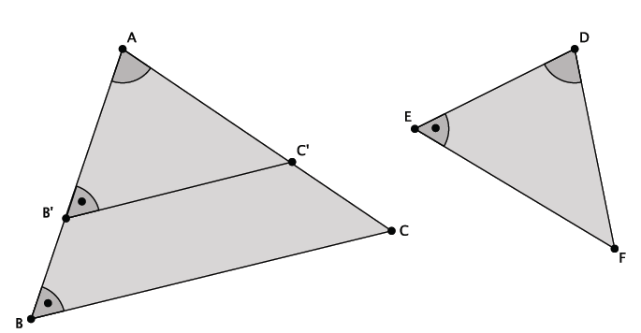

* Therefore, there is a composition of basic rigid motions that takes to Thus, a dilation with scale factor composed with basic rigid motions takes to Since a similarity transformation exists that maps to , then

Exercises 7–10 (9 minutes)

In Exercises 7–10, students practice using the AA criterion to determine if two triangles are similar and then determine unknown side lengths and/or angle measures of the triangles.

Exercises 7–10

1. Are the triangles shown below similar? Explain. If the triangles are similar, identify any missing angle and side length measures.



28

Yes, the triangles are similar because they have two pairs of equal corresponding angles. By the AA criterion, they must be similar. The angle measures and side lengths are shown below.

1. Are the triangles shown below similar? Explain. If the triangles are similar, identify any missing angle and side length measures.

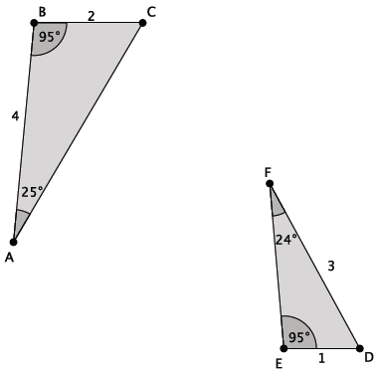

*The triangles are not similar because they have just one pair of corresponding equal angles. By the triangle sum theorem, and . Since similar triangles must have equal corresponding angles, we can conclude that the triangles shown are not similar.*

1. The triangles shown below are similar. Use what you know about similar triangles to find the missing side lengths and .

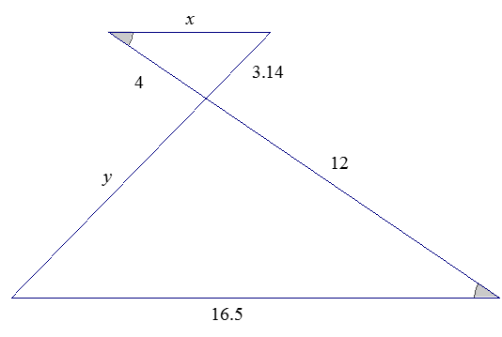

Side length is units, and side length is units.

1. The triangles shown below are similar. Write an explanation to a student, Claudia, of how to find the lengths of and

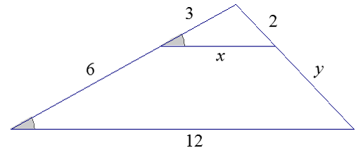

Claudia,

We are given that the triangles are similar; therefore, we know that they have equal corresponding angles and corresponding sides that are equal in ratio. For that reason, we can write , which represents two pairs of corresponding sides of the two triangles. We can solve for as follows.

We can solve for in a similar manner. We begin by writing two pairs of corresponding sides as equal ratios, making sure that one of the ratios contains the length .

Therefore, side length is units, and side length is units.

Closing (4 minutes)

* Explain what the AA criterion means.
  + *It means that when two pairs of corresponding angles of two triangles are equal, the triangles are similar.*
* Why is it enough to check only two conditions, two pairs of corresponding angles, as opposed to all six conditions ( angles and sides), to conclude that a pair of triangles are similar?
  + *We know that for two triangles, when two pairs of corresponding angles are equal and the included corresponding sides are equal in length, the triangles are congruent. By the triangle sum theorem, we can actually state that all three pairs of corresponding angles of the triangles are equal. Since a unique triangle is formed by two fixed angles and a fixed included side length, the other two sides are also fixed by the construction, meeting all criteria. In the case of similarity, given two pairs of equal angles, we would expect the lengths of the corresponding included sides to be equal in ratio to the scale factor, again meeting all conditions. For this reason, we can conclude that two triangles are similar by verifying that two pairs of corresponding angles are equal.*

Exit Ticket (5 minutes)

Name Date

Lesson 15: The Angle-Angle (AA) Criterion for Two Triangles to be Similar

Exit Ticket

1. 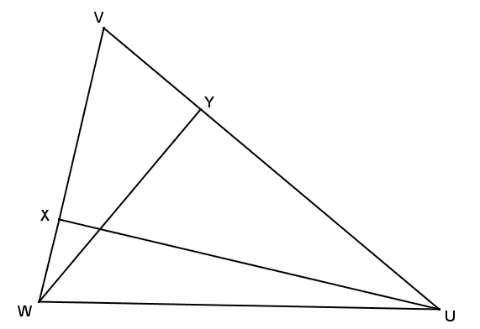Given the diagram to the right, , and . Show that .
2. 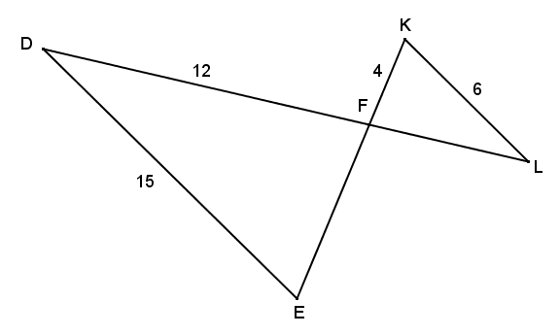Given the diagram to the right and , find and .

Exit Ticket Sample Solutions

1. Given the diagram to the right, , and . Show that .

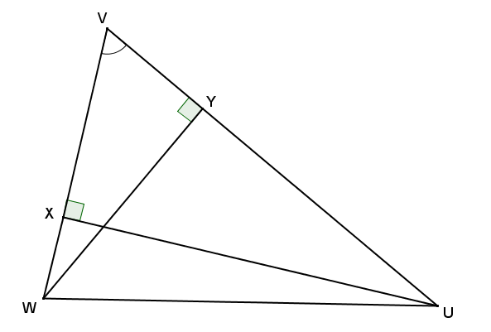By the definition of perpendicular lines, and are right angles, and all right angles are congruent, so . Both and share , and by reflexive property . Therefore, by the criterion for proving similar triangles, .

1. Given the diagram to the right and , find and .

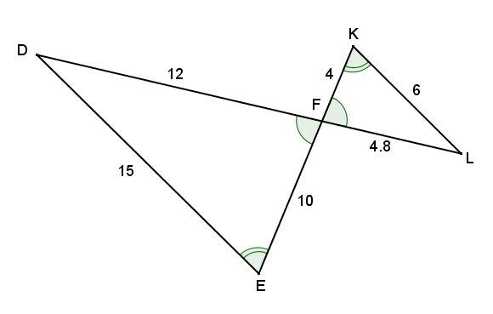By alt. int. , it follows that (and by a similar argument, ). and are vertically opposite angles and therefore congruent. By AA criterion for proving similar triangles, . Therefore,

.

|  |  |
| --- | --- |
|  |  |

Using the relationship of similar triangles, , and .

Problem Set Sample Solutions

1. 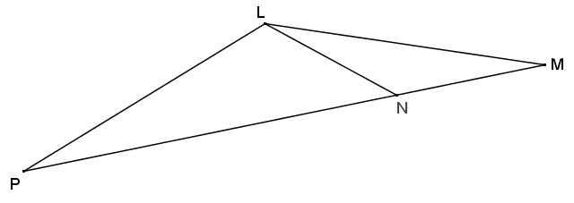In the figure to the right, .
   1. Classify based on what you know about similar triangles, and justify your reasoning.

By the given similarity statement, and are corresponding vertices; therefore, the angles at and must be congruent. This means that is an isosceles triangle by conv. base 's.

* 1. If , find the remaining angles in the diagram.

*, , , , , and . Triangle is also isosceles.*

1. 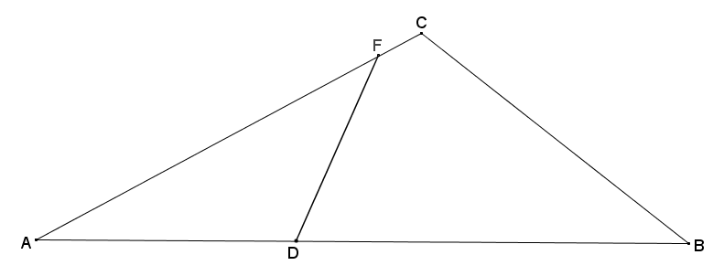In the diagram below, . Determine whether the following statements must be true from the given information, and explain why.

This statement is true because corresponding vertices are the same as in the given similarity statement but are listed in a different order.

There is no information given to draw this conclusion.

There is no information given to draw this conclusion.



This statement is true because corresponding vertices are the same as in the given similarity statement but listed in a different order.

1. 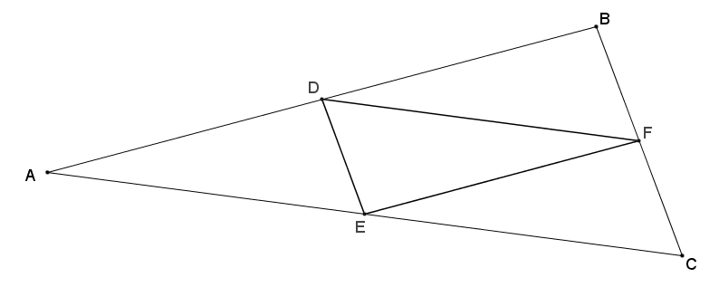In the diagram below, is the midpoint of , is the midpoint of , and is the midpoint of . Prove that .

Using the triangle side splitter theorem, since , , and are all midpoints of the sides of , the sides are cut proportionally; therefore, , , and . This provides multiple pairs of parallel lines with parallel transversals.

by corresponding 's, , and by alternate interior 's, , so by transitivity, .

by corresponding 's, , and by alternate interior 's, , so by transitivity, .

by the AA criterion for proving similar triangles.

1. 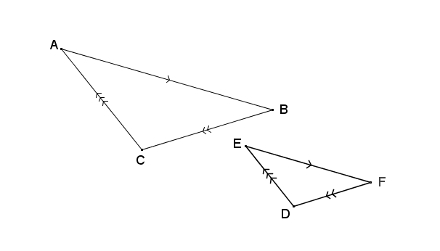Use the diagram below to answer each part.
   1. If , , and , prove that the triangles are similar.

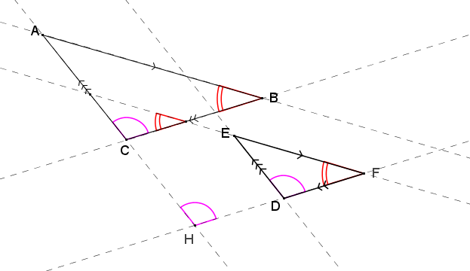By extending all sides of both triangles, there are several pairs of parallel lines cut by parallel transversals. Using corresponding angles within parallel lines and transitivity, by the AA criterion for proving similar triangles.

* 1. The triangles are not congruent. Find the dilation that takes one to the other.

Extend lines joining corresponding vertices to find their intersection , which is the center of dilation.

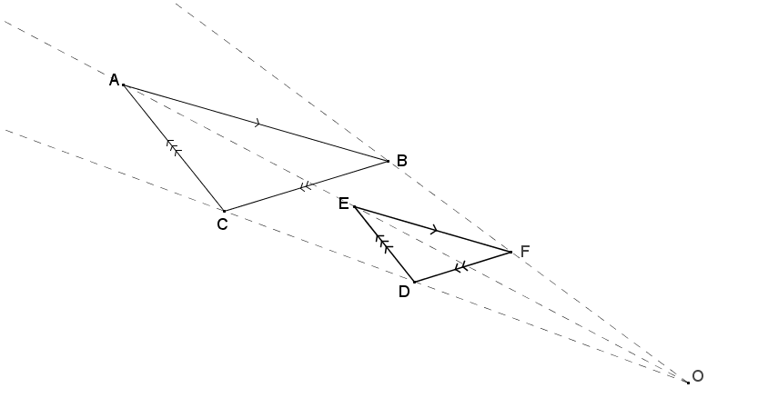

1. Given trapezoid , and , prove that .

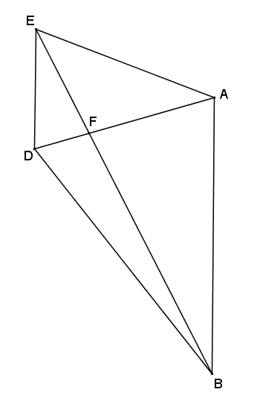

From the given information, by alternate interior 's, (by the same argument, ). Furthermore, because vertical angles are congruent. Therefore, by the AA criterion for proving similar triangles.

Cutouts to use for in-class discussion:

