Lesson 15: The Angle-Angle (AA) Criterion for Two Triangles to be Similar

Classwork

Exercises 1–5

1. Draw two triangles of different sizes with two pairs of equal angles. Then measure the lengths of the corresponding sides to verify that the ratio of their lengths is proportional. Use a ruler, compass, or protractor, as necessary.
2. Are the triangles you drew in Exercise 1 similar? Explain.
3. Why is it that you only needed to construct triangles where two pairs of angles were equal and not three?
4. Why were the ratios of the corresponding sides proportional?
5. Do you think that what you observed will be true when you construct a pair of triangles with two pairs of equal angles? Explain.

Exercises 6–10

1. Draw another two triangles of different sizes with two pairs of equal angles. Then measure the lengths of the corresponding sides to verify that the ratio of their lengths is proportional. Use a ruler, compass, or protractor, as necessary.
2. Are the triangles shown below similar? Explain. If the triangles are similar, identify any missing angle and side length measures.



28

1. Are the triangles shown below similar? Explain. If the triangles are similar identify any missing angle and side length measures.

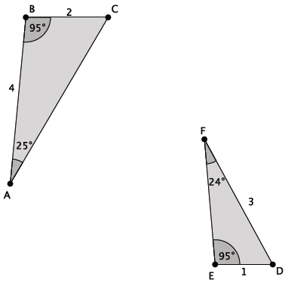

1. The triangles shown below are similar. Use what you know about similar triangles to find the missing side lengths and .

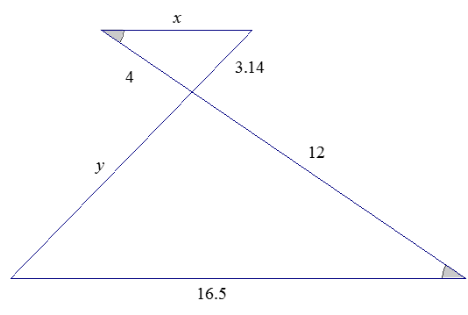

1. The triangles shown below are similar. Write an explanation to a student, Claudia, of how to find the lengths of and

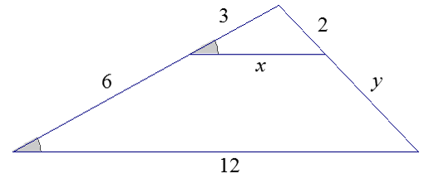

Problem Set

1. In the figure to the right, .

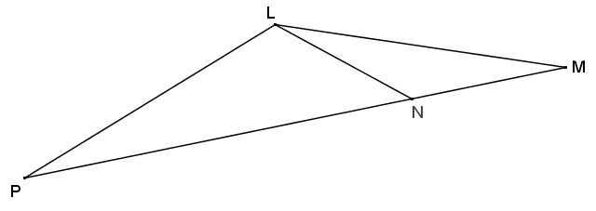

* 1. Classify based on what you know about similar triangles and justify your reasoning.
  2. If , find the remaining angles in the diagram.

1. 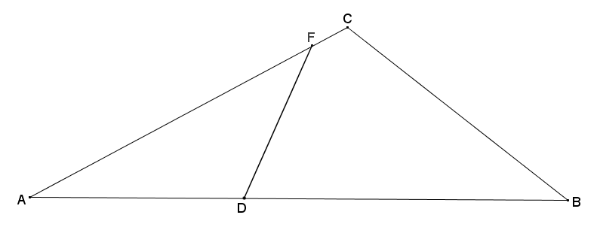In the diagram below, . Determine whether the following statements must be true from the given information, and explain why.
2. 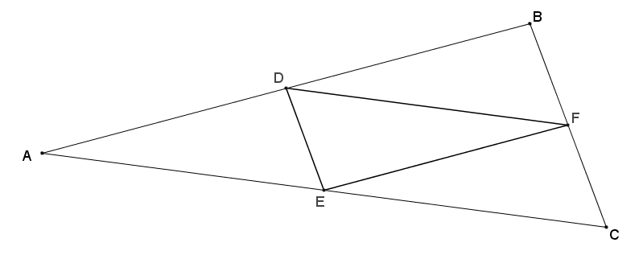In the diagram below, is the midpoint of , is the midpoint of , and is the midpoint of . Prove that .
3. 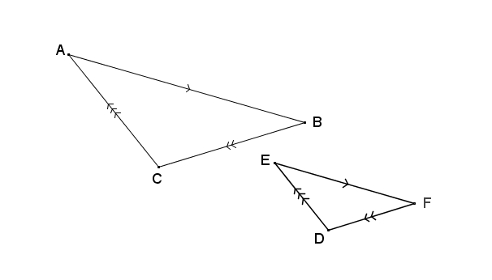Use the diagram below to answer each part.
   1. If , , and , prove that the triangles are similar.
   2. The triangles are not congruent. Find the dilation that takes one to the other.
4. Given trapezoid , and , prove that .

