|  |
| --- |
|  |

Lesson 14: Similarity

Student Outcomes

* Students understand that similarity is reflexive, symmetric, and transitive.
* Students recognize that if two triangles are similar, there is a correspondence such that corresponding pairs of angles have the same measure and corresponding sides are proportional. Conversely, they know that if there is a correspondence satisfying these conditions, then there is a similarity transformation taking one triangle to the other respecting the correspondence.

Lesson Notes

In Lesson 14, students delve more deeply into what it means for figures to be similar. Examples address the properties of similarity and also focus on circles and finally triangles. We note here that Lessons 12–13 were, again, intentionally not focused on triangles, to emphasize that as instructors we need to move away from equating similarity with triangles, or strictly rectilinear figures in our minds, and rather think of and teach similarity as a broader concept. With this idea imprinted on the last two lessons, we turn our attention to triangles in the second half of this lesson, in order to prepare for triangle similarity criteria in Lessons 15 and 17.

Classwork

**Opening (4 minutes)**

* As initially mentioned in Lesson 12, two figures in the plane are similar if there is a similarity transformation that takes one to the other. If and are similar, we write where “” denotes similarity.
* Which of the following properties do you believe to be true? Vote yes by raising your hand.
* For a Figure in the plane, do you believe that ?

After taking the vote, show students a simple figure such as the following triangle and ask them to reconsider if the figure is similar to itself.

Allow students 30 seconds to justify their responses in a sentence, and then have them compare reasons with a neighbor before sharing out and moving onto the next property.

**MP.3**

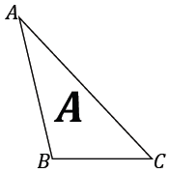

*Scaffolding:*

For struggling students, place the triangles in the coordinate plane.

* For two figures and in the plane, do you believe that if , then ?

After taking the vote, show Figures and , and ask them to reconsider if is similar to , then is similar to .

Allow students 30 seconds to justify their responses in a sentence and, then have them compare reasons with a neighbor before sharing out and moving onto the next property.

**MP.3**

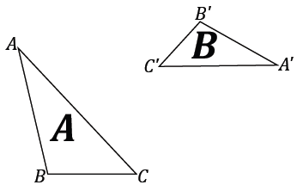

* For Figures , and in the plane, do you believe that if and, then ?

After taking the vote, show students Figures , , and and ask them to reconsider if is similar to , and is similar to , then is similar to .

Allow students 30 seconds to justify their responses in a sentence, and then have them compare reasons with a neighbor before sharing out and moving onto the next property.

**MP.3**

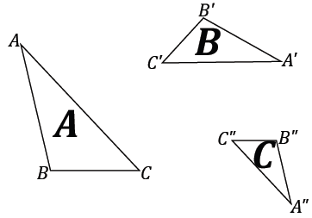

Announce that the properties are in fact true and state them:

* For each figure in the plane, . Similarity is reflexive.
* If and are figures in the plane so that , then . Similarity is symmetric.
* If and are figures in the plane such that and , then . Similarity is transitive.
* In Examples 1 and 2, we will form informal arguments to prove why the conditions on similarity must be true.

Example 1 (4 minutes)

Present the question to the class, and then consider employing any discussion strategies you commonly use for a brief brainstorming session, whether it is a whole-group share out, timed talk and turn session with a neighbor, or a Quick Write. Allow about 2 minutes for whichever strategy is selected and the remaining 2 minutes sharing out as a whole group, demonstrating as needed any of the student’s suggestions on the board.

Example 1

We said that for a figure in the plane, it must be true that . Describe why this must be true.

* Remember, to show that two figures are similar, there must be a similarity transformation that maps one to the other. Are there such transformations to show that maps to ?

Take multiple suggestions of transformations that map to :

**MP.3**

* There are several different transformations that will map onto itself such as a rotation of or a rotation of .
* A reflection of across a line and a reflection right back will achieve the same result.
* A translation with a vector of length also maps to .
* A dilation with scale factor will map to , and any combination of these transformations will also map   
   to .
* Therefore, must be similar to because there are many similarity transformations that will map to .
* This condition is labeled as reflexive because every figure is similar to itself.

Example 2 (4 minutes)

Present the question to the class, and then consider employing any discussion strategies you commonly use for a brief brainstorming session, whether it is a whole-group share out, timed talk and turn session with a neighbor, or a Quick Write. Allow about 2 minutes for whichever strategy is selected and the remaining 2 minutes sharing out as a whole group, demonstrating as needed any of the student’s suggestions on the board.

Example 2

We said that for figures and in the plane so that , then it must be true that . Describe why this must be true.

Now that students have completed Example 1, allow them time to discuss Example 2 among themselves.

* This condition must be true because for any composition of transformations that maps to , there will be a composition of transformations that can undo the first composition. For example, if a translation by vector maps to , then the vector will undo the transformation and map to .
* A rotation of in the counterclockwise direction can be undone by a rotation of in the clockwise direction.
* A dilation by a scale factor of can be undone with a dilation by a scale factor of .
* A reflection across a line can be undone by a reflection back across the same line.
* Therefore, it must be true that if a figure is similar to a figure in the plane, or, in other words, if there is a similarity transformation that maps to , then there must also be a composition of transformations that can undo that similarity transformation and map back to .
* This condition is labeled as symmetric because of its likeness to the symmetric property of equality where if one number is equal to another number, then they both must have the same value (if , then ).

We leave the third condition, that similarity is transitive, for the Problem Set.

Example 3 (10 minutes)

In Example 3, students must show that any circle is similar to any other circle. Note we use the term similar here, unlike in Lesson 8 where students proved the dilation theorem for circles. Encourage students to first discuss the question with a partner.

Example 3

*Scaffolding:*

* For more advanced learners, have students discuss what cases must be considered in order to show similarity between circles.
* Consider assigning cases (a), (b), and (c) to small groups. Share out results after allowing for group discussion. Case (b) is likely the easiest case to consider since the circles are congruent by a translation and, therefore, also similar.

Based on the definition of *similar,* how would you show that any two circles are similar?

Based on your students’ discussions, provide students with the following cases to help them along:

* Consider the different cases you must address in showing that any two circles are similar to each other:

1. Circles with different centers but radii of equal length

**MP.3**

* + *If two circles have different centers but have radii of equal length, then the circles are congruent, and a translation along a vector that brings one center to the other will map one circle onto the other.*

1. Circles with the same center but radii of different lengths
   * *If two circles have the same center, but one circle has radius and the other has radius , then a dilation about the center with scale factor will map one circle onto the other so that .*
2. Circles with different centers and radii of different lengths
   * *If two circles have different centers and radii of different lengths, then the composition of a dilation described in (b) and the translation described in (a) will map one onto the other.*

Students may notice that two circles with different centers and different radii length may alternatively be mapped onto each other by a single dilation as shown in the following image.



**Discussion (3 minutes)**

This Discussion leads to the proof of the converse of the theorem on similar triangles in Example 4.

* What do we mean when we say that two triangles are similar?
  + *Two triangles* *and* *are similar if there is a similarity transformation that maps* *to* .
* When we write , we mean, additionally, that the similarity transformation takes to , to , and to . So when we see , we know that a correspondence exists such that the corresponding angles are equal in measurement and the corresponding lengths of sides are proportional; i.e., ,, , and .
* **Theorem on similar triangles:** If , then ,, , and .

Example 4 (7 minutes)

Example 4 asks students whether the converse of the theorem on similar triangles is true. Students begin with the fact that a correspondence exists between two triangles or that the corresponding lengths are proportional and corresponding angles are equal in measurement. Students must argue whether this makes the triangles similar.

The argument may not be a stretch for students to make since they have worked through the original argument. Allow students a few minutes to attempt the informal proof before reviewing it with them.

Example 4

Suppose and under this correspondence, corresponding angles are equal and corresponding sides are proportional. Does this guarantee that and are similar?

* We have already shown that if two figures (e.g., triangles) are similar, then corresponding angles are of equal measurement and corresponding sides are proportional in length.
* This question is asking whether the converse of the theorem is true. We know that a correspondence exists between and . What does the correspondence imply?
  + *The correspondence implies that* ,, , *and* .
* We will show there is a similarity transformation taking to that starts with a dilation. How can we use what we know about the correspondence to express the scale factor ?
  + *Since the side lengths are proportional under the correspondence, then .*
* The dilation that takes to can have any point for a center. The dilation maps to , to , and to so that .
* How would you describe the length ?
* We take this one step further and say that . Similarly, and . So all the sides and all the angles of and match up, and the triangles are congruent.
* Since they are congruent, a sequence of basic rigid motions takes to .
* So a dilation takes to , and a congruence transformation takes to , and we conclude that .

Example 5 (7 minutes)

The intent of Example 5 is to highlight how an efficient sequence of transformations can be found to map one figure onto its similar image. There are many sequences that will get the job done, but the goal here is to show the least number of needed transformations to map one triangle onto the other.

*Scaffolding:*

Example 5 is directed at more advanced learners who show proficiency with similarity transformations. The question poses an interesting consideration but is not a requirement. In general, time and focus in this lesson should be placed on the content preceding Example 5.

Example 5

1. In the diagram below, . Describe a similarity transformation that maps   
    to .

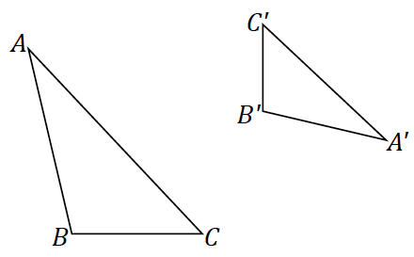

Students will most likely describe some sequence that involves a dilation, a reflection, a translation, and a rotation. Direct them to part (b).

1. Joel says the sequence must require a dilation and three rigid motions, but Sharon is sure there is a similarity composed of just a dilation and just two rigid motions. Who is right?

Allow students to struggle with the question before revealing that it is in fact possible to describe a similarity composed of a dilation and just two rigid motions shown in the following sequence.

* Step 1: Dilate by a scale factor and center so that (1) the resulting is congruent to  
   and (2) one pair of corresponding vertices coincide.

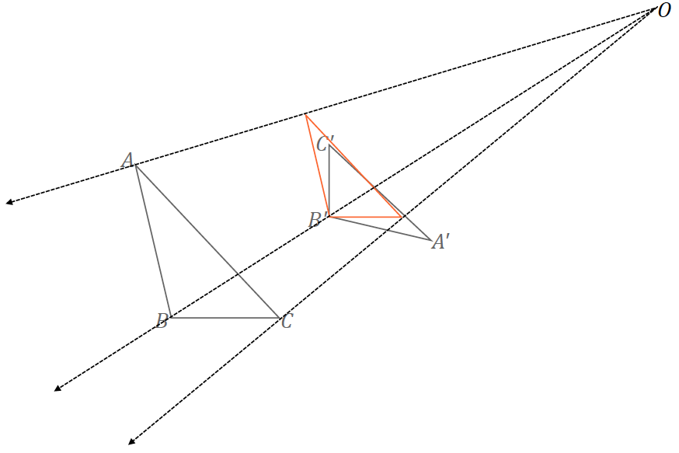

* Step 2: Reflect the dilated triangle across .

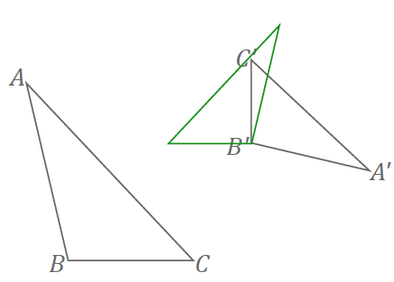

* Step 3: Rotate the reflected triangle until it coincides with .

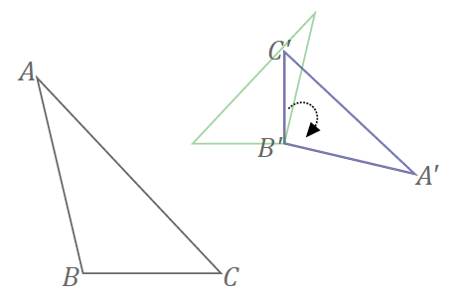

* We have found a similarity transformation that maps to with just one dilation and two rigid motions instead of three.

Closing (1 minute)

* What does it mean for similarity to be reflexive? Symmetric?

Students develop an informal argument for why similarity is transitive in the Problem Set.

* + *Similarity is reflexive because a figure is similar to itself. Similarity is symmetric because once a similarity transformation is determined to take a figure to another, there are inverse transformations that will take the figure back to the original.*
* We have seen in our earlier work that if two figures, e.g., two triangles, are similar, then there exists a correspondence such that corresponding lengths are proportional and corresponding angles are equal in measurement. What is the converse of this statement? Is it true?

Lesson Summary

Similarity is reflexive because a figure is similar to itself.

Similarity is symmetric because once a similarity transformation is determined to take a figure to another, there are inverse transformations that will take the figure back to the original.

Exit Ticket (5 minutes)

Name Date

Lesson 14: Similarity

Exit Ticket

1. In the diagram, by the dilation with center and scale factor . Explain why .

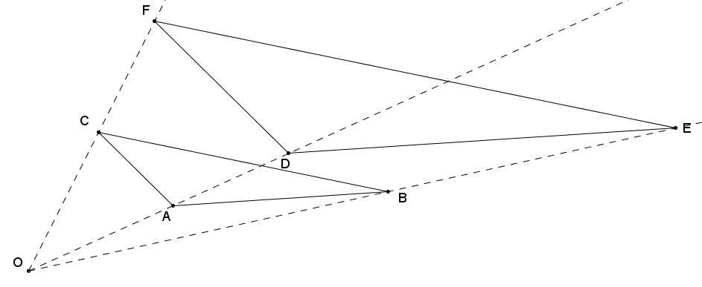

1. 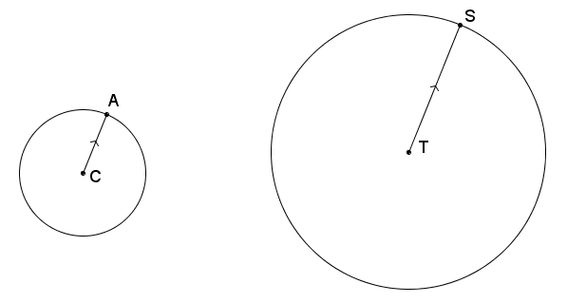Radii and are parallel. Is circle similar to circle ? Explain.
2. Two triangles, and , are in the plane so that ,, , and . Summarize the argument that proves that the triangles must be similar.

Exit Ticket Sample Solutions

1. In the diagram, by the dilation with center and scale factor . Explain why .

We know that by a dilation with center and scale factor . A dilation with the same center but scale factor maps onto ; this means .

1. Radii and are parallel. Is circle similar to circle ? Explain.

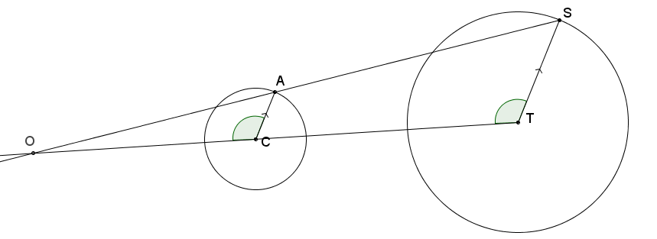Yes, the circles are similar because a dilation with center and   
scale factor exists that maps onto .

1. Two triangles, and , are in the plane so that ,, , and . Briefly describe the argument that proves that the triangles must be similar.

A dilation exists such that the lengths of one triangle will be made equal to the lengths of the other triangle. Once the triangles have lengths and angles of equal measurement, or are congruent, then a sequence of rigid motions will map one triangle to the other. Therefore, a similarity transformation exists that maps one triangle onto the other, and the triangles must be similar.

Problem Set Sample Solutions

1. If you are given any two congruent triangles, describe a sequence of basic rigid motions that will take one to the other.



Translate one triangle to the other by a vector so that the triangles coincide at a vertex.

Case 1: If both triangles are of the same orientation, simply rotate about the common vertex until the triangles coincide.

Case 2: If the triangles are of opposite orientations, reflect the one triangle over one of its two sides that include the common vertex, and then rotate around the common vertex until the triangles coincide.

1. If you are given two similar triangles that are not congruent triangles, describe a sequence of dilations and basic rigid motions that will take one to the other.



Dilate one triangle with a center such that when the lengths of its sides are equal to the corresponding lengths of the other triangle, one pair of corresponding vertices will coincide. Then follow one of the sequences described in Case 1 or Case 2 of Problem 1.

Students may have other similarity transformations that map one triangle to the other consisting of translations, reflections, rotations, and dilations. For example, they might dilate one triangle until the corresponding lengths are equal, then translate one triangle to the other by a vector so that the triangles coincide at a vertex, and then follow one of the sequences described in Case 1 or Case 2 of Problem 1.

1. Given two line segments, and , of different lengths, answer the following questions.
   1. It is always possible to find a similarity transformation that maps to sending to and to . Describe one such similarity transformation.

Rotate so that it is parallel to with corresponding points and (and likewise and ) on the same side of each line segment. Then translate the image of by a vector so that the midpoint of coincides with the midpoint of . Finally, dilate until the two segments are equal in length.

* 1. If you are given that and are not parallel, are not congruent, do not share any points, and do not lie in the same line, what is the least number of transformations needed in a sequence to map to ? Which transformations make this work?

Rotate to so that and are parallel and oriented in the same direction; then use the fact that there is a dilation that takes to .

* 1. If you performed a similarity transformation that instead takes to and to , either describe what mistake was made in the similarity transformation, or describe what additional transformation is needed to fix the error so that maps to and maps to .

The rotation in the similarity transformation was not sufficient to orient the directed line segments in the same direction, resulting in mismatched corresponding points. This error could be fixed by changing the rotation such that the desired corresponding endpoints lie on the same end of each segment.

If the desired endpoints do not coincide after a similarity transformation, rotate the line segment about its midpoint by .



1. We claim that similarity is transitive, i.e., that if, , and are figures in the plane such that and , then . Describe why this must be true.

If similarity transformation maps to and similarity transformation maps to , then the composition of basic rigid motions and dilations that takes to together with the composition of basic rigid motions and dilations that takes to , shows that .

1. Given two line segments, and , of different lengths, we have seen that it is always possible to find a similarity transformation that maps to , sending to and to with one rotation and one dilation. Can you do this with one reflection and one dilation?



Yes. Reflect to so that and are parallel, and then use the fact that there is a dilation that takes to .

1. Given two triangles, , is it always possible to rotate so that the sides of are parallel to the corresponding sides in ; i.e., , etc.?

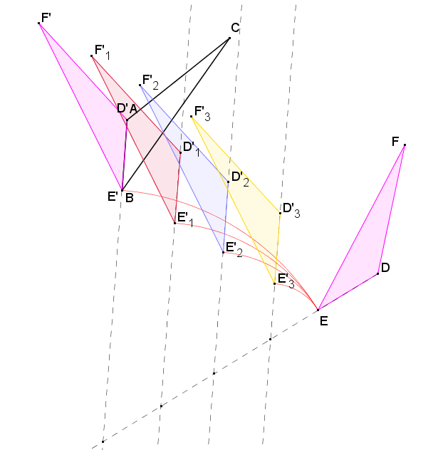No, it is not always possible. Sometimes a reflection is necessary. If you consider the diagram below, can be rotated in various ways such that either coincides with or is parallel to , where corresponding points and are located at the same end of the segment. However, in each case, lies on one side of but is opposite the side on which lies with regard to . This means that a reflection is necessary to reorient the third vertex of the triangle.