Lesson 14: Similarity

Classwork

**Example 1**

We said that for a figure in the plane, it must be true that . Describe why this must be true.

Example 2

We said that for figures and in the plane so that , then it must be true that . Describe why this must be true.

Example 3

Based on the definition of *similar,* how would you show that any two circles are similar?

Example 4

Suppose and under this correspondence, corresponding angles are equal and corresponding sides are proportional. Does this guarantee that and are similar?

Example 5

* 1. In the diagram below, . Describe a similarity transformation that maps   
      to .

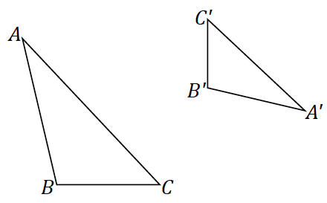

* 1. Joel says the sequence must require a dilation and three rigid motions, but Sharon is sure there is a similarity composed of just a dilation and just two rigid motions. Who is right?

Problem Set

1. If you are given any two congruent triangles, describe a sequence of basic rigid motions that will take one to the other.

Lesson Summary

Similarity is reflexive because a figure is similar to itself.

Similarity is symmetric because once a similarity transformation is determined to take a figure to another, there are inverse transformations that will take the figure back to the original.

1. If you are given two similar triangles that are not congruent triangles, describe a sequence of dilations and basic rigid motions that will take one to the other.
2. Given two line segments, and , of different lengths, answer the following questions.
   1. It is always possible to find a similarity transformation that maps to sending to and to . Describe one such similarity transformation.
   2. If you are given that and are not parallel, are not congruent, do not share any points, and do not lie in the same line, what is the least number of transformations needed in a sequence to map to ? Which transformations make this work?
   3. If you performed a similarity transformation that instead takes to and to , either describe what mistake was made in the similarity transformation, or describe what additional transformation is needed to fix the error so that maps to and maps to .
3. We claim that similarity is transitive, i.e., that if, , and are figures in the plane such that and , then . Describe why this must be true.
4. Given two line segments, and , of different lengths, we have seen that it is always possible to find a similarity transformation that maps to , sending to and to with one rotation and one dilation. Can you do this with one reflection and one dilation?
5. Given two triangles, , is it always possible to rotate so that the sides of are parallel to the corresponding sides in ; i.e., , etc.?