Lesson 13: Properties of Similarity Transformations

Student Outcomes
- Students know the properties of a similarity transformation are determined by the transformations that compose the similarity transformation.
- Students are able to apply a similarity transformation to a figure by construction.

Lesson Notes
In Lesson 13, students apply similarity transformations to figures by construction. It is important to note here that teachers should emphasize unhurried, methodical drawing and careful use of tools to students. Each exercise entails many construction marks, and part of students’ success will depend on their perseverance. Having said that, this is the only lesson where students actually construct what happens to a figure that undergoes a similarity transformation; students experience this process once to witness how the points of a figure move about the plane instead of just hearing about it or describing it.
Just as part of any lesson preparation, it is a good idea to do the examples to better anticipate where students will have difficulty. Teachers should tailor the number examples for their respective classes. Examples of varying difficulty have been provided so that teachers have options to differentiate for their diverse classrooms.
Finally, space will be available in the student books, but teachers may feel it best to work outside of the books to maximize available space. This can be done by photocopying the initial image onto blank paper. The initial image of each problem is provided at the close of the lesson.

Classwork
Scaffolding:
- To help organize students’ thinking, write a list of all possible similarity transformations that are composed of exactly two different transformations. Consider why those that contain a dilation do not preserve distance, and keep all other properties that are consistent across each of the similarity transformations in the list as properties of similarity transformations.
- Two examples of similarity transformations are (1) a translation and reflection and (2) a reflection and dilation.

Opening (10 minutes)
- We have spent a good deal of time discussing the properties of transformations. For example, we know that the property that distinguishes dilations from rigid motions is that dilations do not preserve distance, whereas translations, rotations, and reflections do preserve distance.
- Take a few moments with a partner to list all the properties that all the transformations have in common.
- As these properties are true for all dilations, reflections, rotations, and translations (the transformations that comprise similarity transformations) also hold true for similarity transformations in general. Title your list as “Properties of Similarity Transformations.”
Allow students time to develop as complete a list as possible of the properties. Develop a comprehensive class list. Consider having a pre-made poster with all the properties listed, and keep each property covered. This can be done on a physical poster with a strip of paper or on a projector or interactive whiteboard. As students list the properties they recalled, reveal that property from the poster. After students have offered their lists, review any remaining properties that were not mentioned. A few words are mentioned below in anticipation of the properties that students may not recall.

Properties of similarity transformations:
- Distinct points are mapped to distinct points.
Scaffolding:
Post the complete list of properties of similarity transformations in a prominent place in the classroom.
- This means that if $P≠Q$, then for a transformation $G$, $G\left(P\right)≠G(Q)$.

- Each point $P'$ in the plane has a pre-image.
- If $P'$ is a point in the plane then $P^{'}=G(P)$ for some point $P$.

- There is a scale factor $r$ for $G$ so that for any pair of points $P$ and $Q$ with images $P^{'}=G(P)$ and $Q^{'}=G(Q)$, then $P^{'}Q^{'}=rPQ$.
- The scale factor for a similarity transformation is the product of the scale factors. Remember, the scale factor associated to any congruence transformation is $1$. The scale factor of a similarity transformation is really the product of the scale factors of all the transformations that compose the similarity; however, since we know the scale factor of all rigid motions is $1$, the scale factor of the similarity transformation is the product of the scale factors of all the dilations in the similarity.

- A similarity transformation sends lines to lines, rays to rays, line segments to line segments, and parallel lines to parallel lines.
- A similarity transformation sends angles to angles of equal measure.
- A similarity transformation maps a circle of radius $R$ to a circle of radius $rR$, where $r$ is the scale factor of the similarity transformation.

- All of the properties are satisfied by a similarity transformation consisting of a single translation, reflection, rotation, or dilation. If the similarity transformation consists of more than one such transformation, then the properties still hold because they hold one step at a time.
- For instance, if $G$ is the composition of three transformations $G_{1}$,$G_{2}$,$G_{3}$, where each of $G_{1}$,$G_{2}$,$G_{3}$ is a translation, reflection, rotation, or dilation, then since $G_{1}$ maps a pair of parallel lines to second pair of parallel lines which are then taken by $G_{2}$ to another pair of parallel lines which are then taken by $G_{3}$ to yet another pair of parallel lines. The composition of $G_{1}$,$G_{2}$,$G_{3}$ takes any pair of parallel lines to another pair of parallel lines.
- We keep these properties in mind as we work on examples where multiple transformations comprise the similarity transformation.

Example 1 (10 minutes)
Scaffolding:
- Depending on student ability and time, consider limiting $G$ to the first two transformations.
- Consider placing examples on the coordinate plane, on grid paper, and/or using transparencies, patty paper, or geometry software.
Students will apply a similarity transformation to an initial figure and determine the image. Review the steps to apply a reflection and rotation in Example 1.
MP.1
- Use a compass, protractor, and straightedge to determine the image of the triangle.
Example 1
Similarity transformation $G$ consists of a rotation about the point $P$ by $90°$, followed by a dilation centered at $P$ with scale factor $r=2$, and then a reflection across line $l$. Find the image of the triangle.

- Before getting to the actual construction process, draw a predictive sketch of the image of the triangle after transformation. You should have three sketches.

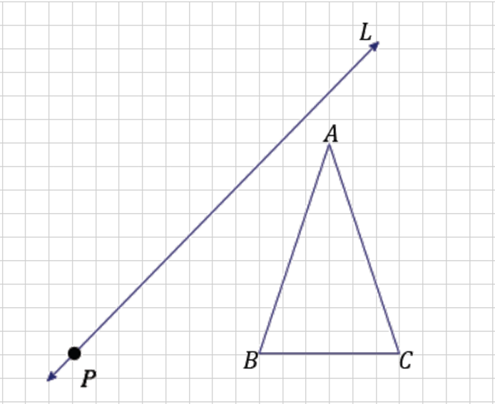
Drawing a predictive sketch helps illuminate the path ahead before getting into the details of each construction. The sketches also provide a time to reflect on how the properties are true for each transformation. For example, ask students to select a property from their list and describe where in their sketch they see it in the transformation. For instance, a student might select property (2), which states that each point has a pre-image $P$ and can point to each pre-image and image with each passing transformation.
$$l$$
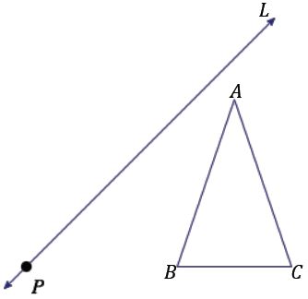
$$l$$

Complete this example with students. Remind them that the rotation will require all three geometry tools.
Note to the teacher: As an alternative strategy, you might consider using coordinate geometry by placing the image over an appropriately scaled grid. Students have had familiarity with coordinate geometry as used with transformations of the plane since Grade 8. The image on the right above has been provided for this alternative. Placement of the $x$- and $y$-axes can be determined where convenient for this example. Given this flexibility, most students will likely choose point $P$ to be the origin of the coordinate plane since two of the given transformations are centered at $P$.
- How will we rotate the triangle $90°$?
  - To locate the vertices of the triangle’s image, draw rays through each vertex of the triangle originating from $P$. Use each ray to form three $90°$ angles, and then use the compass to locate each new vertex on the corresponding ray.
Point out to students that in their constructions, the ray through $B'$ and $C'$ coincide and will appear to be one ray, giving an appearance of only two rays not three.
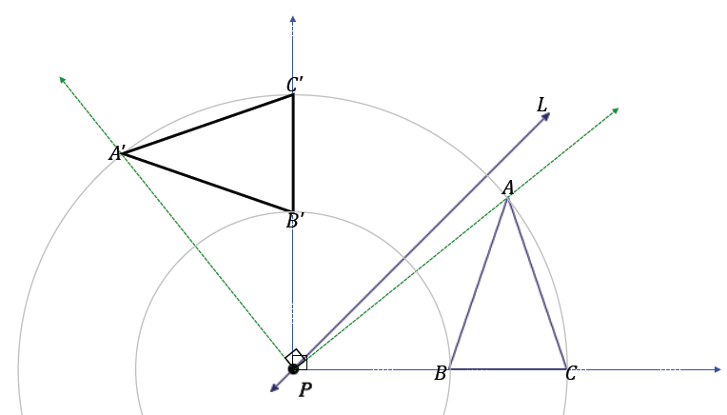
$$l$$
Next, allow students time to dilate $△A'B'C'$. If necessary, review the steps to create a dilation.
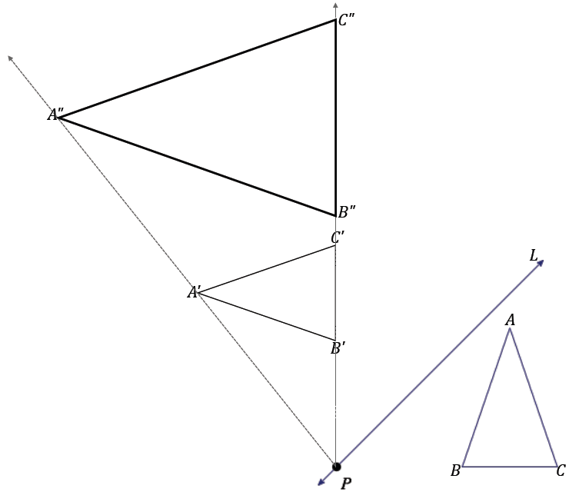
MP.1
$$l$$
- How will we reflect the triangle over the line?
  - Create the construction marks that determine the image of each vertex so that the line of reflection is the perpendicular bisector of the segment that joins each vertex with its image. In other words, we must create the construction marks so that the images of the vertices are located so that the line of reflection is the perpendicular bisector of $A''A'''$, $B''B'''$, $C''C'''$.
The steps to determine $B'''$ are shown below.
Scaffolding:
- Diagrams with more than two transformations of a figure can become cluttered very quickly. Consider allowing students to use different colored pencils (or pens) to complete each stage of the similarity transformation.
- Also to reduce clutter, draw only construction arcs as opposed to full construction circles as are shown in the diagram.

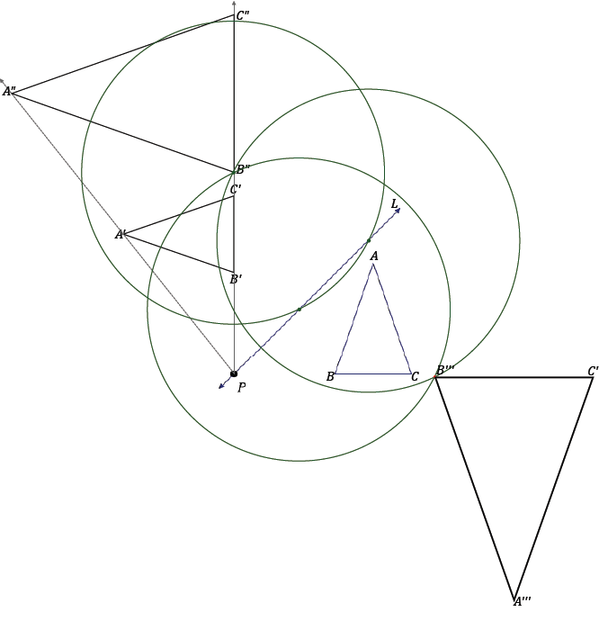
MP.1
$$l$$
- We have applied the outlined similarity transformation to $△ABC$ and found its image, i.e., the similar figure
$△A'''B'''C'''$.
- Since $G$ is composed of three individual transformations, and each of the transformations satisfies the known properties, we know that $G$ also satisfies the properties.

Example 2 (10 minutes)
Example 2 incorporates a translation, a reflection, and a dilation in the similarity transformation. Review the steps of how to apply a translation in Example 2.

Example 2
A similarity transformation $G$ applied to trapezoid $ABCD$ consists of a translation by vector $\vec{XY}$, followed by a reflection across line $m$, and then followed by a dilation centered at $P$ with scale factor $r=2$. Recall that we can describe the same sequence using the following notation: $D_{P,2}\left(r_{m}\left(T_{XY}\left(ABCD\right)\right)\right)$. Find the image of $ABCD$.

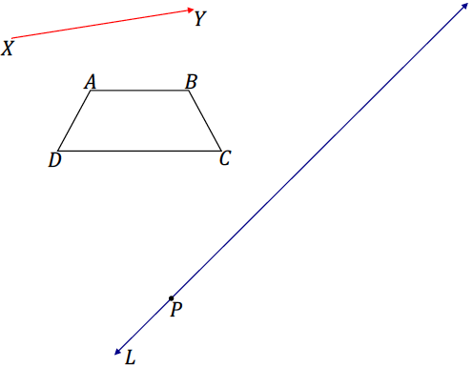
$$m$$

Encourage students to draw a predictive sketch for each stage of the transformation before beginning the construction.
- Describe the steps to apply the translation by vector $XY$ to one point of the figure.
  - To apply the translation to $A$, construct $C_{1}$: center $A$, radius $XY$. Then construct $C_{2}$: center $Y$, radius $YA'$.
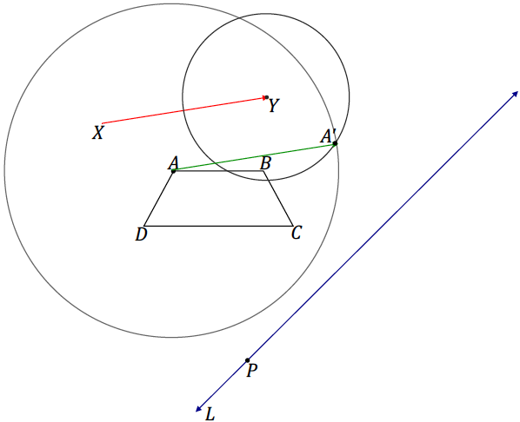
Scaffolding:
Help students get started at translating point $A$ by finding the fourth vertex, $A'$, of parallelogram $XAA'Y$. Finding the images of the remaining points $B, C$, and $D$ under the translation can be found by following similar processes.
$$C_{2}$$
$$C_{1}$$
$$m$$

The process for locating the image of $B$ under the translation is shown below:
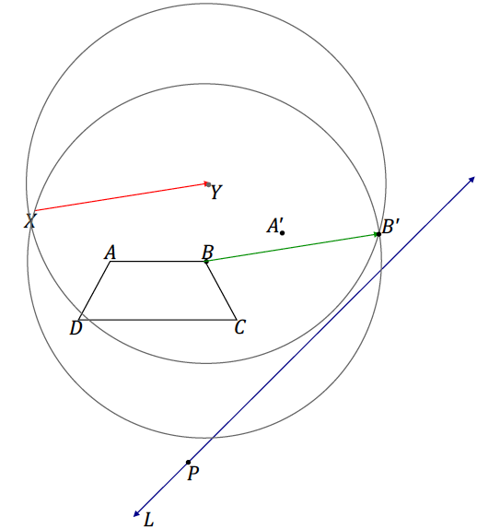
$$m$$

Allow students time to complete the rest of the example before reviewing it.
The following image shows the reflection of vertex $C$:
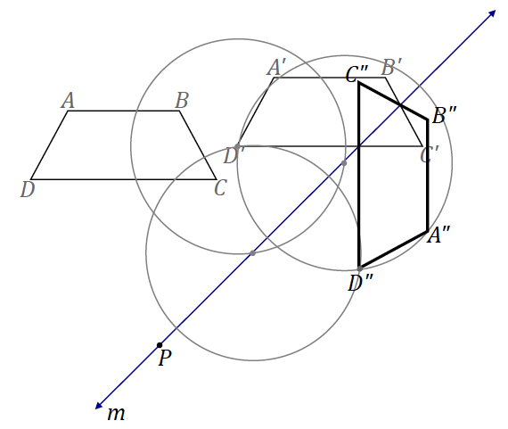

The following image shows the dilation of $ABCD$:
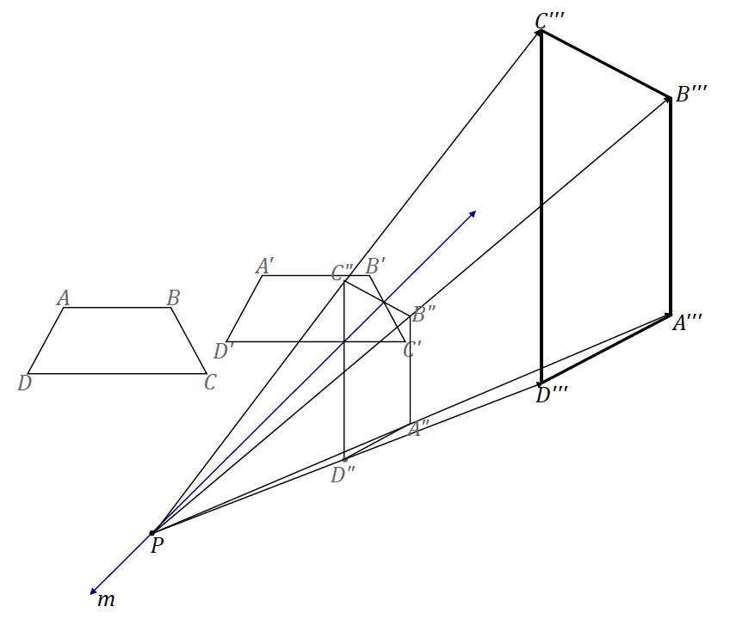

Exercise 1 (8 minutes)
Allow students to work on Exercise 1 independently. Encourage students to draw a predictive sketch for each stage of the transformation before beginning the construction.
Exercise 1
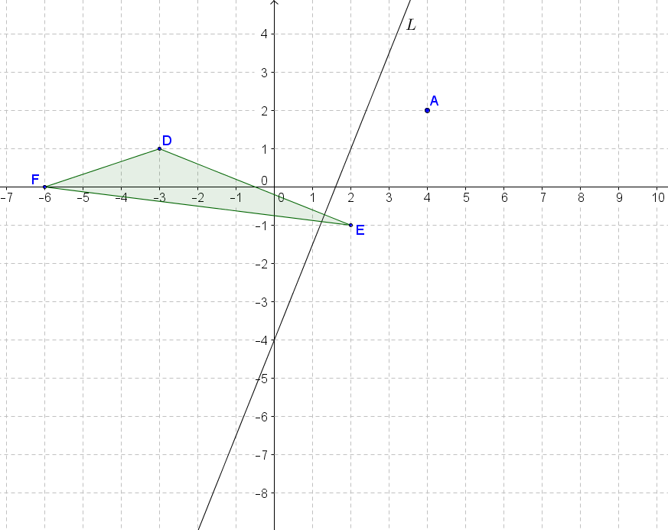
A similarity transformation for triangle $DEF$ is described by $r_{n}\left(D_{A,\frac{1}{2}}\left(R_{A,90°}\left(DEF\right)\right)\right)$. Locate and label the image of triangle $DEF$ under the similarity.
$$n$$
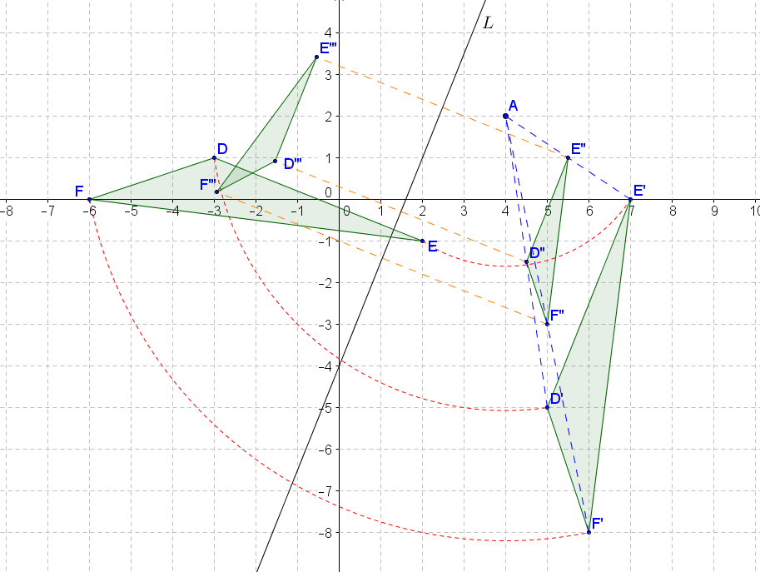
$$n$$

Closing (2 minutes)
- Why are the properties of a similarity transformation the same as those of both dilations and rigid motions?
  - The properties enjoyed by individual transformations are true for a similarity transformation, as each transformation in a composition is done one transformation at a time.
Review the properties of similarity transformations:
- Distinct points are mapped to distinct points.
- Each point $P'$ in the plane has a pre-image.
- There is a scale factor $r$ for $G$ so that for any pair of points $P$ and $Q$ with images $P^{'}=G(P)$ and
$Q^{'}=G(Q)$, then $P^{'}Q^{'}=rPQ$.
- A similarity transformation sends lines to lines, rays to rays, line segments to line segments, and parallel lines to parallel lines.
- A similarity transformation sends angles to angles of equal measure.
- A similarity transformation maps a circle of radius $R$ to a circle of radius $rR$, where $r$ is the scale factor of the similarity transformation.
Lesson Summary
Properties of similarity transformations:
- Distinct points are mapped to distinct points.
- Each point $P'$ in the plane has a pre-image.
- There is a scale factor $r$ for $G$, so that for any pair of points $P$ and $Q$ with images $P^{'}=G(P)$ and
$Q^{'}=G(Q)$, then $P^{'}Q^{'}=rPQ$.
- A similarity transformation sends lines to lines, rays to rays, line segments to line segments, and parallel lines to parallel lines.
- A similarity transformation sends angles to angles of equal measure.
- A similarity transformation maps a circle of radius $R$ to a circle of radius $rR$, where $r$ is the scaling factor of the similarity transformation.

Exit Ticket (5 minutes)
Note to the teacher: The Exit Ticket contains a sequence of three transformations on the plane that may require more than 5 minutes to complete. The second step in the sequence is a dilation, so it is advised that students be directed to complete at least the first two transformations in the sequence to find $A''B''C''D''$.

Name Date
Lesson 13: Properties of Similarity Transformations

Exit Ticket

A similarity transformation consists of a translation along the vector $\vec{FG}$, followed by a dilation from point $P$ with a scale factor $r=2$, and finally a reflection over line $m$. Use construction tools to find $A'''C'''D'''E'''$.
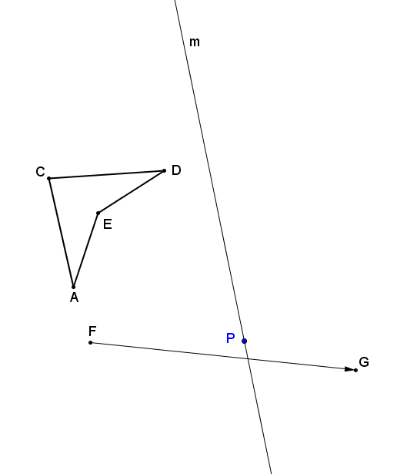

Exit Ticket Sample Solutions

A similarity transformation consists of a translation along the vector $\vec{FG}$, followed by a dilation from point $P$ with a scale factor $r=2$, and finally a reflection over line $m$. Use construction tools to find $A'''C'''D'''E'''$.

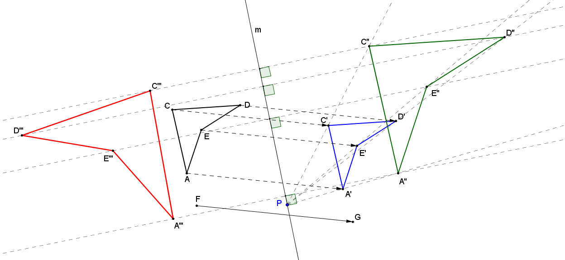

Problem Set Sample Solutions

- A similarity transformation consists of a reflection over line $l$, followed by a dilation from $O$ with a scale factor of $r=\frac{3}{4}$. Use construction tools to find $△G''H''I''$.

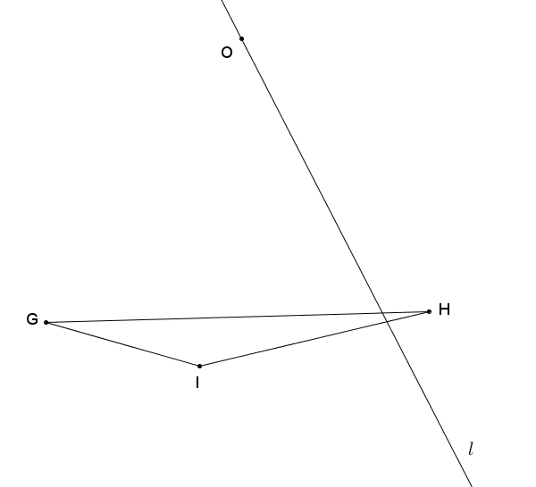
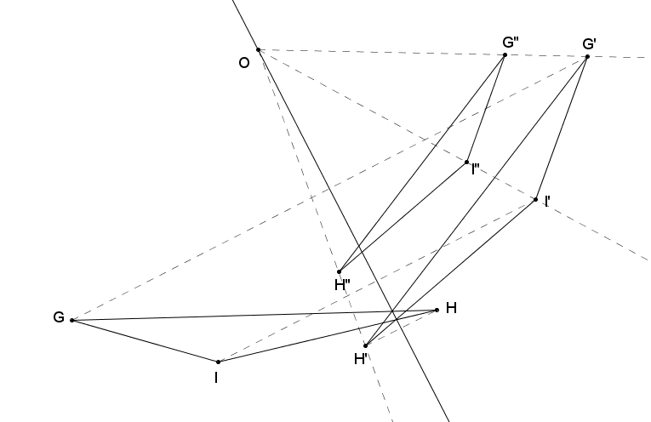

- A similarity transformation consists of a dilation from point $O$ with a scale factor of$r=2\frac{1}{2}$, followed by a rotation about $O$ of $-90°$. Use construction tools to find kite $A''B''C''D''$.
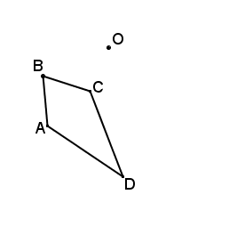
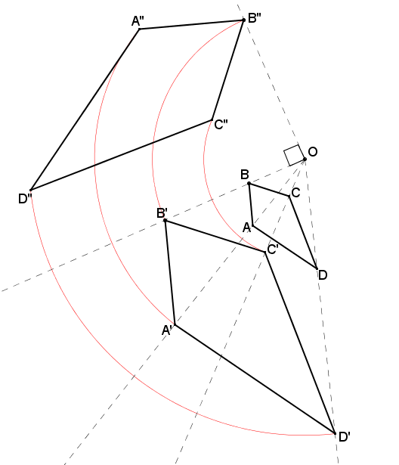

- For the Figure $Z$, find the image of ${r_{l}(R}_{P,90˚}\left(D_{P,\frac{1}{2}}\left(Z\right)\right)$.
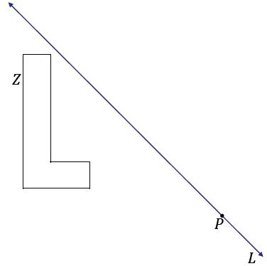
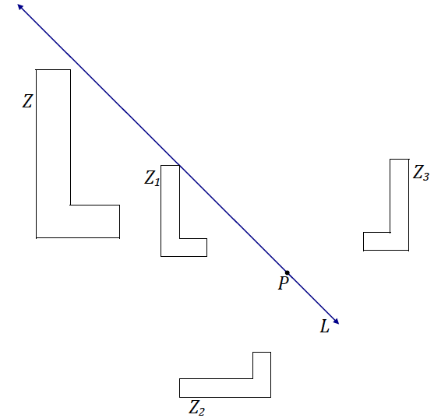
$$l$$
$$l$$

- A similarity transformation consists of a translation along vector $\vec{UV}$, followed by a rotation of $60°$ about $P$, then a dilation from $P$ with scale factor $r=\frac{1}{3}$. Use construction tools to find $△X'''Y'''Z'''$.
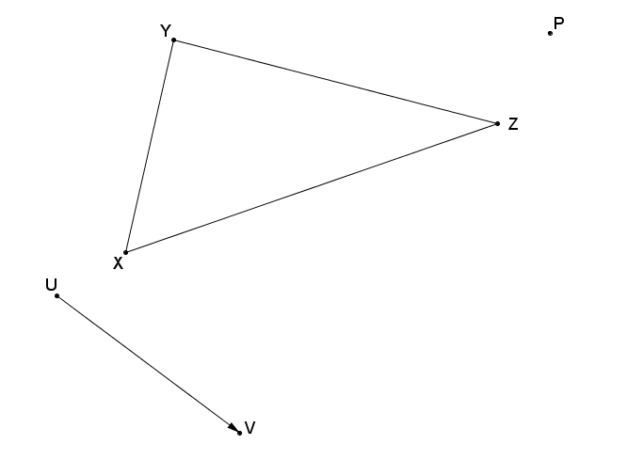

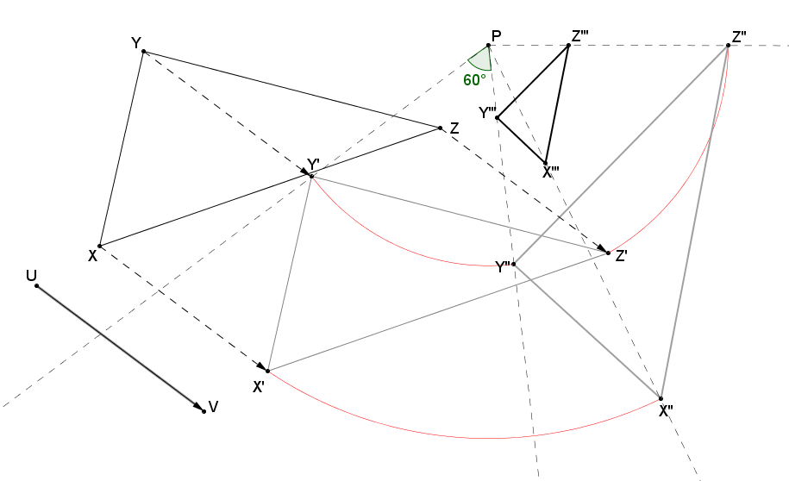

- Given the quarter-circular figure determined by points $A$,$B$, and $C$, a similarity transformation consists of a $-65°$ rotation about point $B$, followed by a dilation from point $O$ with a scale factor of $r=\frac{1}{2}$. Find the image of the figure determined by points $A^{''}$, $B^{''}$, and $C''$.
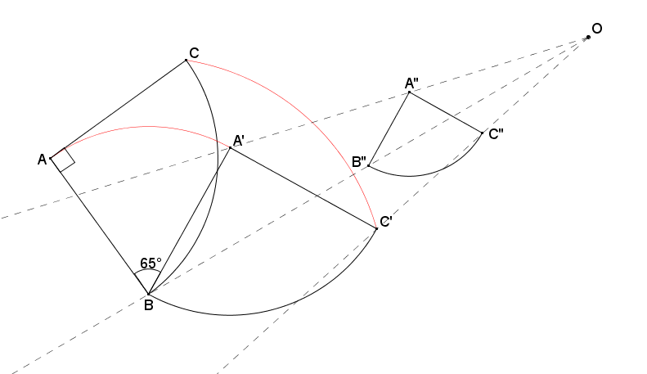

Describe a different similarity transformation that would map quarter-circle $ABC$ to quarter-circle $A''B''C''$.
The quarter-circular region could have first been dilated from point $O$ using a scale factor of $\frac{1}{2}$, followed by a rotation of $65°$ about point $B'$.

- A similarity transformation consists of a dilation from center $O$ with a scale factor of $\frac{1}{2}$, followed by a rotation of $60°$ about point $O$. Complete the similarity transformation on Figure $T$ to complete the drawing of Figure $T''$.
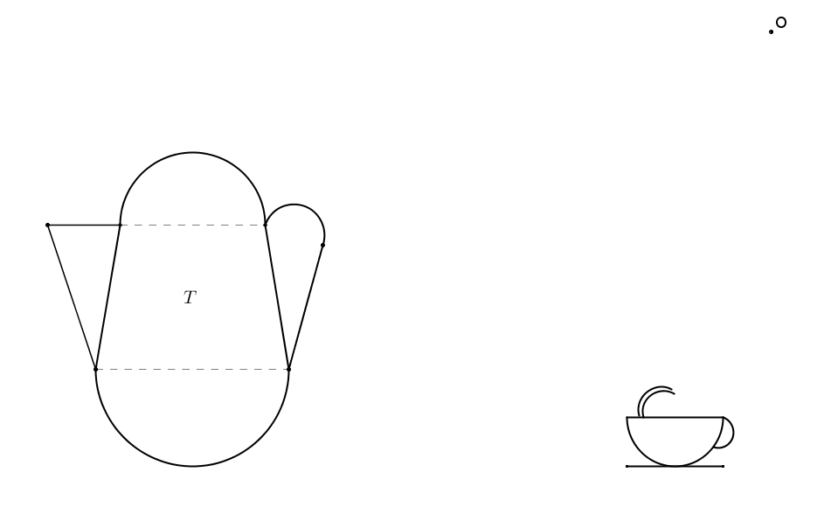
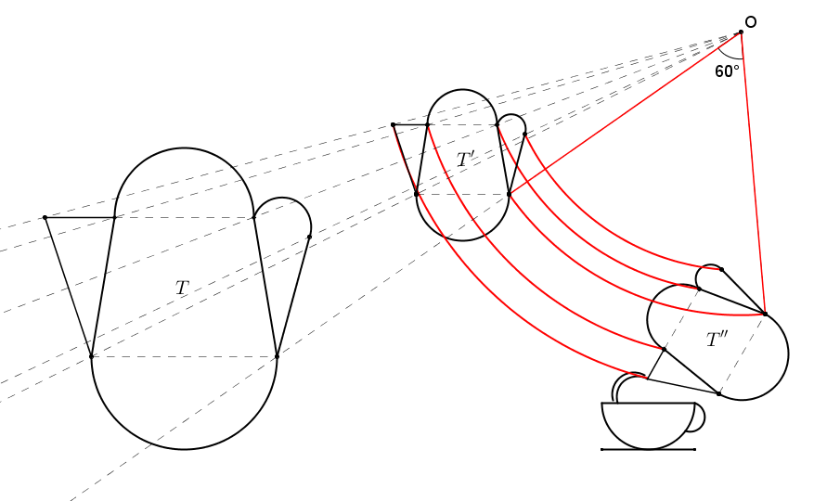

- Given Figure $R$ on the coordinate plane shown below, a similarity transformation consists of a dilation from $(0,6)$ with a scale factor of $\frac{1}{4}$, followed by a reflection over line $x=-1$, then by a vertical translation of $5$ units down. Find the image of Figure $R$.
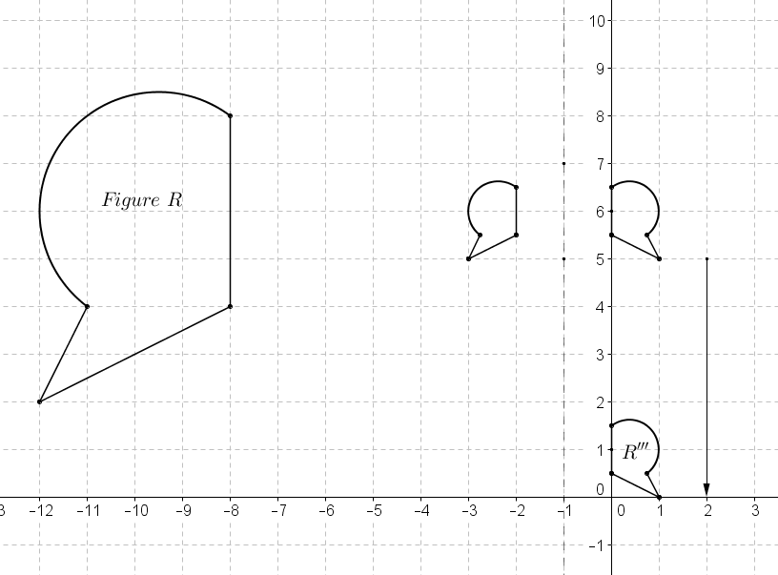
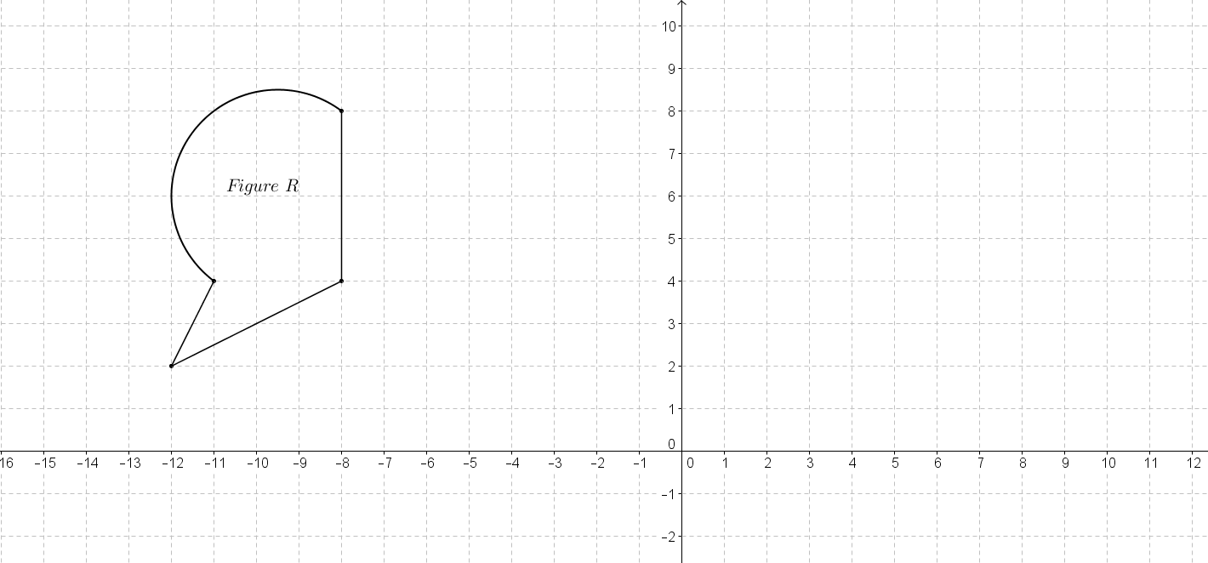
$R'$
$R''$

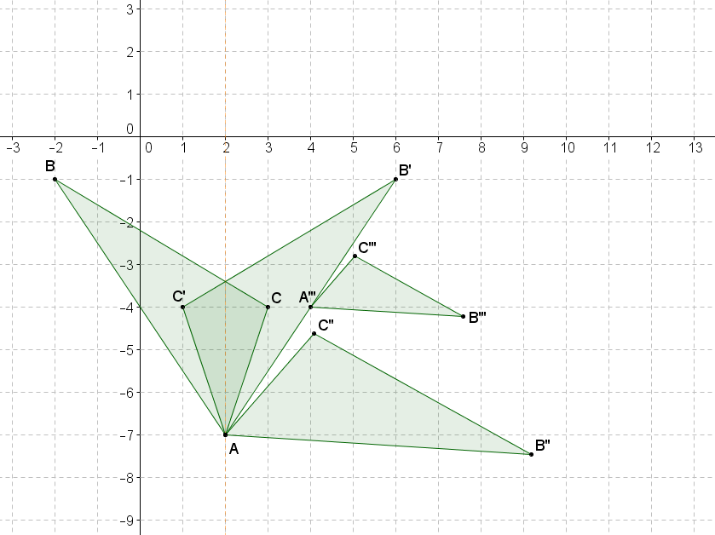
- Given $△ABC$, with vertices $A(2,-7)$, $B(-2,-1)$, and $C(3,-4)$, locate and label the image of the triangle under the similarity transformation $D_{B^{'},\frac{1}{2}}\left(R_{A,120°}\left(r_{x=2}\left(ABC\right)\right)\right)$.

- In Problem 8, describe the relationship of $A'''$ to $\overline{AB'}$, and explain your reasoning.
$A'''$ is the midpoint of $\overline{AB'}$. I know this because $A=A^{'}=A''$, and since the dilation at the end of the similarity transformation was centered at $B'$, the image of $A''$ must lie on the ray joining it to the center $B'$, which means that $A'''$ lies on $\overline{AB'}$. Furthermore, by the definition of dilation, $A^{'''}B^{'}=r\left(A^{''}B^{'}\right)$, and since the given scale factor was $r=\frac{1}{2}$, it follows that $A^{'''}B^{'}=\frac{1}{2}\left(A^{''}B^{'}\right)$, so $A'''$ must, therefore, be the midpoint of $\overline{AB'}$.

- Given $O(-8,3)$ and quadrilateral $BCDE$, with $B(-5,1)$, $C(-6,-1)$, $D(-4,-1)$, and $E(-4,2)$, what are the coordinates of the vertices of the image of $BCDE$ under the similarity transformation $r_{x-axis}\left(D_{O,3}\left(BCDE\right)\right)$?

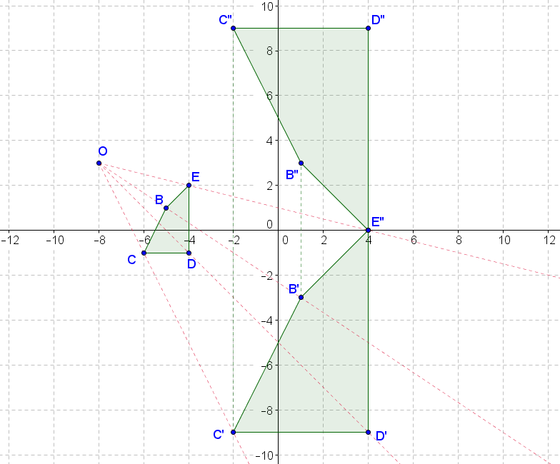

The coordinates of the image of $BCDE$ are $B''(1,3)$, $C''(-2,9)$, $D''(4,9)$, and $E''(4,0)$.

- Given triangle $ABC$ as shown on the diagram of the coordinate plane:
  - Perform a translation so that vertex $A$ maps to the origin.
See diagram.

  - Next, dilate the image $A'B'C'$ from the origin using a scale factor of $\frac{1}{3}$.
See diagram.

  - Finally, translate the image $A''B''C''$ so that the vertex $A''$ maps to the original point $A$.
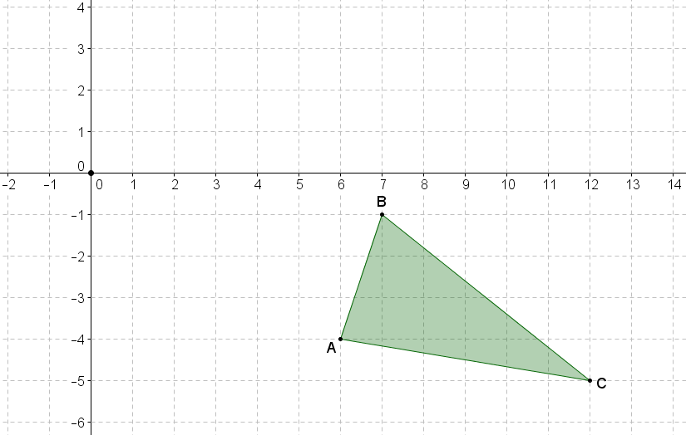
See diagram.

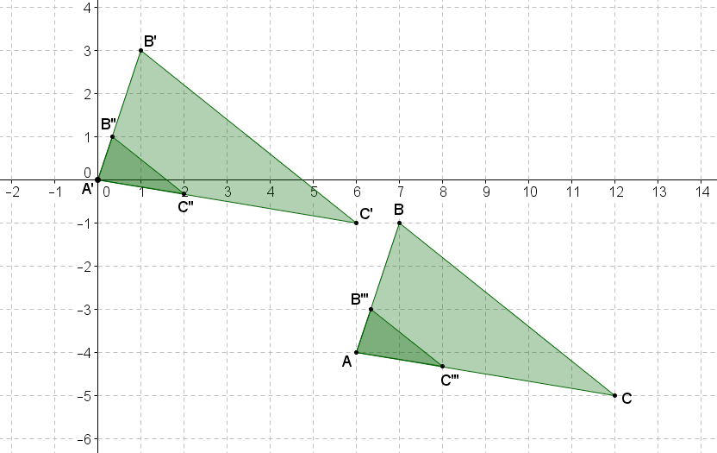
$A^{'}=A''$
$A=A'''$

  - Using transformations, describe how the resulting image $A'''B'''C'''$ relates to the original figure $ABC$.
The image $A'''B'''C'''$ is a dilation of figure $ABC$ from point $A$ with a scale factor of $\frac{1}{3}$.

  - In the coordinate plane, name the single transformation that is the result of the composition of the two dilations shown below:
$D_{(0,0),2}$ followed by $D_{\left(0,4\right),\frac{1}{2}}$
(Hint: Try it!)
The image can be obtained by a translation two units to the right (a vector that has half the distance as the distance between the centers of dilation).

  - In the coordinate plane, name the single transformation that is the result of the composition of the two dilations shown below:
$D_{\left(0,0\right),2}$ followed by $D_{\left(4,4\right),\frac{1}{2}}$
(Hint: Try it!)
The image can be obtained by a translation two units to the right (a vector that has half the distance as the distance between the centers of dilation).

  - Using the results from parts (a) and (b), describe what happens to the origin under both similarity transformations.
The origin maps to the midpoint of a segment joining the centers used for each dilation.

Example 1

$$l$$

Example 2

$$m$$

