Lesson 13: Properties of Similarity Transformations

Classwork
Example 1
Similarity transformation $G$ consists of a rotation about the point $P$ by $90°$, followed by a dilation centered at $P$ with scale factor $r=2$, and then a reflection across line $l$. Find the image of the triangle.

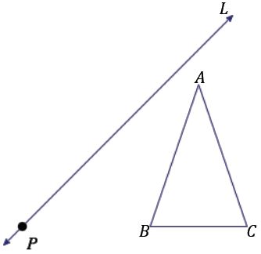
$$l$$

Example 2
A similarity transformation $G$ applied to trapezoid $ABCD$ consists of a translation by vector $\vec{XY}$, followed by a reflection across line $m$, and then followed by a dilation centered at $P$ with scale factor $r=2$. Recall that we can describe the same sequence using the following notation: $D_{P,2}\left(r_{m}\left(T_{XY}\left(ABCD\right)\right)\right)$. Find the image of $ABCD$.

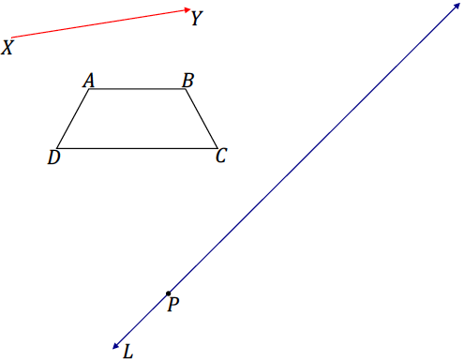
$$m$$
Exercise 1
A similarity transformation for triangle $DEF$ is described by $r_{n}\left(D_{A,\frac{1}{2}}\left(R_{A,90°}\left(DEF\right)\right)\right)$. Locate and label the image of triangle $DEF$ under the similarity.
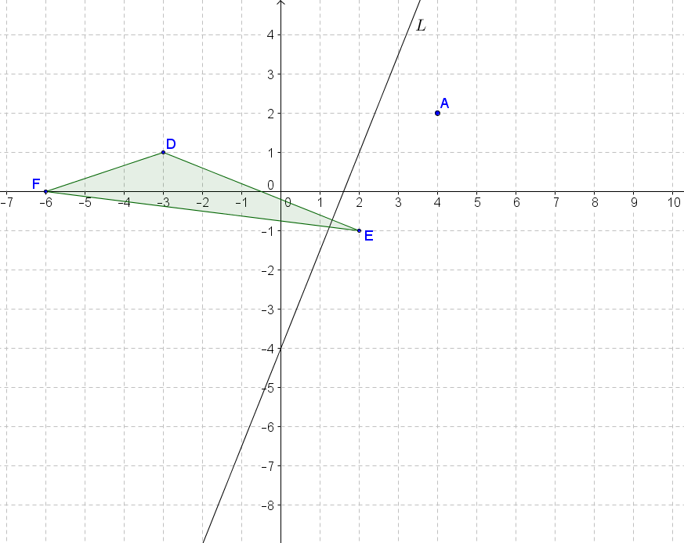
$$n$$
$$m$$

Problem Set

- A similarity transformation consists of a reflection over line $l$, followed by a dilation from $O$ with a scale factor of $r=\frac{3}{4}$. Use construction tools to find $△G''H''I''$.

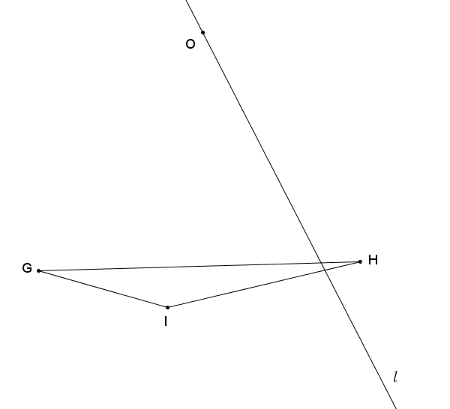
Lesson Summary
Properties of similarity transformations:
- Distinct points are mapped to distinct points.
- Each point $P'$ in the plane has a pre-image.
- There is a scale factor $r$ for $G$, so that for any pair of points $P$ and $Q$ with images $P^{'}=G(P)$ and
$Q^{'}=G(Q)$, then $P^{'}Q^{'}=rPQ$.
- A similarity transformation sends lines to lines, rays to rays, line segments to line segments, and parallel lines to parallel lines.
- A similarity transformation sends angles to angles of equal measure.
- A similarity transformation maps a circle of radius $R$ to a circle of radius $rR$, where $r$ is the scaling factor of the similarity transformation.

- A similarity transformation consists of a dilation from point $O$ with a scale factor of$r=2\frac{1}{2}$, followed by a rotation about $O$ of $-90°$. Use construction tools to find kite $A''B''C''D''$.

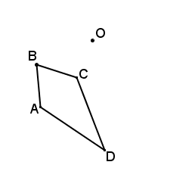

- For the Figure $Z$, find the image of ${r_{l}(R}_{P,90˚}\left(D_{P,\frac{1}{2}}\left(Z\right)\right)$.

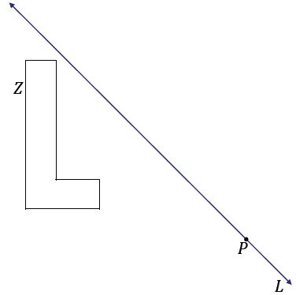

- A similarity transformation consists of a translation along vector $\vec{UV}$, followed by a rotation of $60°$ about $P$, then a dilation from $P$ with scale factor $r=\frac{1}{3}$. Use construction tools to find $△X'''Y'''Z'''$.

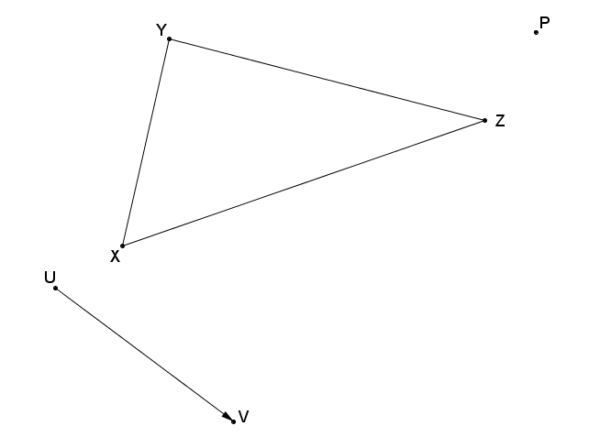
- Given the quarter-circular figure determined by points $A$,$B$, and $C$, a similarity transformation consists of a $-65°$ rotation about point $B$, followed by a dilation from point $O$ with a scale factor of $r=\frac{1}{2}$. Find the image of the figure determined by points $A^{''}$, $B^{''}$, and $C''$.

Describe a different similarity transformation that would map quarter-circle $ABC$ to quarter-circle $A''B''C''$.
- A similarity transformation consists of a dilation from center $O$ with a scale factor of $\frac{1}{2}$, followed by a rotation of $60°$ about point $O$. Complete the similarity transformation on Figure $T$ to complete the drawing of Figure $T''$.
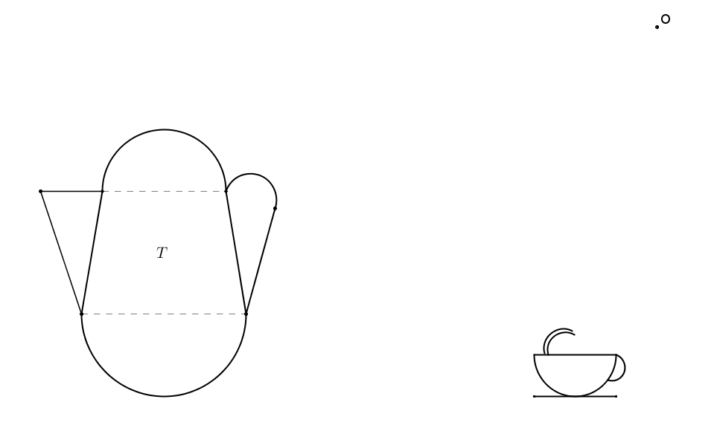

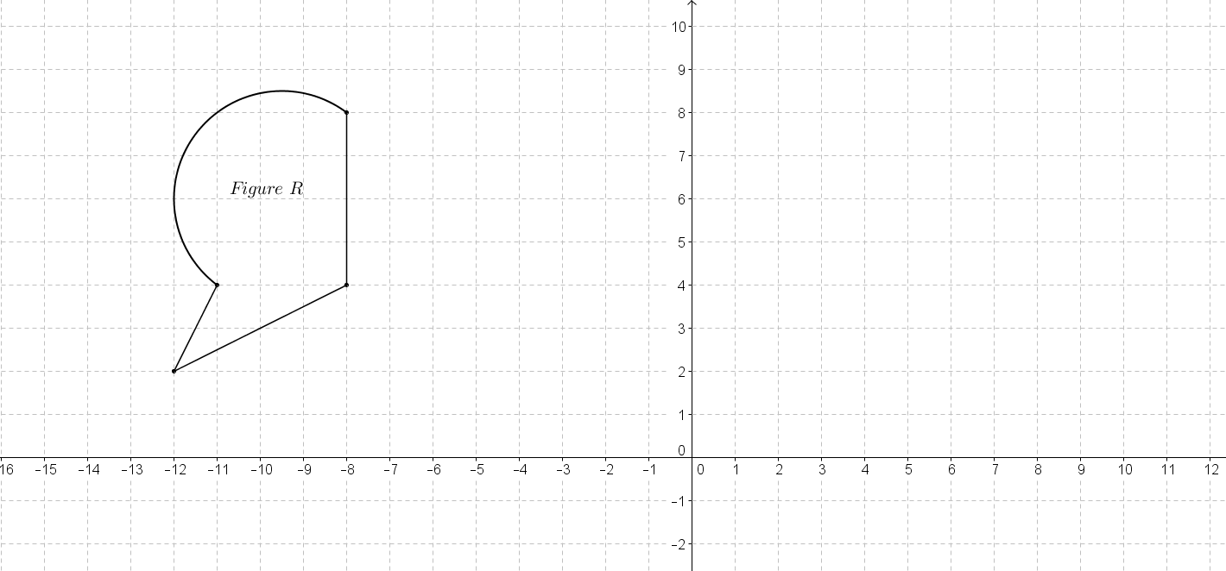
- Given Figure $R$ on the coordinate plane shown below, a similarity transformation consists of a dilation from $\left(0,6\right)$ with a scale factor of $\frac{1}{4}$, followed by a reflection over line $x=-1$, then by a vertical translation of $5$ units down. Find the image of Figure $R$.

- Given $△ABC$, with vertices $A(2,-7)$, $B(-2,-1)$, and $C(3,-4)$, locate and label the image of the triangle under the similarity transformation $D_{B^{'},\frac{1}{2}}\left(R_{A,120°}\left(r_{x=2}\left(ABC\right)\right)\right)$.

- In Problem 8, describe the relationship of $A'''$ to $\overline{AB'}$, and explain your reasoning.

- Given $O(-8,3)$ and quadrilateral $BCDE$, with $B(-5,1)$, $C(-6,-1)$, $D(-4,-1)$, and $E(-4,2)$, what are the coordinates of the vertices of the image of $BCDE$ under the similarity transformation $r_{x-axis}\left(D_{O,3}\left(BCDE\right)\right)$?

- Given triangle $ABC$ as shown on the diagram of the coordinate plane:
  - Perform a translation so that vertex $A$ maps to the origin.
  - Next, dilate the image $A'B'C'$ from the origin using a scale factor of $\frac{1}{3}$.
  - Finally, translate the image $A''B''C''$ so that the vertex $A''$ maps to the original point $A$.
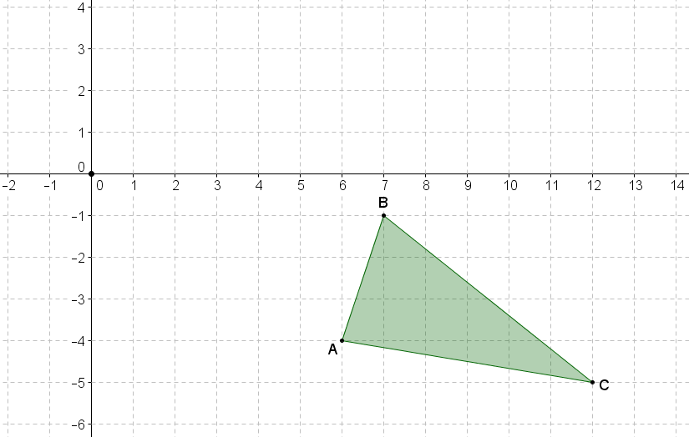
  - Using transformations, describe how the resulting image $A'''B''C''$ relates to the original figure $ABC$.

  - In the coordinate plane, name the single transformation that is the result of the composition of the two dilations shown below:
$D_{(0,0),2}$ followed by $D_{\left(0,4\right),\frac{1}{2}}$
(Hint: Try it!)

  - In the coordinate plane, name the single transformation that is the result of the composition of the two dilations shown below:
$D_{\left(0,0\right),2}$ followed by $D_{\left(4,4\right),\frac{1}{2}}$
(Hint: Try it!)

  - Using the results from parts (a) and (b), describe what happens to the origin under both similarity transformations.

