|  |
| --- |
|  |

Lesson 12: What Are Similarity Transformations, and Why Do We Need Them?

Student Outcomes

* Students define a *similarity transformation* as the composition of basic rigid motions and dilations. Students define two figures to be similar if there is a similarity transformation that takes one to the other.
* Students can describe a similarity transformation applied to an arbitrary figure (i.e., not just triangles) and can use similarity to distinguish between figures that resemble each other versus those that are actually similar.

Lesson Notes

As noted earlier in this curriculum, congruence and similarity are presented differently than in most previous curricula. While in the past congruence criteria have first been defined for triangles (e.g. SSS or ASA), and then by extension, for polygonal figures, with similarity being treated in like manner, the Common Core Standards approach these concepts via transformations, allowing one to accommodate not only polygonal figures but also curvilinear figures in one stroke.

Students begin Topic C with an understanding of what similarity transformations are and what it means for figures to be similar. They should see how similarity transformations are like the rigid motions in their use to compare figures in the plane. Unlike the work done with similarity in Grade 8, students will study similarity in the plane and not in the coordinate plane. This is of course because we want students to fully realize what we refer to as the “abundance” of transformations in the plane. It is not that transformations are limited in the coordinate system but rather that the coordinate system simply encourages students to see certain transformations as more natural than others (e.g., a translation parallel to the -axis: ). Removing the coordinate system prevents this natural gravitation toward certain transformations over others.

Classwork

Opening Exercise (3 minutes)

Opening Exercise

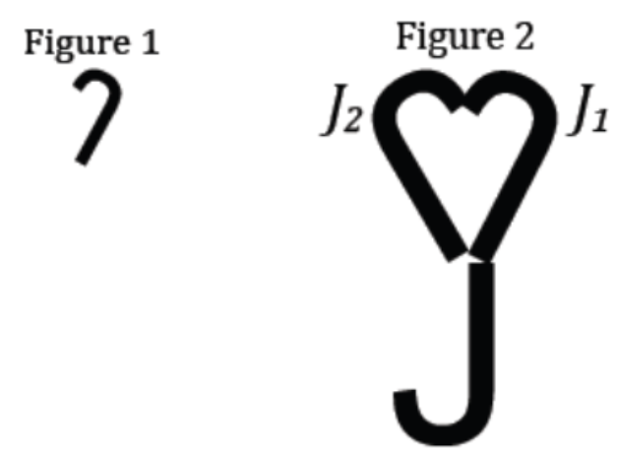Observe Figures 1 and 2 and the images of the intermediate figures between Figures 1 and 2. Figures 1 and 2 are called *similar.*

What observations can you make about Figures 1 and 2?

Answers will vary; students might say that the two figures look alike in terms of shape but not size. Accept reasonable answers at this point to start the conversation and move onto filling out the chart below.

Definition:

*Scaffolding:*

Depending on student ability, consider using a “fill in the blank” approach to the definitions listed here.

A *___________________ ___________________* (or *___________________*) is a composition of a finite number of dilations or basic rigid motions. The *scale factor* of a similarity transformation is the product of the scale factors of the dilations in the composition; if there are no dilations in the composition, the scale factor is defined to be 1.

**similarity transformation, similarity**

Definition:

Two figures in a plane are *_______________________* if there exists a similarity transformation taking one figure onto the other figure.

**similar**

Direct students to sketch possibilities for the Examples and Non-Examples boxes, and offer them the provided example after they voice their ideas. Have them list characteristics of the Examples, and then provide them with the definitions of *similar* and *similarity transformation* (see definitions above).

|  |  |
| --- | --- |
| Definition | Characteristics |
| A similarity transformation (or similarity) is a composition of a finite number of dilations or basic rigid motions. The scale factor of a similarity transformation is the product of the scale factors of the dilations in the composition; if there are no dilations in the composition, the scale factor is defined to be .  Two figures in a plane are similar if there exists a similarity transformation taking one figure onto the other figure.  **similar** | Similar figures should look the same, but one is a different size, flipped, rotated, or translated relative to the other. |
| Examples | Non-Examples |
|  |  |

Discussion (10 minutes)

* Consider what you know about congruence when thinking about similarity. One use of the rigid motions was to establish whether two figures were identical or not in the plane. How did we use rigid motions to establish this?
  + *If a series of rigid motions mapped one figure onto the other and the figures coincided, we could conclude that they were congruent.*
* We can use similarity transformations in the same way. Consider Figure 1 below.

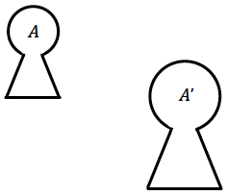

Figure 1

* From our work on dilations, we can see that there is in fact a dilation that would map figure to . Note that a similarity transformation does not have a minimum number of dilations or rigid motions; e.g., a single reflection or a single dilation is a similarity transformation.

Note that we have not mentioned the similarity symbol “” in this lesson. If your students remember it and have no trouble with it, feel free to discuss it. We will be addressing the symbol in Lesson 14.

* Now examine Figure 2. In Figure 2, the figure was rotated and is now labeled as .

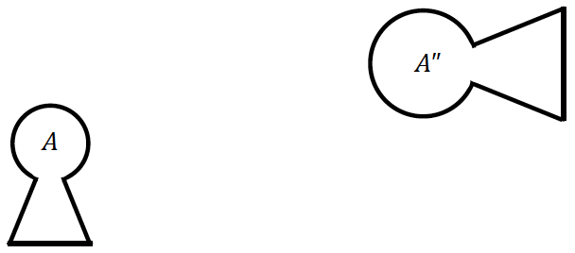

Figure 2

* Would it be correct to say that is a dilation of ?
  + *No, this is not a dilation because corresponding segments are neither parallel nor collinear.*
* Yet we saw in Figure 1 that it is possible to transform to , which we know to be congruent to , so what are the necessary steps to map to ?

Allow a moment for students to discuss this. Confirm that either both the composition of a dilation and rotation or the composition of a dilation, rotation, and translation will map to .

* The series of steps needed to map to , the dilation and rotation, or rotation and dilation, can be thought of as a composition of transformations, or more specifically, a similarity transformation. .
* If a similarity transformation maps one figure to another, we say the figures are similar.
* Note this important distinction. We know that it is not enough to say, “If two figures look identical, they must be congruent.” We know that they are congruent only if a series of rigid motions maps one figure to the other. In the same way, it is not enough to say that two figures look like they have the same shape; we have to show that a similarity transformation maps one figure to the other to be sure that the figures really do have the same shape.
* Recall also that a scale drawing of a figure is one whose corresponding lengths are proportional and whose corresponding angles are equal in measurement. We know that a dilation produces a scale drawing. Therefore, figures that are similar must be scale drawings. Why must this be true?
  + *Any figure that maps onto another figure by similarity transformation will either have a finite number of dilations or will not have any dilations. If there are dilations involved, we have seen that dilations result in figures with proportional, corresponding lengths and corresponding angles of equal measurement. If there are no dilations, then the rigid motions that compose the similarity transformation have a scale factor of by definition. Therefore, in either case, the two similar figures will be scale drawings of each other.*

Note that we have not said that figures that are scale drawings must be similar. We have this discussion in Lesson 14.

* We will denote a similarity transformation with . The transformations that compose a similarity transformation can be in any order; however, as a matter of convention, we will usually begin a similarity transformation with the dilation (as we did in Grade 8) and follow with rigid motions.

Note that this convention is apparent in problems where students must describe the series of transformations that map one figure onto its similar image; we will adhere to the convention so that in the first step the two figures become congruent, and then we are left to determine the congruence transformation that will map one to the other.

* If is a similarity transformation, then is the composition of basic rigid motions and dilations. The scale factor of is the product of the scale factors of the dilations in the transformation. With respect to the above example, .
* If there is no dilation in the similarity transformation, it is a congruence. However, a congruence is simply a more specific similarity transformation, which is why the definition allows for the composition of transformations which need not include a dilation.

*Scaffolding:*

Curvilinear figures such as that shown in Example 1 may be difficult for some students. Try using the same similarity transformations with simpler figures such as asymmetrical letters like and , and then scaffold up to those involving curves such as and .

Example 1 (5 minutes)

Students identify the transformations that map one figure onto another. Remind students that as a matter of convention, any dilation in a similarity transformation is identified first.

Example 1

Figure is similar to Figure . Describe a transformation that will map Figure onto Figure ?



* We are not looking for specific parameters (e.g., scale factor or degree of rotation of each transformation); rather, we want to identify the series of transformations needed to map Figure to Figure .

*Scaffolding:*

Consider having more advanced students sketch the general locations of centers of rotation or dilation, lines of reflection, and translation vectors.

* Step 1: The dilation will have a scale factor of since is smaller than .
* Step 2: Notice that is *flipped* from . So take a reflection of to get over a line .
* Step 3: Translate the plane such that a point of maps to a corresponding point in . Call the new figure .
* Step 4: Rotate until coincides with .



Figure maps to Figure by first dilating by a scale factor of until the corresponding lengths are equal in measurement and then reflecting over line to ensure that both figures have the same orientation. Next, translate along a vector so that one point of the image corresponds to Finally, a rotation around a center of degree will orient Figure so that it coincides with Figure .

Exercises 1–3 (8 minutes)

Exercises 1–3 allow students the opportunity to practice describing transformations that map an original figure onto its corresponding transformed figure. If time is an issue, have students complete one exercise that seems appropriate and move on to Example 2.

Exercises 1–3

1. 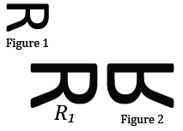Figure 1 is similar to Figure 2. Which transformations compose the similarity transformation that maps Figure 1 onto Figure 2?

First dilate Figure 1 by a scale factor of until the corresponding lengths are equal in measurement and then reflect over a line so that Figure 1 coincides with Figure 2.

1. Figure is similar to Figure . Which transformations compose the similarity transformation that maps onto ?

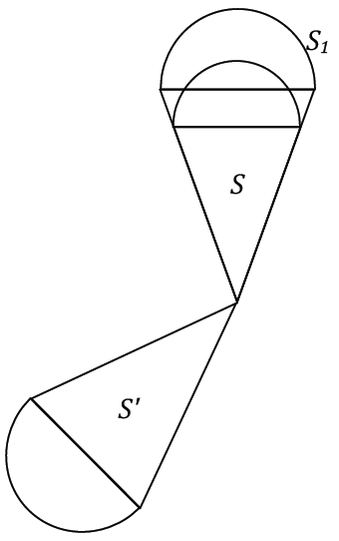

First dilate by a scale factor of until the corresponding segment lengths are equal in measurement to those of . Then must be rotated around a center of degree so that coincides with .

1. Figure 1 is similar to Figure 2. Which transformations compose the similarity transformation that maps Figure 1 onto Figure 2?

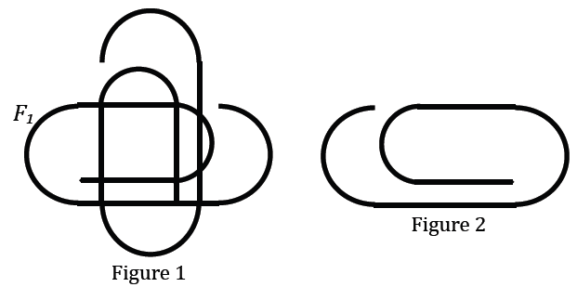

It is possible to only use two transformations: a rotation followed by a reflection, but to do this, the correct center must be found. Solution image reflects this approach. However, students may say to first rotate Figure 1 around a center by in the clockwise direction. Then reflect Figure over a vertical line . Finally, translate Figure 1 by a vector so that Figure 1 coincides with Figure 2.

Reemphasize to students that a similarity transformation does not *need* to have a dilation. Just as a square is a special type of rectangle, but the relationship does not work in reverse, so is a congruence transformation. Similarity transformations generalize the notion of congruency.

Example 2 (5 minutes)

If needed, reiterate to students that the question asks them to take measurements in Example 2; further prompt them if needed to consider measurements of segments, not of any curved segment. This should alert them to the fact that there are few possible measurements to make and that a relationship must exist between these measurements and what the question is asking.

Example 2

Show that no sequence of basic rigid motions and dilations takes the small figure to the large figure. Take measurements as needed.



A similarity transformation that maps the small outer circle to the large outer circle would need to have scale factor of about . A similarity transformation that maps the small line segment to the large line segment would need to have scale factor about . So there is no similarity transformation that maps the small figure onto the large figure.

Exercises 4–5 (7 minutes)

Exercises 4–5

1. 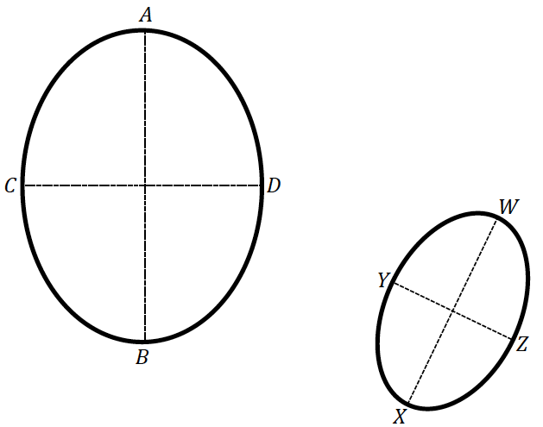Is there a sequence of dilations and basic rigid motions that takes the large figure to the small figure? Take measurements as needed.

A similarity transformation that maps to would need to have scale factor of about , but a similarity transformation that maps the small segment to would need to have scale factor of about . So there is no similarity transformation that maps the large figure onto the small figure.

1. What purpose do transformations serve? Compare and contrast the application of rigid motions to the application of similarity transformations.

We use all the transformations to compare figures in the plane. Rigid motions are distance preserving while dilations, integral to similarity transformations, are not distance preserving. We use compositions of rigid motions to determine whether two figures are congruent, and we use compositions of rigid motions and dilations, specifically similarity transformations, to determine whether figures are similar.

Closing (2 minutes)

* What does it mean for two figures to be similar?
  + *We classify two figures as similar if there exists a similarity transformation that maps one figure onto the other.*
* What are similarity transformations and how can we use them?
  + *A similarity transformation is a composition of a finite number of dilations or rigid motions. Similarity transformations precisely determine whether two figures have the same shape (i.e., two figures are similar). If a similarity transformation does map one figure onto another, we know that one figure is a scale drawing of the other.*
* How do congruence and similarity transformations compare to each other?
  + *Both congruence and similarity transformations are a means of comparing figures in the plane. A congruence transformation is also a similarity transformation, but a similarity transformation does not need to be a congruence transformation.*

Lesson Summary

**Two figures are similar if there exists a similarity transformation that maps one figure onto the other.**

**A similarity transformation is a composition of a finite number of dilations or rigid motions.**

Exit Ticket (5 minutes)

Name Date

Lesson 12: What Are Similarity Transformations, and Why Do We Need Them?

Exit Ticket

1. Figure A' is similar to Figure A. Which transformations compose the similarity transformation that maps Figure A onto Figure A'?

Figure A

Figure A'

1. Is there a sequence of dilations and basic rigid motions that takes the small figure to the large figure? Take measurements as needed.

Figure B

Figure A

Exit Ticket Sample Solutions

1. Figure A' is similar to Figure A. Which transformations compose the similarity transformation that maps Figure A onto Figure A'?

**Figure A**

**Figure A'**

***We first take a dilation of Figure A with a scale factor and center , the point where the two line segments meet, until the corresponding lengths are equal to those in Figure A'. Next, take a rotation about , and then finally, take a reflection over a (vertical) line*** .

1. Is there a sequence of dilations and basic rigid motions that takes the small figure to the large figure? Take measurements as needed.

**Figure A**

**Figure B**

No similarity transformation exists because the circled corresponding distances and the corresponding distances marked by the arrows on Figure B are not in the same ratio.

Problem Set Sample Solutions

1. What is the relationship between scale drawings, dilations, and similar figures?
   1. How are scale drawings and dilations alike?

Scale drawings and dilated figures are alike in that all corresponding angles are congruent and all corresponding distances are in the equivalent ratio, , called the scale factor. A dilation of a figure produces a scale drawing of that figure.

* 1. How can scale drawings and dilations differ?

Dilations are a transformation of the plane in which all corresponding points from the image and pre-image are mapped along rays that originate at the center of dilation. This is not a requirement for scale drawings.

* 1. What is the relationship of similar figures to scale drawings and dilations?

Similar figures are scale drawings because they can be mapped together by a series of dilations and rigid motions.

1. 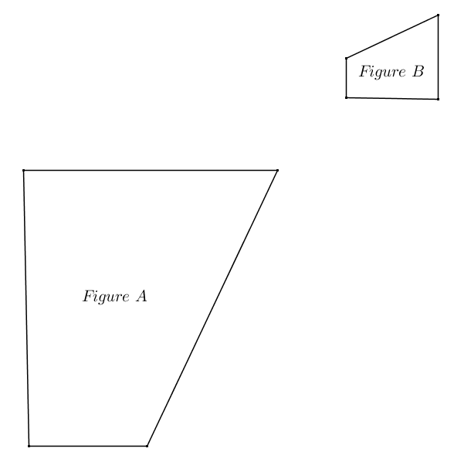Given the diagram below, identify a similarity transformation, if one exists, mapping Figure A onto Figure B. If one does not exist, explain why.

(Note to the teacher: The solution below is only one of many valid solutions to this problem.)

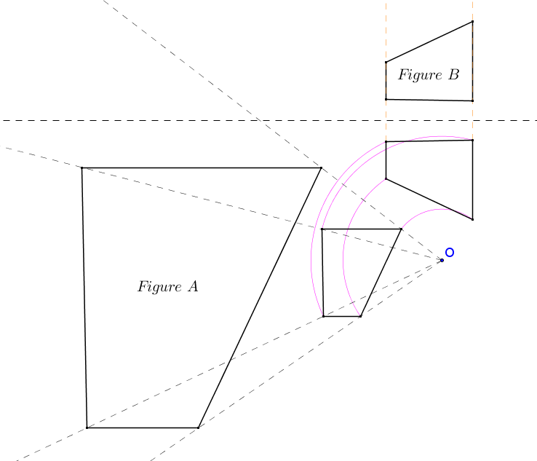

First, Figure A is dilated from center with a scale factor of . Next the image is rotated about center . Finally the image is reflected over horizontal line onto Figure B.

1. Teddy correctly identified a similarity transformation with at least one dilation that maps Figure onto Figure . Megan correctly identified a congruence transformation that maps Figure onto Figure . What must be true about Teddy’s similarity transformation?

If Megan correctly identified a congruence transformation that maps Figure onto Figure , then Figure and Figure must be congruent. Therefore, Teddy’s similarity transformation must have either included a single dilation with a scale factor of or must have included more than one dilation of which the product of all scale factors was because it included at least one dilation.

1. Given the coordinate plane shown, identify a similarity transformation, if one exists, mapping onto . If one does not exist, explain why.

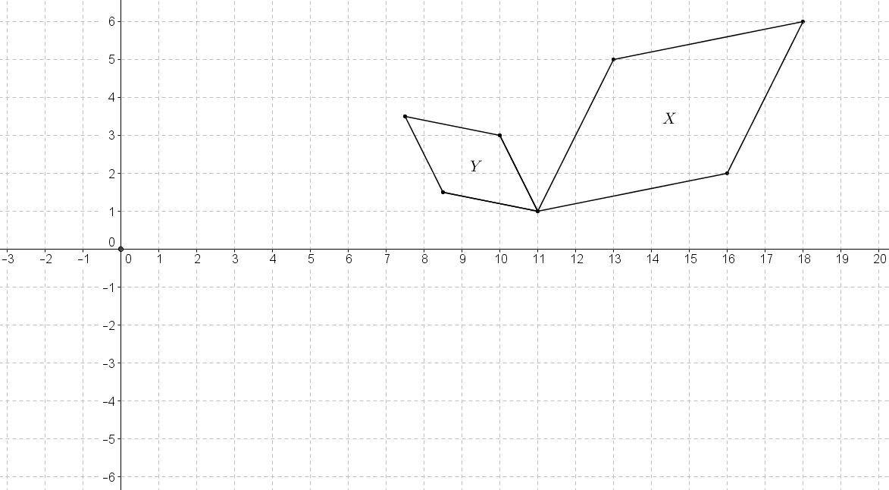

(Note to the teacher: The solution below is only one of many valid solutions to this problem.)

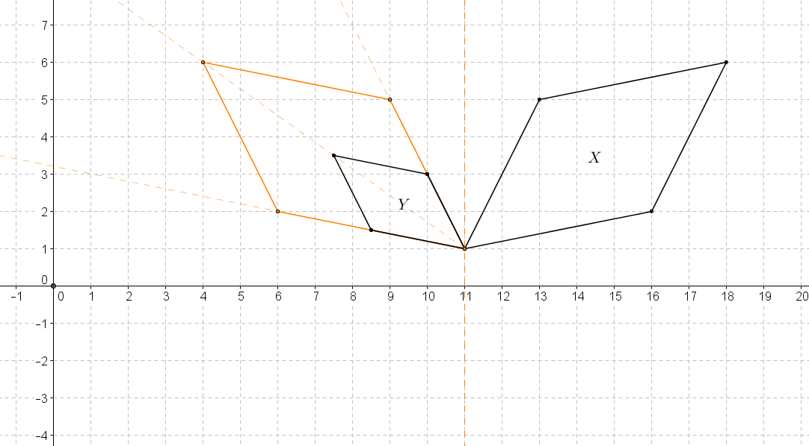

First reflect over line . Then dilate the image from center with a scale factor of to obtain .

1. Given the diagram below, identify a similarity transformation, if one exists, that maps onto . If one does not exist, explain why. Provide any necessary measurements to justify your answer.

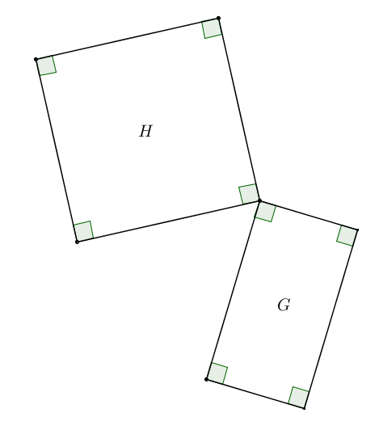

A similarity transformation does not exist that maps onto because the side lengths of the figures are not all proportional. Figure is a rectangle (not a square) whereas Figure is a square.

1. Given the coordinate plane shown, identify a similarity transformation, if one exists, that maps onto . If one does not exist, explain why.

(Notes to the teacher: Students will need to use a protractor to obtain the correct degree measure of rotation. The solution below is only one of many valid solutions to this problem.)

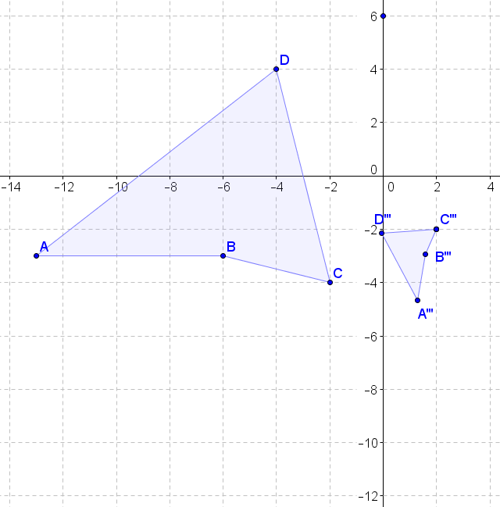

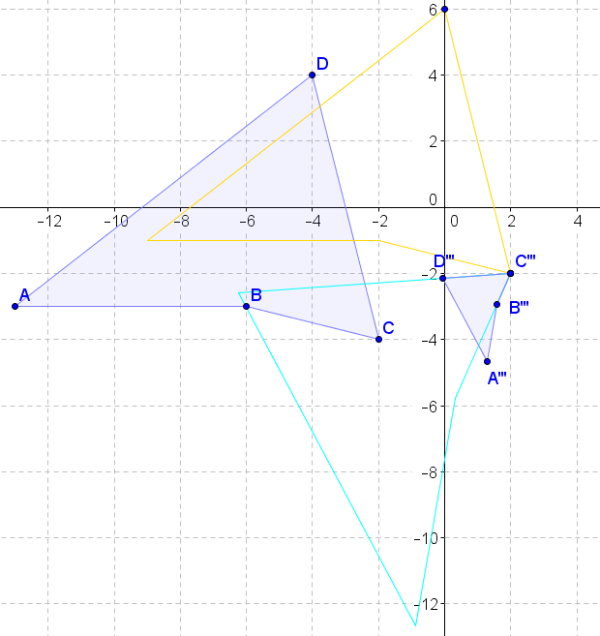 can be mapped onto by first translating along the vector , then rotating about point by , and finally dilating from point using a scale factor of .

1. The diagram below shows a dilation of the plane…or does it? Explain your answer.

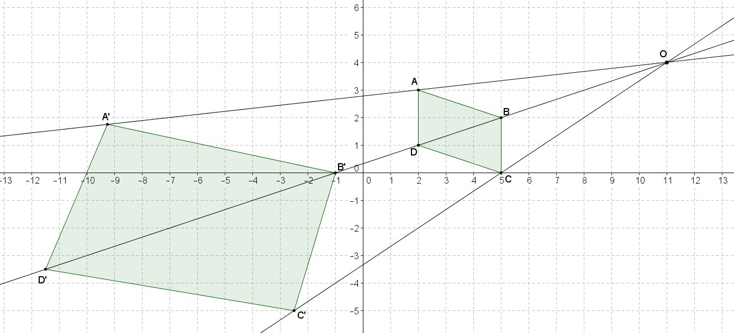

The diagram does not show a dilation of the plane from point , even though the corresponding points are collinear with the center . To be a dilation of the plane, a constant scale factor must be used for all points from the center of dilation; however, the scale factor relating the distances from the center in the diagram range from to .