Lesson 12: What Are Similarity Transformations, and Why Do We Need Them?

Classwork

Opening Exercise

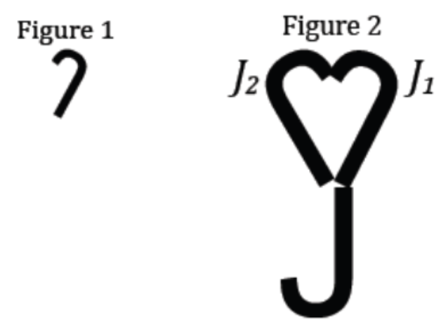Observe Figures 1 and 2 and the images of the intermediate figures between Figures 1 and 2. Figures 1 and 2 are called *similar.*

What observations can you make about Figures 1 and 2?

Definition:

A *___________________ ___________________* (or *___________________*) is a composition of a finite number of dilations or basic rigid motions. The *scale factor* of a similarity transformation is the product of the scale factors of the dilations in the composition; if there are no dilations in the composition, the scale factor is defined to be 1.

Definition:

Two figures in a plane are *_______________________* if there exists a similarity transformation taking one figure onto the other figure.

|  |  |
| --- | --- |
| Definition | Characteristics |
| **similar** |  |
| Examples | Non-Examples |
|  |  |

Example 1

Figure is similar to Figure . Describe a transformation that will map Figure onto Figure ?



Exercises 1–3

1. Figure 1 is similar to Figure 2. Which transformations compose the similarity transformation that maps Figure 1 onto Figure 2?

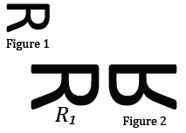

1. Figure is similar to Figure . Which transformations compose the similarity transformation that maps onto ?

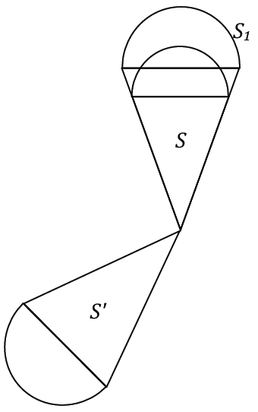

1. Figure 1 is similar to Figure 2. Which transformations compose the similarity transformation that maps Figure 1 onto Figure 2?

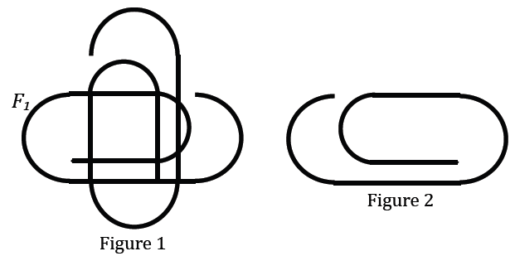

Example 2

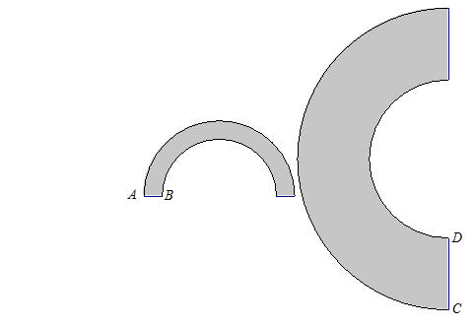Show that no sequence of basic rigid motions and dilations takes the small figure to the large figure. Take measurements as needed.

Exercises 4–5

1. Is there a sequence of dilations and basic rigid motions that takes the large figure to the small figure? Take measurements as needed.

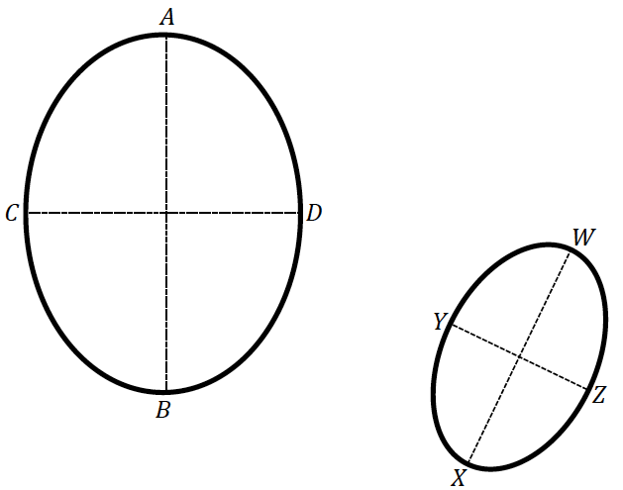

1. What purpose do transformations serve? Compare and contrast the application of rigid motions to the application of similarity transformations.

Problem Set

Lesson Summary

Two figures are similar if there exists a similarity transformation that maps one figure onto the other.

A similarity transformation is a composition of a finite number of dilations or rigid motions.

1. What is the relationship between scale drawings, dilations, and similar figures?
   1. How are scale drawings and dilations alike?
   2. How can scale drawings and dilations differ?
   3. What is the relationship of similar figures to scale drawings and dilations?
2. 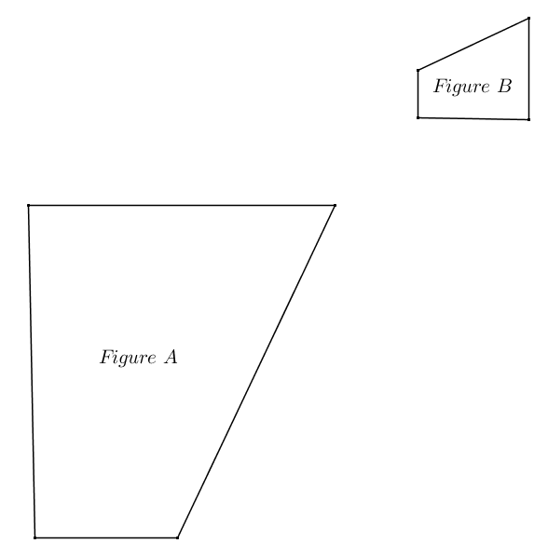Given the diagram below, identify a similarity transformation, if one exists, mapping Figure A onto Figure B. If one does not exist, explain why.
3. Teddy correctly identified a similarity transformation with at least one dilation that maps Figure onto Figure . Megan correctly identified a congruence transformation that maps Figure onto Figure . What must be true about Teddy’s similarity transformation?
4. Given the coordinate plane shown, identify a similarity transformation, if one exists, mapping onto . If one does not exist, explain why.

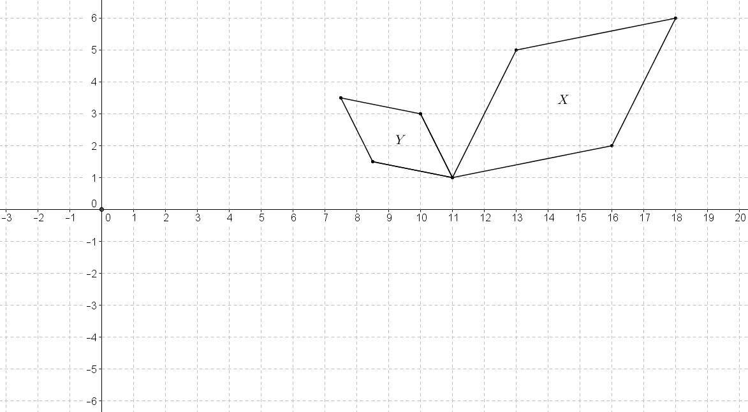

1. Given the diagram below, identify a similarity transformation, if one exists, that maps onto . If one does not exist, explain why. Provide any necessary measurements to justify your answer.

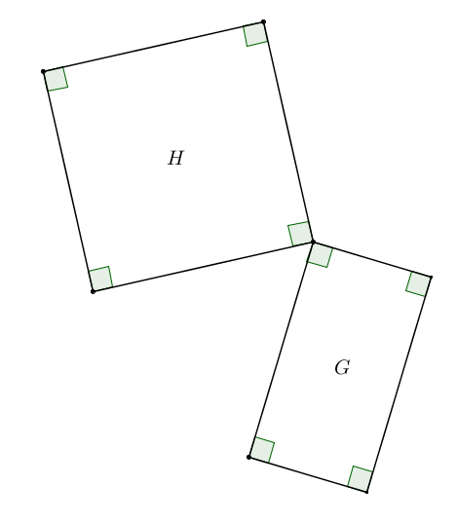

1. Given the coordinate plane shown, identify a similarity transformation, if one exists, that maps onto . If one does not exist, explain why.

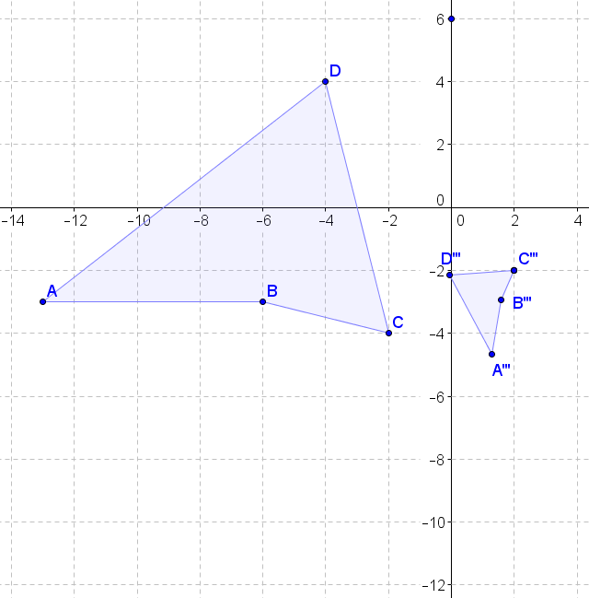

1. The diagram below shows a dilation of the plane…or does it? Explain your answer.

