|  |
| --- |
|  |

Lesson 11: Dilations from Different Centers

Student Outcomes

* Students verify experimentally that the dilation of a figure from two different centers by the same scale factor gives congruent figures. These figures are congruent by a translation along a vector that is parallel to the line through the centers.
* Students verify experimentally that the composition of dilations and is a dilation with scale factor and center on unless .

Lesson Notes

In Lesson 11, students examine the effects of dilating figures from two different centers. By experimental verification, they examine the impact on the two dilations of having two different scale factors, the same two scale factors, and scale factors whose product equals . Each of the parameters of these cases provides information on the centers of the dilations, their scale factors, and the relationship between individual dilations versus the relationship between an initial figure and a composition of dilations.

Classwork

**Exploratory Challenge 1 (15 minutes)**

In Exploratory Challenge 1, students verify experimentally that the dilation of a figure from two different centers by the same scale factor gives congruent figures that are congruent by a translation along a vector that is parallel to the line through the centers.

* In this example, we examine scale drawings of an image from different center points.

Exploratory Challenge 1

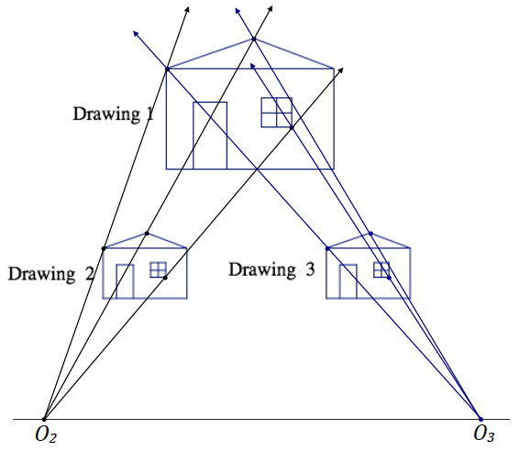Drawing 2 and Drawing 3 are both scale drawings of Drawing 1.



* 1. Determine the scale factor and center for each scale drawing. Take measurements as needed.

The scale factor for each drawing is the same; the scale factor for both is . Each scale drawing has a different center.

* 1. Is there a way to map Drawing 2 onto Drawing 3 or map Drawing 3 onto Drawing 2?

Since the two drawings are identical, a translation will map either Drawing 2 onto Drawing 3 or Drawing 3 onto Drawing 2.

* What do you notice about a translation vector that will map either scale drawing onto the other and the line that passes through the centers of the dilations?
  + *A translation vector that maps either scale drawing onto the other is parallel to the line that passes through the centers of the dilations.*

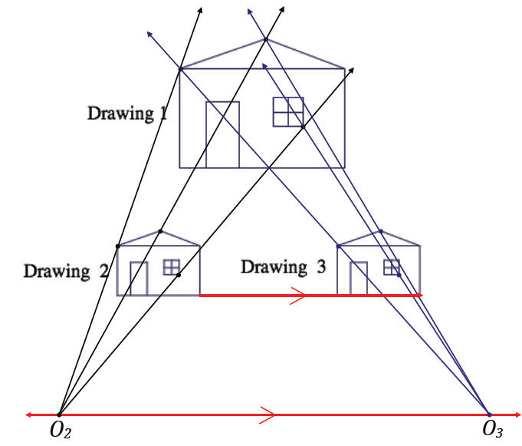

*Scaffolding:*

* Students can take responsibility for their own learning by hand-drawing the houses; however, if time is an issue, teachers can provide the drawings of the houses located at the beginning of Exploratory Challenge 1.
* Use patty paper or geometry software to help students focus on the concepts.
* Consider performing the dilation in the coordinate plane with center at the origin, for example, with coordinates and .
* We are not going to generally prove this, but let’s experimentally verify this by dilating a simple figure, i.e. a segment, by the same scale factor from two different centers and .
* Do this twice, in two separate cases, to observe what happens.
* In the first case, dilate by a factor of , and be sure to give each dilation a different center. Label the dilation about as and the dilation about as .

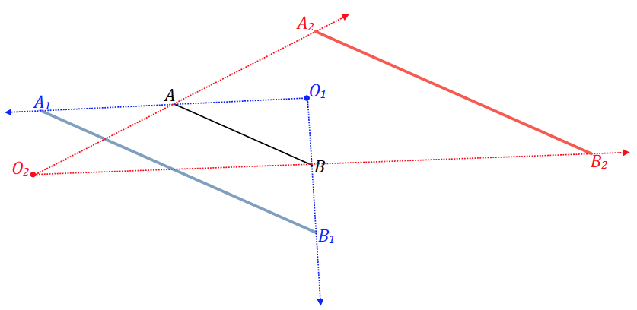

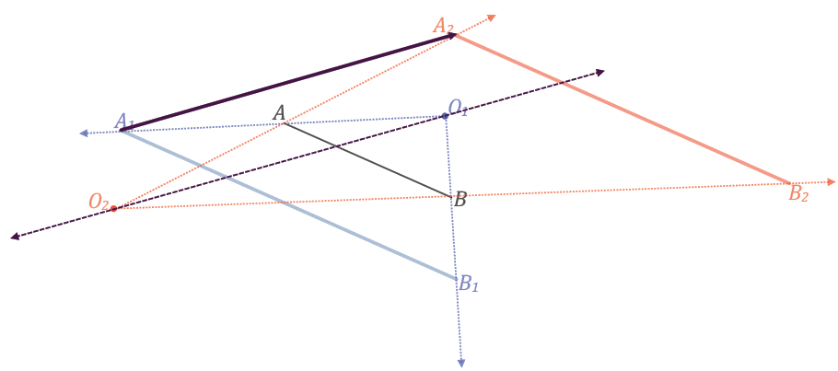

* Repeat the experiment and create a segment, , different from . Dilate by a factor of and be sure to give each dilation a different center. Label the dilation about as and the dilation about as .

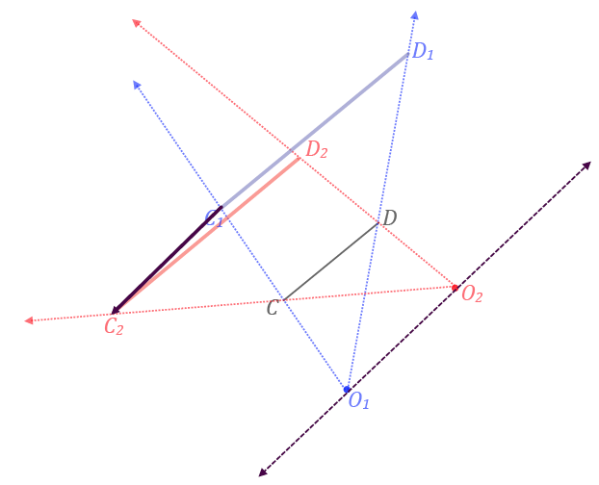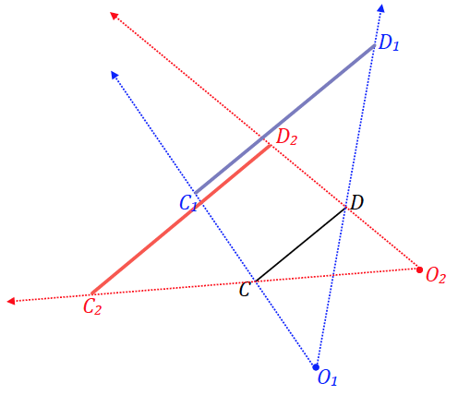

* What do you notice about the translation vector that maps the scale drawings to each other relative to the line that passes through the centers of the dilations, e.g., the vector that maps to ?

Allow students time to complete this mini-experiment and verify that the translation vector is parallel to the line that passes through the centers of the dilations.

* + *The translation vector is always parallel to the line that passes through the centers of the dilations*.
  1. Generalize the parameters of this example and its results.

**MP 8**

The dilation of a figure from two different centers by the same scale factor yields congruent figures that are congruent by a translation along a vector that is parallel to the line through the centers.

Exercise 1 (4 minutes)

Exercise 1

Triangle has been dilated with scale factor from centers and . What can you say about line segments , ,?

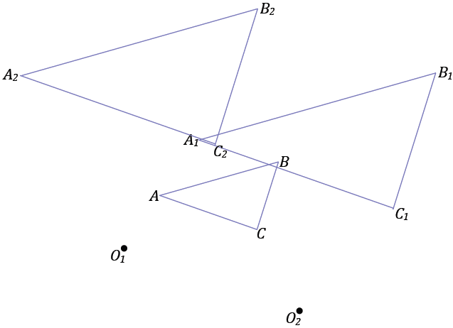

They are all parallel to the line that passes through .

**Exploratory Challenge 2 (15 minutes)**

In Exploratory Challenge 2, students verify experimentally (1) that the composition of dilations is a dilation with scale factor and (2) that the center of the composition lies on the line unless . Students may need poster paper or legal sized paper to complete part (c).

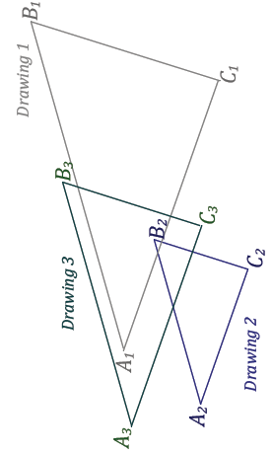Exploratory Challenge 2

If Drawing 2 is a scale drawing of Drawing 1 with scale factor , and Drawing 3 is a scale drawing of Drawing 2 with scale factor , what is the relationship between Drawing 3 and Drawing 1?

* 1. Determine the scale factor and center for each scale drawing. Take measurements as needed.

The scale factor for Drawing 2, relative to Drawing 1 is , and the scale factor for Drawing 3 relative to Drawing 2 is .

* 1. What is the scale factor going from Drawing 1 to Drawing 3? Take measurements as needed.

The scale factor to go from Drawing 1 to Drawing 3 is .

* Do you see a relationship between the value of the scale factor going from Drawing 1 to Drawing 3 and the scale factors determined going from Drawing 1 to Drawing 2 and Drawing 2 to Drawing 3?

Allow students a moment to discuss before taking responses.

* + *The scale factor to go from Drawing 1 to Drawing 3 is the same as the product of the scale factors to go from Drawing 1 to Drawing 2 and then Drawing 2 to Drawing 3. So the scale factor to go from Drawing 1 to Drawing 3 is .*
* To go from Drawing 1 to Drawing 3 is the same as taking a composition of the two dilations: .
* So, with respect to scale factor, a composition of dilations will result in a dilation whose scale factor is .

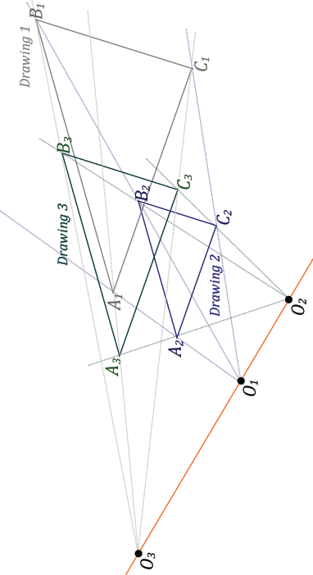

* 1. Compare the centers of dilations of Drawing 1 (to Drawing 2) and of Drawing 2 (to Drawing 3). What do you notice about these centers relative to the center of the composition of dilations ?

**MP.1**

**&**

**MP.7**

The centers of each for Drawing 1 and Drawing 2 are collinear with the center of dilation of the composition of dilations.

*Scaffolding:*

Students with difficulty in spatial reasoning can be provided this image and asked to observe what is remarkable about the centers of the dilations.

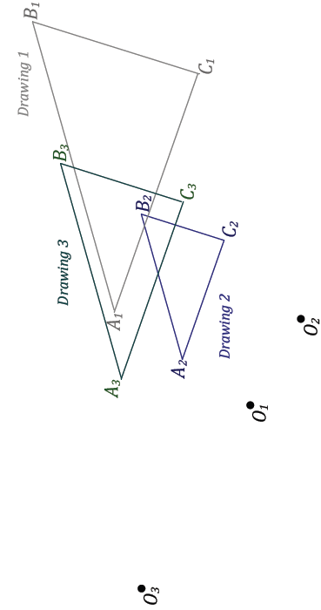

* From this example, it is tempting to generalize and say that with respect to the centers of the dilations, the centerof the composition of dilations, will be collinear with the centers and, but there is one situation where this is not the case.
* To observe this one case, draw a segment that will serve as the figure of a series of dilations.
* For the first dilation , select a center of dilation and scale factor . Dilate and label the result as .
* For the second dilation , select a new center and scale factor . Determine why the centers of each of these dilations cannot be collinear with the center of dilation of the composition of dilations .

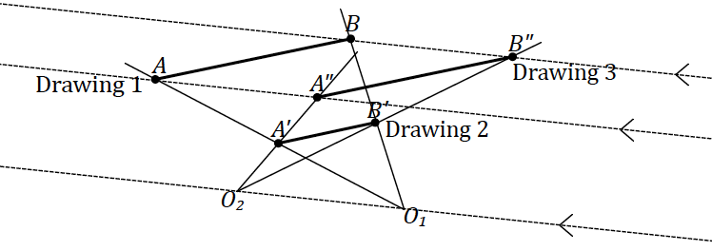

* + *Since* *Drawing 1 and Drawing 3 are identical figures, the lines that pass through the corresponding endpoints of the segments are parallel; a translation will map Drawing 1 to Drawing 3.*
* Notice that this occurs only when .
* Also notice that the translation that maps to must be parallel to the line that passes through the centers of the two given dilations.
  1. Generalize the parameters of this example and its results.

A composition of dilations, and , is a dilation with scale factor and center on unless . If , then there is no dilation that maps a figure onto the image of the composition of dilations; there is a translation parallel to the line passing through the centers of the individual dilations that will map the figure onto its image.

Exercise 2 (4 minutes)

Exercise 2

Triangle has been dilated with scale factor from center to get triangle , and then triangle is dilated from center with scale factor to get triangle . Describe the dilation that maps triangle to triangle . Find the center and scale factor for that dilation.

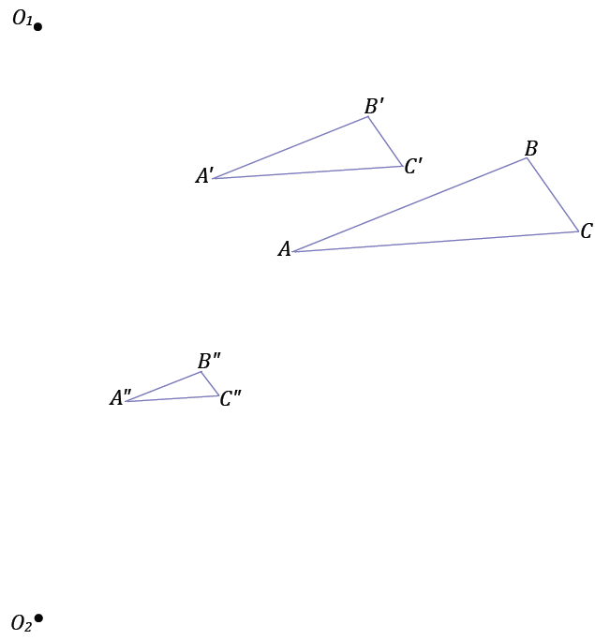

The dilation center is a point on the line segment , and the scale factor is .

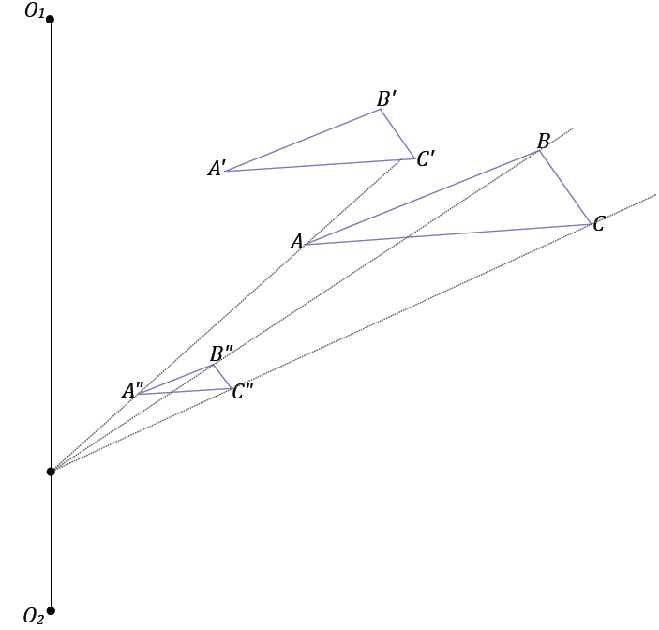

Closing (2 minutes)

* In a series of dilations, how does the scale factor that maps the original figure to the final image compare to the scale factor of each successive dilation?
  + *In a series of dilations, the scale factor that maps the original figure onto the final image is the product of all the scale factors in the series of dilations.*
* We remember here that unlike the previous several lessons, we did not prove facts in general; we made observations through measurements.

Lesson Summary

In a series of dilations, the scale factor that maps the original figure onto the final image is the product of all the scale factors in the series of dilations.

Exit Ticket (5 minutes)

Name Date

Lesson 11: Dilations from Different Centers

Exit Ticket

Marcos constructed the composition of dilations shown below. Drawing 2 is the size of Drawing 1, and Drawing 3 is twice the size of Drawing 2.

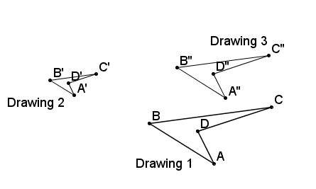

1. Determine the scale factor from Drawing 1 to Drawing 3.
2. Find the center of dilation mapping Drawing 1 to Drawing 3.

Exit Ticket Sample Solutions

1. Marcos constructed the composition of dilations shown below. Drawing 2 is the size of Drawing 1, and Drawing 3 is twice the size of Drawing 2.

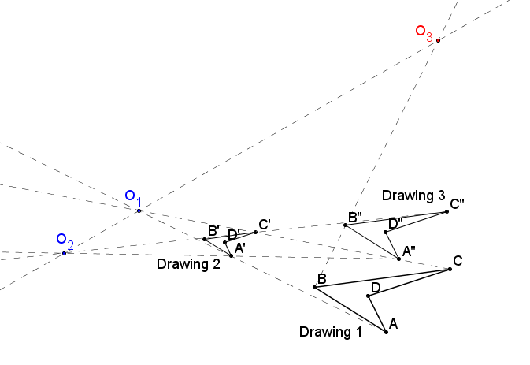

1. Determine the scale factor from Drawing 1 to Drawing 3.

Drawing 2 is a scale drawing of Drawing1, and Drawing 3 is a scale drawing of Drawing 2, so Drawing 3 then is a scale drawing of a scale drawing:

The scale factor from Drawing 1 to Drawing 3 is .

1. Find the center of dilation mapping Drawing 1 to Drawing 3.

See diagram: Center of dilation .

Problem Set Sample Solutions

1. In Lesson 7, the dilation theorem for line segments said that if two different length line segments in the plane were parallel to each other, then a dilation exists mapping one segment onto the other. Explain why the line segments must be different lengths for a dilation to exist.

If the line segments were of equal length, then it would have to be true that the scale factor of the supposed dilation would be ; however, we found that any dilation with a scale factor of maps any figure to itself, which implies that the line segment would have to be mapped to itself. Two different line segments that are parallel to one another implies that the line segments are not one and the same, which means that the supposed dilation does not exist.

1. 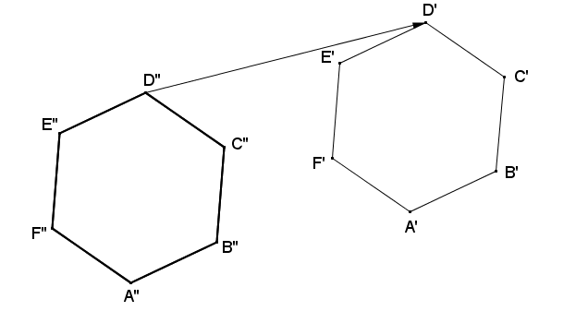Regular hexagon is the image of regular hexagon under a dilation from center , and regular hexagon is the image of regular hexagon under a dilation from center . Points ,,, , , and are also the images of points ,,,, , and, respectively, under a translation along vector . Find a possible regular hexagon .

Student diagrams will vary; however, the centers of dilation and must lie on a line parallel to vector .

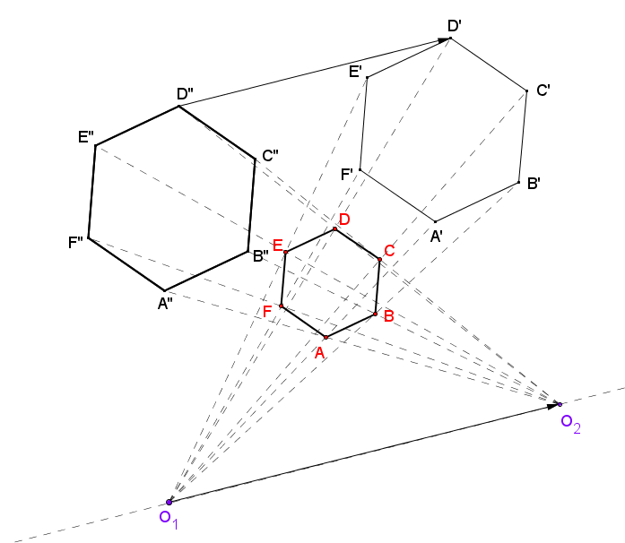

1. A dilation with center and scale factor maps figure to figure . A dilation with center and scale factor maps figure to figure . Draw figures and , and then find the center and scale factor of the dilation that takes to .

Answer:

1. If a figure is dilated from center with a scale factor to yield image , and figure is then dilated from center with a scale factor to yield figure . Explain why .

For any distance, , between two points in figure , the distance between corresponding points in figure will be . For the said distance between points in , , the distance between corresponding points in figure will be . This implies that all distances between two points in figure are equal to the distances between corresponding points in figure . Furthermore, since dilations preserve angle measures, angles formed by any three non-collinear points in figure will be congruent to the angles formed by the corresponding three non-collinear points in figure . There is then a correspondence between and in which distance is preserved and angle measures are preserved, implying that a sequence of rigid motions maps onto ; hence, a congruence exists between figures and .

1. A dilation with center and scale factor maps figure to figure . A dilation with center and scale factor maps figure to figure . Draw figures and . Find a vector for a translation that maps to .

Solution:



1. Figure is dilated from with a scale factor to yield . Figure is then dilated from center with a scale factor to yield .
   1. 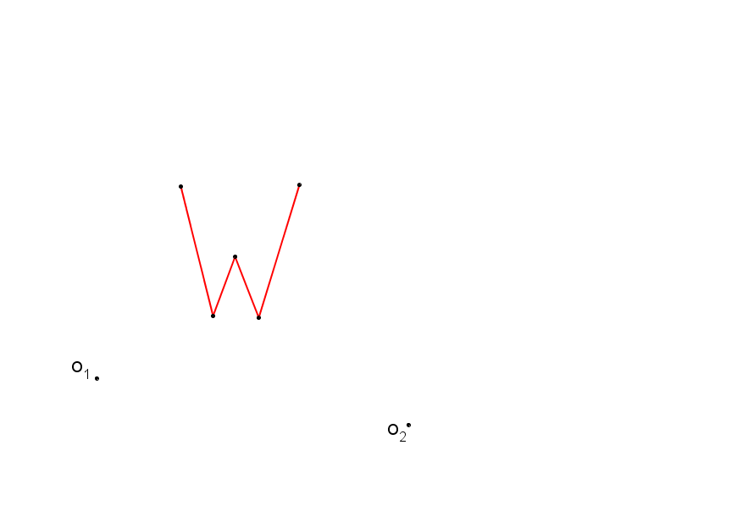Construct the composition of dilations of figure described above.

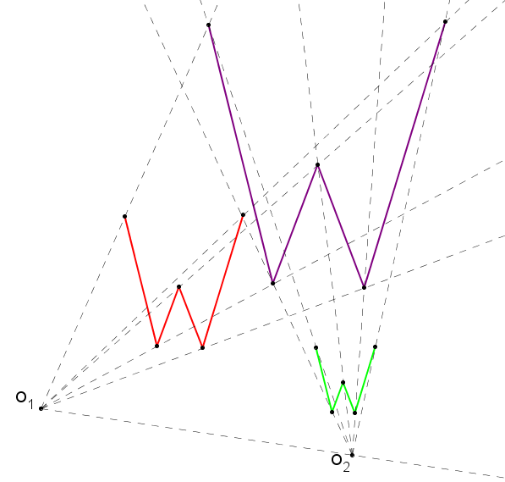

* 1. If you were to dilate figure , what scale factor would be required to yield an image that is congruent to figure ?

In a composition of dilations, for the resulting image to be congruent to the original pre-image, the product of the scale factors of the dilations must be .

The scale factor necessary to yield an image congruent to the original pre-image is .

* 1. Locate the center of dilation that maps to using the scale factor that you identified in part (b).

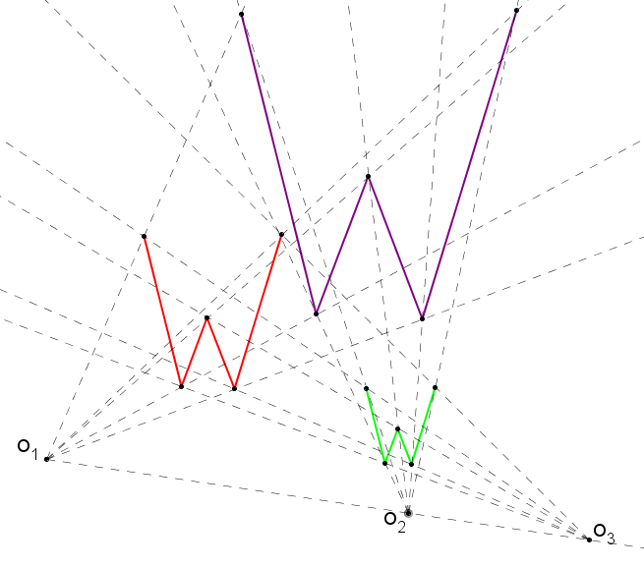

1. Figures and in the diagram below are dilations of from centers and , respectively.
   1. Find .

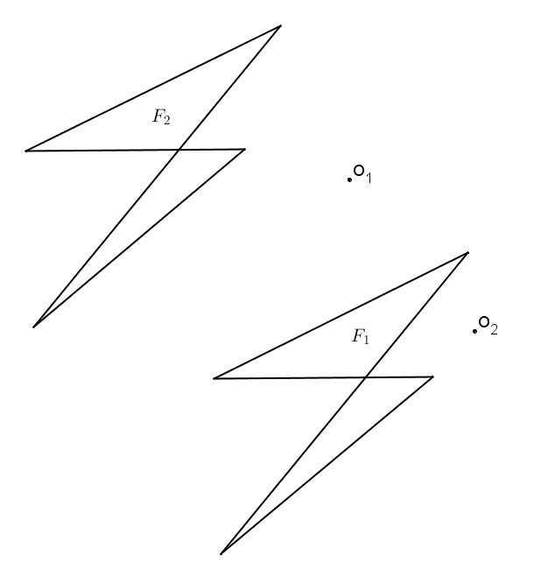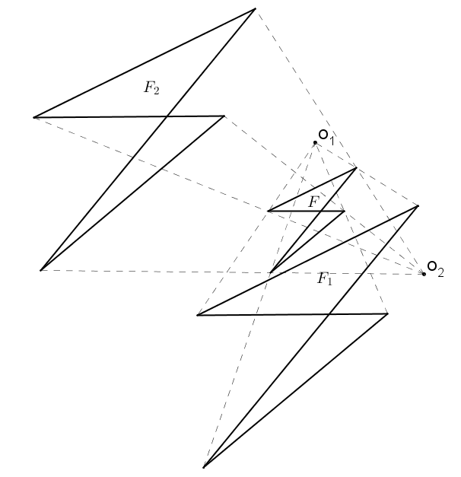

* 1. If , what must be true of the scale factors and of each dilation?

The scale factors must be equal.

* 1. Use direct measurement to determine each scale factor for and .

By direct measurement, the scale factor used for each dilation is .

Note to the teacher: Parts of this next problem involve a great deal of mathematical reasoning and may not be suitable for all students.

1. 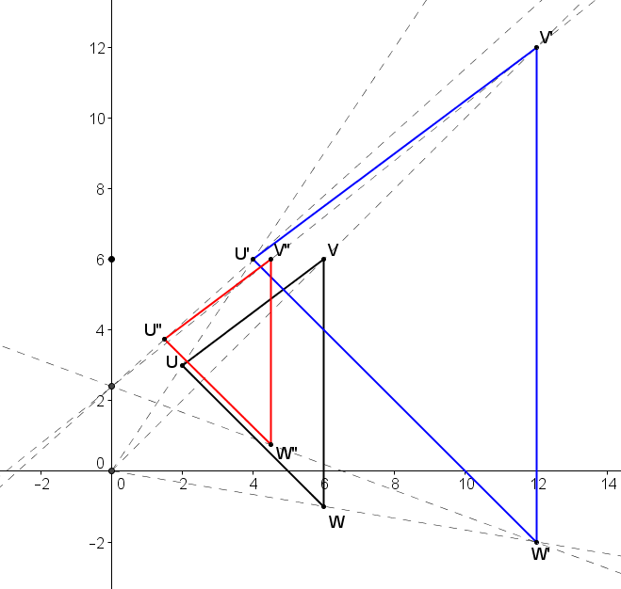Use a coordinate plane to complete each part below using , , and .
   1. Dilate from the origin with a scale factor . List the coordinate of image points , , and .

, , and .

* 1. Dilate from with a scale factor of . List the coordinates of image points , , and .

The center of this dilation is not the origin. The -coordinate of the center is , so the -coordinates of the image points can be calculated in the same manner as in part (a). However, the -coordinates of the pre-image must be considered as their distance from the -coordinate of the center, .

Point is units below the center of dilation, point is at the same vertical level as the center of dilation, and point is units below the center of dilation.

, , and .

* 1. Find the scale factor, , from to .

is the image of with a scale factor , so it follows that can be considered the image of with a scale factor of . Therefore, can be considered the image of the composition of dilations of . This means that the scale factor .

* 1. Find the coordinates of the center of dilation that maps to .

The center of dilation must lie on the -axis with centers and . Therefore, the -coordinate of is . Using the graph, it appears that the -coordinate of is a little more than .

Considering the points and :

The center of dilation is .