Lesson 11: Dilations from Different Centers

Classwork

Exploratory Challenge 1

Drawing 2 and Drawing 3 are both scale drawings of Drawing 1.

* 1. Determine the scale factor and center for each scale drawing. Take measurements as needed.
  2. Is there a way to map Drawing 2 onto Drawing 3 or map Drawing 3 onto Drawing 2?
  3. Generalize the parameters of this example and its results.

Exercise 1

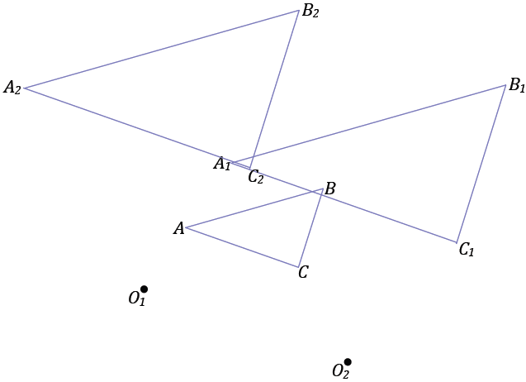Triangle has been dilated with scale factor from centers and . What can you say about line segments , ,?

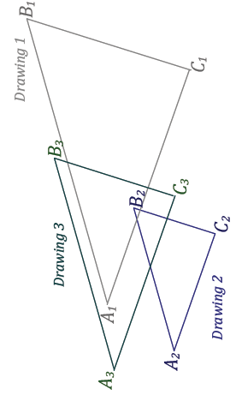Exploratory Challenge 2

If Drawing 2 is a scale drawing of Drawing 1 with scale factor , and Drawing 3 is a scale drawing of Drawing 2 with scale factor , what is the relationship between Drawing 3 and Drawing 1?

* 1. Determine the scale factor and center for each scale drawing. Take measurements as needed.
  2. What is the scale factor going from Drawing 1 to Drawing 3? Take measurements as needed.
  3. Compare the centers of dilations of Drawing 1 (to Drawing 2) and of Drawing 2 (to Drawing 3). What do you notice about these centers relative to the center of the composition of dilations ?
  4. Generalize the parameters of this example and its results.

Exercise 2

Triangle has been dilated with scale factor from center to get triangle , and then triangle is dilated from center with scale factor to get triangle . Describe the dilation that maps triangle to triangle . Find the center and scale factor for that dilation.

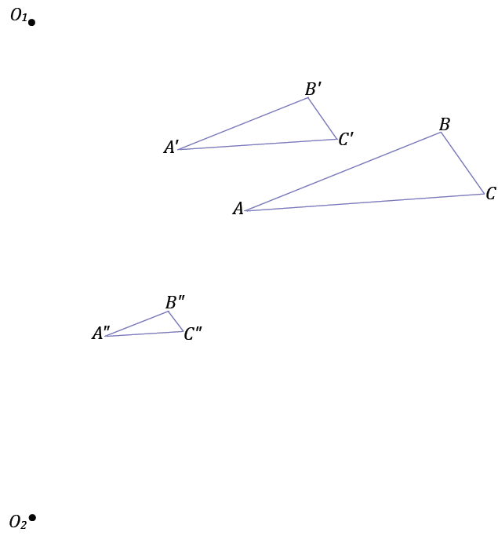

Lesson Summary

In a series of dilations, the scale factor that maps the original figure onto the final image is the product of all the scale factors in the series of dilations.

Problem Set

1. In Lesson 7, the dilation theorem for line segments said that if two different length line segments in the plane were parallel to each other, then a dilation exists mapping one segment onto the other. Explain why the line segments must be different lengths for a dilation to exist.
2. 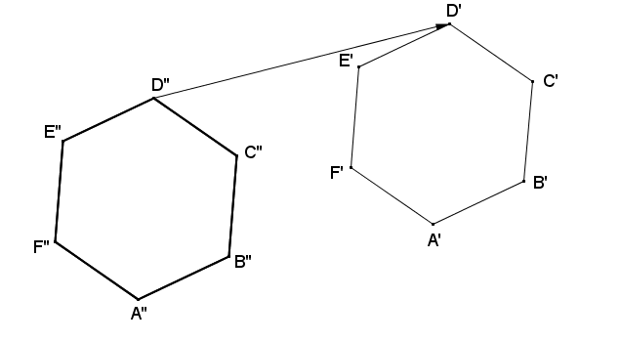Regular hexagon is the image of regular hexagon under a dilation from center , and regular hexagon is the image of regular hexagon under a dilation from center . Points ,,, , , and are also the images of points ,,,, , and, respectively, under a translation along vector . Find a possible regular hexagon .
3. A dilation with center and scale factormaps figure to figure . A dilation with center and scale factor maps figure to figure . Draw figures and , and then find the center and scale factor of the dilation that takes to .
4. If a figure is dilated from center with a scale factor to yield image , and figure is then dilated from center with a scale factor to yield figure . Explain why .
5. A dilation with center and scale factor maps figure to figure . A dilation with center and scale factor maps figure to figure . Draw figures and . Find a vector for a translation that maps to .
6. Figure is dilated from with a scale factor to yield . Figure is then dilated from center with a scale factor to yield .

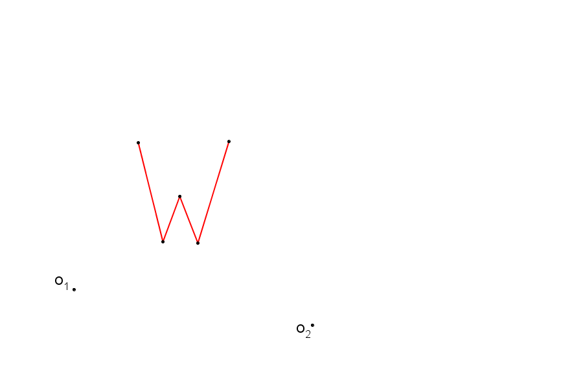

* 1. Construct the composition of dilations of figure described above.
  2. If you were to dilate figure , what scale factor would be required to yield an image that is congruent to figure ?
  3. Locate the center of dilation that maps to using the scale factor that you identified in part (b).

1. Figures and in the diagram below are dilations of from centers and , respectively.

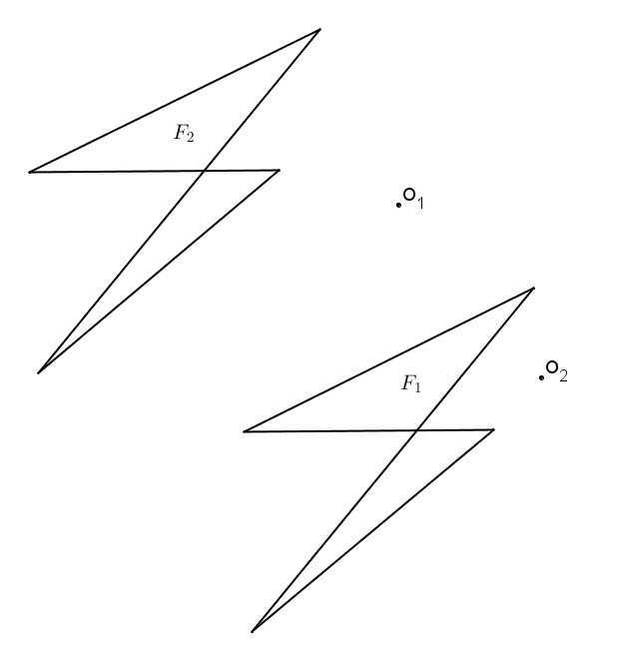

* 1. Find .
  2. If , what must be true of the scale factors and of each dilation?
  3. If , what must be true of the scale factors and of each dilation?

1. Use a coordinate plane to complete each part below using , , and .
   1. Dilate from the origin with a scale factor . List the coordinate of image points , , and .
   2. Dilate from with a scale factor of . List the coordinates of image points , , and .
   3. Find the scale factor, , from to .
   4. Find the coordinates of the center of dilation that maps to .