Lesson 10: Dividing the King’s Foot into 12 Equal Pieces

Student Outcomes
- Students divide a line segment into $n$ equal pieces by the side splitter and dilation methods.
- Students know how to locate fractions on the number line.

Materials
- Poster paper or chart paper
- Yard stick
- Compass
- Straightedge
- Set square

Lesson Notes
Students explore how their study of dilations relates to the constructions that divide a segment into a whole number of equal-length segments.

Classwork
Opening (2 minutes)
In an age when there was no universal consensus on measurement, the human body was often used to create units of measurement. You can imagine how a king might declare the length of his foot to be what we know as the unit of a foot. How would we go about figuring out how to divide one foot into twelve equal portions, as the $12$ inches that comprise a foot? Have students write or discuss their thoughts.
MP.3

Opening Exercise (3 minutes)
Opening Exercise
Use a compass to mark off equally spaced points $C$, $D$, $E$, and $F$ so that $AB$, $BC$, $CD$, $DE$, and $EF$ are equal in length. Describe the steps you took.

I adjust the compass to the length of $AB$ and then place the point of the compass on $B$ and use the adjustment to make a mark so that it intersects with the ray. This is the location of $C$, and I will repeat these steps until I locate point $F$.
- Marking off equal segments is entirely a matter of knowing how to use the compass.
- What if you knew the length of a segment but needed to divide it into equal-length intervals? For example, suppose you had a segment $AB$ that was $10 cm$ in length. How could you divide it into ten $1 cm$ parts?
  - Allow students time to discuss. They may try and use what they know about creating a perpendicular bisector to locate the midpoint of the segment; however, they will quickly see that it does not easily lead to determining a $1 cm$ unit.
- We can tackle this problem with a construction that relates to our work on dilations.

Exploratory Challenge 1 (12 minutes)
In the Exploratory Challenge, students learn a construction that divides a segment into $n$ equal parts. They understand that the constructed parallel segments are evenly spaced proportional side splitters of $△ABA_{3}$.
- We are going to use a compass and straightedge to divide a segment of known length by a whole number $n$.
- We are going to divide the following segment $AB$ into three segments of equal length.
Exploratory Challenge 1
Divide segment $AB$ into three segments of equal lengths.

Draw each step of the Exploratory Challenge so that students can refer to the correct steps whether they are ahead or working alongside you.
- Pick a point $A_{1}$ not on $\overline{AB}$. Draw $\vec{AA_{1}}$.
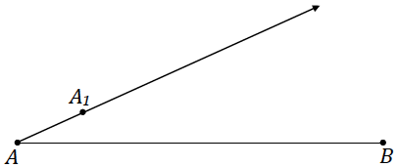

- Mark points $A_{2}$ and $A_{3}$ on the ray so that $AA_{1}=A_{1}A_{2}=A_{2}A_{3}$.
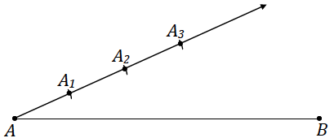

- Use a straight edge to draw $A_{3}B$. Use a setsquare to draw segments parallel to $A_{3}B$ through $A_{1}$ and $A_{2}$.
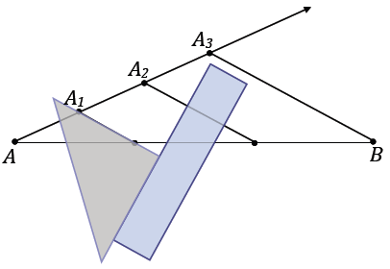

- Label the points where the constructed segments intersect $\overline{AB}$ as $B_{1}$ and $B_{2}$.
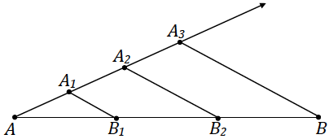

Allow students time to discuss with each other why the construction divides $AB$ into equal parts.
- Did we succeed? Measure segments $AB_{1}$, $B_{1}B_{2}$, and $B_{2}B$. Are they all equal in measurement?
- After the last step of the construction, answer the following: Why does this construction divide the segment $AB$ into equal parts?
Allow students a moment to jot down their thoughts and then take responses.
  - By construction, segments $A_{1}B_{1}$ and $A_{2}B_{2}$ are parallel to $A_{3}B$. By the triangle side splitter theorem, $A_{1}B_{1}$ and $A_{2}B_{2}$ are proportional side splitters of triangle $ABA_{3}$. So $\frac{AB_{1}}{AB}=\frac{AA_{1}}{AA_{3}}=\frac{1}{3}$ and $\frac{AB_{2}}{AB}=\frac{AA_{2}}{AA_{3}}=\frac{2}{3}$. Thus, $AB_{1}=\frac{1}{3}AB$ and $AB_{2}=\frac{2}{3}AB$, and we can conclude that $B_{1}$ and $B_{2}$ divide line segment $AB$ into three equal pieces.
MP.2
- Would the construction work if you had chosen a different location for $A_{1}$? Try the construction again and choose a location different from the location in the first construction.
Scaffolding:
- Consider having students use a different color for this construction.
- Additionally, consider splitting the class so that one half begins the construction from $A$, while the other half begins at $B$.

Students should retry the construction and discover that the location of $A_{1}$ is irrelevant to dividing $\overline{AB}$ into three equal-length segments. The triangle drawn in this second attempt will be different from the one initially created, so though $A_{1}$ is in a different location, the triangle drawn is also different. Therefore, the proportional side splitters are also different but achieve the same result, dividing $AB$ into three equal-length segments. Furthermore, the location of $A_{1}$ was never specified to begin with, nor was the relative angle of $∠BAA_{1}$. So, technically, we have already answered this question.
- We call this method of dividing the segment into $n$ equal-length segments the side splitter method in reference to the triangle side splitter theorem.
- Side splitter method: If $\overline{AB}$ is a line segment, construct a ray $AA_{1}$ and mark off $n$ equally-spaced points using a compass of fixed radius to get points $A=A_{0}, A_{1}, A_{2}, ⋯,A_{n}$. Construct $\overline{A_{n}B}$ that is a side of $△ABA_{n}$. Through each point $A_{1}$,$A_{2}$,$⋯$,$A_{n-1}$, construct line segments $\overline{A_{1}B_{1}}$, $\overline{A_{2}B_{2}}$, … $\overline{A_{n-1}B_{n-1}}$ parallel to $\overline{A_{n}B}$ that connect two sides of $△AA_{n}B$.

Exercise 1 (3 minutes)
Teachers may elect to move directly to the next Exploratory Challenge depending on time. Alternatively, if there is some time, the teacher may elect to reduce the number of divisions to 3.
Exercise 1
Divide segment $AB$ into five segments of equal lengths.

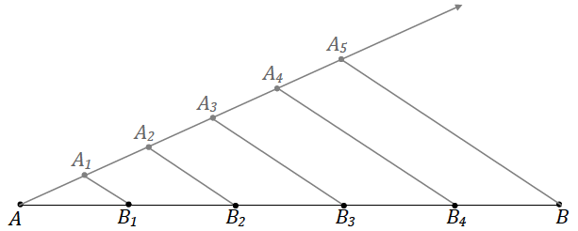

Exploratory Challenge 2 (10 minutes)
Now students try an alternate method of dividing a segment into $n$ equal-length segments.
Scaffolding:
- Consider focusing on the side splitter method alone for struggling students.
- Using this strategy, select an early question from the Problem Set to work on in class.
- Let’s continue with our exploration and try a different method to divide a segment of known length by a whole number $n$. Again, we rely on the use of a compass, straightedge, and this time, a setsquare.
Exploratory Challenge 2
Divide segment $AB$ into four segments of equal length.

- Use the setsquare to create a ray $XY$parallel to $\overline{AB}$. Select the location of the endpoint $X$ so that it falls to the left of $A$; the location of $Y$ should be oriented in relation to $X$ in the same manner as $B$ is in relation to $A$. We construct the parallel ray below $\overline{AB}$, but it can be constructed above the segment as well.
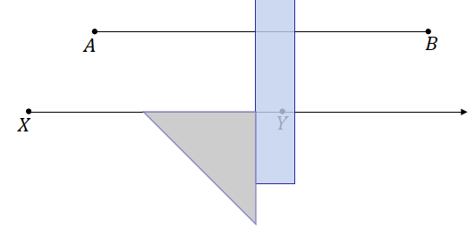
- From $X$, use the compass to mark off four equal segments along $\vec{XY}$. Label each intersection as $X_{1}$, $X_{2}$, $X_{3}$, and $X_{4}$. It is important that $XX_{4}≠AB$. In practice, $XX_{4}$ should be clearly more or clearly less than $AB$.

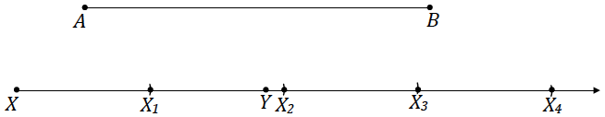

- Draw line $XA$ and line $X_{4}B$. Mark the intersection of the two lines as $O$.
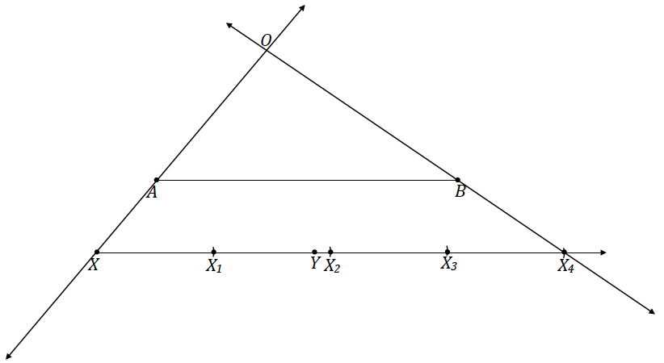

- Construct rays from $O$ through $X_{1}$, $X_{2}$, and $X_{3}$. Label each intersection with $\overline{AB}$ as $A_{1}$, $A_{2}$, and $A_{3}$.
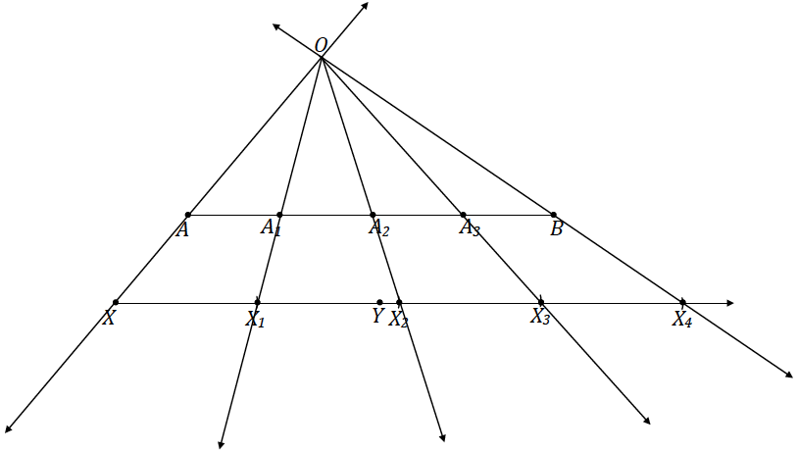
- $\overline{AB}$ should now be divided into four segments of equal length. Measure segments $AA_{1}$, $A_{1}A_{2}$, $A_{2}A_{3}$, and $A_{3}B$. Are they all equal in measurement?
- Why does this construction divide the segment $AB$ into equal parts?
Allow students time to discuss with each other why the construction divides $\overline{AB}$ into equal parts.
  - We constructed $\overline{AB}$ to be parallel to $\vec{XY}$. In $△XOX_{4}$, since the side splitter $\overline{AB}$ is parallel to $\overline{XX_{4}}$, by the triangle side splitter theorem, it must also be a proportional side splitter. By the dilation theorem, this means that $\frac{AA_{1}}{XX_{1}}=\frac{A_{1}A_{2}}{X_{1}X_{2}}=\frac{A_{2}A_{3}}{X_{2}X_{3}}=\frac{A_{3}B}{X_{3}X_{4}}$. Since we know that the values of all four denominators are the same, the value of all four numerators must also be the same to make the equation true. Therefore, $\overline{AB}$ has been divided into four segments of equal length.
- We call this method of dividing the segment into equal lengths the dilation method, as the points that divide $\overline{AB}$ are by definition dilated points from center $O$ with scale factor $r=\frac{OA}{OX}$ of the evenly spaced points on $\vec{XY}$.
- Dilation method: Construct a ray $XY$ parallel to $\overline{AB}$ . On the parallel ray, use a compass to mark off $n$ equally-spaced points $X_{1}$, $X_{2}$,$⋯$,$X_{n}$ so that $XX_{n}≠AB$. Lines $\overset{⃡}{AX}$ and $\overset{⃡}{BX_{n}}$ intersect at a point $O$. Construct the rays $\vec{OX_{1}}$, $\vec{OX_{2}}$, …, $\vec{OX_{n}}$ that meet $\overline{AB}$ in points $A_{1}$, $A_{2}$, …, $A_{n}$ respectively.
- What happens if line segments $XX_{n}$ and $AB$ are close to the same length?
  - The point $O$ is very far away.
- That is why it is best to make $XX_{n}$ clearly more or less than $AB$. It is also best to keep line segments $XX_{n}$ and $AB$ centered or the point $O$ will also be far away.

Exercise 2 (8 minutes)
Students should complete Exercise 2 in pairs. If possible, the teacher should pre-mark each piece of poster paper with a $1$-foot mark to allow students to get right to the activity.
- Let’s return to our opening remarks on the King’s foot.

Exercise 2
On a piece of poster paper, draw a segment $AB$ with a measurement of $1$ foot. Use the dilation method to divide $\overline{AB}$ into twelve equal-length segments, or into $12$ inches.
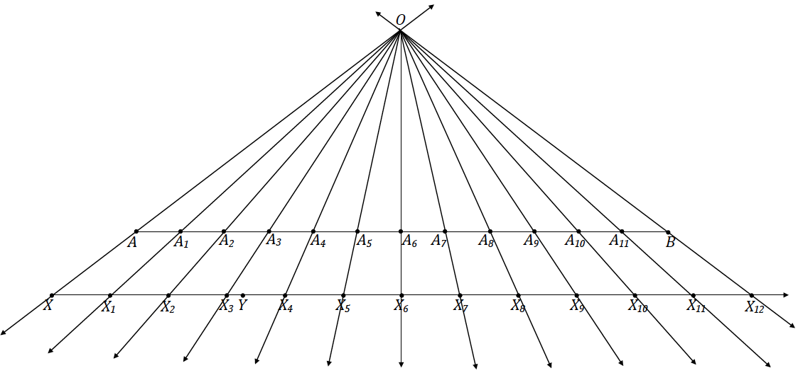

Closing (2 minutes)
- Compare the side splitter method to the dilation method: What advantage does the first method have?
  - With the side splitter method, we do not have to worry about checking lengths (i.e., the initial point can be chosen completely arbitrarily), whereas with the dilation method, we have to choose our unit so that $n$ units does not match the original length (or come close to matching).
- How does either of the methods help identify fractions on the number line?
  - We can break up whole units on a number line into any division we choose; for example, we can mimic a ruler in inches by dividing up a number line into eighths.
Lesson Summary
Side splitter method: If $\overline{AB}$ is a line segment, construct a ray $AA_{1}$ and mark off $n$ equally spaced points using a compass of fixed radius to get points $A=A_{0}$, $A_{1}$, $A_{2}$, $⋯$,$A_{n}$. Construct $\overline{A_{n}B}$ that is a side of $△ABA_{n}$. Through each point $A_{1}$,$A_{2}$,$⋯$,$A_{n-1}$, construct line segments $\overline{A_{i}B_{i}}$ parallel to $\overline{A_{n}B}$ that connect two sides of $△AA_{n}B$.
Dilation method: Construct a ray $XY$ parallel to $\overline{AB}$ . On the parallel ray, use a compass to mark off $n$ equally spaced points $X_{1}$, $X_{2}$,$⋯$,$X_{n}$ so that $XX_{n}≠AB$. Lines $\overset{⃡}{AX}$ and $\overset{⃡}{BX_{n}}$ intersect at a point $O$. Construct the rays $\vec{OX_{i}}$ that meet $\overline{AB}$ in points $A_{i}$.

Exit Ticket (5 minutes)
Name Date
Lesson 10: Dividing the King’s Foot into 12 Equal Pieces

Exit Ticket

- Use the side splitter method to divide $\overline{MN}$ into $7$ equal-sized pieces.

- Use the dilation method to divide $\overline{PQ}$ into $11$ equal-sized pieces.

- If the segment below represents the interval from zero to one on the number line, locate and label $\frac{4}{7}$.
Exit Ticket Sample Solutions
$$1$$
$$0$$

- Use the side splitter method to divide $\overline{MN}$ into 7 equal-sized pieces.
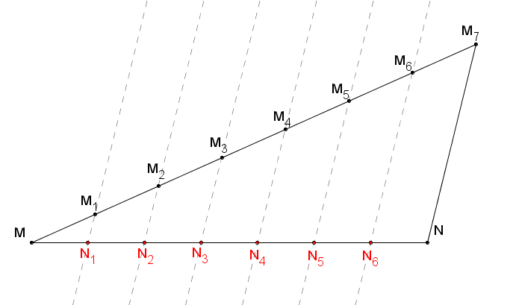

- Use the dilation method to divide $\overline{PQ}$ into $11$ equal-sized pieces.
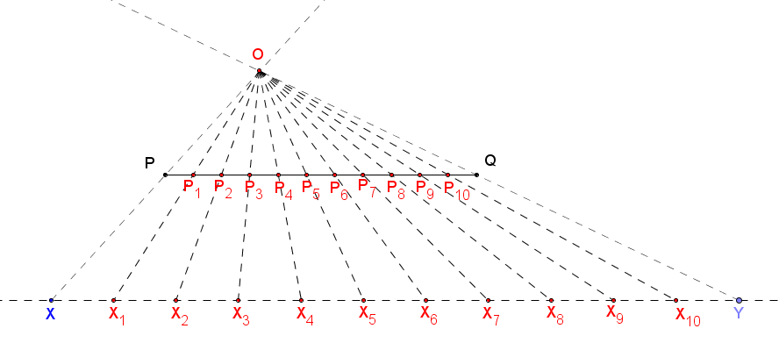

- If the segment below represents the interval from zero to one on the number line, locate and label $\frac{4}{7}$.
Students may use either the side splitter method or the dilation method and need only find the location of the fourth equal-sized piece of the segment as shown in the diagram below.
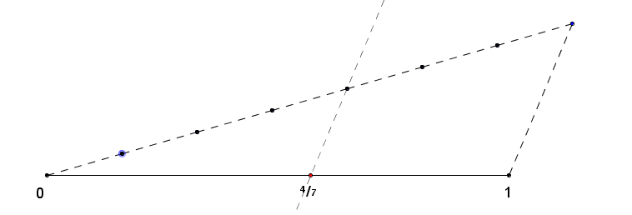

Problem Set Sample Solutions

- Pretend you are the king or queen and that the length of your foot is the official measurement for one foot. Draw a line segment on a piece of paper that is the length of your foot. (You may have to remove your shoe.) Use the method above to find the length of $1$ inch in your kingdom.
I drew $\overline{AB}$ representing the length of my foot. I then divided $\overline{AB}$ into twelve equal pieces using the dilation method as follows:
I constructed $\overset{⃡}{DE}$ parallel to $\overline{AB}$ and, using a compass, marked off twelve consecutive segments on $\overset{⃡}{DE}$, each having length $DC$. (Note that because $\overline{AB}$ is a large segment, students will likely choose a length $DC$ so that the total length of all of the segments constructed on $\overset{⃡}{DE}$ is noticeably shorter than $\overline{AB}$.)
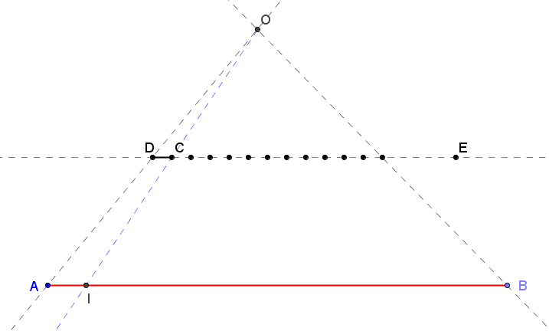
I then constructed a ray from $A$ and $B$ through the endpoints of the composed segment as shown in the diagram to form a triangle $ABO$. Next I constructed $\vec{OC}$, and then marked its intersection with $\overline{AB}$ point $I$. This distance $AI$ is the length of $1$ inch in my kingdom.

- Using a ruler, draw a segment that is $10 cm$. This length is referred to as a decimeter. Use the side splitter method to divide your segment into ten equal-sized pieces. What should be the length of each of those pieces based on your construction? Check the length of the pieces using a ruler. Are the lengths of the pieces accurate?
Verify that student diagrams show the use of the side splitter method. The length of each piece should be $1 cm$.

- Repeat Problem 2 using the dilation method. What should be the length of each of those pieces based on your construction? Check the length of the pieces using a ruler. Are the lengths of the pieces accurate?
Verify that student diagrams show the use of the dilation method. The length of each piece should be $1 cm$.

- A portion of a ruler that measured whole centimeters is shown below. Determine the location of $5\frac{2}{3} cm$ on the portion of the ruler shown.
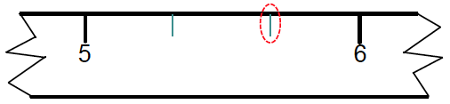
Responses should show the segment between $5$ and $6$ divided into $3$ equal pieces with the division point closest to $6$ chosen as the location of $5\frac{2}{3}$.

- Merrick has a ruler that measures in inches only. He is measuring the length of a line segment that is between $8$ and $9 in$. Divide the one-inch section of Merrick’s ruler below into eighths to help him measure the length of the segment.

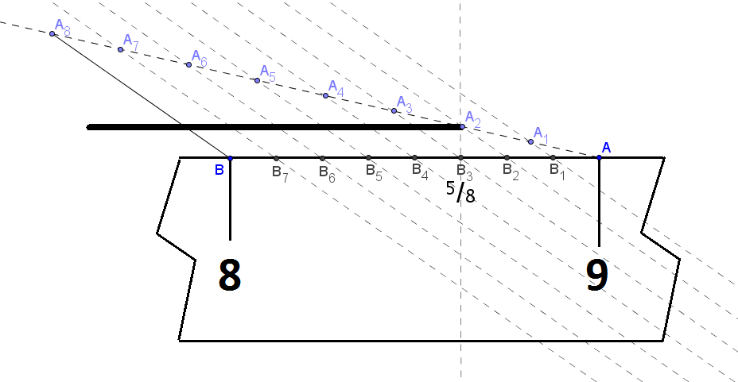
Using the side splitter method, I divided the one-inch interval into eighths, labeled as $B_{1}$, $B_{2}$, etc. on the diagram. The line segment that Merrick is measuring closely corresponds with $B_{3}$, which represents $\frac{5}{8}$ of the distance from $8 in$. to $9 in$. Therefore, the length of the line segment that Merrick is measuring is approximately $8\frac{5}{8} in$.

- Use the dilation method to create an equally spaced $3×3$ grid in the following square.

There are several ways to complete this construction. The sample below used the dilation method along two sides of the square with centers $O$ and $O_{2}$ to divide the side into three equal-size segments. The sides of the square were extended such that $DD^{'}=CD$, $CC^{'}=CD$, $BB^{'}=CB$, and $C{C'}_{1}=CB$.

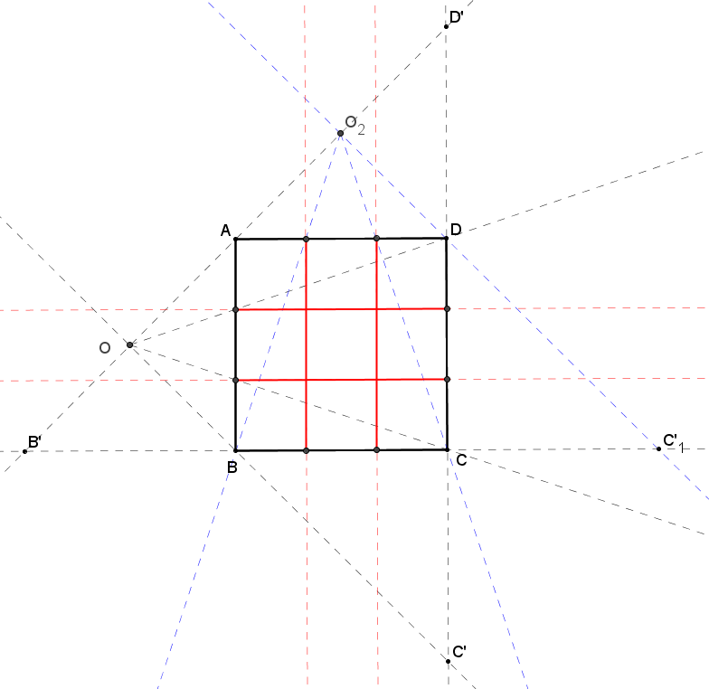

- Use the side splitter method to create an equally spaced $3×3$ grid in the following square.

There are several ways to complete this construction. The sample below used the side splitter method along two sides of the square to divide the side into three equal-size segments.

