|  |
| --- |
|  |

Lesson 9: How Do Dilations Map Angles?

Student Outcomes

* Students prove that dilations map an angle to an angle with equal measure.
* Students understand how dilations map triangles, squares, rectangles, trapezoids, and regular polygons.

Lesson Notes

In this lesson, students show that dilations map angles to angles of equal measure. The Exploratory Challenge requires students to make conjectures about how dilations map polygonal figures, specifically, the effect on side lengths and angle measures. The goal is for students to informally verify that dilations map angles to angles of equal measure. Further, students describe the effect dilations have on side lengths, e.g., if side length and is dilated from a center with scale factor , then the dilated side The discussion that follows the Exploratory Challenge focuses on the effect dilations have on angles. Students should already be familiar with the effect of dilation on lengths of segments, so the work with polygonal figures extends students’ understanding of the effect of dilations on figures other than triangles. Consider extending the lesson over two days where on the first day students complete all parts of the Exploratory Challenge and on the second day students work to prove their conjectures about how dilations map angles. The last discussion of the lesson (dilating a square inscribed in a triangle) is optional and can be completed if class time permits.

This lesson highlights Mathematical Practice 3: Construct viable arguments and critique the reasoning of others. Throughout the lesson, students are asked to make a series of conjectures and justify them by experimenting with diagrams and direct measurements.

Classwork

**Exploratory Challenge/Exercises 1–4 (13 minutes)**

The Exploratory Challenge allows students to informally verify how dilations map polygonal figures in preparation for the discussion that follows. Make clear to students that they must first make a conjecture about how the dilation will affect the figure and then verify their conjecture by actually performing a dilation and directly measuring angles and side lengths. Consider having students share their conjectures and drawings with the class. It may be necessary to divide the class into four groups and assign each group one exercise to complete. When all groups are finished, they can share their results with the whole class.

*Scaffolding:*

Some groups of students may benefit from a teacher-led model of the first exercise. Additionally, use visuals or explicit examples, such as dilating triangle , ,,, by a variety of scale factors to help students make a conjecture.

Exploratory Challenge/Exercises 1–4

**MP.3**

1. How do dilations map triangles?
   1. Make a conjecture.

A dilation maps a triangle to a triangle with the same angles, and all of the sides of the image triangle are proportional to the sides of the original triangle.

* 1. Verify your conjecture by experimenting with diagrams and directly measuring angles and lengths of segments.

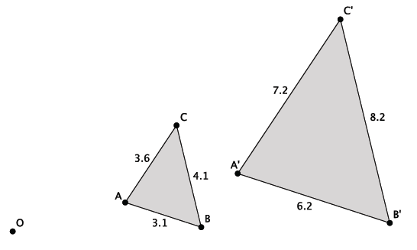

**MP.3**

The value of ratios of the lengths of the dilated triangle to the original triangle is equal to the scale factor. The angles map to angles of equal measure; all of the angles in the original triangle are dilated to angles equal in measure to the corresponding angles in the dilated triangle.

1. How do dilations map rectangles?
   1. Make a conjecture.

A dilation maps a rectangle to a rectangle so that the ratio of length to width is the same.

* 1. Verify your conjecture by experimenting with diagrams and directly measuring angles and lengths of segments.

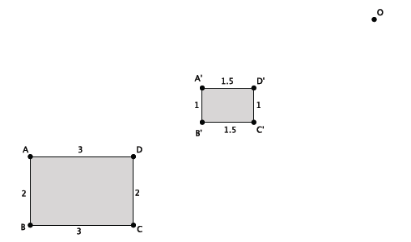

The original rectangle has a length to width ratio of . The dilated rectangle has a length to width ratio of . The value of the ratios are equal. Since angles map to angles of equal measure, all of the right angles in the original rectangle are dilated to right angles.

1. How do dilations map squares?
   1. Make a conjecture.

A dilation maps a square with side length to a square with side length where is the scale factor of dilation. Since each segment of length is mapped to a segment of length and each right angle is mapped to a right angle, then the dilation maps a square with side length to a square with side length .

* 1. Verify your conjecture by experimenting with diagrams and directly measuring angles and lengths of segments.

Sample student drawing:

**MP.3**

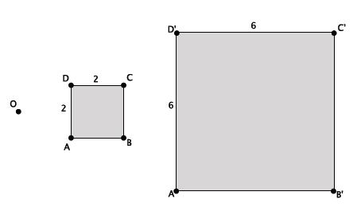

The side length of the original square is units. The side length of the dilated square is units. The side length of the dilated square is equal to the length of the original square multiplied by the scale factor. Since angles map to angles of equal measure, all of the right angles in the original square are dilated to right angles.

1. How do dilations map regular polygons?
   1. Make a conjecture.

A dilation maps a regular polygon with side length to a regular polygon with side length where is the scale factor of dilation. Since each segment of length is mapped to a segment of length and each angle is mapped to an angle that is equal in measure, then the dilation maps a regular polygon with side length to a regular polygon with side length .

* 1. Verify your conjecture by experimenting with diagrams and directly measuring angles and lengths of segments.

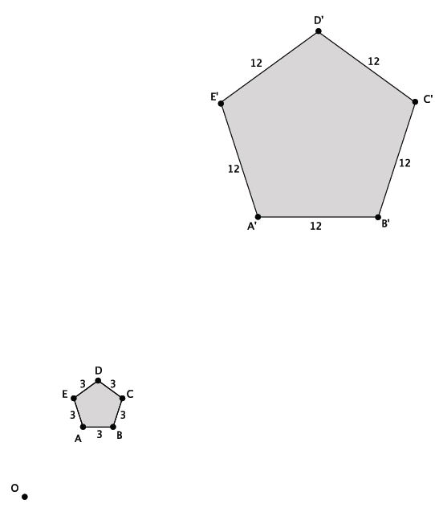

The side length of the original regular polygon is units. The side length of the dilated regular polygon is units. The side length of the dilated regular polygon is equal to the length of the original regular polygon multiplied by the scale factor. Since angles map to angles of equal measure, all of the angles in the original regular polygon are dilated to angles of each measure.

Discussion (7 minutes)

Begin the discussion by debriefing the Exploratory Challenge. Elicit the information about the effect of dilations on angle measures and side lengths as described in the sample student responses above. Then continue with the discussion below.

* In Grade 8, we showed that under a dilation with a center at the origin and scale factor , an angle formed by the union of two rays and the image of the angle would be equal in measure.
* The multiplicative effect that dilation has on points (when the origin is the center of dilation) was used to show that rays and map to rays and respectively. Then facts about parallel lines cut by a transversal were used to prove that

Macintosh HD:Users:shassan:Desktop:discus1.pdf

*Scaffolding:*

For some groups of students, a simpler example where the vertex of the angle is on the -axis may aid understanding.

* Now that we know from the last two lessons that a dilation maps a segment to a segment, a ray to a ray, and a line to a line, we can prove that dilations map angles to angles of equal measure without the need for a coordinate system.

Exercises 5–6 (9 minutes)

*Scaffolding:*

* If students struggle, reference the first exercise, particularly the corresponding angles, as a hint that guides students’ thinking.
* Consider offering the proof to students as the work of a classmate and having students paraphrase the statements in the proof.

Provide students time to develop the proof that under a dilation, the measure of an angle and its dilated image are equal. Consider having students share their proofs with the class. If necessary, share the proof shown below with the class as described in the scaffolding box below.

**MP.3**

Exercises 5–6

1. Recall what you learned about parallel lines cut by a transversal, specifically about the angles that are formed.

When parallel lines are cut by a transversal, then corresponding angles are equal in measure, alternate interior angles are equal in measure, and alternate exterior angles are equal in measure.

1. A dilation from center by scale factor maps to . Show that

*By properties of dilations, we know that a dilation maps a line to itself or a parallel line. We consider a case where the dilated rays of the angle are mapped to parallel rays as shown below and two rays meet in a single point. Then the line containing is parallel to the line containing is a transversal that cuts the parallel lines. Let be the point of intersection of and, and let be a point to the right of on . Since corresponding angles of parallel lines are congruent and, therefore, equal in measure, then . The dilation maps to , and the lines containing those rays are parallel. Then is a transversal that cuts the parallel lines. Therefore, . Since and , by the transitive property . Therefore, the dilation maps an angle to an angle of equal measure.*

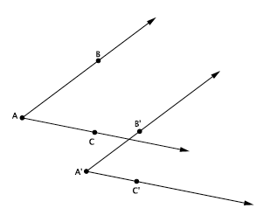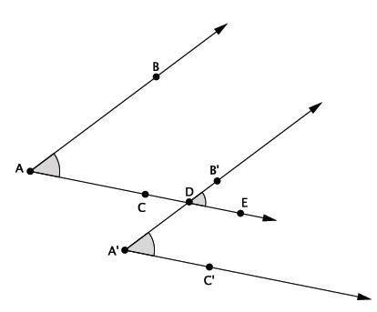

**MP.7**

**Discussion (4 minutes)**

While leading the discussion, students should record the information about the dilation theorem and its proof in their student pages.

Discussion

The dilation theorem for angles is as follows:

Theorem: A dilation from center and scale factor maps an angle to an angle of equal measure.

We have shown this when the angle and its image intersect at a single point, and that point of intersection is not the vertex of the angle.

* So far we have seen the case when the angles intersect at a point. What are other possible cases that we will need to consider?

Provide time for students to identify the two other cases: (1) The angles do not intersect at a point, and (2) the angles have vertices on the same ray. You may need to give students this information if they cannot develop the cases on their own.

* We will cover another case where a dilation maps to When the angle and its dilated image do not have intersecting rays (as shown below), how can we show that the angle and its dilated image are equal in measure?

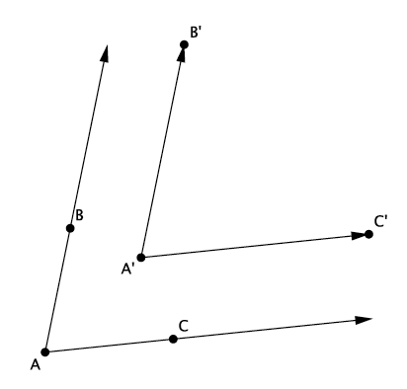

If students do not respond, you may need to give the information in the bullet point below.

* + *You can draw an auxiliary line and use the same reasoning to show that the angle and its image are equal in measure.*

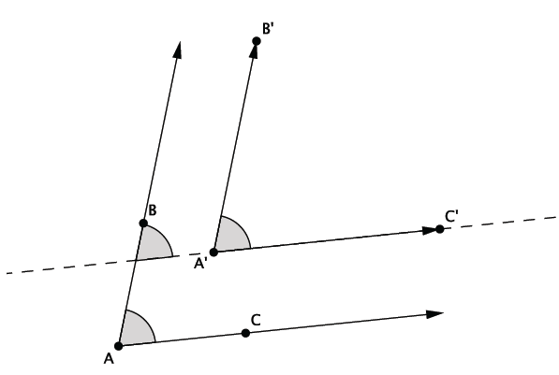

* Notice now that by drawing the auxiliary line, we have two angles that intersect at a point, much like we had in the Opening Exercise. Therefore, the same reasoning shows that .
* The only case left to consider is when the line containing a ray also contains the image of the ray. In this case, ray and ray lie in the same line.



* Why does?
  + *They are corresponding angles from parallel lines cut by a transversal.*

**Discussion (5 minutes)**

This discussion is optional and can be used if class time permits.

* Given with and acute, inscribe a square inside the triangle so that two vertices of the square lie on side , and the other two vertices lie on the other two sides.

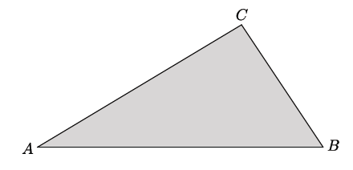

* We begin by drawing a small square near vertex so that one side is on and one vertex is on

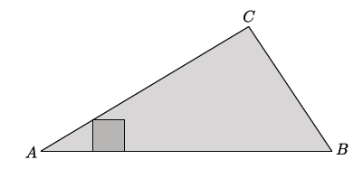

Ask students how we can dilate the square so that the other two vertices lie on the other two sides. Provide time for students to discuss this challenging question in small groups and to share their thoughts with the class. Validate any appropriate strategies, or suggest the strategy described below.

* Next, draw a ray from through the vertex of the square that does not touch any side of the triangle. Name the point where the ray intersects the triangle

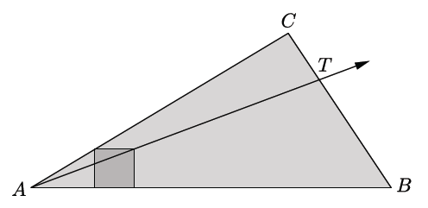

* The point can be used as one of the vertices of the desired square. The parallel method can then be used to construct the desired square.

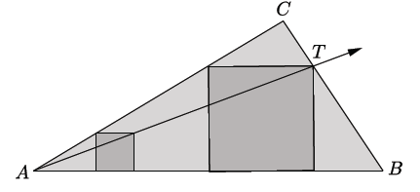

Consider trying this on another triangle before proceeding with the question below.

* Why does this work?
  + *Three of the four vertices of the square are on two sides of the triangle. The location of the fourth vertex must be on side Since the ray was drawn through the vertex of the small square, a scale factor will map the dilated vertex on the ray. To inscribe it in the desired location, we note the location where the ray intersects the side of the triangle, giving us the vertex of the desired square. Since dilations map squares to squares, it is just a matter of locating the point of the vertex along the opposite side of and then constructing the square.*

Closing (2 minutes)

* How do dilations map angles?
  + *Dilations map angles to angles of equal measure.*
* What foundational knowledge did we need to prove that dilations map angles to angles of equal measure?
  + *We needed to know that rays are dilated to rays that are parallel or rays that coincide with the original ray. Then, using what we know about parallel lines cut by a transversal, we could use what we knew about corresponding angles of parallel lines being equal to show that dilations map angles to angles of equal measure. We also needed to know about auxiliary lines and how to use them in order to produce a diagram where parallel lines are cut by a transversal.*
* How do dilations map polygonal figures?
  + *Dilations map polygonal figures to polygonal figures whose angles are equal in measure to the corresponding angles of the original figure and whose side lengths are equal to the corresponding side lengths multiplied by the scale factor.*

Lesson Summary

* **Dilations map angles to angles of equal measure.**
* **Dilations map polygonal figures to polygonal figures whose angles are equal in measure to the corresponding angles of the original figure and whose side lengths are equal to the corresponding side lengths multiplied by the scale factor.**

Exit Ticket (5 minutes)

Name Date

Lesson 9: How Do Dilations Map Angles?

Exit Ticket

1. Dilate parallelogram from center using a scale factor of .

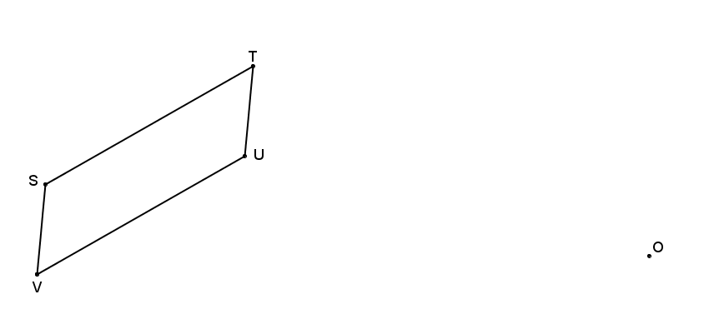

1. How does compare to ?
2. Using your diagram, prove your claim from Problem 2.

Exit Ticket Sample Solutions

1. Dilate parallelogram from center using a scale factor of .

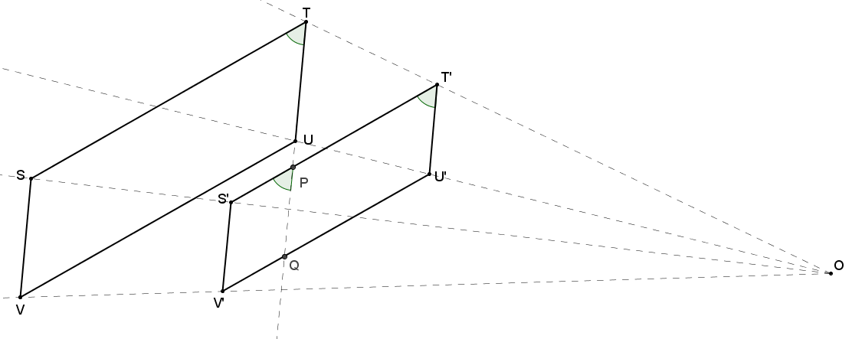

1. How does compare to ?

*because dilations preserve angle measure.*

1. Using your diagram, prove your claim from part (a).

Extend such that it intersects at a point . Dilations map lines to parallel lines, so ; therefore, by corresponding s, , . Under the same dilation, , again, by corresponding 's, , . By transitivity, .

Problem Set Sample Solutions

1. Shown below is and its image after it has been dilated from center by scale factor Prove that the dilation maps to so that ,, and .

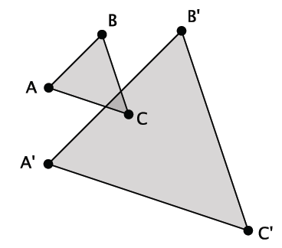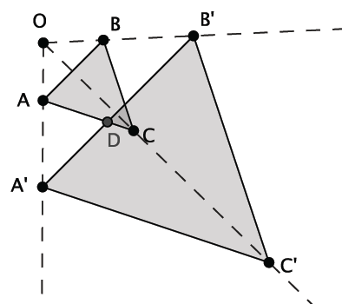

**Locate the center of dilation by drawing rays through each of the pairs of corresponding points. The intersection of the rays is the center of dilation, . Since dilations map segments to segments, and the dilated segments must either coincide with their pre-image or be parallel, then we know that, , and . Let be the point where side intersects with side . Then is congruent to because corr. 's, , cut by a transversal, , are congruent. Then because corr. 's, , cut by a transversal , are congruent. By the transitive property, and .**

***Since congruent angles are equal in measure, and , then . Similar reasoning shows that and .***

1. Explain the effect of a dilation with scale factor on the length of the base and height of a triangle. How is the area of the dilated image related to the area of the pre-image?

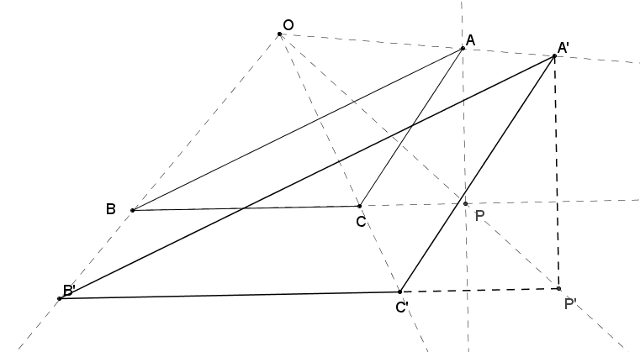Let represent the endpoint of altitude of , such that lies on . Thus, the base length of the triangle is , and the height of the triangle is . The area of the given triangle then is . By the definition of dilation, and , so the base and height of the dilated image are proportional to the base and height of the original just as the lengths of the sides of the triangle. The area of the dilated triangle then would be . The ratio of area of the dilated image to the area of the pre-image is .

1. Dilate trapezoid from center using a scale factor of .

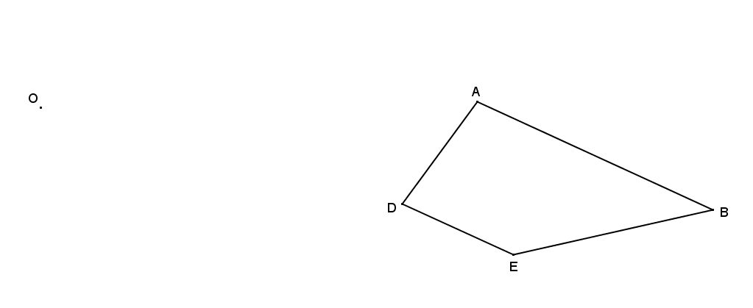

A dilation maps a trapezoid to a trapezoid so that the ratio of corresponding sides is the same and corresponding interior angles are the same measure.

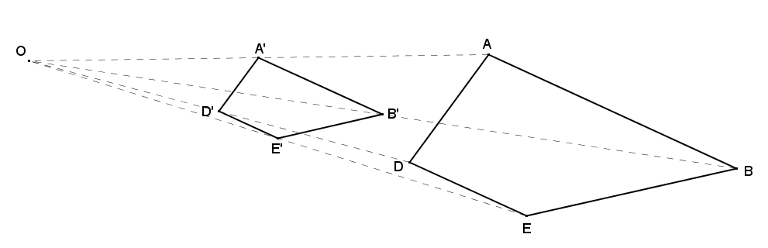

1. 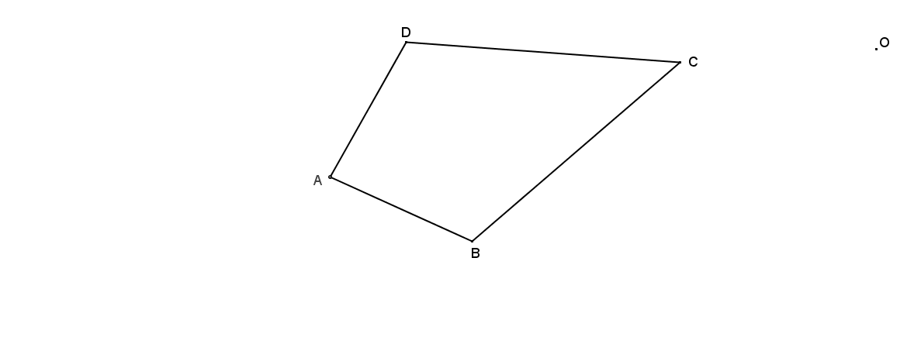Dilate kite from center using a scale factor .

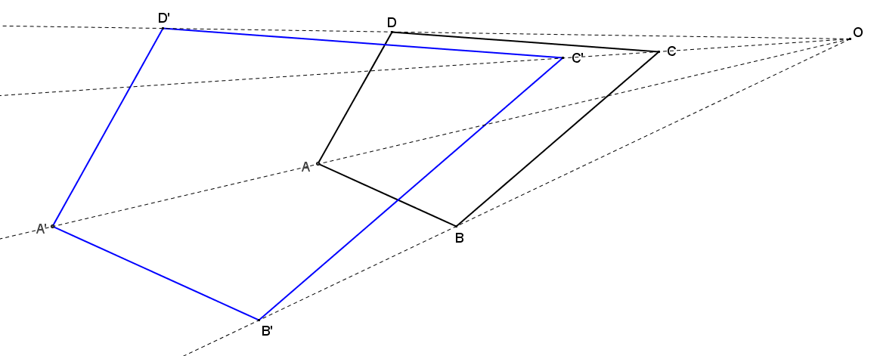A dilation maps a kite to a kite so that the ratio of corresponding sides is the same and corresponding interior angles are the same measure.

1. Dilate hexagon from center using a scale factor of .

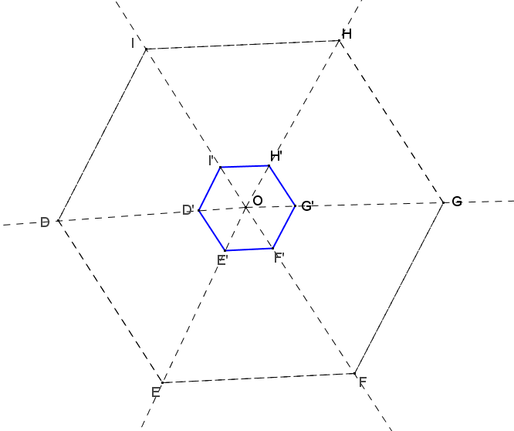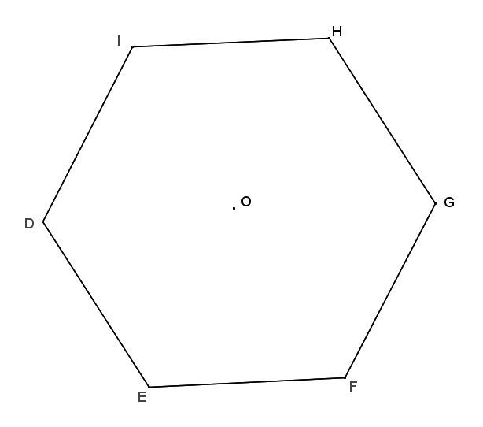

1. Examine the dilations that you constructed in Problems 2–5, and describe how each image compares to its pre-image under the given dilation. Pay particular attention to the sizes of corresponding angles and the lengths of corresponding sides.

In each dilation, the angles in the image are the same size as the corresponding angle in the pre-image as we have shown that dilation preserves angle measure. We also know that the lengths of corresponding sides are in the same ratio as the scale factor.