Lesson 9: How Do Dilations Map Angles?

Classwork
Exploratory Challenge/Exercises 1–4
- How do dilations map triangles?
  - Make a conjecture.

  - Verify your conjecture by experimenting with diagrams and directly measuring angles and lengths of segments.

- How do dilations map rectangles?
  - Make a conjecture.

  - Verify your conjecture by experimenting with diagrams and directly measuring angles and lengths of segments.

- How do dilations map squares?
  - Make a conjecture.

  - Verify your conjecture by experimenting with diagrams and directly measuring angles and lengths of segments.

- How do dilations map regular polygons?
  - Make a conjecture.

  - Verify your conjecture by experimenting with diagrams and directly measuring angles and lengths of segments.

Exercises 5–6
- Recall what you learned about parallel lines cut by a transversal, specifically about the angles that are formed.

- A dilation from center $O$ by scale factor $r$ maps $∠BAC$ to $∠B^{'}A'C^{'}$. Show that $m∠BAC=m∠B^{'}A'C^{'}.$

Discussion
The dilation theorem for angles is as follows:
Theorem: A dilation from center $O$ and scale factor $r$ maps an angle to an angle of equal measure.
We have shown this when the angle and its image intersect at a single point, and that point of intersection is not the vertex of the angle.

Problem Set
Lesson Summary
- Dilations map angles to angles of equal measure.
- Dilations map polygonal figures to polygonal figures whose angles are equal in measure to the corresponding angles of the original figure and whose side lengths are equal to the corresponding side lengths multiplied by the scale factor.

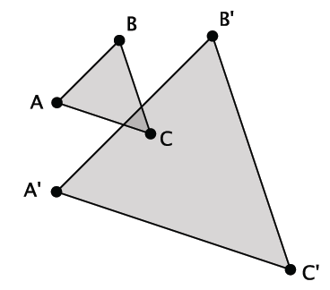
- Shown below is $△ABC$ and its image $△A'B'C'$ after it has been dilated from center $O$ by scale factor $r=\frac{5}{2}.$ Prove that the dilation maps $△ABC$ to $△A'B'C'$so that $m∠A=m∠A^{'}$,$m∠B=m∠B'$, and $m∠C=m∠C^{'}$.

- Explain the effect of a dilation with scale factor $r$ on the length of the base and height of a triangle. How is the area of the dilated image related to the area of the pre-image?

- Dilate trapezoid $ABDE$ from center $O$ using a scale factor of $r=\frac{1}{2}$.
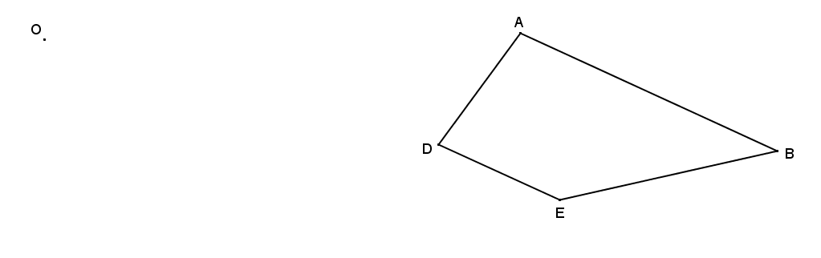

- Dilate kite $ABCD$ from center $O$ using a scale factor $r=1\frac{1}{2}$.

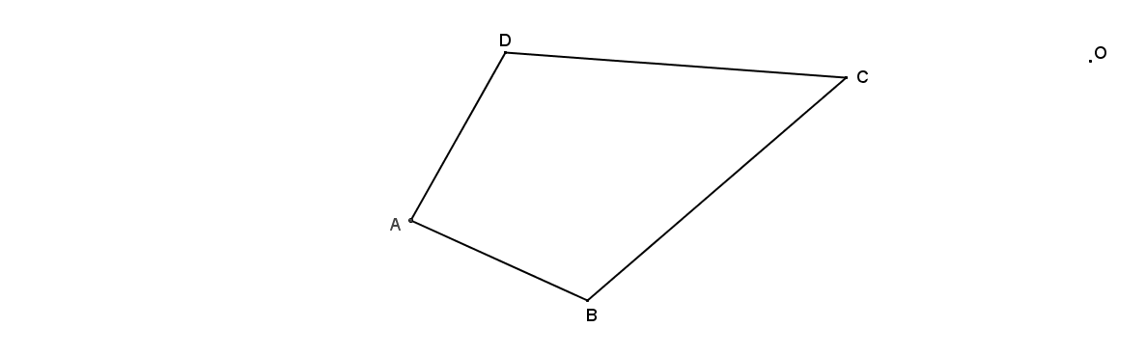

- Dilate hexagon $DEFGHI$ from center $O$ using a scale factor of $r=\frac{1}{4}$.

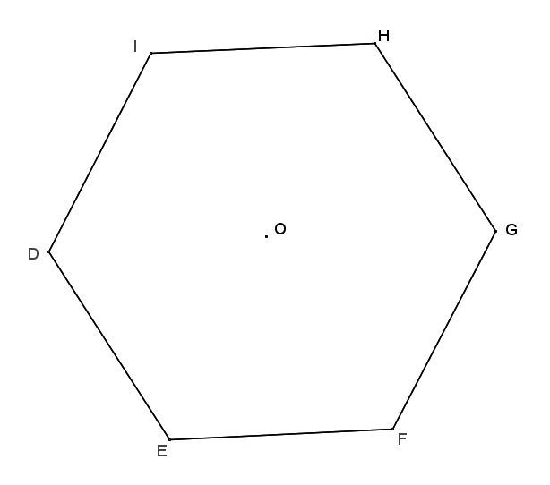

- Examine the dilations that you constructed in Problems 2–5, and describe how each image compares to its pre-image under the given dilation. Pay particular attention to the sizes of corresponding angles and the lengths of corresponding sides.

