|  |
| --- |
|  |

Lesson 8: How Do Dilations Map Rays, Lines, and Circles?

Student Outcomes

* Students prove that a dilation maps a ray to a ray, a line to a line, and a circle to a circle.

Lesson Notes

The objective in Lesson 7 was to prove that a dilation maps a segment to segment; in Lesson 8, students prove that a dilation maps a ray to a ray, a line to a line, and a circle to a circle. An argument similar to that in Lesson 7 can be made to prove that a ray maps to a ray; allow students the opportunity to establish this argument as independently as possible.

Classwork

Opening (2 minutes)

As in Lesson 7, remind students of their work in Grade 8, when they studied the multiplicative effect that dilation has on points in the coordinate plane when the center is at the origin. Direct students to consider what happens to the dilation of a ray that is not on the coordinate plane.

* Today we are going to show how to prove that dilations map rays to rays, lines to lines, and circles to circles.
* Just as we revisited what dilating a segment on the coordinate plane is like, so we could repeat the exercise here. How would you describe the effect of a dilation on a point on a ray about the origin by scale factor in the coordinate plane?
  + *A point on the coordinate plane dilated about the origin by scale factor would then be located at .*
* Of course, we must now consider what happens in the plane versus the coordinate plane.

Opening Exercise (3 minutes)

Opening Exercise

**MP.3**

* 1. Is a dilated ray still a ray? If the ray is transformed under a dilation, explain how.

Accept any reasonable answer. The goal of this line of questioning is for students to recognize that a segment dilates to a segment that is times the length of the original.

* 1. Dilate the ray by a scale factor of from center

**MP.3**

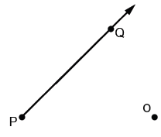 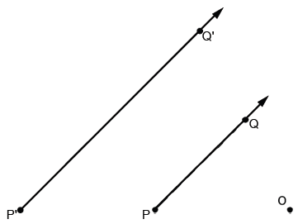

* + 1. Is the figurea ray?

Yes, the dilation of ray produces a ray.

* + 1. How, if at all, has the segment been transformed?

The segment in ray , is twice the length of the segment in ray The segment has increased in length according to the scale factor of dilation.

* + 1. Will a ray always be mapped to a ray? Explain how you know.

Students will most likely say that a ray will always map to a ray; they may defend their answer by citing the definition of a dilation and its effect on the center and a given point.

* We are going to use our work in Lesson 7 to help guide our reasoning today.
* In proving why dilations map segments to segments, we considered three variations of the position of the center relative to the segment and value of the scale factor of dilation:

(1) A center and scale factor and segment .

(2) A line that does not contain the center and scale factor .

(3) A line that does contain the center and scale factor .

Point out that the condition in case (1) does not specify the location of center relative to the line that contains segment ; we can tell by this description that the condition does not impact the outcome and, therefore, is not more particularly specified.

* We will use the set up of these cases to build an argument that shows dilations map rays to rays.

Examples 1–3 focus on establishing the dilation theorem of rays: A dilation maps a ray to a ray sending the endpoint to the endpoint. The arguments for Examples 1 and 2 are very similar to those of Lesson 7, Examples 1 and 3, respectively. Use discretion and student success with the Lesson 7 examples to consider allowing small-group work on the following Examples 1–2, possibly providing a handout of the solution once groups have arrived at solutions of their own. Again, since the arguments are quite similar to those of Lesson 7, Examples 1 and 3, it is important to stay within the time allotments of each example. Otherwise, Examples 1–2 should be teacher-led.

Example 1 (2 minutes)

Encourage students to draw upon the argument from Lesson 1, Example 1. This is intended to be a quick exercise; consider giving 30-second time warnings or using a visible timer.

Example 1

Will a dilation about center and scale factor map to ? Explain.

A scale factor of means that the ray and its image are equal. That is, the dilation does not enlarge or shrink the image of the figure but remains unchanged. Therefore, when the scale factor of dilation is , then the dilation maps the ray to itself.

Example 2 (6 minutes)

Encourage students to draw upon the argument for Lesson 1, Example 3.

*Scaffolding:*

* If students have difficulty following the logical progression of the proof, ask them instead to draw rays and dilate them by a series of different scale factors and then make generalization about the results.
* For students that are above grade level, ask them to attempt to prove the theorem independently.

Example 2

The line that contains does not contain point . Will a dilation about center and scale factor map every point of onto a point of?

**MP.1**

* A restatement of this problem is: If is a point on , then is a point on ? Also, if a point lies on the ray , then is there a point on the ray such that ?
* Consider the case where the center is not in the line that contains , and the scale factor is . Then points , , and form .

Draw the following figure on the board.

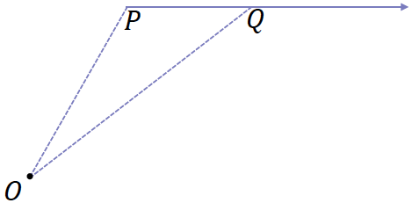

* We examine the case with a scale factor ; the proof for is similar.
* Under a dilation about center and , goes to and goes to ’; and What conclusion can we draw from these lengths?
* Summarize the proof and result to a partner.

Draw the following figure on the board.

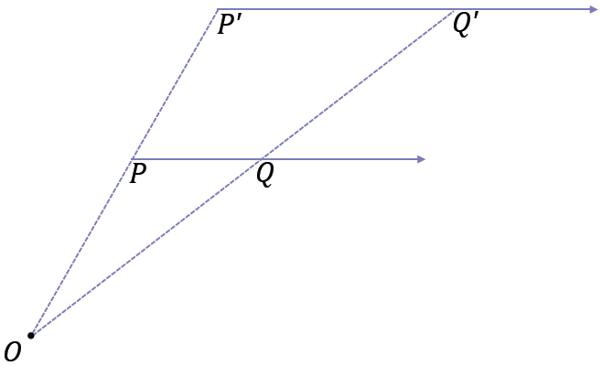

* + *We can rewrite each length relationship as* .
* By the triangle side splitter theorem what else can we now conclude?
  + *The segment*  *splits*  *proportionally.*
  + *The lines that contain*  *and* *are parallel*; ; therefore, .
* By the dilation theorem for segments (Lesson 7), the dilation from of the segment is the segment , that is, as sets of points. Therefore we need only consider an arbitrary point on that lies outside of . For any such point , what point is contained in the segment ?
  + The point .
* Let .



**MP.7**

* By the dilation theorem for segments, the dilation from of the segment is the segment . Also by the dilation theorem for segments, the point is a point on segment . Therefore the ray and the ray must be the same ray. In particular, is a point on , which was what we needed to show.

To show that for every point on the ray there is a point on the ray such that , consider the dilation from center with scale factor (the inverse of the dilation ). This dilation maps to a point on the ray by the same reasoning as above. Then .

* We conclude that the points of ray are mapped onto to the points of ray and, more generally, that dilations map rays to rays.

Example 3 (12 minutes)

Encourage students to draw upon the argument for Lesson 1, Example 3.

Example 3

The line that contains contains point . Will a dilation about center and scale factor map ray to a ray ?

* Consider the case where the center belongs to the line that contains .

1. Examine the case where the endpoint of coincides with the center of the dilation.

* If the endpoint of coincides with the center , what can we say about and ?

Ask students to draw what this looks like, and draw the following on the board after giving them a head start.



* + *All the points on* *also belong to* ; .
* By definition, a dilation always sends its center to itself. What are the implications for the dilation of and ?

**MP.1**

* + *Since a dilation always sends its center to itself, then* .
* Let be a point on so that . What happens to under a dilation about with scale factor ?
  + *The dilation sends*  *to on , and .*

Ask students to draw what the position of and might look like if or . Points may move further away ( or move closer to the center (). We will not draw this for every case, rather, it is a reminder up front.



* Since , , and are collinear, then , , and will also be collinear; is on the ray ,which coincides with by definition of dilation.
* Therefore, a dilation of (or when the endpoint of of coincides with the center ) about center and scale factor maps to . We have answered the bigger question that a dilation maps a ray to a ray.

1. Examine the case where the endpoint of is between and on the line containing ,, and .

Ask students to draw what this looks like, and draw the following on the board after giving them a head start.



**MP.1**

* We already know from the previous case that the dilation of the ray maps onto itself. All we need to show is that any point on the ray that is further away from the center than will map to a point that is further away from the center than .
* Let be a point on so that . What can be concluded about the relative lengths of and ?

Ask students to draw what this looks like, and draw the following on the board after giving them a head start. The following is one possibility.



* + .
* Describe how the lengths and compare once a dilation about center and scale factor sends to and to .
  + *and* .
  + *Multiplying both sides of* *by* , *gives* , *so* .

Ask students to draw what this might look like if and draw the following on the board after giving them a head start.



* Therefore, we have shown that any point on the ray that is further away from the center than will map to a point that is further away from the center than . In this case, we still see that a dilation maps a ray to a ray.

1. Examine the remaining case where the center of the dilation and point are on the same side of on the line containing ,, and .

* Now consider the relative position of and on We will use an additional point as a reference point so the is between and .

Draw the following on the board; these are all the ways that and are on the same side of .



* By case (a), we know that a dilation with center maps to itself.

**MP.1**

* Also, by our work in Lesson 7 on how dilations map segments to segments, we know that is taken to , where lies on .
* The union of the segment and the ray is the ray . So the dialation maps the ray to the ray
* Since is a point on the ray and , we see =. Therefore, in this case, we still see that maps to under a dilation.

Example 4 (6 minutes)

In Example 4, students prove the dilation theorem for lines: A dilation maps a line to a line. If the center of the dilation lies on the line or if the scale factor of the dilation is equal to , then the dilation maps the line to the same line. Otherwise, the dilation maps the line to a parallel line.

The dilation theorem for lines can be proved using arguments similar to those used in Examples 1–3 for rays and to Examples 1–3 in Lesson 7 for segments. Consider asking students to prove the theorem on their own as an exercise, especially if time is an issue, and then provide the following proof.

* We have just seen that dilations map rays to rays. How could we use this to reason that dilations map lines to lines?
  + *The line is the union of the two rays and . Dilate rays and ; the dilation yields rays and . The line is the union of the two rays and . Since the dilation maps the rays and to the rays and , respectively, then the dilation maps the line to the line .*

**MP.3**

Example 5 (8 minutes)

In Example 5, students prove the dilation theorem for circles: A dilation maps a circle to a circle and maps the center to the center. Students will need the dilation theorem for circles for proving that all circles are similar in Module 5 (**G-C.A.1**).

Example 5

Will a dilation about a center and scale factor map a circle of radius onto another circle?

1. Examine the case where the center of the dilation coincides with the center of the circle.

* We first do the case where the center of the dilation is also the center of the circle. Let be a circle with center and radius .

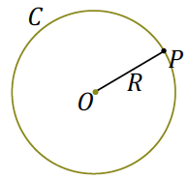Draw the following figure on the board.

* If the center of the dilation is also , then every point on the circle is sent to a point on so that ; i.e., the point goes to the point on the circle with center and radius .
* We also need to show that every point on is the image of a point from : For every point on circle , put a coordinate system on the line such that the ray corresponds to the nonnegative real numbers with zero corresponding to point (by the ruler axiom). Then there exists a point on such that , that is, is a point on the circle that is mapped to by the dilation.

Draw the following figure on the board.

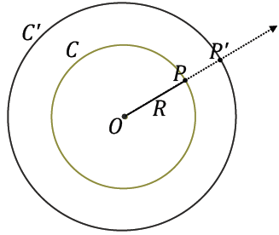

* Effectively, a dilation moves every point on a circle toward or away from the center the same amount, so the dilated image is still a circle. Thus, the dilation maps the circle to the circle .
* Circles that share the same center are called *concentric circles.*

1. Examine the case where the center of the dilation is not the center of the circle; we call this the general case.

* The proof of the general case works no matter where the center of dilation is. We can actually use this proof for case (a), when the center of the circle coincides with the center of dilation.
* Let be a circle with center and radius . Consider a dilation with center and scale factor that maps to . We will show that the dilation maps the circle to the circle with center and radius .

Draw the following figure on the board.



* If is a point on circle and the dilation maps to the dilation theorem implies that . So is on circle .
* We also need to show that every point of is the image of a point from . There are a number of ways to prove this, but we will follow the same idea that we used in part (a). For a point on circle that is not on line , consider the ray (the case when is on line is straightforward). Construct line through such that , and let be a point on that is in the same half-plane of as . Put a coordinate system on such that the ray corresponds to the nonnegative numbers with zero corresponding to point (by the ruler axiom). Then there exists a point on such that , which implies that is on the circle . By the dilation theorem, is mapped to the point on the circle .
* The diagram below shows how the dilation maps points ,, ,, and of circle . Ask students to find point on circle that is mapped to point on circle .



Closing (1 minute)

Ask students to respond to the following questions and summarize the key points of the lesson.

* How are the proofs for the dilation theorems on segments, rays, and lines similar to each other?

Theorems addressed in this lesson:

* **Dilation theorem for rays**: A dilation maps a ray to a ray sending the endpoint to the endpoint.
* **Dilation theorem for lines**: A dilation maps a line to a line. If the center of the dilation lies on the line or if the scale factor of the dilation is equal to 1, then the dilation maps the line to the same line. Otherwise, the dilation maps the line to a parallel line.
* **Dilation theorem for circles**: A dilation maps a circle to a circle and maps the center to the center.

Lesson Summary

* **Dilation theorem for rays: A dilation maps a ray to a ray sending the endpoint to the endpoint.**
* **Dilation theorem for lines: A dilation maps a line to a line. If the center of the dilation lies on the line or if the scale factor of the dilation is equal to 1, then the dilation maps the line to the same line. Otherwise, the dilation maps the line to a parallel line.**
* **Dilation theorem for circles: A dilation maps a circle to a circle, and maps the center to the center.**

Exit Ticket (5 minutes)

Name Date

Lesson 8: How Do Dilations Map Rays, Lines, and Circles?

Exit Ticket

Given points , , and below, complete parts (a)–(e):

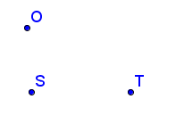

* 1. Draw rays and. What is the union of these rays?
  2. Dilate from using scale factor . Describe the image of
  3. Dilate from using scale factor . Describe the image of .
  4. What does the dilation of the rays in parts (b) and (c) yield?

e. Dilate circle with radius from using scale factor .

Exit Ticket Sample Solutions

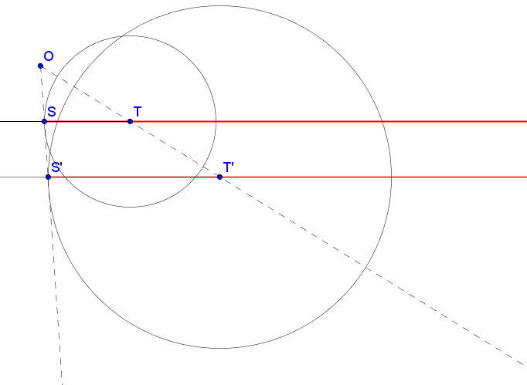

Given points, , and below, complete parts (a)–(e):

* 1. Draw rays and . What is the union of these rays?

The union of and is line .

* 1. Dilate from using scale factor . Describe the image of .

The image of is .

* 1. Dilate from using scale factor . Describe the image of .

The image of is .

* 1. What does the dilation of the rays in parts (b) and (c) yield?

The dilation of rays and yields .

* 1. Dilate circle with radius from using scale factor .

See diagram above.

Problem Set Sample Solutions

1. In Lesson 8, Example 2, you proved that a dilation with a scale factor maps a ray to a ray . Prove the remaining case that a dilation with scale factor maps a ray to a ray .

Given the dilation , with maps to and to , prove that maps to .

By the definition of dilation, , and likewise, .

By the dilation theorem, .

Through two different points lies only one line, so .

Draw point on and then draw . Mark point at intersection of and .

By the triangle side splitter theorem, splits and proportionally, so . Therefore, because was chosen as an arbitrary point, for any point on .

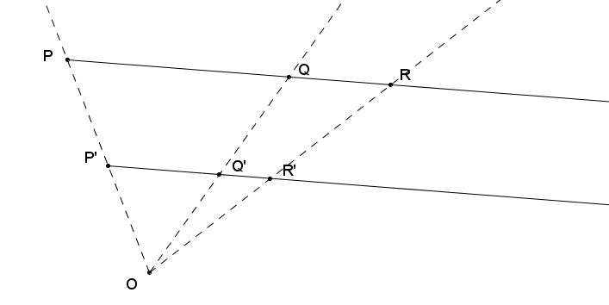

1. In the diagram below, is the image of under a dilation from point with an unknown scale factor, maps to and maps to . Use direct measurement to determine the scale factor , and then find the center of dilation .

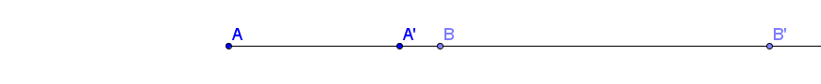

By the definition of dilation, , , and . By direct measurement,   
.

The images of and are pushed to the right on under the dilation and , so the center of dilation must lie on to the left of points and .

By the definition of dilation:

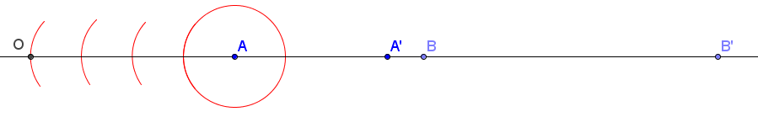

1. Draw a line and dilate points and from center where is not on . Use your diagram to explain why a line maps to a line under a dilation with scale factor .

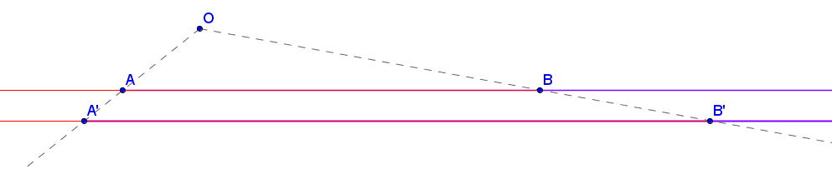Two rays and on the points and point in opposite directions as shown in the diagram below. The union of the two rays is . We showed that a ray maps to a ray under a dilation, so maps to ; likewise, maps to . The dilation yields two rays and on the points and pointing in opposite directions. The union of the two rays is ; therefore, it is true that a dilation maps a line to a line.

1. Let be a line segment, and let be a line that is the perpendicular bisector of . If a dilation with scale factor maps to (sending to and to ) and also maps line to line , show that is the perpendicular bisector of .

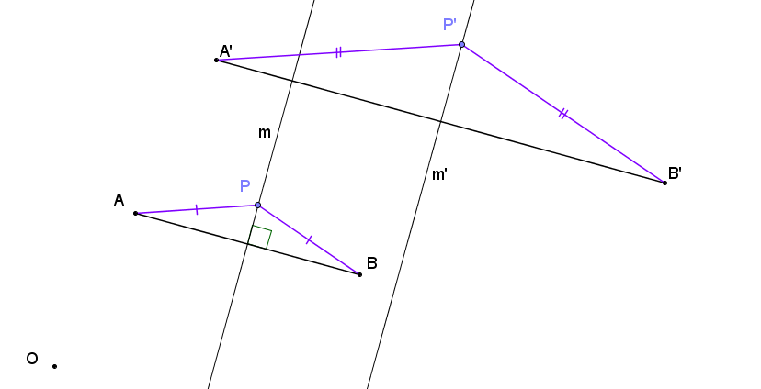Let be a point on line and let the dilation send to the point on line . Since is on the perpendicular bisector of , . By the dilation theorem, and . So and is on the perpendicular bisector of .

1. 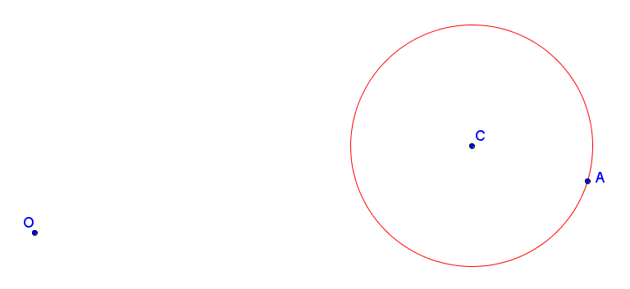Dilate circle with radius from center with a scale factor .

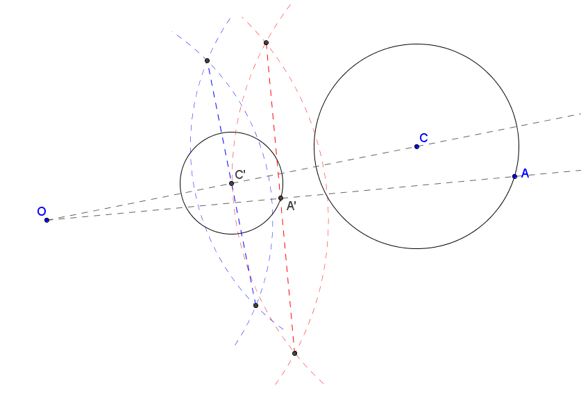

1. 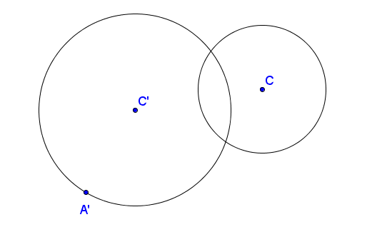In the picture below, the larger circle is a dilation of the smaller circle. Find the center of dilation .

Draw . Center lies on . Since is not on a line with both and , I can use the parallel method to find point on circle such that .

Under a dilation, a point and its image(s) lie on a ray with endpoint , the center of dilation. Draw and label center of dilation .

