|  |
| --- |
|  |

Lesson 4: Comparing the Ratio Method with the Parallel Method

Student Outcomes

* Students understand that the ratio and parallel methods produce the same scale drawing and understand the proof of this fact.
* Students relate the equivalence of the ratio and parallel methods to the *triangle side splitter theorem*: A line segment splits two sides of a triangle proportionally if and only if it is parallel to the third side.

Lesson Notes

This lesson challenges students to understand the reasoning that connects the ratio and parallel methods that have been used in the last two lessons for producing a scale drawing. The Opening Exercises are important to the discussions that follow and are two important ideas in their own right. The first key idea is that two triangles with the same base that have vertices on a line parallel to the base are equal in area. The second key idea is that two triangles with different bases, but equal altitudes will have a ratio of areas that is equal to the ratio of their bases. Following the Opening Exercises students and the teacher show that the ratio method and parallel method are equivalent. The concluding discussion shows how that work relates to the triangle side splitter theorem.

Classwork

Today, our goal is to show that the parallel method and the ratio method are equivalent; that is, given a figure in the plane and a scale factor , the scale drawing produced by the parallel method is congruent to the scale drawing produced by the ratio method. We start with two easy exercises about the areas of two triangles whose bases lie on the same line, which will help show that the two methods are equivalent.

Opening Exercises 1–2 (10 minutes)

Students will need the formula for the area of a triangle. The first exercise is a famous proposition of Euclid’s (Proposition 37 of Book 1). You might ask your students to go online after class and read how Euclid proves the proposition.

Give students two minutes to work on the first exercise in groups, and walk around the room answering questions and helping students to draw pictures. After two minutes, go through the proof on the board, answering questions about the parallelogram as you go. Repeat the process for Exercise 2.

You are not looking for pristine proofs from your students on these exercises; you are merely looking for confirmation that they understand the statements. For example, in Exercise 1, they should understand that two triangles between two parallel lines with the same base must have the same area. These two exercises help avoid the quagmire of drawing altitudes and calculating areas in the proofs that follow; these exercises will help your students to simply recognize when two triangles have the same area or recognize when the ratio of the bases of two triangles is the same as the ratio of their areas.

It will be useful to leave the statements of Opening Exercises 1 and 2 on the board throughout the lesson so that you can refer back to them.

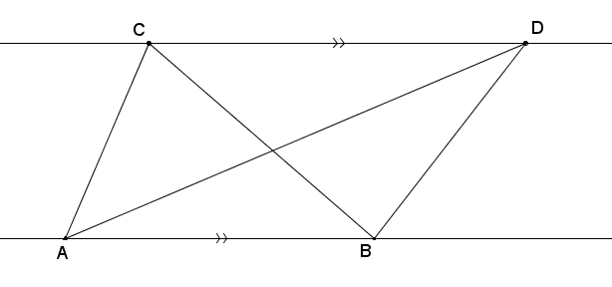  
Opening Exercises 1–2

1. Suppose two triangles, and , share the same base such that points and lie on a line parallel to line . Show that their areas are equal, i.e., . (Hint: Why are the altitudes of each triangle equal in length?)

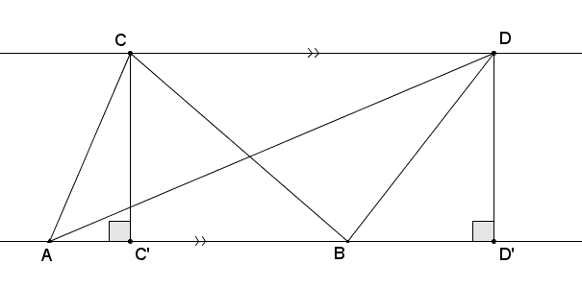Draw a perpendicular line to through and label the intersection of both lines . Then is an altitude for . Do the same for to get an altitude .

Quadrilateral is a parallelogram and, therefore, , both of which follow from the properties of parallelograms. Since and are altitudes of the triangles, we get by the area formula for triangles,

Draw the first picture below as you read through Opening Exercise 2 with your class. Ask questions that check for understanding, like, “Are the points , , and collinear? Why?” and “Does it matter if and are on the same side of on the line?”

**MP.6**

1. 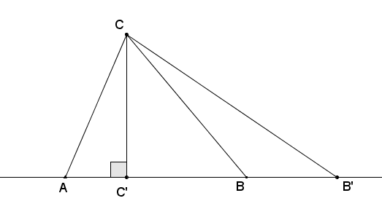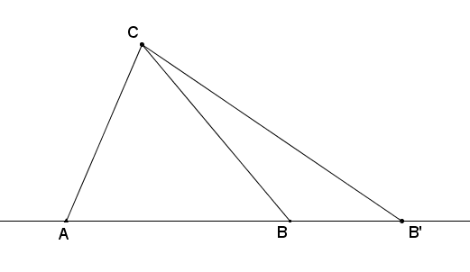Suppose two triangles have different length bases, and , that lie on the same line. Furthermore, suppose they both have the same vertex opposite these bases. Show that value of the ratio of their areas is equal to the value of the ratio of the lengths of their bases, i.e.,

Draw a perpendicular line to through and label the intersection of both lines . Then is an altitude for both triangles.

By the area formula for triangles,

Ask students to summarize to a neighbor the two results from the Opening Exercises. Use this as an opportunity to check for understanding.

**Discussion (20 minutes)**

The next two theorems generate the so-called “triangle side splitter theorem,” which is the most important result of this module. (In standard **G-SRT.B.4**, it is stated as, “A line parallel to one side of a triangle divides the other two proportionally, and conversely.”) We will use the triangle side splitter theorem over and many times over again in the next few lessons to understand dilations and similarity. Note thatusing theAA similarity criterion to prove thetriangle side splitter theoremis *circular*: The triangle side splitter theorem is the reason why a dilation takes a line to a parallel line and an angle to another angle of equal measure, which are both needed to prove the AA similarity criterion. Thus, we need to prove the triangle side splitter theorem in a way that does not invoke these two ideas. (Note that in Grade 8, we assumed the triangle side splitter theorem and its immediate consequences and, in doing so, glossed over many of the issues we will need to deal with in this course.)

Even though the following two proofs are probably the simplest known proofs of these theorems (and should be easy to understand), they rely on subtle tricks that you should not expect your students to discover on their own. Brilliant mathematicians constructed these careful arguments over 2,300 years ago. However, that does not mean that this part of the lesson is a “lecture.” Take your time in going through the proofs with your students, ask them questions to check for understanding, and have them articulate the reasons for each step. If done well, you and your class can take joy in the clever arguments presented here!

Discussion

To show that the parallel and ratio methods are equivalent, we need only look at one of the simplest versions of a scale drawing: scaling segments. First, we need to show that the scale drawing of a segment generated by the parallel method is the same segment that the ratio method would have generated and vice versa. That is,

The parallel method The ratio method,

and

The ratio method The parallel method.

**MP.1**

**&**

**MP.3**

Ask students why scaling a segment is sufficient for showing equivalence of both methods for scaling polygonal figures. That is, if we wanted to show that both methods would produce the same polygonal figure, why is it enough to only show that both methods would produce the same segment?

Students should respond that polygonal figures are composed of segments. If we can show that both methods produce the same segment, then it makes sense that both methods would work for all segments that comprise the polygonal figure.

The first implication above can be stated as the following theorem:

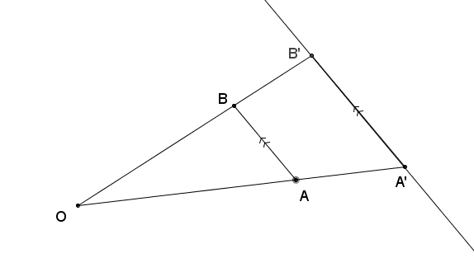Parallel ratio theorem: Given a line segment and point not on the line , construct a scale drawing of with scale factor using the parallel method: Let , and be the line parallel to that passes through . Let be the point where ray intersects . Then is the same point found by the ratio method; that is, .

Discuss the statement of the theorem with your students. Ask open-ended questions that lead students through the following points:

* Segment is the scale drawing of using the parallel method. Why?
* is already the first step in the ratio method. The difference between the parallel method and ratio method is that is found using the parallel method by intersecting the parallel line with ray, while in the ratio method, the point is found by dilating point at center by scale factor to get . We need to show that these are the same point, that is, that . Since both points lie on the ray, this can be done by showing that .

There is one subtlety with the theorem as it is stated above that you may or may not wish to discuss with your students. In it, we assumed—asserted really—that and ray intersect. They do, but is it clear that they do? (Pictures can be deceiving!) First, suppose that did not intersect the entire line , and then by definition, and are parallel. Since is also parallel to , then and are parallel (by parallel transitivity from Module 1), which is clearly a contradiction since both contain the point . Hence, it must be that intersects . But where does it intersect? Does it intersect ray , or the opposite ray from ? There are two cases to consider. Case 1: If and are in opposite half-planes of (i.e., as in the picture above when ), then is contained completely in the half-plane that contains by the plane separation axiom. Thus, cannot intersect the ray , which means it must intersect ray . Case 2: Now suppose that and are in the same half-plane of (when ), and consider the two half-planes of . The points and must lie in the opposite half-planes of . (Why? Hint: What fact would be contradicted if they were in the same half-plane?) Thus, by the plane separation axiom, the line intersects the segment , and thus intersects ray .

There is a set of theorems that revolve around when two lines intersect each other as in the paragraph above, which fall under the general heading of “crossbar theorems.” We encourage you to explore these theorems with your students by looking the theorems up on the web. The theorem above is written in a way that asserts that and intersect, and so “covers up” these intersection issues in a factually correct way that will help us avoid unnecessarily pedantic crossbar discussions in the future.

Proof: We prove the case when ; the case when is the same but with a different picture. Construct two line segments and to form two triangles and , labeled as and , respectively, in the picture below.

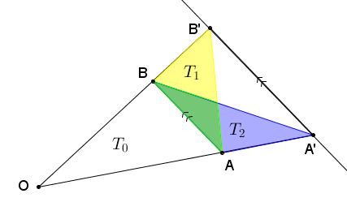

The areas of these two triangles are equal,

,

by Exercise 1. Why? Label by . Then because areas add:

Next, we apply Exercise 2 to two sets of triangles: (1) and and (2) and .

**(1) and with  
 bases on**

**(2) and with  
 bases on**

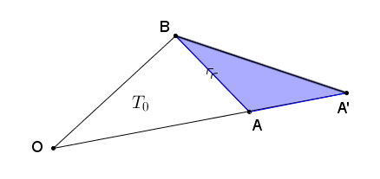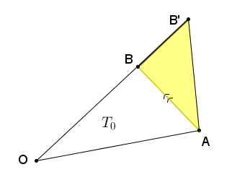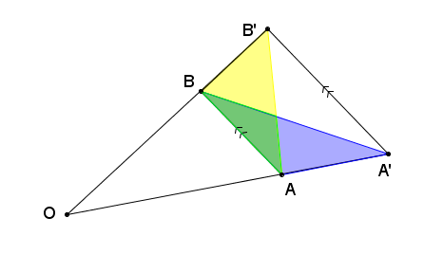

Therefore,

, and

.

Since , we can equate the fractions: . Since is the scale factor used in dilating to , we know that ; therefore, , or . This last equality implies that is the dilation of from by scale factor , which is what we wanted to prove.

Next, we prove the reverse implication to show that both methods are equivalent to each other.

Ask students why showing that “the ratio method implies the parallel method” establishes equivalence. Why isn’t the first implication “good enough”? (Because we do not know yet that a scale drawing produced by the ratio method would be the same scale drawing produced by the parallel method—the first implication does help us conclude that.)

**MP.3**

This theorem is easier to prove than the previous one. In fact, we can use the previous theorem to quickly prove this one!

Ratio parallel theorem: Given a line segment and point not on the line , construct a scale drawing of with scale factor using the ratio method (Find and , and draw ). Then is the same as the point found using the parallel method.

Proof: Since both the ratio method and the parallel method start with the same first step of setting , the only difference between the two methods is in how the second point is found. If we use the parallel method, we construct the line parallel to that passes through and label the point where intersects by . Then is the same as the point found using the parallel method if we can show that .

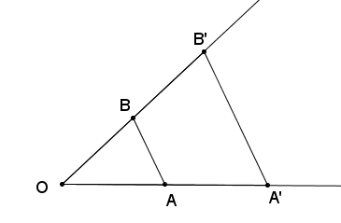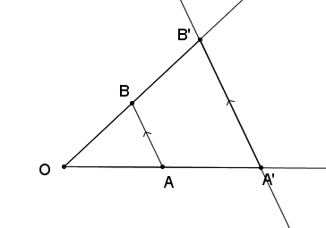

The ratio method

The parallel method

C

**By the parallel**  ratio theorem, we know that , i.e., that is the point on ray such that . But is also the point on ray such that . Hence, they must be the same point.

**Discussion (8 minutes)**

  
The fact that the ratio and parallel methods are equivalent is often stated as the triangle side splitter theorem. To understand the triangle side splitter theorem, we need a definition:

Side splitter: A line segment is said to *split the sides of*  *proportionally* if is a point on , is a point on , and . We call line segment a *side splitter.*

Triangle side splitter theorem*:* A line segment splits two sides of a triangle proportionally if and only if it is parallel to the third side.

Provide students with time to read and make sense of the theorem. Students should be able to state that a line segment that splits two sides of a triangle is called a side splitter. If the sides of a triangle are split proportionally, then the line segment that split the sides must be parallel to the third side of the triangle. Conversely, if a segment that intersects two sides of a triangle is parallel to the third side of a triangle, then that segment is a side splitter.

Ask students to rephrase the statement of the theorem for a triangle and a segment (i.e., the terminology used in the theorems above). It should look like this:

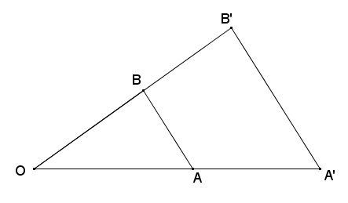  
Restatement of the triangle side splitter theorem:

In , splits the sides proportionally (i.e., ) if and only if .

* Ask students to relate the restatement of the triangle side splitter theorem to the two theorems above. In order for students to do this, they will need to translate the statement into one about dilations. Begin with the implication that splits the sides proportionally.
* What does mean in terms of dilations?
  + *This means that there is a dilation with scale factor such that and .*
* Which method (parallel or ratio) does the statement “ splits the sides proportionally” correspond to?
  + *The ratio method*
* What does the ratio parallel theorem imply about ?
  + *This implies that can be found by constructing a line parallel to through and intersecting that line with .*
* Since , what does that imply about and ?
  + *The two segments are also parallel as in the triangle side splitter theorem.*
* Now, suppose that as in the picture below. Which method (parallel or ratio) does this statement correspond to?

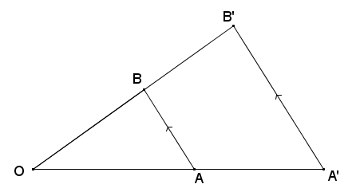

* + *This statement corresponds to the parallel method because in the parallel method, only the endpoint of line segment is dilated from center by scale factor to get point . To draw , a line is drawn through that is parallel to , and is the intersection of that line and .*
* What does the parallel ratio theorem imply about the point ?
  + *This implies that , i.e., .*
* What does and imply about ?
  + *splits the sides of triangle .*

Closing (3 minutes)

Ask students to summarize the main points of the lesson. Students may respond in writing, to a partner or the whole class.

* **The triangle side splitter theorem**: A line segment splits two sides of a triangle proportionally if and only if it is parallel to the third side.
* Prior to this lesson we have used the ratio method and the parallel method separately to produce a scale drawing. The triangle side splitter theorem is a way of saying that we can use either method because both will produce the same scale drawing.

Consider asking students to compare and contrast the two methods in their own words as a way of explaining how the triangle side splitter theorem captures the mathematics of *why* each method produces the same scale drawing.

Lesson Summary

The triangle side splitter theorem: A line segment splits two sides of a triangle proportionally if and only if it is parallel to the third side.

Exit Ticket (5 minutes)

Name Date

Lesson 4: Comparing the Ratio Method with the Parallel Method

Exit Ticket

In the diagram, . Use the diagram to answer the following:

1. If , , and , what is ?

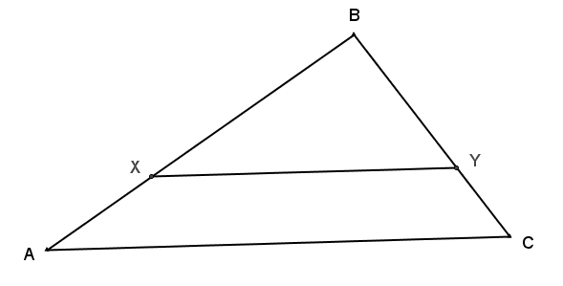

Not drawn to scale

1. If , , and , what is ?

Exit Ticket Sample Solutions

In the diagram, . Use the diagram to answer the following:



Not drawn to scale

1. If , , and , what is ?

1. If , , and , what is ?

Problem Set Sample Solutions

1. Use the diagram to answer each part below.
   1. Measure the segments in the figure below to verify that the proportion is true.

Actual measurements may vary due to copying, but students should state that the proportion is true.

* 1. Is the proportion also true? Explain algebraically.

True because the reciprocals of equivalent ratios are also equivalent.

* 1. Is the proportion also true? Explain algebraically.

True. , and . So, using the equivalent ratios in part (a):

1. Given the diagram below, , line is parallel to , and the distance from to is . Locate point on line such that has the greatest area. Defend your answer.



l

The distance between two parallel lines is constant and in this case is units. serves as the base of all possible triangles . The area of a triangle is one-half the product of its base and its height. No matter where point is located on line , triangle will have a base of and a height (distance between the parallel lines) of . All possible triangles will therefore have area of units2.

1. 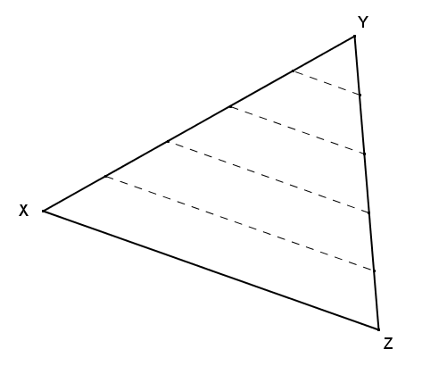Given , and are partitioned into equal length segments by the endpoints of the dashed segments as shown. What can be concluded about the diagram?

The dashed lines joining the endpoints of the equal length segments are parallel to by the triangle side splitter theorem.

1. Given the diagram, , , , , and , find .

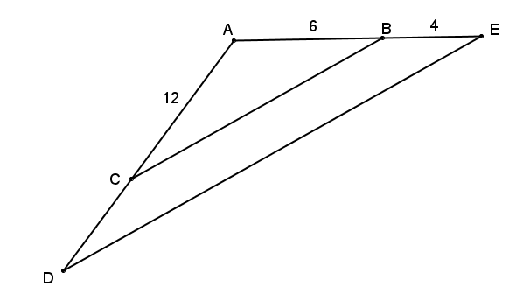Since and are corresponding angles and are both , it follows that . By the triangle side-splitter theorem, is a proportional side splitter so .

1. 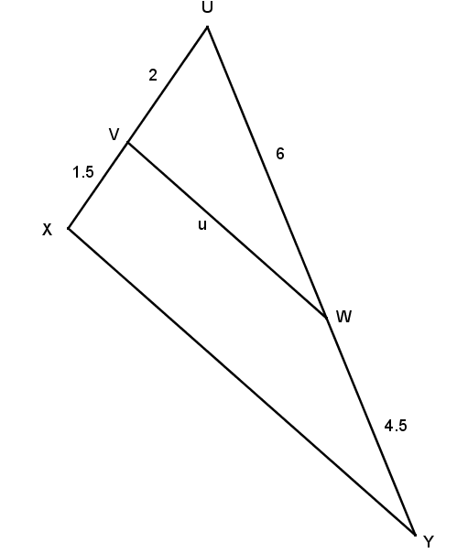What conclusions can be drawn from the diagram shown to the right? Explain.

Since and , , so the side splitter is a proportional side splitter.

This provides several conclusions:

* + 1. The side splitter is parallel to the third side of the triangle by the triangle side splitter theorem.
    2. and because corresponding angles formed by parallel lines cut by a transversal are congruent.
    3. is a scale drawing of with a scale factor of .
    4. because corresponding lengths in scale drawings are proportional.

1. 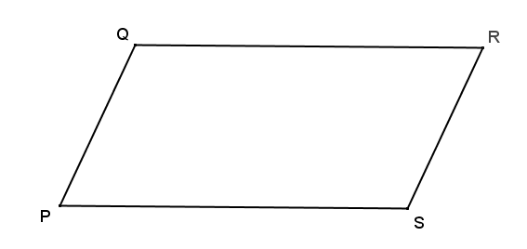Parallelogram is shown. Two triangles are formed by a diagonal within the parallelogram. Identify those triangles and explain why they are guaranteed to have the same areas.

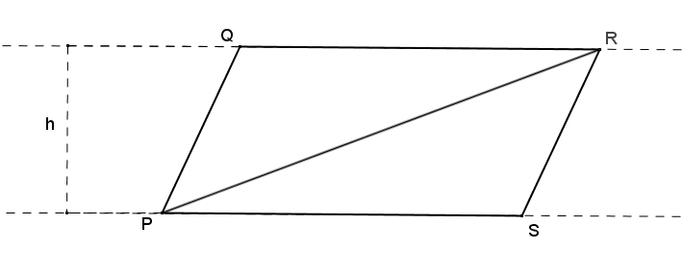Opposite sides of a parallelogram are parallel and have the same length, so , and the distance between and is a constant, . Diagonal forms and that have the same base length and the same height and, therefore, the same area.

Diagonal forms and that have the same base length and the same height and, therefore, the same area.

1. 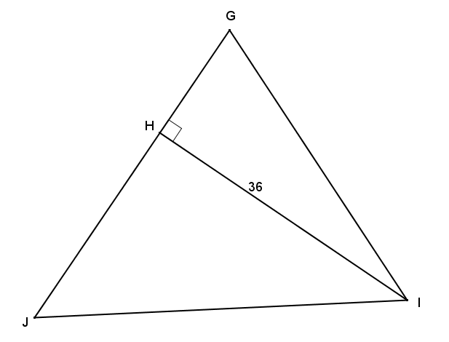In the diagram to the right, and . If the ratio of the areas of the triangles is , find , , , and .

is the altitude of both triangles so the bases of the triangles will be in the ratio of the areas of the triangles. is composed of and , so .

,

By the Pythagorean theorem, and .