Lesson 4: Comparing the Ratio Method with the Parallel Method

Classwork

Today, our goal is to show that the parallel method and the ratio method are equivalent; that is, given a figure in the plane and a scale factor , the scale drawing produced by the parallel method is congruent to the scale drawing produced by the ratio method. We start with two easy exercises about the areas of two triangles whose bases lie on the same line, which will help show that the two methods are equivalent.

Opening Exercises 1–2

1. 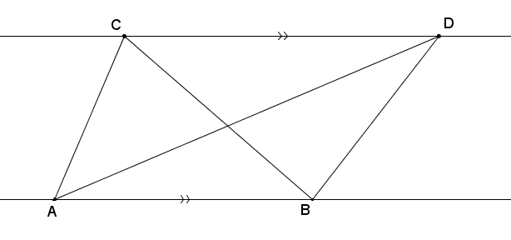Suppose two triangles, and , share the same base such that points and lie on a line parallel to line . Show that their areas are equal, i.e., . (Hint: Why are the altitudes of each triangle equal in length?)
2. Suppose two triangles have different length bases, and , that lie on the same line. Furthermore, suppose they both have the same vertex opposite these bases. Show that value of the ratio of their areas is equal to the value of the ratio of the lengths of their bases, i.e.,

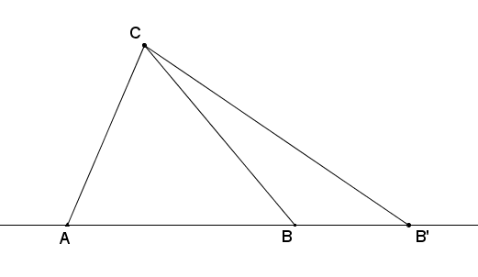

Discussion

To show that the parallel and ratio methods are equivalent, we need only look at one of the simplest versions of a scale drawing: scaling segments. First, we need to show that the scale drawing of a segment generated by the parallel method is the same segment that the ratio method would have generated and vice versa. (i.e., that the scaled segment generated by the ratio method is the same segment generated by the parallel method.) That is,

The parallel method The ratio method,

and

The ratio method The parallel method.

The first implication above can be stated as the following theorem:

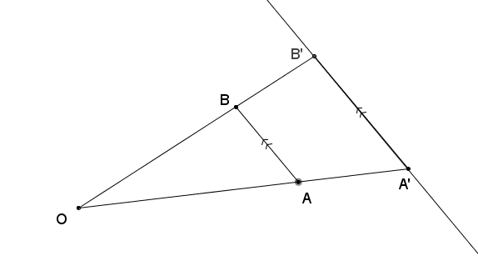**Parallel ratio theorem**: Given a line segment and point not on the line , construct a scale drawing of with scale factor using the parallel method: Let , and be the line parallel to that passes through . Let be the point where ray intersects . Then is the same point found by the ratio method; that is, .

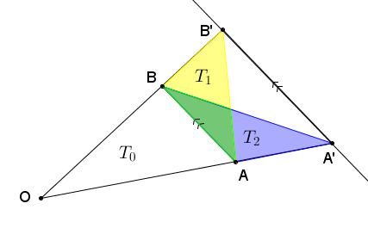**Proof**: We prove the case when ; the case when is the same but with a different picture. Construct two line segments and to form two triangles and , labeled as and , respectively, in the picture below.

The areas of these two triangles are equal,

,

by Exercise 1 (why?). Label by . Then because areas add:

Next, we apply Exercise 2 to two sets of triangles: (1) and and (2) and .

**(1) and with  
 bases on**

**(2) and with  
 bases on**

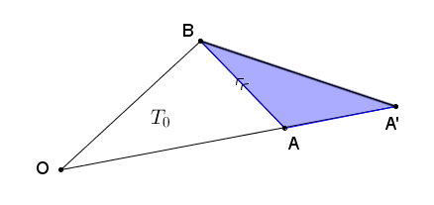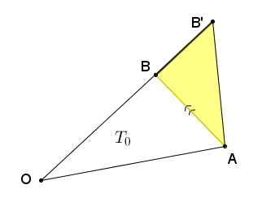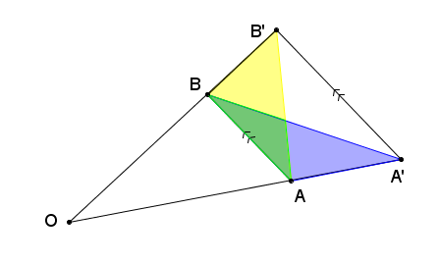

Therefore,

Since , we can equate the fractions: . Since is the scale factor used in dilating to , we know that ; therefore, , or . This last equality implies that is the dilation of from by scale factor , which is what we wanted to prove.

Next, we prove the reverse implication to show that both methods are equivalent to each other.

**Ratio parallel theorem**: Given a line segment and point not on the line , construct a scale drawing of with scale factor using the ratio method (Find and , and draw ). Then is the same as the point found using the parallel method.

**Proof**: Since both the ratio method and the parallel method start with the same first step of setting , the only difference between the two methods is in how the second point is found. If we use the parallel method, we construct the line parallel to that passes through and label the point where intersects by . Then is the same as the point found using the parallel method if we can show that .

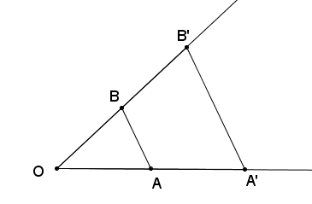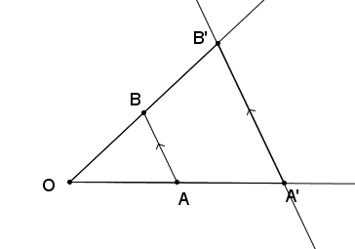

The ratio method

The parallel method

C

By the parallel ratio theorem, we know that , i.e., that is the point on ray such that . But is also the point on ray such that . Hence, they must be the same point.

The fact that the ratio and parallel methods are equivalent is often stated as the triangle side splitter theorem. To understand the triangle side splitter theorem, we need a definition:

**Side splitter:**  A line segment is said to *split the sides of*  *proportionally* if is a point on , is a point on , and (or equivalently, ). We call line segment a *side splitter.*

**Triangle side splitter theorem:** A line segment splits two sides of a triangle proportionally if and only if it is parallel to the third side.

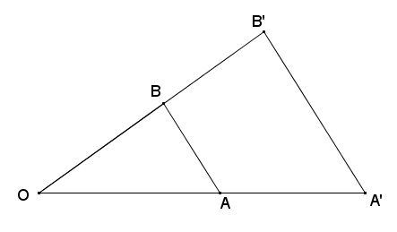Restatement of the triangle side splitter theorem:

Lesson Summary

**The triangle side splitter theorem**: A line segment splits two sides of a triangle proportionally if and only if it is parallel to the third side.

Problem Set



1. Use the diagram to answer each part below.
   1. Measure the segments in the figure below to verify that the proportion is true.
   2. Is the proportion also true? Explain algebraically.
   3. Is the proportion also true? Explain algebraically.
2. Given the diagram below, , line is parallel to , and the distance from to is . Locate point on line such that has the greatest area. Defend your answer.



l

1. Given , and are partitioned into equal length segments by the endpoints of the dashed segments as shown. What can be concluded about the diagram?

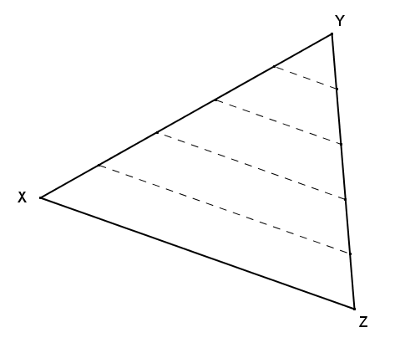

1. Given the diagram, , , , , and , find .

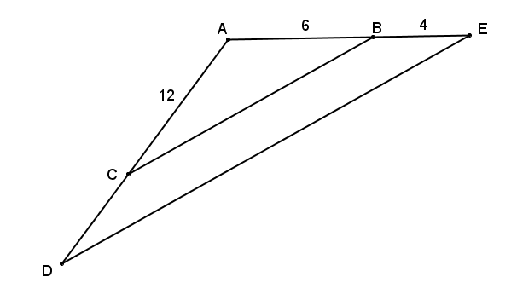

1. 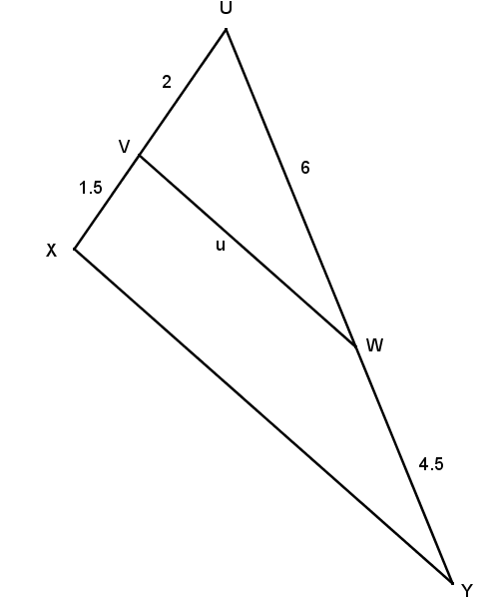What conclusions can be drawn from the diagram shown to the right? Explain.
2. 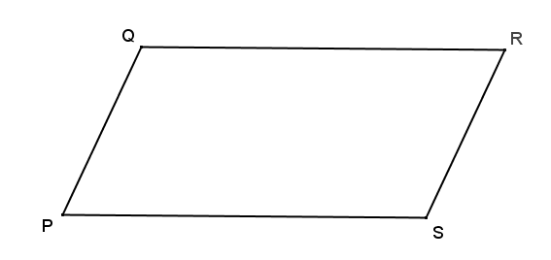Parallelogram is shown. Two triangles are formed by a diagonal within the parallelogram. Identify those triangles and explain why they are guaranteed to have the same areas.
3. In the diagram to the right, and . If the ratio of the areas of the triangles is , find , , , and .

