Lesson 3: Making Scale Drawings Using the Parallel Method

Student Outcomes
- Students create scale drawings of polygonal figures by the parallel method.
- Students explain why angles are preserved in scale drawings created by the parallel method using the theorem of parallel lines cut by a transversal.

Lesson Notes
In Lesson 3, students learn the parallel method as yet another way of creating scale drawings. The lesson focuses on constructing parallel lines with the use of setsquares, although parallel lines can also be constructed using a compass and straightedge; setsquares will reduce the time needed for the construction. Straightedges, compasses, and setsquares are needed for this lesson (setsquares can be made in class; refer to Grade 7, Module 6, Lesson 7). Rulers are allowed in one instance in the lesson (Example 1, part (b)), but the question can completed without it as long as compasses (or other devices for maintaining a fixed distance) are available.

Classwork
Opening Exercise (2 minutes)
The purpose of this Opening Exercise is to get students thinking about how parallel lines can be used to create a dilation. Accept all ideas and use responses to segue to Example 1.
Opening Exercise
Dani dilated $△ABC$ from center $O$, resulting in $△A'B'C'$. She says that she completed the drawing using parallel lines. How could she have done this? Explain.
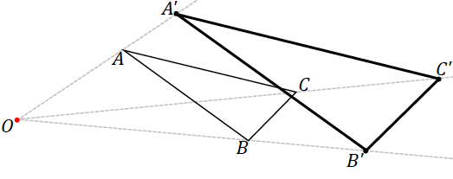
MP.2

Example 1 (6 minutes)
Scaffolding:
For further practice with setsquares, see Grade 7, Module 6, Lesson 7. If students are familiar with using a setsquare, they may skip to Example 2.
Example 1 is intended to remind students how to create a parallel line with the use of a setsquare. Provide students with compasses or allow the use of measurement for part (b).
Example 1
  - Use a ruler and setsquare to draw a line through $C$ parallel to $AB$. What ensures that the line drawn is parallel to $AB$?

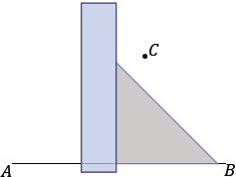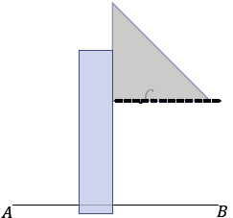

Since the setsquare is in the shape of a right triangle, we are certain that the legs of the setsquare are perpendicular. Then, when one leg is aligned with $AB$ and the other leg is flush against the ruler and can slide along the ruler, the $90°$ angle between the horizontal leg and the ruler remains fixed; in effect, there are corresponding angles that are equal in measure. The two lines must be parallel.

  - Use a ruler and setsquare to draw a parallelogram $ABCD$ around $AB$ and point $C$.

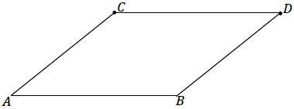
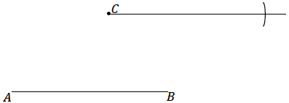
Step 1
Step 2
Step 3

Example 2 (10 minutes)
Example 1 demonstrates how to create a scale drawing using the parallel method.
- The basic parameters and initial steps to the parallel method are like those of the initial steps to the ratio method; a ray must be drawn from the center through all vertices, and one corresponding vertex of the scale drawing must be determined using the scale factor and ruler. However, as suggested by the name of the method, the following steps require a setsquare to draw a segment parallel to each side of the figure.
Example 2
Use the figure below with center $O$ and a scale factor of $r=2$ and the following steps to create a scale drawing using the parallel method.
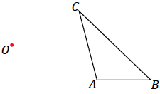

Step 1. Draw a ray beginning at $O$ through each vertex of the figure.
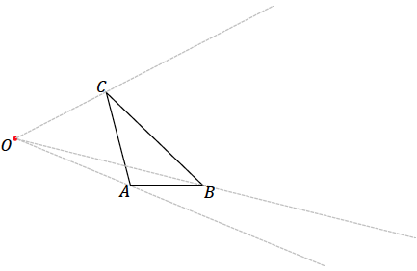

Step 2. Select one vertex of the scale drawing to locate; we have selected $A'$. Locate $A'$ on ray $\vec{OA }$so that $OA^{'}=2OA$.
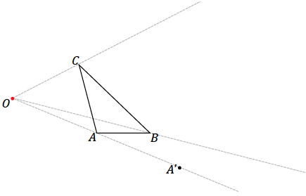

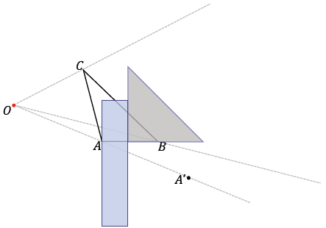
Step 3. Align the setsquare and ruler as in the image below; one leg of the setsquare should line up with side $AB,$ and the perpendicular leg should be flush against the ruler.

Scaffolding:
These steps should be modeled for all students, but depending on student needs, these images may need to be made larger or teachers may need to model the steps more explicitly.

Step 4. Slide the setsquare along the ruler until the edge of the setsquare passes through $A'$. Then, along the perpendicular leg of the setsquare, draw the segment through $A'$ that is parallel to $AB$ until it intersects with $\vec{OB},$ and label this point $B'$.

Ask students to summarize how they created the scale drawing and why they think this method works.
It may happen that it is not possible to draw the entire parallel segment $A'B'$ due to the position of the setsquare and the location of $B'$. Alert students that this may happen and that they should simply pick up the setsquare (or ruler) and complete the segment once it has been started.
It may even happen that the setsquare is not long enough to meet point $A'$. In such a case, a ruler can be placed flush against the other leg of the setsquare, and then the setsquare can be removed and a line drawn through $A^{'}.$
In a similar vein, if any of the rays is not long enough, extend it so that the intersection between the parallel segment and ray is visible.

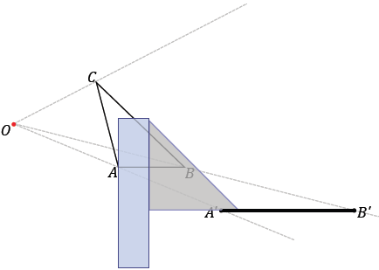

Step 5. Continue to create parallel segments to determine each successive vertex point. In this particular case, the setsquare has been aligned with $AC$. This is done because, in trying to create a parallel segment from $BC$, the parallel segment was not “reaching” $B'$. This could be remedied with a larger setsquare and longer ruler, but it is easily avoided by working on the segment parallel to $AC$ instead.
MP.1
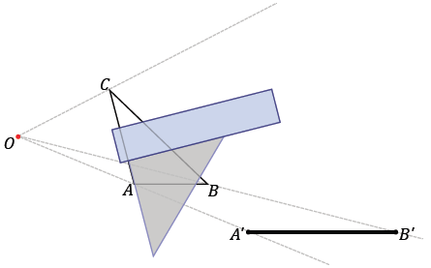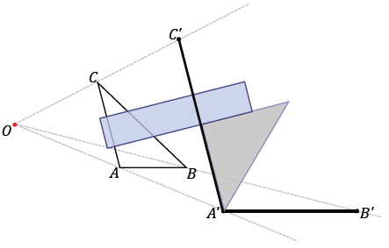

Step 6. Use your ruler to join the final two unconnected vertices.
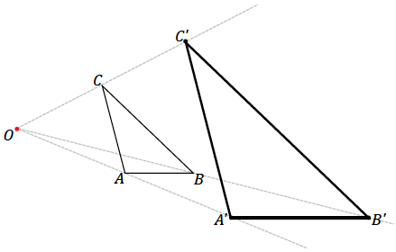

Have students show that $△A'B'C'$ is a scale drawing; measure and confirm that the length of each segment in the scale drawing is twice the length of each segment in the original drawing and that the measurements of all corresponding angles are equal. $△ABC$ angle measurements are $m∠A=104°$, $m∠B=44°$, and $m∠C=32°$. We will not provide the measurements of the side lengths as they will differ from the images that appear in print form.
Scaffolding:
Patty paper may facilitate measurements in the Examples and Exercises, but students should be prepared to use measuring tools in an Exit Ticket or Assessment.
- We want to note here that though we began with a scale factor of $r=2$ for the dilation, we consider the resulting scale factor of the scale drawing created by the parallel method separately. As we can see by trying the dilations out, the scale factor for the dilation and the scale factor for the scale drawing by the parallel method are in fact one and the same.
- There is a concrete reason why this is, but we will not go into the explanation of why the parallel method actually yields a scale drawing with the same scale factor as the dilation until later lessons.

Exercises 1–2 (10 minutes)
Exercise 1 differs from Example 1 in one way: in Example 1, students had to locate the initial point $A'$, whereas in Exercise 1, students are provided with the location of the initial point but not told explicitly how far from the center the point is. Teachers should use their discretion to decide if students are ready for the slightly altered situation or whether they need to retry a problem as in Example 1.
Exercises 1–3
- With a ruler and setsquare, use the parallel method to create a scale drawing of $WXYZ$ by the parallel method. $W'$ has already been located for you. Determine the scale factor of the scale drawing. Verify that the resulting figure is in fact a scale drawing by showing that corresponding side lengths are in constant proportion and that corresponding angles are equal in measurement.

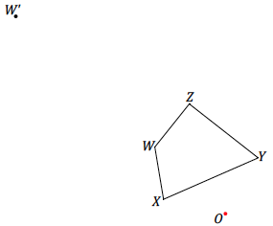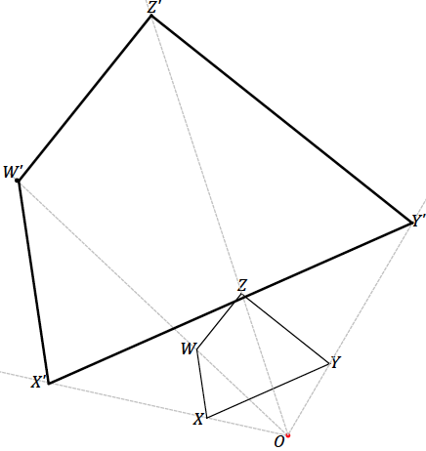

The scale factor is $3$. Verification of the enlarged figure should show that the length of each segment in the scale drawing is three times the length of each segment in the original figure, e.g., $W^{'}X^{'}= 3(WX)$. The angle measurements are $m∠W=132°$, $m∠X=76°$, $m∠Y=61°$, and $m∠Z=91°$.

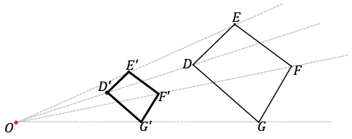
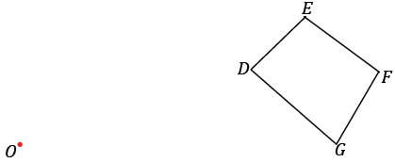
- With a ruler and setsquare, use the parallel method to create a scale drawing of $DEFG$ about center $O$ with scale factor $r=\frac{1}{2}$. Verify that the resulting figure is in fact a scale drawing by showing that corresponding side lengths are in constant proportion and that the corresponding angles are equal in measurement.

Verification of the reduced figure should show that the length of each segment in the scale drawing is one half the length of each segment in the original figure, e.g., $D^' E^'=\frac{1}{2}(DE)$. The angle measurements are
$m∠D=85°$, $m∠E=99°$, $m∠F=97°$, and $m∠G=79°$.

Discussion (5 minutes)
- So far we have verified that corresponding angles between figures and their scale drawings are equal in measurement by actually measuring each pair of angles. Instead of measuring each time, we can recall what we know about parallel lines cut by transversals to verify that corresponding angles are in fact equal in measurement. How would you explain this? Mark the following figure as needed to help explain.
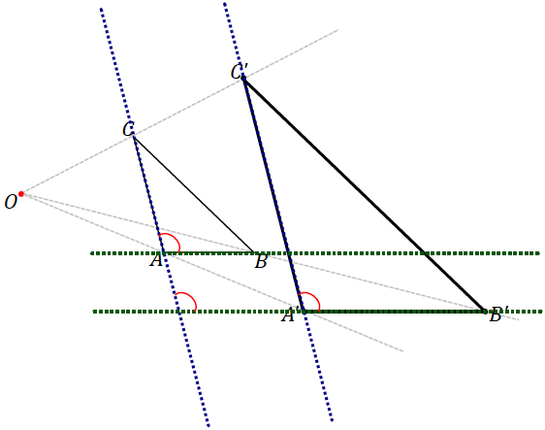
  - If a transversal intersects two parallel lines, then corresponding angles are equal in measurement. Since we have constructed corresponding segments to be parallel, we are certain that $AC∥A'C'$ and $AB∥A'B'$. We make use of the corresponding angles fact twice to show that corresponding angles $∠A$ and $∠A'$ are equal in measurement. A similar argument shows the other angles are equal in measurement.
Exercise 3 (5 minutes)
The center $O$ lies within the figure in Exercise 3. Ask students if they think this will affect the resulting scale drawing and allow them to confer with a neighbor.

- With a ruler and setsquare, use the parallel method to create a scale drawing of pentagon $PQRST$ about center $O$ with scale factor $\frac{5}{2}$. Verify that the resulting figure is in fact a scale drawing by showing that corresponding side lengths are in constant proportion and that corresponding angles are equal in measurement.
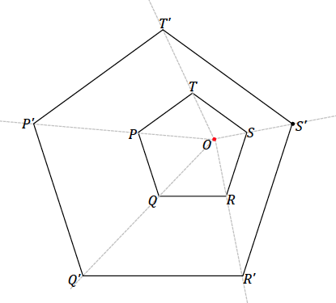

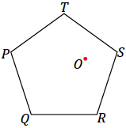

Verification of the enlarged figure should show that the length of each segment in the scale drawing is two-and-a-half times the length of each segment in the original figure, e.g., $P^{'}T^{'}=\frac{5}{2}(PT)$. Each of the angles has a measurement of $108°$.

Closing (2 minutes)
Ask students to summarize the key points of the lesson. Additionally, consider having them answer the following questions independently in writing, to a partner, or to the whole class.
- How are dilations and scale drawings related?
  - Dilations can be used to create scale drawings by the ratio method or the parallel method.
- To create a scale drawing using the ratio method, a center, a figure, and a scale factor must be provided. Then the dilated vertices can either be measured or located using a compass. To use the parallel method, a center, a figure, and a scale factor or one provided vertex of the dilated figure must be provided. Then use a setsquare to help construct sides parallel to the sides of the original figure, beginning with the side that passes through the provided dilated vertex.

Exit Ticket (5 minutes)

Name Date
Lesson 3: Making Scale Drawings Using the Parallel Method

Exit Ticket

With a ruler and setsquare, use the parallel method to create a scale drawing of quadrilateral $ABCD$about center $O$ with scale factor $r=\frac{3}{4}$. Verify that the resulting figure is in fact a scale drawing by showing that corresponding side lengths are in constant proportion and that the corresponding angles are equal in measurement.

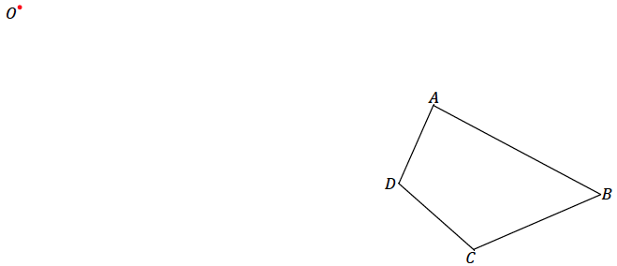

What kind of error in the parallel method might prevent us from having parallel, corresponding sides?

Exit Ticket Sample Solutions

With a ruler and setsquare, use the parallel method to create a scale drawing of quadrilateral $ABCD$about center $O$ with scale factor $r=\frac{3}{4}$. Verify that the resulting figure is in fact a scale drawing by showing that corresponding side lengths are in constant proportion and that the corresponding angles are equal in measurement.

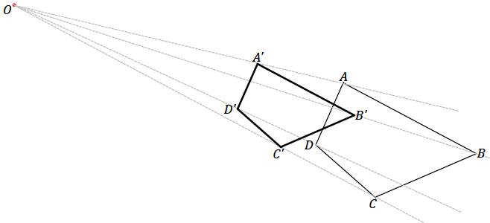
The measurements of the angles in the figure are $m∠A=86°$,$m∠B=51°$,$m∠C=115°$, and$m∠D=108°$. All side length measurements of the scale drawing should be in the constant ratio of $3:4$.

What kind of error in the parallel method might prevent us from having parallel, corresponding sides?
If the setsquare is not aligned with the segment of the figure, you will not create a parallel segment. Also, if the setsquare is not perfectly flush with the ruler, it will not be possible to create a segment parallel to the segment of the figure.

Problem Set Sample Solutions

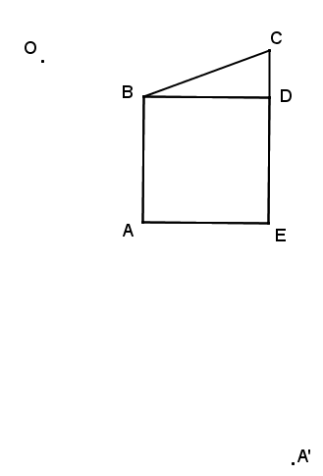
- With a ruler and setsquare, use the parallel method to create a scale drawing of the figure about center $O$. One vertex of the scale drawing has been provided for you.

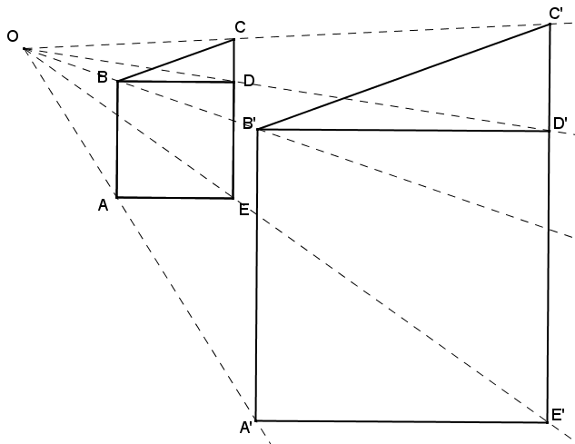
Determine the scale factor. Verify that the resulting figure is in fact a scale drawing by showing that corresponding side lengths are in constant proportion and that the corresponding angles are equal in measurement.
The scale factor is $\frac{5}{2}$. The measurements of the angles in the figure are $m∠A=m∠B=m∠D=m∠E=90°$, $m∠DBC=20°$, $m∠CDB=90°$, and $m∠C=70°$. All side length measurements of the scale drawing are in the constant ratio of $5:2$.

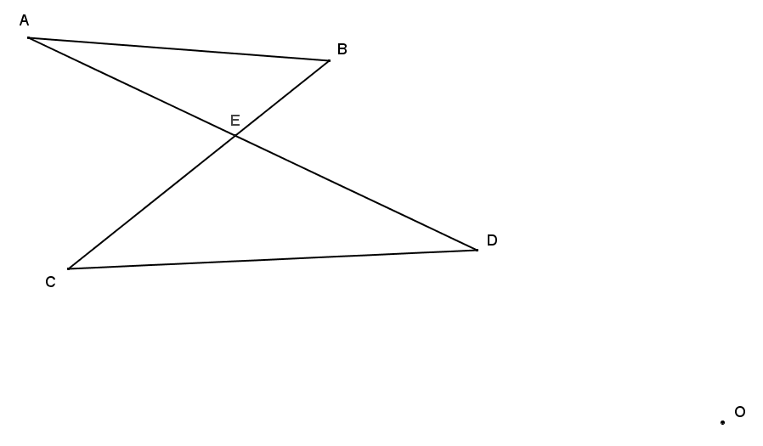
- With a ruler and setsquare, use the parallel method to create a scale drawing of the figure about center $O$ and scale factor $\frac{1}{3}$. Verify that the resulting figure is in fact a scale drawing by showing that corresponding side lengths are in constant proportion and the corresponding angles are equal in measurement.

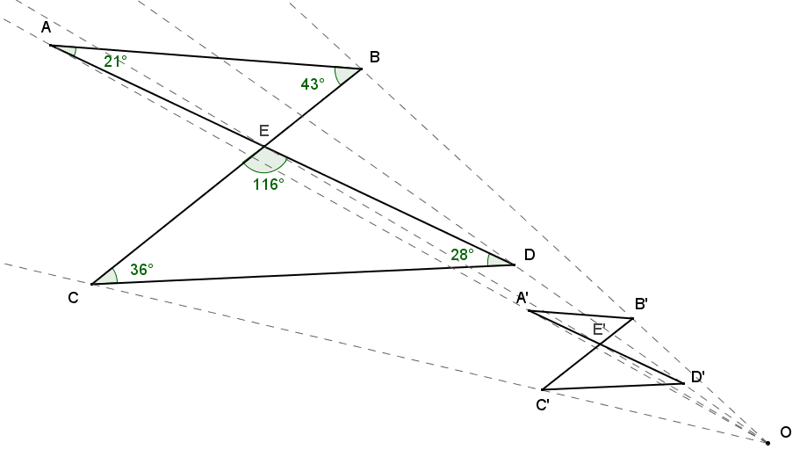
The measurements of the angles in the figure are$m∠A=21°$,$m∠B=43°$,$m∠C=36°$,$m∠D=28°$, and $m∠CED=m∠BEA=116°$. All side length measurements of the scale drawing are in the constant ratio of $1:3$.

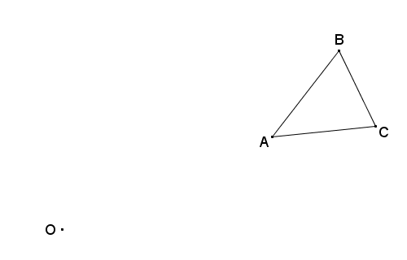
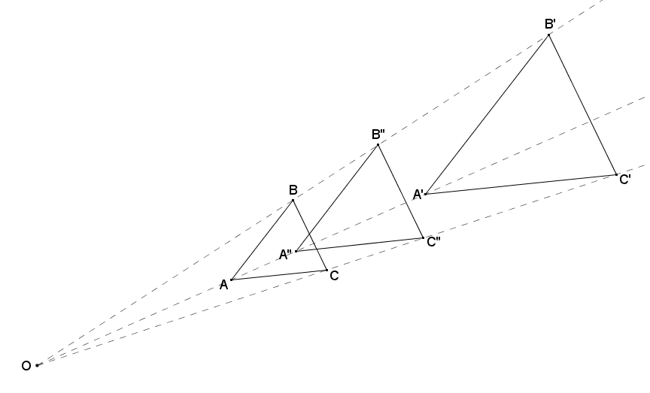
- With a ruler and setsquare, use the parallel method to create the following scale drawings about center $O$: (1) first use a scale a factor of 2 to create $△A'B'C'$, (2) then, with respect to $△A'B'C'$, use a scale factor of $\frac{2}{3}$ to create scale drawing $△A"B"C"$. Calculate the scale factor for $△A^{''}B''C''$ as a scale drawing of $△ABC$. Use angle and side length measurements and the appropriate proportions to verify your answer.
The scale factor of $△A'B'C'$ relative to $△ABC$ is $2$. The measurements of the angles in the figure are $m∠A≈46°$, $m∠B≈64°$, and $m∠C≈70°$. The scale factor from $△ABC$ to $△A''B''C''$ is $\frac{2}{3}⋅2=\frac{4}{3}$. Solutions should show the side length proportions between $△A''B''C''$ and $△ABC$: $\frac{A^{''}B^{''}}{AB}=\frac{B^{''}C^{''}}{BC}=\frac{C^{''}A^{''}}{CA}=\frac{4}{3}$.

- Follow the direction in each part below to create three scale drawings of $△ABC$ using the parallel method.
  - With the center at vertex $A$, make a scale drawing of $△ABC$ with a scale factor of $\frac{3}{2}$.
  - With the center at vertex $B$, make a scale drawing of $△ABC$ with a scale factor of $\frac{3}{2}$.
  - With the center at vertex $C$, make a scale drawing of $△ABC$ with a scale factor of $\frac{3}{2}$.
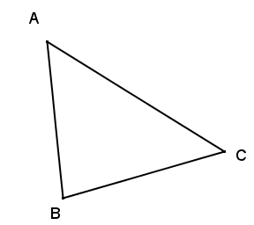
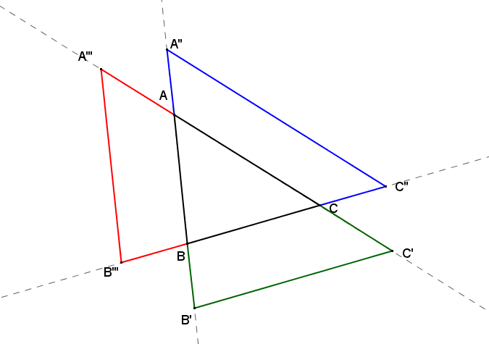

  - What conclusions can be drawn about all three scale drawings from parts (a)–(c)?
The three scale drawings are congruent.
$AB^{'}=A^{''}B=\frac{3}{2}AB$ Dilation using scale factor $\frac{3}{2}$.
$∠A''≅∠BAC$ Corresponding$∠'s$ formed by parallel lines are congruent.
$∠B'≅∠ABC$ Corresponding$∠'s$ formed by parallel lines are congruent.
$△AB^{'}C^{'}≅ △A''BC''$ ASA

A similar argument can be used to show $△AB^{'}C^{'}≅ △A'''B'''C$, and by transitivity of congruence, all three scale drawings are congruent to each other.

- Use the parallel method to make a scale drawing of the line segments in the following figure using the given $W'$, the image of vertex $W$, from center $O$. Determine the scale factor.
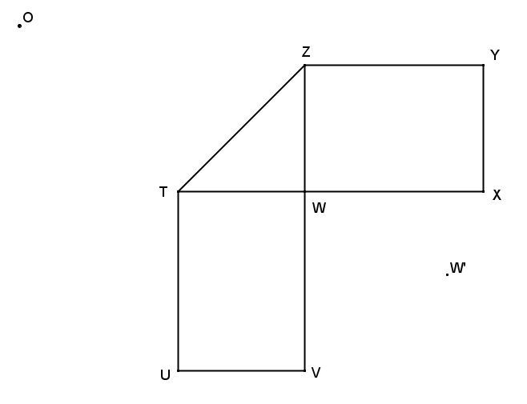
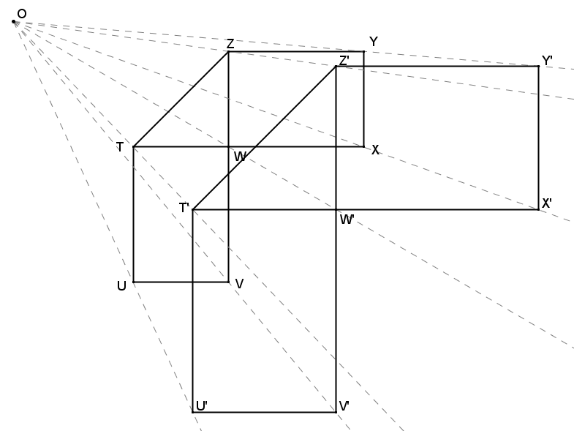
The ratio of $OW':OW$ is $3:2$, so the scale factor is $\frac{3}{2}$. All corresponding lengths are in the ratio of $3:2$.
Use your diagram from Problem 1 to answer this question.
- If we switch perspective and consider the original drawing $ABCDE$ to be a scale drawing of the constructed image $A'B'C'D'E'$, what would the scale factor be?
If the original figure were the scale drawing and the scale drawing were the original figure, the scale factor would be $\frac{2}{5}$.

