Lesson 3: Making Scale Drawings Using the Parallel Method

Classwork
Opening Exercise
Dani dilated $△ABC$ from center $O$, resulting in $△A'B'C'$. She says that she completed the drawing using parallel lines. How could she have done this? Explain.
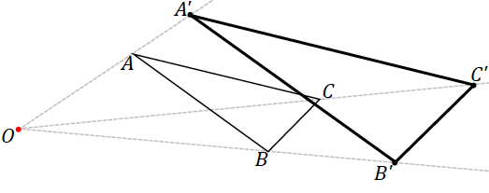

Example 1
  - Use a ruler and setsquare to draw a line through $C$ parallel to $AB$. What ensures that the line drawn is parallel to $AB$?

  - Use a ruler and setsquare to draw a parallelogram $ABCD$ around $AB$ and point $C$.

Example 2
Use the figure below with center $O$ and a scale factor of $r=2$ and the following steps to create a scale drawing using the parallel method.
Step 1. Draw a ray beginning at $O$ through each vertex of the figure.
Step 2. Select one vertex of the scale drawing to locate; we have selected $A'$. Locate $A'$ on ray $\vec{OA }$so that $OA^{'}=2OA$.
Step 3. Align the setsquare and ruler as in the image below; one leg of the setsquare should line up with side $AB,$ and the perpendicular leg should be flush against the ruler.
Step 4. Slide the setsquare along the ruler until the edge of the setsquare passes through $A'$. Then, along the perpendicular leg of the setsquare, draw the segment through $A'$ that is parallel to $AB$ until it intersects with $\vec{OB},$ and label this point $B'$.
Step 5. Continue to create parallel segments to determine each successive vertex point. In this particular case, the setsquare has been aligned with $AC$. This is done because, in trying to create a parallel segment from $BC$, the parallel segment was not “reaching” $B'$. This could be remedied with a larger setsquare and longer ruler, but it is easily avoided by working on the segment parallel to $AC$ instead.
Step 6. Use your ruler to join the final two unconnected vertices.

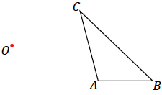

Exercises 1–3
- With a ruler and setsquare, use the parallel method to create a scale drawing of $WXYZ$ by the parallel method. $W'$ has already been located for you. Determine the scale factor of the scale drawing. Verify that the resulting figure is in fact a scale drawing by showing that corresponding side lengths are in constant proportion and that corresponding angles are equal in measurement.

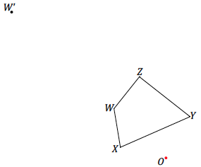

- With a ruler and setsquare, use the parallel method to create a scale drawing of $DEFG$ about center $O$ with scale factor $r=\frac{1}{2}$. Verify that the resulting figure is in fact a scale drawing by showing that corresponding side lengths are in constant proportion and that the corresponding angles are equal in measurement.

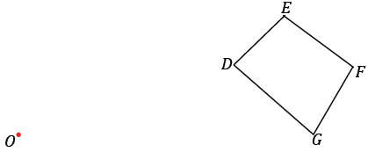

- With a ruler and setsquare, use the parallel method to create a scale drawing of pentagon $PQRST$ about center $O$ with scale factor $\frac{5}{2}$. Verify that the resulting figure is in fact a scale drawing by showing that corresponding side lengths are in constant proportion and that corresponding angles are equal in measurement.

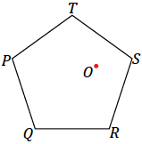
Problem Set

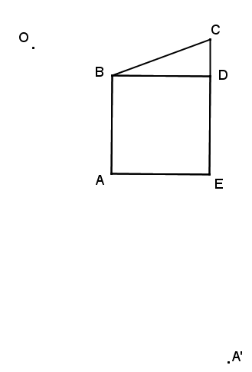
- With a ruler and setsquare, use the parallel method to create a scale drawing of the figure about center $O$. One vertex of the scale drawing has been provided for you.
Determine the scale factor. Verify that the resulting figure is in fact a scale drawing by showing that corresponding side lengths are in constant proportion and that the corresponding angles are equal in measurement.

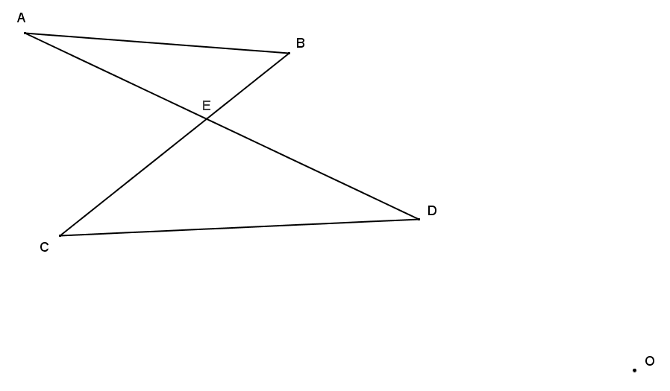
- Determine the scale factor. Verify that the resulting figure is in fact a scale drawing by showing that corresponding side lengths are in constant proportion and that the corresponding angles are equal in measurement.
- With a ruler and setsquare, use the parallel method to create the following scale drawings about center $O$: (1) first use a scale a factor of $2$ to create $△A'B'C'$, (2) then, with respect to $△A'B'C'$, use a scale factor of $\frac{2}{3}$ to create scale drawing $△A"B"C"$. Calculate the scale factor for $△A^{''}B''C''$ as a scale drawing of $△ABC$. Use angle and side length measurements and the appropriate proportions to verify your answer.

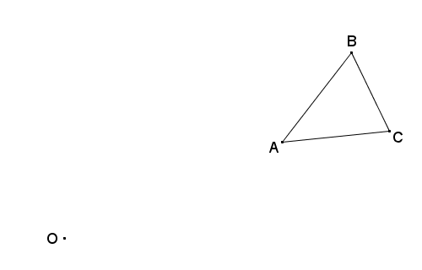

- Follow the direction in each part below to create three scale drawings of $△ABC$ using the parallel method.
  - With the center at vertex $A$, make a scale drawing of $△ABC$ with a scale factor of $\frac{3}{2}$.
  - With the center at vertex $B$, make a scale drawing of $△ABC$ with a scale factor of $\frac{3}{2}$.
  - With the center at vertex $C$, make a scale drawing of $△ABC$ with a scale factor of $\frac{3}{2}$.

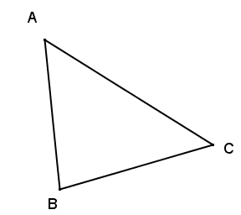
  - What conclusions can be drawn about all three scale drawings from parts (a)–(c)?
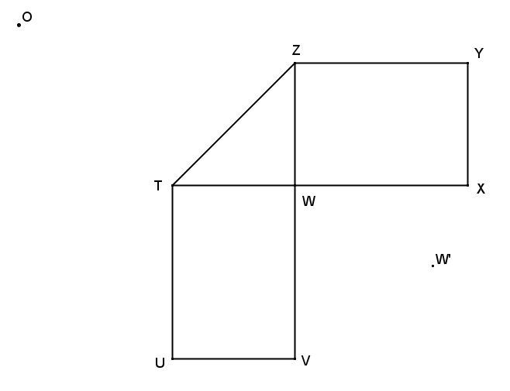
- Use the parallel method to make a scale drawing of the line segments in the following figure using the given $W'$, the image of vertex $W$, from center $O$. Determine the scale factor.

Use your diagram from Problem 1 to answer this question.
- If we switch perspective and consider the original drawing $ABCDE$ to be a scale drawing of the constructed image $A'B'C'D'E'$, what would the scale factor be?

