2
Lesson 2: Making Scale Drawings Using the Ratio Method

Student Outcomes
- Students create scale drawings of polygonal figures by the ratio method.
- Given a figure and a scale drawing from the ratio method, students answer questions about the scale factor and the center.

Lesson Notes
In Lesson 1, students created scale drawings in any manner they wanted, as long as the scale drawings met the criteria of well-scaled drawings. Lesson 2 introduces students to a systematic way of creating a scale drawing: the ratio method, which relies on dilations. Students dilate the vertices of the provided figure and verify that the resulting image is in fact a scale drawing of the original. It is important to note that we approach the ratio method as a method that strictly dilates the vertices. After some practice with the ratio method, students dilate a few other points of the polygonal figure and notice that they lie on the scale drawing. They may speculate that the dilation of the entire figure is the scale drawing, but we do not generalize this fact in Lesson 2.
Note that students will require rulers, protractors, and calculators for this lesson.
Scaffolding:
Providing an example of a dilation (such as in the image below) may help students recall details about dilations.
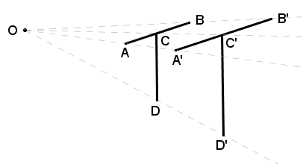
Classwork
Opening Exercise (2 minutes)
Opening Exercise
Based on what you recall from Grade 8, describe what a dilation is.
Student responses will vary; students may say that a dilation results in a reduction or an enlargement of the original figure or that corresponding side lengths are proportional in length and corresponding angles are equal in measure. The objective is to prime them for an in-depth conversation about dilations; take one or two responses and move on.

Discussion (5 minutes)
- In Lesson 1, we reviewed the properties of a scale drawing and created scale drawings of triangles using construction tools. We observed that as long as our scale drawings had angles equal in measure to the corresponding angles of the original figure and lengths in constant proportion to the corresponding lengths of the original figure, the location and orientation of our scale drawing did not concern us.
- In Lesson 2, we use a systematic process of creating a scale drawing called the ratio method. The ratio method dilates the vertices of the provided polygonal figure. The details that we recalled in the Opening Exercise are characteristics that are consistent with scale drawings too. We will verify that the resulting image created by dilating these key points is in fact a scale drawing.

- Recall the definition of a dilation:
Definition | Characteristics
For $r>0$, a dilation with center $O$ and scale factor $r$ is a transformation $D_{O,r}$ of the plane defined as follows:  For the center $O$, $D_{O,r}\left(O\right)=O$, and  For any other point $P$, $D_{O,r}\left(P\right)$ is the point $P$ on the ray $\vec{OP}$so that $\left|OP'\right|=r∙\left|OP\right|.$ | - Preserves angles  - Names a center and a scale factor  Dilation
Examples | Non-Examples
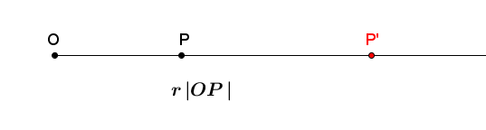 | - Rigid motions such as translations, rotations, reflections

Note that students last studied dilations in Grade 8, Module 3. At that time, the notation used was not the capital letter $D$, but the full word $dilation$. Students have since studied rigid motion notation in Grade 10, Module 1 and should be familiar with the style of notation presented here.
Scaffolding:
- Consider displaying a poster with the definition and notation of dilation.
- Ask students to draw some examples to demonstrate understanding, such as, "Draw a segment $OP$ on your paper. Dilate the segment using $D_{O,3}$."

- A dilation is a rule (a function) that moves points in the plane a specific distance along the ray that originates from a center $O.$ What determines the distance a given point moves?
  - The location of the scaled point is determined by the scale factor and the distance of the original point from the center.
- What can we tell about the scale factor of a dilation that pulls any point that is different from the center towards the center $O$?
  - We know that the scale factor for a dilation where a point is pulled towards the center must be $0<r<1$.
- What can we tell about the scale factor of a dilation that pushes all points, except the center, away from the center $O$?
  - The scale factor for a dilation where a point is pushed away from the center must be $r>1$.
- A point, different from the center, that is unchanged in its location after a dilation must have a scale factor of $r=1$.
- Scale factor is always a positive value, as we use it when working with distance. If we were to use negative values for scale factor, we would be considering distance as a negative value, which does not make sense. Hence, scale factor is always positive.

Example 1 (8 minutes)
Examples 1–2 demonstrate how to create a scale drawing using the ratio method. In this example, the ratio method is used to dilate the vertices of a polygonal figure about center $O$, by a scale factor of $r=\frac{1}{2}$.
- To use the ratio method to scale any figure, we must have a scale factor and center in order to dilate the vertices of a polygonal figure.
- In the steps below, we have a figure with center $O$ and a scale factor of$r=\frac{1}{2}$. What effect should we expect this scale factor to have on the image of the figure?
  - Since the scale factor is a value less than one (but greater than zero), the image should be a reduction of the original figure. Specifically, each corresponding length should be half of the original length.
Example 1
Create a scale drawing of the figure below using the ratio method about center $O$ and scale factor $r=\frac{1}{2}$.
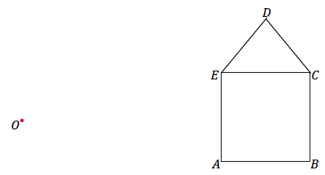
Step 1. Draw a ray beginning at $O$ through each vertex of the figure.
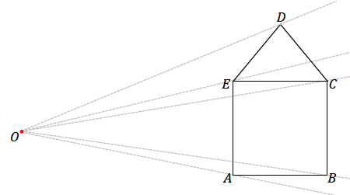

Step 2. Dilate each vertex along the appropriate ray by scale factor $r=\frac{1}{2}$. Use the ruler to find the midpoint between $O$ and $D$ and then each of the other vertices. Label each respective midpoint with prime notation, i.e., $D’$.

- Why are we locating the midpoint between $O$ and $D$?
  - The scale factor tells us that the distance of the scaled point should be half the distance from $O$ to $D$, which is the midpoint of $\overline{OD}$.
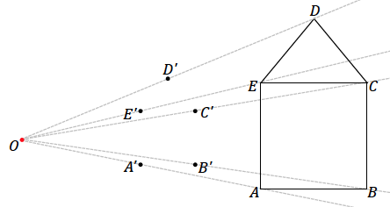

Step 3. Join vertices in the way they are joined in the original figure, e.g., segment $A'B'$ corresponds to segment $AB$.
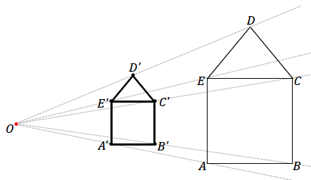

- Does $A'B'C'D'E'$ look like a scale drawing? How can we verify whether $A'B'C'D'E'$ is really a scale drawing?
  - Yes. We can measure each segment of the original and the scale drawing; the segments of $A'B'C'D'E'$ appear to be half as long as their corresponding counterparts in $ABCDE$, and all corresponding angles appear to be equal in measurement; the image is a reduction of the original figure.
MP.5
- It is important to notice that the scale factor for the scale drawing is the same as the scale factor for the dilation.
Students may notice that in the triangle formed by the center and the endpoints of any segment on the original figure, the dilated segment forms the mid-segment of the triangle.
Scaffolding:
Teachers may want to consider using patty paper as an alternate means to measuring angles with a protractor in the interest of time.
Have students measure and confirm that the length of each segment in the scale drawing is half the length of each segment in the original drawing and that the measurements of all corresponding angles are equal. The quadrilateral $ABCD$ is a square and all four angles are $90°$ in measurement. The measurement of $∠D=80°$, and the measurements of $∠C$ and $∠E$ are both $50°$. We will not provide the measurements of the side lengths as they will differ from the images that appear in print form.

Exercise 1 (5 minutes)
Scaffolding:
In preparing for this lesson, consider whether your class will have time for each example and exercise. If time is short, consider moving from Example 1 to Example 2.
Exercise 1
- Create a scale drawing of the figure below using the ratio method about center $O$ and scale factor $r=\frac{3}{4}$. Verify that the resulting figure is in fact a scale drawing by showing that corresponding side lengths are in constant proportion and the corresponding angles are equal in measurement.
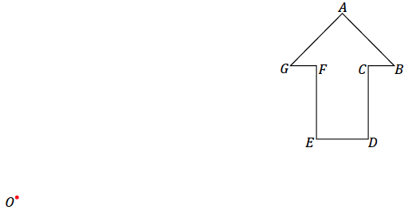
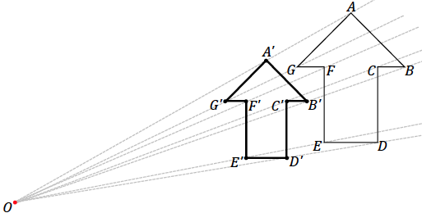

Verification of the reduced figure should show that the length of each segment in the scale drawing is $\frac{3}{4}$ the length of each segment in the original figure, e.g., $A^{'}G^{'}=\frac{3}{4}(AG)$. The angle measurements are as follows (when an angle could be interpreted as having two possible measurements, the smaller one was selected in all cases): $m∠A=90°$, $m∠B=45°$, $m∠C=90°$, $m∠D=90°$, $m∠E=90°$, $m∠F=90°$, and $m∠G=45°$.

Example 2 (7 minutes)
Example 2
- Create a scale drawing of the figure below using the ratio method about center $O$ and scale factor $r=3$.
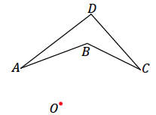
Step 1. Draw a ray beginning at $O$ through each vertex of the figure.

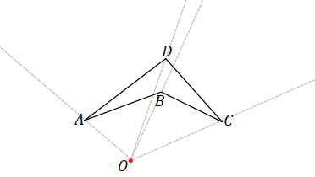

Step 2. Use your ruler to determine the location of $A'$ on $\vec{OA}$; $A'$ should be three times as far from $O$ as $A$. Determine the locations of $B'$ and $C'$ in the same way along the respective rays.
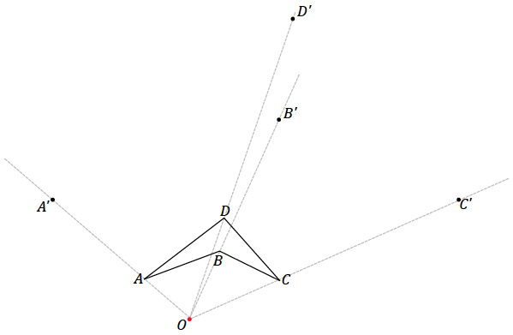

Step 3. Draw the corresponding line segments, e.g., segment $A'B'$ corresponds to segment $AB$.
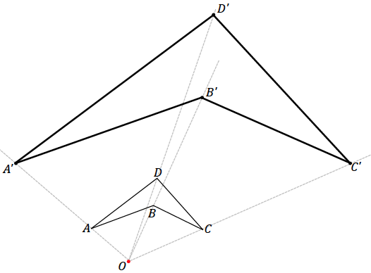

- Does $A'B'C'D'$ look like a scale drawing of $ABCD$?
  - Yes.
- How can we verify whether $A'B'C'D'$ is really a scale drawing of $ABCD$?
  - We can measure each segment of the original and the scale drawing; the segments of $A'B'C'D'$ should be three times as long as their corresponding counterparts in $ABCD$, and all corresponding angles should be equal in measurement; the image is an enlargement of the original figure.
Have students measure and confirm that the length of each segment in the scale drawing is three times the length of each segment in the original drawing and that the measurements of all corresponding angles are equal. The measurements of the angles in the figure are as follows: $m∠A=17°$, $m∠B=134°$ (we selected the smaller of the two possible options of measuring the angle, either will do), $m∠C=22°$, $m∠D=23°$. Again, we will not provide the measurements of the side lengths as they will differ from the images that appear in print form.

- Locate a point $X$ so that it lies between endpoints $A$ and $B$ on segment $AB$ of the original figure in part (a). Use the ratio method to locate $X'$ on the scale drawing in part (a).
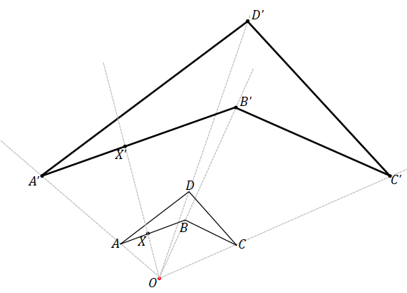
Sample response:

- Consider that everyone in class could have chosen a different location for $X$ between points $A$ and $B$. What does the result of part (b) imply?
  - The result of part (b) implies that all the points between $AB$ are dilated to corresponding points between points $A'$and $B'$.
- It is tempting to draw the conclusion that the dilation of the vertices is the same as the dilation of each segment onto corresponding segments in the scale drawing. Even though this appears to be the case here, we will wait until later lessons to definitively show whether this is actually the case.

- Imagine a dilation of the same figure as in parts (a) and (b). What if the ray from the center passed through two distinct points, such as $B$ and $D$ below? What does that imply about the locations of $B'$ and $D'$?
Both $B^{'}$ and $D'$ will also lie on the same ray.
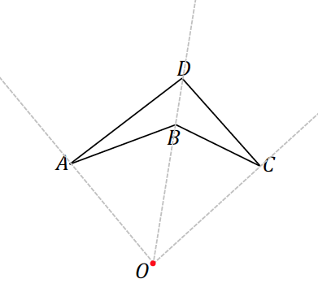

Exercises 2–6 (11 minutes)
Exercises 2–6
- $△A'B'C'$ is a scale drawing of $△ABC$ drawn by using the ratio method. Use your ruler to determine the location of the center $O$ used for the scale drawing.
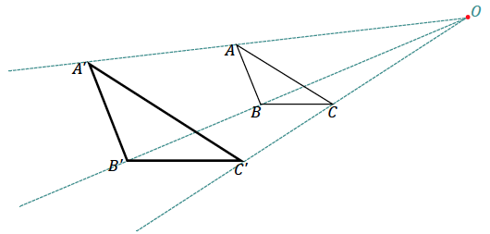
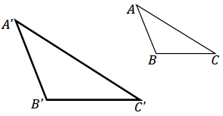

- Use the figure below with center $O$ and a scale factor of $r=\frac{5}{2}$ to create a scale drawing. Verify that the resulting figure is in fact a scale drawing by showing that corresponding side lengths are in constant proportion and that the corresponding angles are equal in measurement.
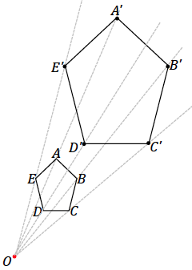
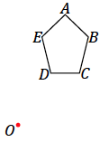

Verification of the enlarged figure should show that the length of each segment in the scale drawing is $2.5$ times the length of each segment in the original figure, e.g., $A^{'}B^{'}=2.5(AB)$. The angle measurements are $m∠A=94°$, $m∠B=118°$, $m∠C=105°$, $m∠D=105°$, and $m∠E=118°$.

- Summarize the steps to create a scale drawing by the ratio method. Be sure to describe all necessary parameters to use the ratio method.
To use the ratio method to create a scale drawing, the problem must provide a polygonal figure, a center $O$, and a scale factor. To begin the ratio method, draw a ray that originates at $O$ and passes through each vertex of the figure. We are dilating each vertex along its respective ray. Measure the distance between $O$ and a vertex and multiply it by the scale factor. The resulting value is the distance away from $O$ at which the scaled point will be located. Once all the vertices are dilated, they should be joined in the same way as they are joined in the original figure.

- A clothing company wants to print the face of the Statue of Liberty on a T-shirt. The length of the face from the top of the forehead to the chin is $17$ feet and the width of the face is $10$ ft. Given that a medium sized T-shirt has a length of $29$ in and a width of $20$ in, what dimensions of the face are needed to produce a scaled version that will fit on the T-shirt?
  - What shape would you use to model the face of the statue?
Answers may vary. Students may say triangle, rectangle or circle.

  - Knowing that the maximum width of the T-shirt is $20$ in, what scale factor is needed to make the width of the face fit on the shirt?
Answers may vary. Sample response shown below.
$$\frac{20}{120}=\frac{1}{6}$$
The width of the face on the T-shirt will need to be scaled to $\frac{1}{6}$ the size of the statues face.

  - What scale factor should be used to scale the length of the face? Explain.
Answers may vary. Students should respond that the scale factor identified in part (b) should be used for the length.
To keep the length of the face proportional to the width, a scale factor of $\frac{1}{6}$ should be used.

  - Using the scale factor identified in part (c), what is the scaled length of the face? Will it fit on the shirt?
Answers may vary.
$$\frac{1}{6}\left(204\right)=34$$
The scaled length of the face would be $34$ in. The length of the shirt is only $29$ in so the face will not fit on the shirt.

  - Identify the scale factor you would use to ensure that the face of the statue was in proportion and would fit on the T-shirt. Identify the dimensions of the face that will be printed on the shirt.
Answers may vary. Scaling by a factor of $\frac{1}{7}$ produces dimensions that are still too large to fit on the shirt. The largest scale factor that could be used is $\frac{1}{8}$ producing a scaled width of $15$ in and a scaled length of $25.5$ inches.

  - The T-shirt company wants the width of the face to be no smaller than $10$ inches. What scale factors could be used to create a scaled version of the face that meets this requirement?
Scale factors of $\frac{1}{8},\frac{1}{9},\frac{1}{10},\frac{1}{11}$ or $\frac{1}{12}$ could be used to ensure the width of the face is no smaller than $10$ inches.

  - If it costs the company $\$0.005$ for each square inch of print on a shirt, what is the maximum and minimum costs for printing the face of the statue of liberty on one T-shirt?
The largest scaled face would have dimensions $15×25.5$ meaning the print would cost approximately $\$1.91$ per shirt. The smallest scaled face would have dimensions $10×17$ meaning the print would cost $\$0.85$ per shirt.
- Create your own scale drawing using the ratio method. In the space below:
Scaffolding:
Figures can be made as simple or as complex as desired – a triangle will involve fewer segments to keep track of than a figure such as the arrow in Exercise 1. Students should work with a manageable figure in the allotted time frame.
  - Draw an original figure.
  - Locate and label a center of dilation $O$.
  - Choose a scale factor $r$.
  - Describe your dilation using appropriate notation.
  - Complete a scale drawing using the ratio method.
Show all measurements and calculations to confirm that the new figure is a scale drawing. The work here will be your answer key.
Next, trace your original figure onto a fresh piece of paper. Trade the traced figure with a partner. Provide your partner with the dilation information. Each partner should complete the other’s scale drawing. When finished, check all work for accuracy against your answer key.
MP.3
Answers will vary. Encourage students to check each other’s work and to discover the reason for any discrepancies found between the author’s answers and the partner’s answers.

Closing (2 minutes)
Ask students to summarize the key points of the lesson. Additionally, consider asking students the following questions independently in writing, to a partner, or to the whole class.
- To create a scale drawing using the ratio method, each vertex of the original figure is dilated about the center $O$ by scale factor $r$. Once all the vertices are dilated, they are joined to each other in the same way as in the original figure.
- The scale factor tells us whether the scale drawing is being enlarged ($r>1$) or reduced ($0<r<1$).
- How can it be confirmed that what is drawn by the ratio method is in fact a scale drawing?
  - By measuring the side lengths of the original figure and the scale drawing, we can establish whether the corresponding sides are in constant proportion. We can also measure corresponding angles and determine whether they are equal in measure. If the side lengths are in constant proportion and the corresponding angle measurements are equal, the new figure is in fact a scale drawing of the original.
- It is important to note that though we have dilated the vertices of the figures for the ratio method, we do not definitively know if each segment is dilated to the corresponding segment in the scale drawing. This remains to be seen. We cannot be sure of this even if the scale drawing is confirmed to be a well-scaled drawing. We learn how to determine this in the next few lessons.

Exit Ticket (5 minutes)
Name Date
Lesson 2: Making Scale Drawings Using the Ratio Method

Exit Ticket

One of the following images shows a well-scaled drawing of $△ABC$ done by the ratio method; the other image is not a well-scaled drawing. Use your ruler and protractor to measure and calculate to justify which is a scale drawing and which is not.

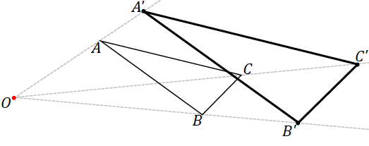
Figure 1

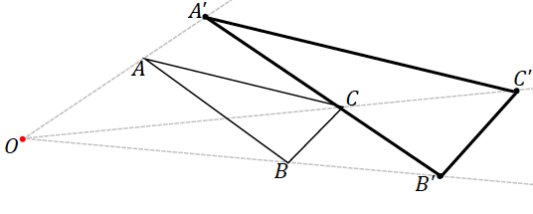
Figure 2

Exit Ticket Sample Solutions

One of the following images shows a well-scaled drawing of $△ABC$ done by the ratio method; the other image is not a well-scaled drawing. Use your ruler and protractor to make the necessary measurements and show the calculations that determine which is a scale drawing and which is not.
Figure 1
Figure 2

Figure 1 shows the true scale drawing.
$△ABC$ angle measurements of $△ABC$: $m∠A=22°$, $m∠B=100°$, $m∠C=58°$, which are the same for $△A'B'C'$ in Figure 1. The ratios of $A^{'}:A$, $B^{'}:B$, and $C^{'}:C$ are the same.
$△A'B'C'$ in Figure 2 has angle measurements $m∠A=20°$, $m∠B^{'}=99°$, $m∠C^{'}=61°$, and the ratios of $A^{'}:A$, $B^{'}:B$, and $C^{'}:C$ are not the same.

Problem Set Sample Solutions
Considering the significant construction needed for the Problem Set questions, teachers may feel that a maximum of three questions is sufficient for a homework assignment. It is up to the teacher to assign what is appropriate for the class.

- Use the ratio method to create a scale drawing about center $O$ with a scale factor of $r=\frac{1}{4}$. Use a ruler and protractor to verify that the resulting figure is in fact a scale drawing by showing that corresponding side lengths are in constant proportion and the corresponding angles are equal in measurement.
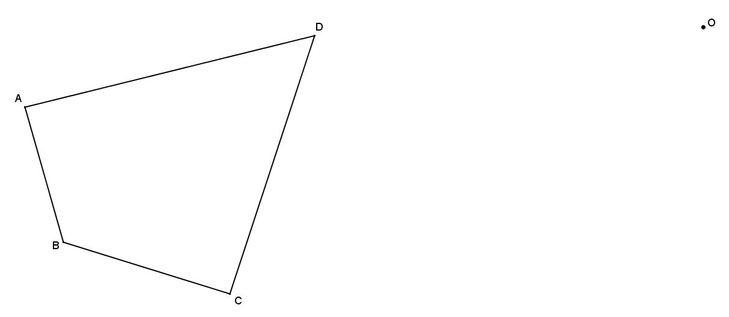
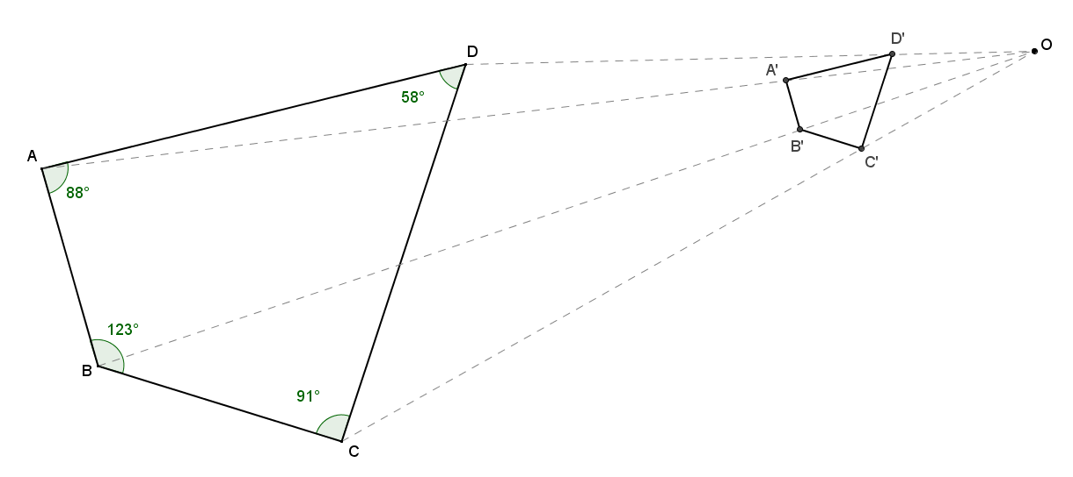

The measurements in the figure are $m∠A=88°$,$m∠B=123°$,$m∠C=91°$, and $m∠D=58°$. All side length measurements of the scale drawing should be in the constant ratio of $1:4$.

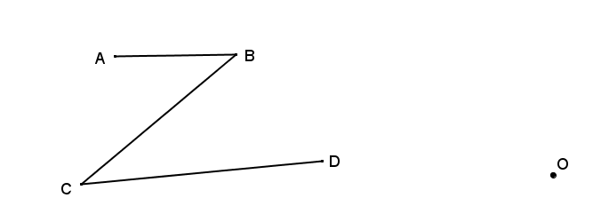
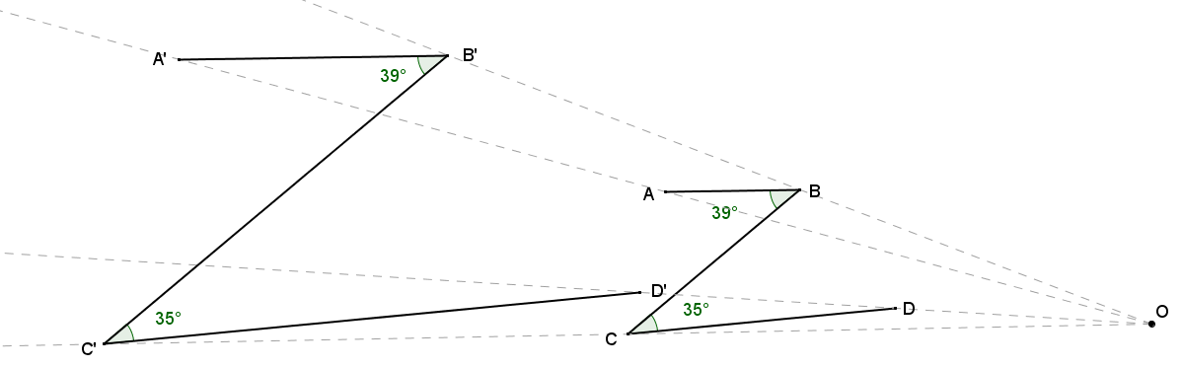
- Use the ratio method to create a scale drawing about center $O$ with a scale factor of $r=2$. Verify that the resulting figure is in fact a scale drawing by showing that corresponding side lengths are in constant proportion and that the corresponding angles are equal in measurement.

The measurements in the figure are $m∠B=39°$ and$m∠C=35°$. All side length measurements of the scale drawing should be in the constant ratio of $2:1$.

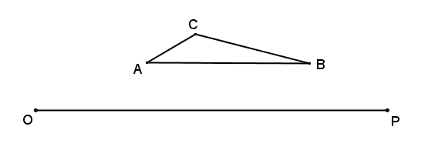
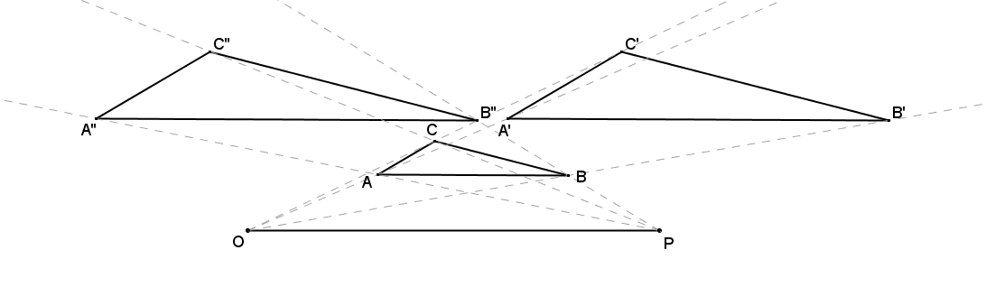
- Use the ratio method to create two scale drawings: $D_{O,2}$ and $D_{P,2}$. Label the scale drawing with respect to center $O$ as $△A'B'C'$ and the scale drawing with respect to center $P$ as $△A''B''C''$.
What do you notice about the two scale drawings?
They are both congruent since each was drawn with the same scale factor.
What rigid motion can be used to map $△A'B'C'$ onto $△A''B''C''$?
Answers may vary. For example, a translation by vector $\vec{A^{'}A''}$ is acceptable.
- Sara found a drawing of a triangle that appears to be a scale drawing. Much of the drawing has faded, but she can see the drawing and construction lines in the diagram below. If we assume the ratio method was used to construct $△A'B'C'$ as a scale model of $△ABC$, can you find the center $O$, the scale factor $r$, and locate $△ABC$?
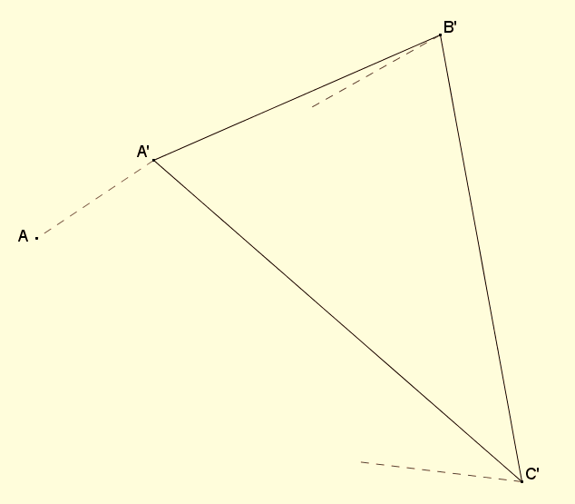

Extend ray $A'A$ and the partial ray drawn from either $B'$ or $C'$. The point where they intersect is center $O$.
$\frac{OA^{'}}{OA}=\frac{3}{2}$; the scale factor is $\frac{3}{2}$. Locate $B$ $\frac{2}{3}$ of the distance from $O$ to $B'$ and $C$ $\frac{2}{3}$ of the way from $O$ to $C'$. Connect the vertices to show original $△ABC$.
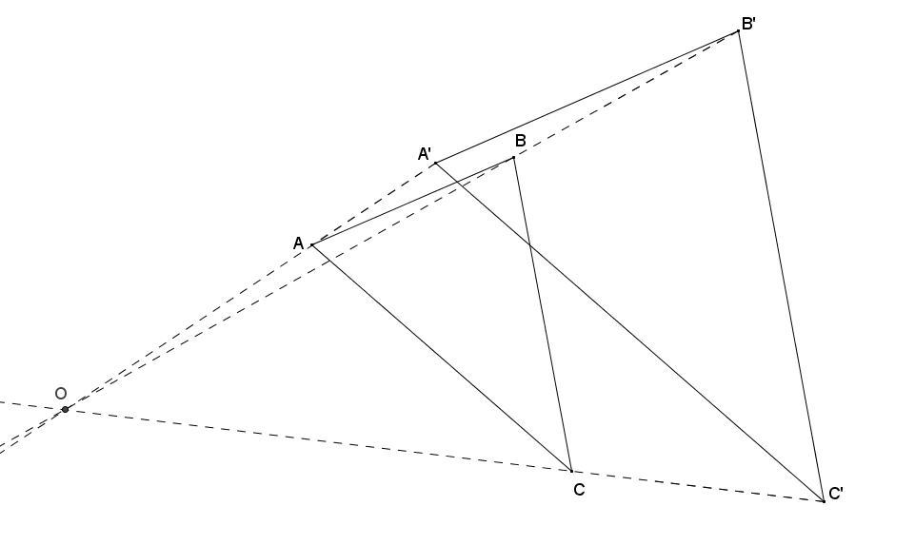

- Quadrilateral $A'''B'''C'''D'''$ is one of a sequence of three scale drawings of quadrilateral $ABCD$ that were all constructed using the ratio method from center $O$. Find the center $O$, each scale drawing in the sequence and the scale factor for each scale drawing. The other scale drawings are quadrilaterals $A'B'C'D'$ and $A''B''C''D''$.
Note to the Teacher: You may choose to simplify this diagram by joining vertices $D'''$ and $B'''$, forming a triangle.
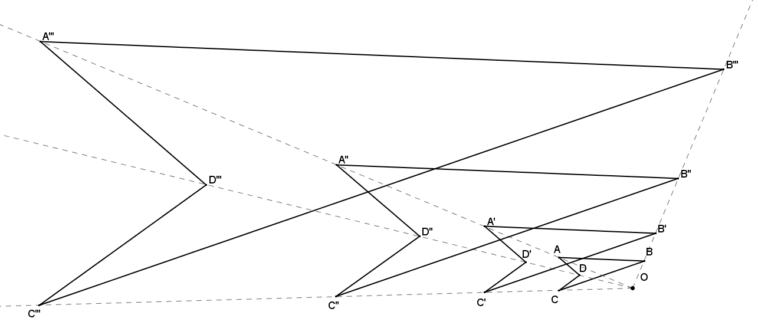
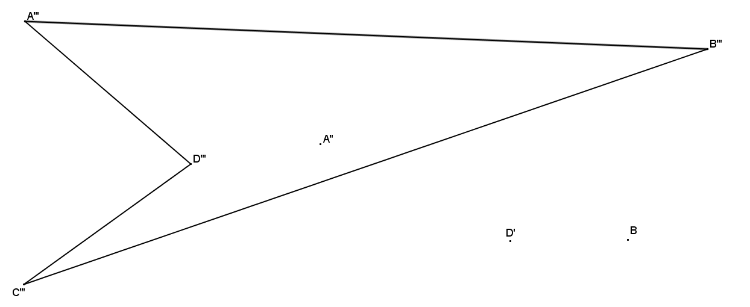
Each scale drawing is created from the same center point, so the corresponding vertices of the scale drawings should align with the center $O$. Draw any two of $\overline{A'''A''}$, $\overline{D'''D'}$, or $\overline{B'''B}$ to find center $O$ at their intersection.

The ratio of $OA^{''}:OA$ is $4:1$, so the scale factor of figure $A''B''C''D''$ is $4$.
The ratio of $OD':OD$ is $2:1$, so the scale factor of figure $A'B'C'D'$ is $2$.
The ratio of $OB^{'''}:OB$ is $8:1$, so the scale factor of figure $A'''B'''C'''D'''$ is $8$.

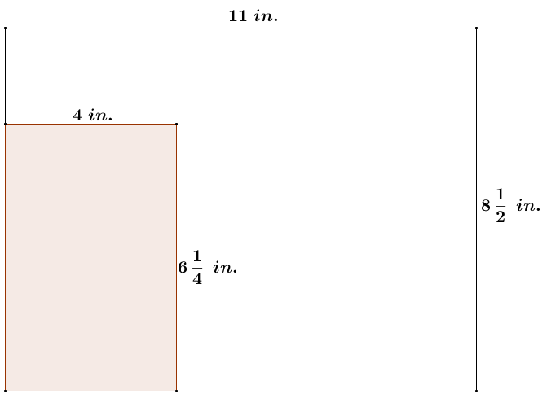
- Maggie has a rectangle drawn in the corner of a $8\frac{1}{2}$ inch by $11$ inch sheet of printer paper as shown in the diagram. To cut out the rectangle, Maggie must make two cuts. She wants to scale the rectangle so that she can cut it out using only one cut with a paper cutter.
  - What are the dimensions of Maggie’s scaled rectangle and what is its scale factor from the original rectangle?
If the rectangle is scaled from the corner of the paper at which it currently sits, the maximum height of the rectangle will be $8\frac{1}{2}$ inches.
$$k=\frac{8\frac{1}{2}}{6\frac{1}{4}}=\frac{34}{25}$$
The scale factor to the enlarged rectangle is $\frac{34}{25}$.
$$y=\frac{34}{25}\left(4\right)$$
$$y=\frac{136}{25}=5.44$$
Using the scale factor, the width of the scaled rectangle is $5.44$ inches.

  - After making the cut for the scaled rectangle, is there enough material left to cut another identical rectangle? If so, what is the area of scrap per sheet of paper?
The total width of the sheet of paper is $11$ inches, which is more than $2\left(5.44 inches\right)=10.88 inches$, so yes, there is enough material to get two identical rectangles from one sheet of paper. The resulting scrap strip measures $8\frac{1}{2}$ inches by $0.12$ inches, giving a scrap area of $1.02 in^{2}$ per sheet of paper.

