Lesson 2: Making Scale Drawings Using the Ratio Method

Classwork
Opening Exercise
Based on what you recall from Grade 8, describe what a dilation is.

Example 1
Create a scale drawing of the figure below using the ratio method about center $O$ and scale factor $r=\frac{1}{2}$.
Step 1. Draw a ray beginning at $O$ through each vertex of the figure.
Step 2. Dilate each vertex along the appropriate ray by scale factor $r=\frac{1}{2}$. Use the ruler to find the midpoint between $O$ and $D$ and then each of the other vertices. Label each respective midpoint with prime notation, i.e., $D’$.
Step 3. Join vertices in the way they are joined in the original figure, e.g., segment $A'B'$ corresponds to segment $AB$.

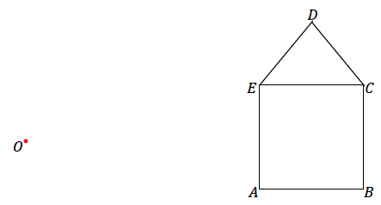

Exercise 1
- Create a scale drawing of the figure below using the ratio method about center $O$ and scale factor $r=\frac{3}{4}$. Verify that the resulting figure is in fact a scale drawing by showing that corresponding side lengths are in constant proportion and the corresponding angles are equal in measurement.

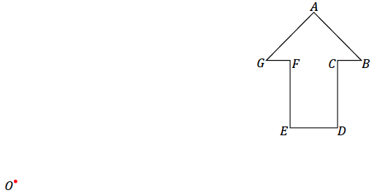

Example 2
  - Create a scale drawing of the figure below using the ratio method about center $O$ and scale factor $r=3$.
Step 1. Draw a ray beginning at $O$ through each vertex of the figure.
Step 2. Use your ruler to determine the location of $A'$ on $\vec{OA}$; $A'$ should be three times as far from $O$ as $A$. Determine the locations of $B'$ and $C'$ in the same way along the respective rays.
Step 3. Draw the corresponding line segments, e.g., segment $A'B'$ corresponds to segment $AB$.

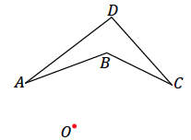
  - Locate a point $X$ so that it lies between endpoints $A$ and $B$ on segment $AB$ of the original figure in part (a). Use the ratio method to locate $X'$ on the scale drawing in part (a).

  - Imagine a dilation of the same figure as in parts (a) and (b). What if the ray from the center passed through two distinct points, such as $B$ and $D$ below? What does that imply about the locations of $B'$ and $D'$?

Exercises 2–6
- $△A'B'C'$ is a scale drawing of $△ABC$ drawn by using the ratio method. Use your ruler to determine the location of the center $O$ used for the scale drawing.

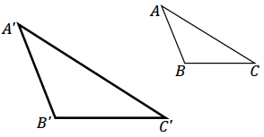

- Use the figure below with center $O$ and a scale factor of $r=\frac{5}{2}$ to create a scale drawing. Verify that the resulting figure is in fact a scale drawing by showing that corresponding side lengths are in constant proportion and that the corresponding angles are equal in measurement.

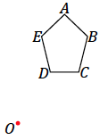

- Summarize the steps to create a scale drawing by the ratio method. Be sure to describe all necessary parameters to use the ratio method.

- A clothing company wants to print the face of the Statue of Liberty on a T-shirt. The length of the face from the top of the forehead to the chin is $17$ feet and the width of the face is $10$ ft. Given that a medium sized T-shirt has a length of $29$ in and a width of $20$ in, what dimensions of the face are needed to produce a scaled version that will fit on the T-shirt?
  - What shape would you use to model the face of the statue?

  - Knowing that the maximum width of the T-shirt is $20$ in, what scale factor is needed to make the width of the face fit on the shirt?

  - What scale factor should be used to scale the length of the face? Explain.

  - Using the scale factor identified in part (c), what is the scaled length of the face? Will it fit on the shirt?

  - Identify the scale factor you would use to ensure that the face of the statue was in proportion and would fit on the T-shirt. Identify the dimensions of the face that will be printed on the shirt.

  - The T-shirt company wants the width of the face to be no smaller than $10$ inches. What scale factors could be used to create a scaled version of the face that meets this requirement?

  - If it costs the company $\$0.005$ for each square inch of print on a shirt, what is the maximum and minimum costs for printing the face of the statue of liberty on one T-shirt?

- Create your own scale drawing using the ratio method. In the space below:
  - Draw an original figure.
  - Locate and label a center of dilation $O$.
  - Choose a scale factor $r$.
  - Describe your dilation using appropriate notation.
  - Complete a scale drawing using the ratio method.
Show all measurements and calculations to confirm that the new figure is a scale drawing. The work here will be your answer key.
Next, trace your original figure onto a fresh piece of paper. Trade the traced figure with a partner. Provide your partner with the dilation information. Each partner should complete the other’s scale drawing. When finished, check all work for accuracy against your answer key.

Problem Set
Lesson Summary
- To create a scale drawing using the ratio method, each vertex of the original figure is dilated about the center $O$ by scale factor $r$. Once all the vertices are dilated, they are joined to each other in the same way as in the original figure.
- The scale factor tells us whether the scale drawing is being enlarged ($r>1$) or reduced ($0<r<1$).

- Use the ratio method to create a scale drawing about center $O$ with a scale factor of $r=\frac{1}{4}$. Use a ruler and protractor to verify that the resulting figure is in fact a scale drawing by showing that corresponding side lengths are in constant proportion and the corresponding angles are equal in measurement.

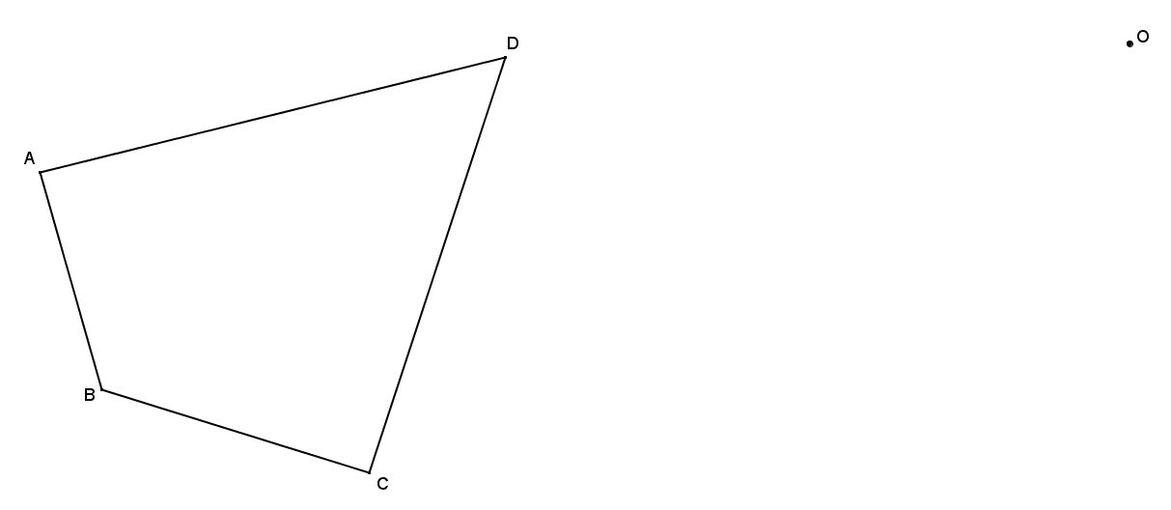

- Use the ratio method to create a scale drawing about center $O$ with a scale factor of $r=2$. Verify that the resulting figure is in fact a scale drawing by showing that corresponding side lengths are in constant proportion and that the corresponding angles are equal in measurement.

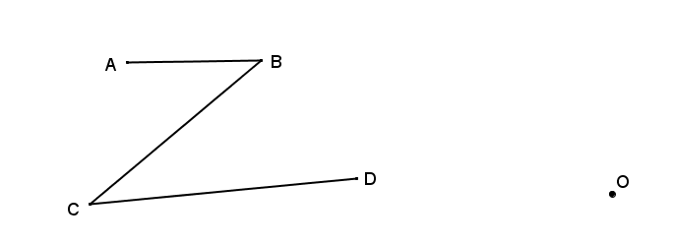
- Use the ratio method to create two scale drawings: $D_{O,2}$ and $D_{P,2}$. Label the scale drawing with respect to center $O$ as $△A'B'C'$ and the scale drawing with respect to center $P$ as $△A''B''C''$.

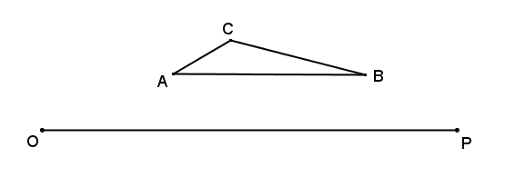

What do you notice about the two scale drawings?

What rigid motion can be used to map $△A'B'C'$ onto $△A''B''C''$?

- Sara found a drawing of a triangle that appears to be a scale drawing. Much of the drawing has faded, but she can see the drawing and construction lines in the diagram below. If we assume the ratio method was used to construct $△A'B'C'$ as a scale model of $△ABC$, can you find the center $O$, the scale factor $r$, and locate $△ABC$?
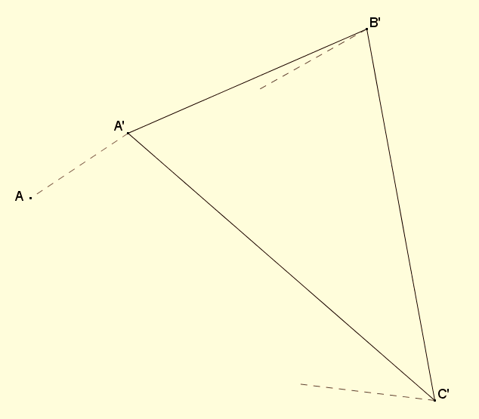

- Quadrilateral $A'''B'''C'''D'''$ is one of a sequence of three scale drawings of quadrilateral $ABCD$ that were all constructed using the ratio method from center $O$. Find the center $O$, each scale drawing in the sequence and the scale factor for each scale drawing. The other scale drawings are quadrilaterals $A'B'C'D'$ and $A''B''C''D''$.
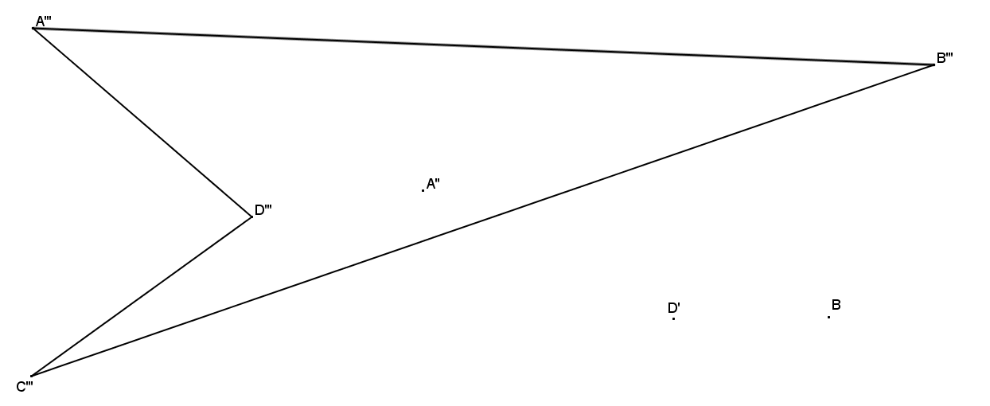

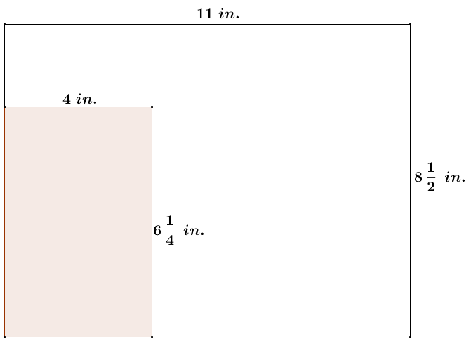
- Maggie has a rectangle drawn in the corner of a $8\frac{1}{2}$ inch by $11$ inch sheet of printer paper as shown in the diagram. To cut out the rectangle, Maggie must make two cuts. She wants to scale the rectangle so that she can cut it out using only one cut with a paper cutter.
  - What are the dimensions of Maggie’s scaled rectangle and what is its scale factor from the original rectangle?
  - After making the cut for the scaled rectangle, is there enough material left to cut another identical rectangle? If so, what is the area of scrap per sheet of paper?

