Lesson 1: Scale Drawings

Student Outcomes
- Students review properties of scale drawings and are able to create them.

Lesson Notes
Lesson 1 reviews the properties of a scale drawing before studying the relationship between dilations and scale drawings in Lessons 2 and 3. Students focus on scaling triangles using construction tools and skills learned in Module 1. The lesson begins by exploring how to scale images using common electronics. After students work on scaling triangles given various pieces of initial information, we tie it all together by showing how triangle scaling can be used in programming a phone to scale a complex image.
Note that students first studied scale drawings in Grade 7 (Module 1, Lessons 16–22). Teachers may need to modify the exercises to include use of graph paper, patty paper, and geometry software (e.g., freely available Geogebra) to make the ideas accessible.

Classwork
Opening (2 minutes)
- A common feature on cell phones and tablets is the ability to scale, that is, to enlarge or reduce an image by putting a thumb and index finger to the screen and making a pinching (to reduce) or spreading movement (to enlarge) as shown in the diagram below.

- Notice that as the fingers move outward on the screen (shown on the right), the image of the puppy is enlarged on the screen.
- How did the code for this feature get written? What general steps must the code dictate?
- Today we will review a concept that is key to tackling these questions.

Opening Exercise (2 minutes)
Opening Exercise
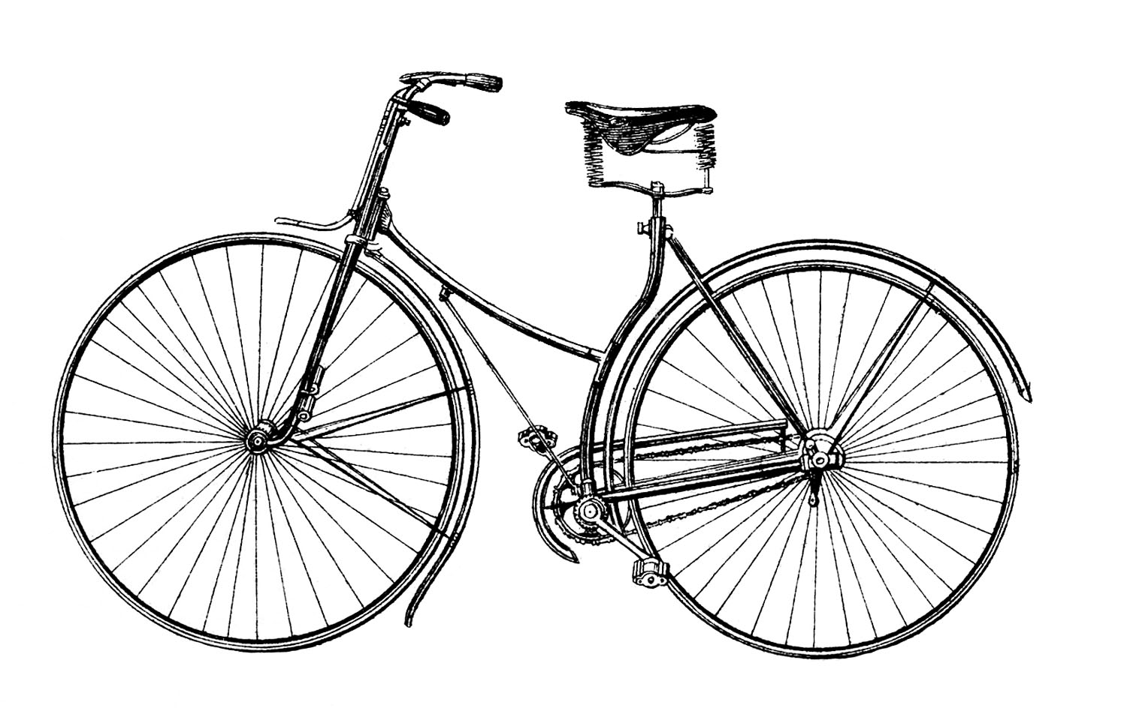
Above is a picture of a bicycle. Which of the images below appears to be a well-scaled image of the original? Why?
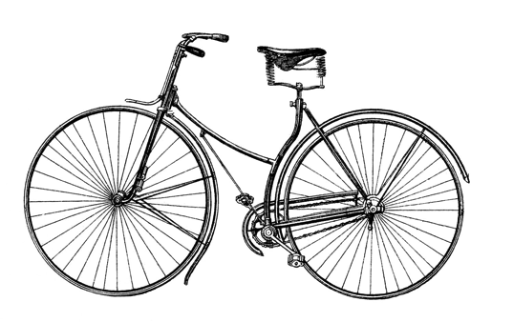

Only the third image appears to be a well-scaled image since the image is in proportion to the original.

As mentioned in the Lesson Notes, students have seen scale drawings in Grades 4 and 7. The Opening Exercise is kept brief to reintroduce the idea of what it means to be “well-scaled” without going into great depth yet.
After the Opening Exercise, refer to the Opening, and re-pose the initial intent. Several questions are provided to help illustrate the pursuit of the lesson. The expectation is not to answer these questions now but to keep them in mind as the lesson progresses.
- How did the code to scale images get written? What kinds of instructions guide the scaling process? What steps take an original figure to a scale drawing? How is the program written to make sure that images are well-scaled and not distorted?

To help students answer these questions, we simplify the problem by examining the process of scaling a simpler figure: a triangle. After tackling this simpler problem, we can revisit the more complex images.
Example 1 (8 minutes)
Example 1 provides students with a triangle and a scale factor. Students use a compass and straightedge to create the scale drawing of the triangle.
Scaffolding:
- One way to facilitate Example 1 is to use graph paper, with $△ABC$ located at $A(-3,-2)$, $B(5,-2)$, and $C(-3,6)$.
- An alternative challenge is to use a scale of $r=\frac{1}{2}$.
Example 1
Use construction tools to create a scale drawing of $△ABC$ with a scale factor of $r=2$.

Before students begin creating the scale drawing, review the following.
- Recall that the scale factor $r$ is the ratio of any length in a scale drawing relative to its corresponding length in the original figure. A scale factor $r>1$ results in an enlargement of the original figure. A scale factor of $0<r<1$ results in a reduction of the original figure.
For further background information, refer to Grade 7 (Module 1, Lesson 17).
- Since we know that a scale drawing can be created without concern for location, a scale drawing can be done in two ways: (1) by drawing it so that one vertex coincides with its corresponding vertex, leaving some overlap between the original triangle and the scale drawing and (2) by drawing it completely independent of the original triangle. Two copies of the original triangle have been provided for you.

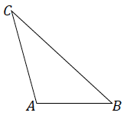
Solution 1: Draw $\vec{AB}$. To determine $B'$, adjust the compass to the length of $AB$. Then reposition the compass so that the point is at $B$ and mark off the length of $AB$; label the intersection with $\vec{AB}$ as $B'$. $C^{'}$is determined in a similar manner. Join $B'$ to $C'$.
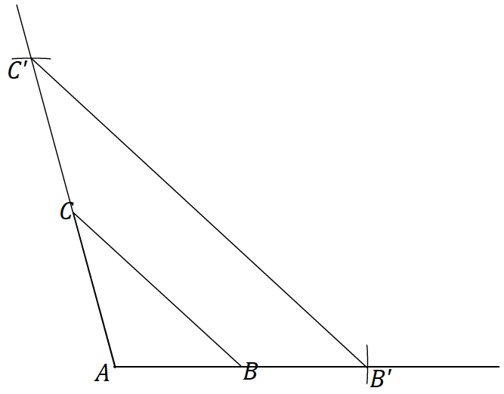
MP.5
Solution 2: Draw a segment that will be longer than double the length of ray $AB$. Label one end as $A'$. Adjust the compass to the length of $AB$ and mark off two consecutive such lengths along the segment and label the endpoint as $B'$. Copy $∠A$. Determine $C'$ along the ray $\vec{AC}$ in the same way as $B'$. Join $B'$ to $C'$.
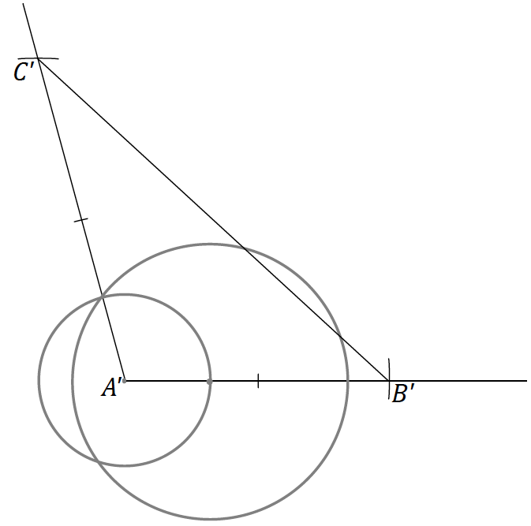
MP.5

- Why do both solutions yield congruent triangles? Both triangles begin with the same criteria: Two pairs of sides that are equal in length and a pair of included angles that are equal in measurement. By SAS, a unique triangle is determined. Since $△ABC$ was scaled by a factor of $2$ in each case, the method in which we scale will not change the outcome; that is, we will have a triangle with the same dimensions whether we position it on top of or independent of the original triangle.
- Regardless of which solution method you used, measure the length of $BC$ and $B'C'$. What do you notice?
  - $B'C'$ is twice the length of $BC$.
- Now measure the angles $∠B$, $∠C$, $∠B'$, and $∠C'$. What do you notice?
  - The measurements of $∠B$ and $∠B'$ are the same, as are $∠C$ and $∠C'$.

Discussion (3 minutes)
- What are the properties of a well-scaled drawing of a figure?
  - A well-scaled drawing of a figure is one where corresponding angles are equal in measure and corresponding lengths are all in the same proportion.
- What is the term for the constant of proportionality by which all lengths are scaled in a well-scaled drawing?
  - The scale factor is the constant of proportionality.
- If somewhere else on your paper you created the scale drawing in Example 1 but oriented at a different angle, would the drawing still be a scale drawing?
  - Yes. The orientation of the drawing does not change the fact that it is a scaled drawing; the properties of a scale drawing concern only lengths and relative angles.
Reinforce this by considering the steps of Solution 2 in Example 1. The initial segment can be drawn anywhere, and the steps following can be completed as is. Ensure that students understand and rehearse the term orientation and record a student-friendly definition.

- Return to the three images of the original bicycle. Why are the first two images classified as not well-scaled?
  - The corresponding angles are not equal in measurement, and the corresponding lengths are not in constant proportion.

Exercise 1 (4 minutes)
Students scale a triangle by a factor of $r=3$ in Exercise 1. Either of the above solution methods is acceptable. As students work on Exercise 1, take time to circulate and check for understanding. Note that teachers may choose to provide graph paper and have students create scale drawings on it.
Exercise 1
Use construction tools to create a scale drawing of $△DEF$ with a scale factor of $r=3$. What properties does your scale drawing share with the original figure? Explain how you know.
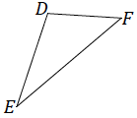
By measurement, I can see that each side is three times the length of the corresponding side of the original figure and that all three angles are equal in measurement to the three corresponding angles in the original figure.

Make sure students understand that any of these diagrams are acceptable solutions.

A solution where $ED'$ and $EF'$ are drawn first.  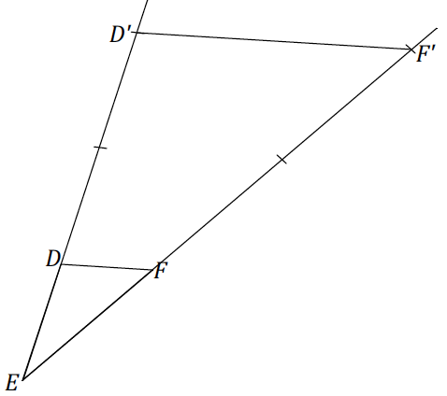 | A solution where $FE'$ and $FD'$ are drawn first.  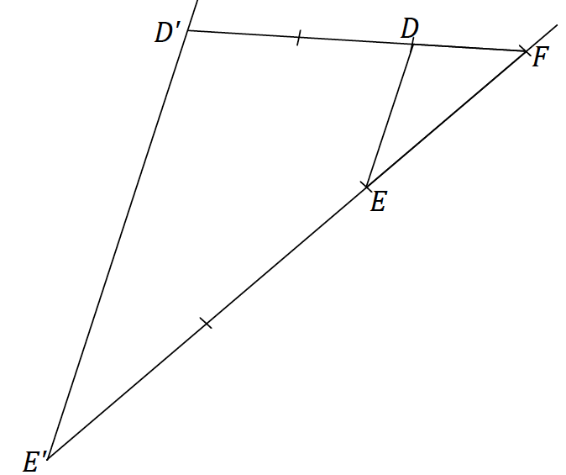

A solution where $DE'$ and $DF'$ are drawn first.

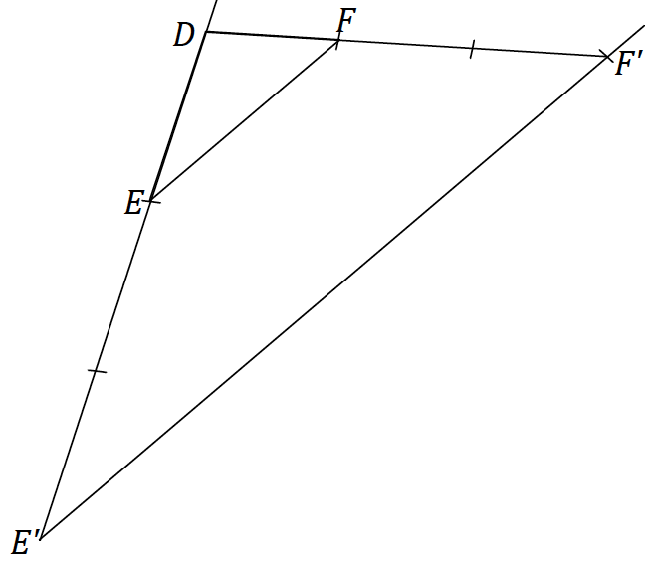

Example 2 (4 minutes)
Example 2 provides a triangle and a scale factor of $r=\frac{1}{2}$. Students will use a compass to locate the midpoint.
Example 2
Use construction tools to create a scale drawing of $△XYZ$ with a scale factor of $r=\frac{1}{2}$.
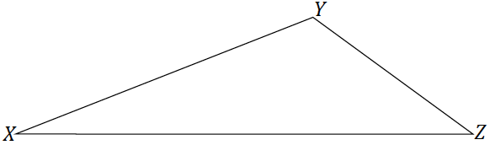

- Which construction technique have we learned that can be used in this question that was not used in the previous two problems?
  - We can use the construction to determine the perpendicular bisector to locate the midpoint of two sides of $△XYZ$.
Scaffolding:
For students struggling with constructions, consider having them measure the lengths of two sides and then determine the midpoints.
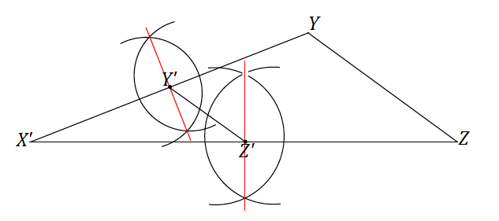
As the solutions to Exercise 1 showed, the constructions can be done on other sides of the triangle, i.e., the perpendicular bisectors of $YZ$ and $XZ$ are acceptable places to start.

Exercises 2–4 (13 minutes)
Have students complete Exercise 2 and, if time allows, go on to Exercises 3 and 4. In Exercise 2, using a scale factor of $r=\frac{1}{4}$ is a natural progression following the use of a scale factor of $r=\frac{1}{2}$ in Example 1. Prompt students to consider how $\frac{1}{4}$ relates to $\frac{1}{2}$. They should recognize that the steps of the construction in Exercise 2 are similar to those in Example 1.
Exercises 2–4
Scaffolding:
For students who are ready for a challenge, consider asking them to use a scale factor of $r=\frac{3}{4}.$
- Use construction tools to create a scale drawing of $△PQR$ with a scale factor of $r=\frac{1}{4}.$ What properties do the scale drawing and the original figure share? Explain how you know.
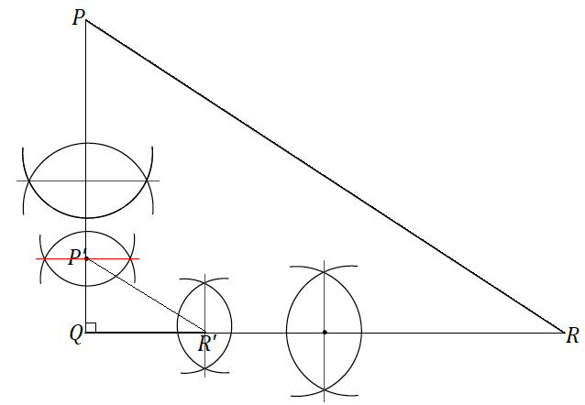

By measurement, I can see that all three sides are each one quarter the lengths of the corresponding sides of the original figure, and all three angles are equal in measurement to the three corresponding angles in the original figure.

- Triangle $EFG$ is provided below, and one angle of scale drawing $△E'F'G'$ is also provided. Use construction tools to complete the scale drawing so that the scale factor is $r=3$. What properties do the scale drawing and the original figure share? Explain how you know.
Extend either ray from $G'$. Use the compass to mark off a length equal to $3EG$ on one ray and a length equal to $3FG$ on the other. Label the ends of the two lengths $E'$ and $F'$, respectively. Join $E'$ to $F'$.

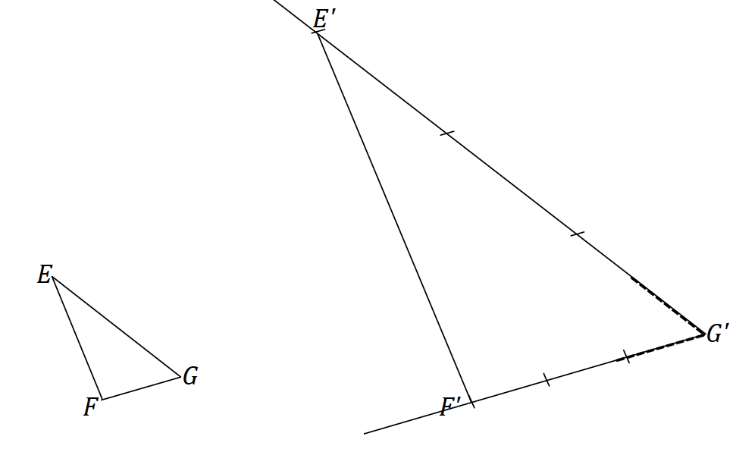

By measurement, I can see that each side is three times the length of the corresponding side of the original figure and that all three angles are equal in measurement to the three corresponding angles in the original figure.

- Triangle $ABC$ is provided below, and one side of scale drawing $△A'B'C'$ is also provided. Use construction tools to complete the scale drawing and determine the scale factor.
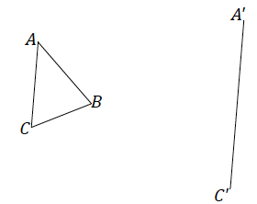
Scaffolding:
- If students struggle with constructing an angle of equal measure, consider allowing them to use a protractor to measure angles $A$ and $C$, and draw angles at $A'$ and $C'$, respectively, with equal measures. This will alleviate time constraints; however, know that constructing an angle is a necessary skill to be addressed in remediation.
- Use patty paper or geometry software to allow students to focus on the concept development.

One possible solution: We can copy $∠A$ and $∠C$ at points $A'$ and $C'$ so that the new rays intersect as shown and call the intersection point $B'$. By measuring, we can see that $A^{'}C^{'}=2AC$, $A^{'}B^{'}=2AB$, and $B^{'}C^{'}=2BC$. We already know that $∠A^{'}=∠A$ and $∠C^{'}=∠C$. By the triangle sum theorem, $∠B^{'}=∠B$.

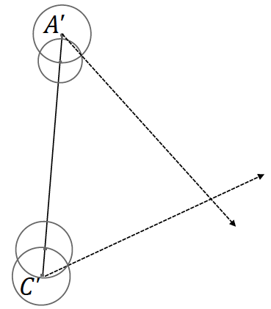
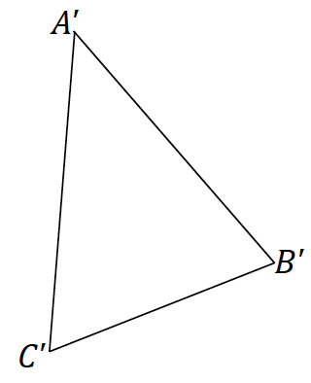
Discussion (3 minutes)
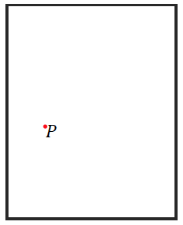
- In the last several exercises, we constructed or completed scale drawings of triangles, provided various pieces of information. We now return to the question that began the lesson.
- What does the work we did with scaled triangles have to do with understanding the code that is written to tell a phone or a computer how to enlarge or reduce an image? Here is one possible way.
- Consider the following figure, which represents an image or perhaps a photo. A single point $P$ is highlighted in the image, which can easily be imagined to be one of many points of the image (e.g., it could be just a single point of the bicycle in the Opening Exercise).
- If we know by how much we want to enlarge or reduce the image (i.e., the scale factor), we can use what we know about scaling triangles to locate where this point will end up in the scale drawing of the image.
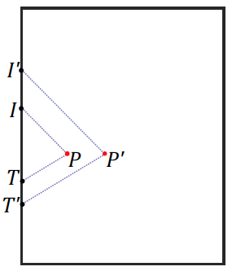
- For example, if we were to place our thumb and index finger on the points $T$ and $I$, respectively, and make the zoom-in movement so that our thumb and index finger end up at $T'$ and $I'$, respectively, the scale factor that corresponds to the zoom-in motion dictates where $P'$ will be located.
- Therefore, we can generalize how the code to enlarge or reduce an image on a phone or a tablet is written. For every point $P$ in an image, a triangle can be formed with vertices $P,T,$and$I$. Since we are able to scale triangles, we are then also able to scale entire images, point by point. In fact, we can use this process not just for the code to program electronics but also to scale a complex image by hand if we so wished.

Closing (1 minute)
- What are the key properties of a scale drawing relative to its original figure?
  - There are two properties of a scale drawing of a figure: Corresponding angles are equal in measurement, and corresponding lengths are proportional in measurement.
- If we were to take any of the scale drawings in our examples and place them in a different location or rotate them on our paper, would it change the fact that the drawing is still a scale drawing?
  - No, the properties of a scale drawing have to do with lengths and relative angles, not location or orientation.
- Provided a triangle and a scale factor or a triangle and one piece of the scale drawing of the triangle, it is possible to create a complete scale drawing of the triangle using a compass and straightedge. No matter which method is used to create the scale drawing, we rely on triangle congruence criteria to ensure that a unique triangle is determined.

Exit Ticket (5 minutes)

Name Date
Lesson 1: Scale Drawings

Exit Ticket

Triangle $ABC$ is provided below, and one side of scale drawing $△A'B'C'$ is also provided. Use construction tools to complete the scale drawing and determine the scale factor. What properties do the scale drawing and the original figure share? Explain how you know.

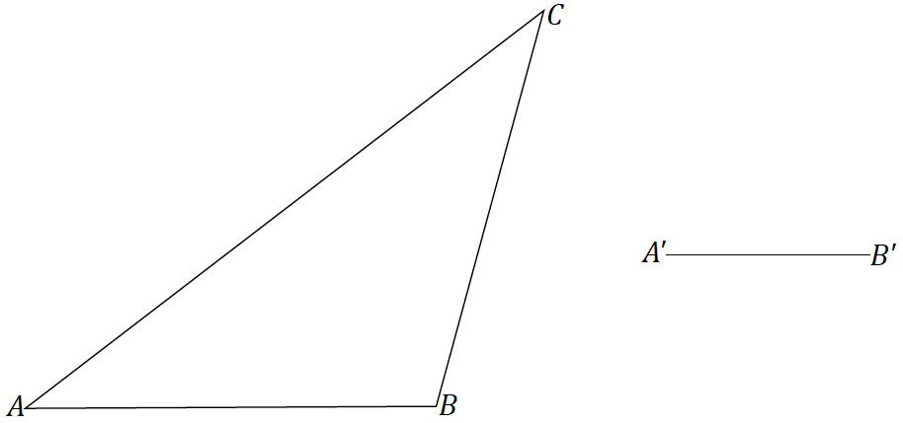

Exit Ticket Sample Solutions

Triangle $ABC$ is provided below, and one side of scale drawing $△A'B'C'$ is also provided. Use construction tools to complete the scale drawing and determine the scale factor. What properties do the scale drawing and the original figure share? Explain how you know.
One possible solution: Since the scale drawing will clearly be a reduction, use the compass to mark the number of lengths equal to the length of $A'B$’ along $AB$. Once $A'C'$ is determined to be $\frac{1}{2}$ the length of $AB$, use the compass to find a length that is half the length of $AB$ and half the length of $BC$. Construct circles with radii of lengths $\frac{1}{2}AC$ and $\frac{1}{2}BC$ from the $A'$ and $B'$respectively to determine the location of $C'$, which is at the intersection of the two circles.
By measurement, I can see that each side is $\frac{1}{2}$ the length of the corresponding side of the original figure and that all three angles are equal in measurement to the three corresponding angles in the original figure.

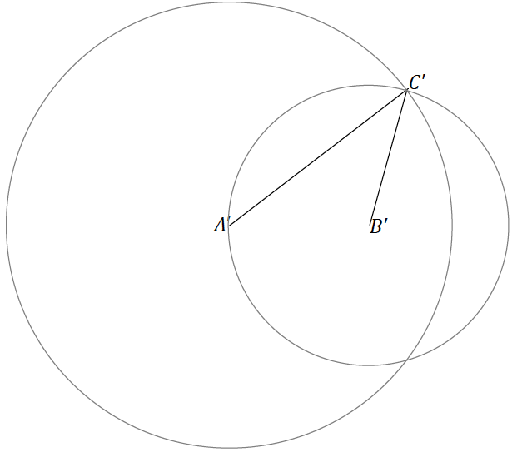

Problem Set Sample Solutions

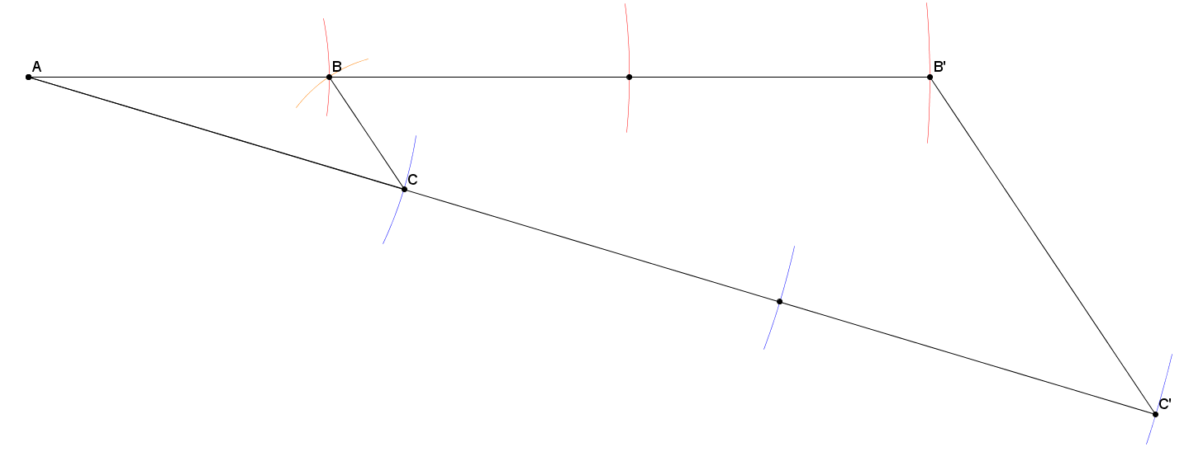
- Use construction tools to create a scale drawing of $△ABC$ with a scale factor of $r=3$.

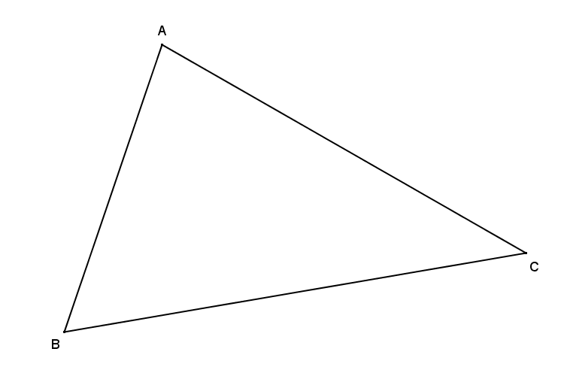
- Use construction tools to create a scale drawing of $△ABC$ with a scale factor of $r=\frac{1}{2}.$

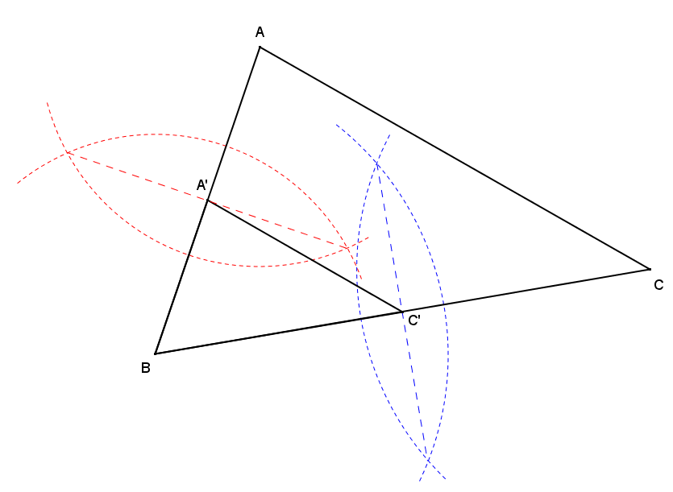

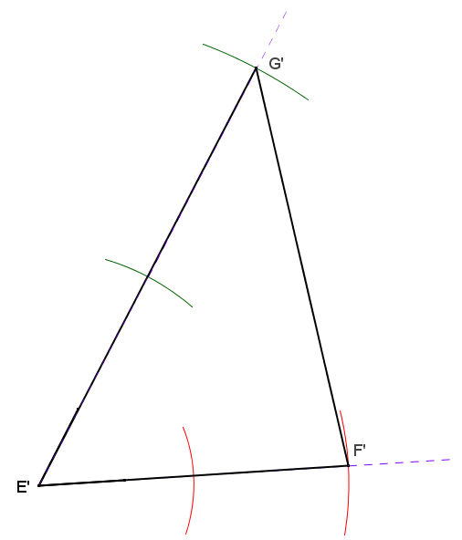
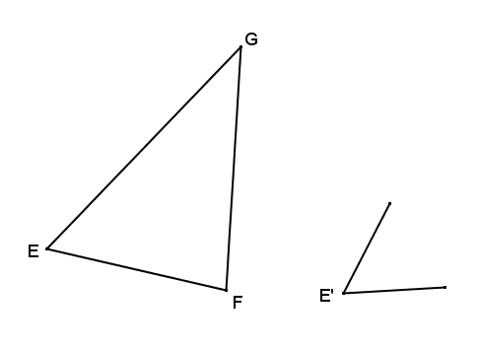
- Triangle $EFG$ is provided below, and one angle of scale drawing $△E'F'G'$ is also provided. Use construction tools to complete a scale drawing so that the scale factor is $r=2$.

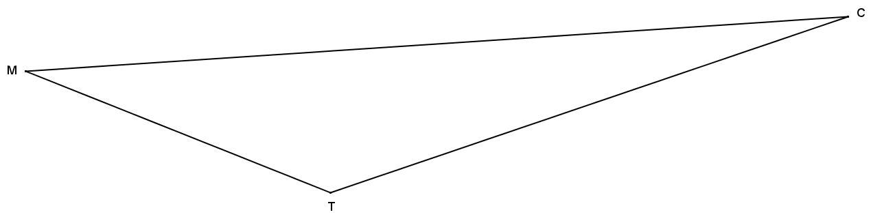
- Triangle $MTC$ is provided below, and one angle of scale drawing $△M'T'C'$ is also provided. Use construction tools to complete a scale drawing so that the scale factor is $\frac{1}{4}$ .
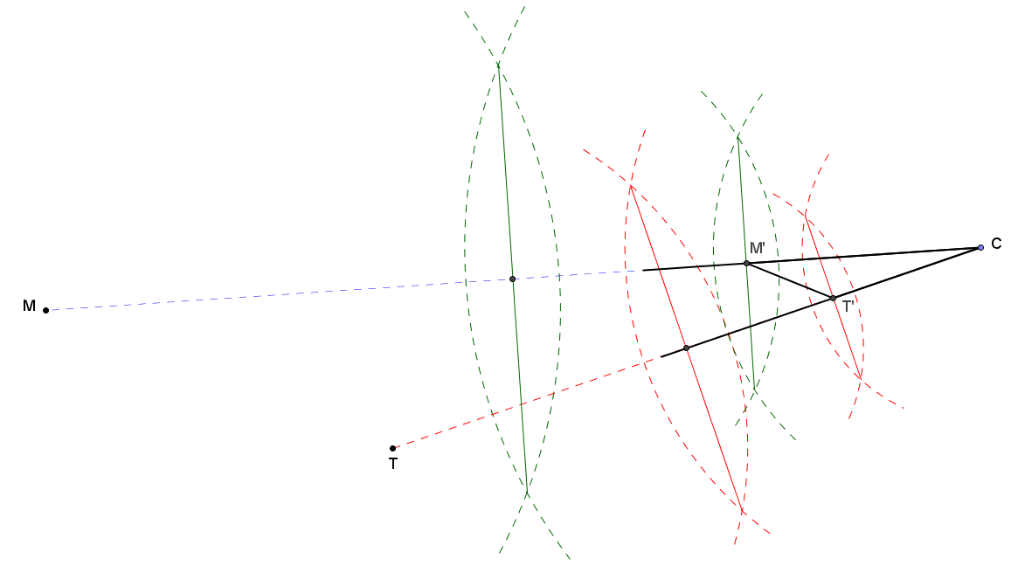

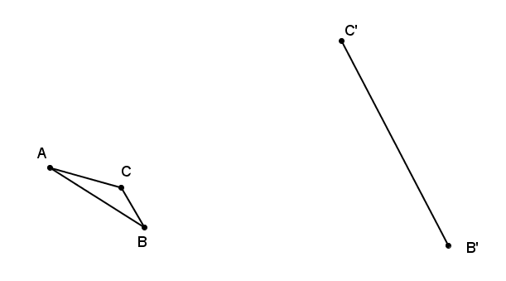
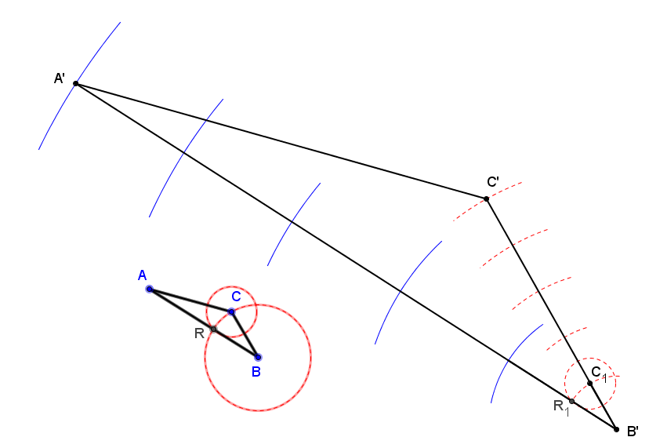
- Triangle $ABC$ is provided below, and one side of scale drawing $△A'B'C'$ is also provided. Use construction tools to complete the scale drawing and determine the scale factor.
The ratio of $B^{'}C^{'}:BC$ is $5:1$, so the scale factor is $5$.

- Triangle $XYZ$ is provided below, and one side of scale drawing $△X'Y'Z'$ is also provided. Use construction tools to complete the scale drawing and determine the scale factor.
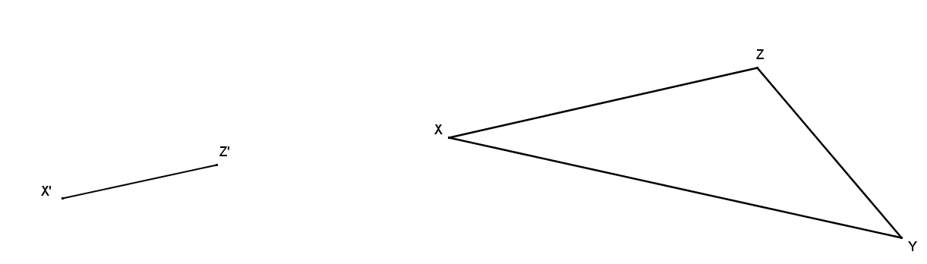
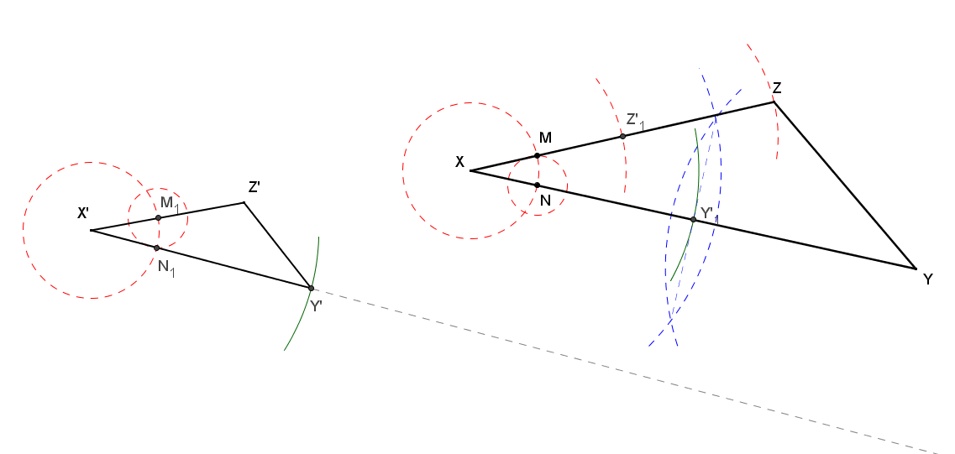
The ratio of $X^{'}Z^{'}:XZ$ is $1:2$, so the scale factor is $\frac{1}{2}$.
- Quadrilateral $GHIJ$ is a scale drawing of quadrilateral $ABCD$ with scale factor $r$. Describe each of the following statements as always true, sometimes true, or never true, and justify your answer.
  - $AB=GH$
Sometimes true, but only if $r=1$.

  - $m∠ABC=m∠GHI$
Always true because $∠GHI$ corresponds to $∠ABC$ in the original drawing, and angle measures are preserved in scale drawings.

  - $\frac{AB}{GH}=\frac{BC}{HI}$
Always true because distances in a scale drawing are equal to their corresponding distances in the original drawing times the scale factor $r$, so $\frac{AB}{GH}=\frac{AB}{r\left(AB\right)}=\frac{1}{r}$ and $\frac{BC}{HI}=\frac{BC}{r\left(BC\right)}=\frac{1}{r}$.

  - $Perimeter \left(GHIJ\right)=r∙Perimeter(ABCD)$
Always true because the distances in a scale drawing are equal to their corresponding distances in the original drawing times the scale factor $r$, so
$Perimeter\left(GHIJ\right)=GH+HI+IJ+JG$
$Perimeter\left(GHIJ\right)=r\left(AB\right)+r\left(BC\right)+r\left(CD\right)+r\left(DA\right)$
$Perimeter\left(GHIJ\right)=r(AB+BC+CD+DA)$
$Perimeter\left(GHIJ\right)=r∙Perimeter(ABCD)$.

  - $Area \left(GHIJ\right)=r∙Area\left(ABCD\right)$ where $r≠1$
Never true because the area of a scale drawing is related to the area of the original drawing by the factor $r^{2}$. The scale factor $r>0$ and $r≠1$, so $r≠r^{2}$.

  - $r<0$
Never true in a scale drawing because any distance in the scale drawing would be negative as a result of the scale factor and, thus, cannot be drawn since distance must always be positive.

