Lesson 1: Scale Drawings

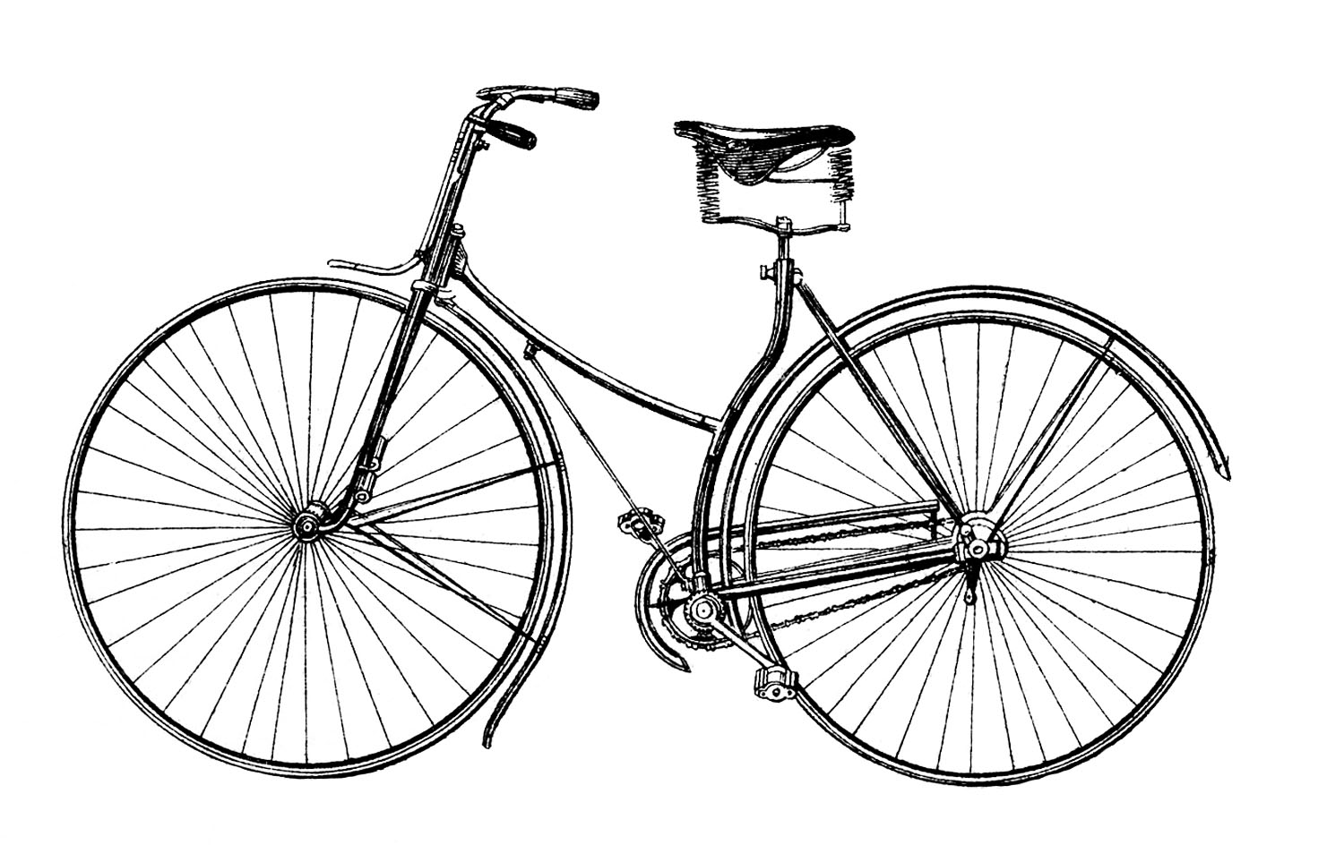
Classwork
Opening Exercise

Above is a picture of a bicycle. Which of the images below appears to be a well-scaled image of the original? Why?

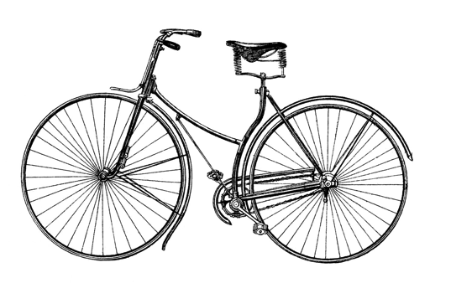

Example 1
Use construction tools to create a scale drawing of $△ABC$ with a scale factor of $r=2$.

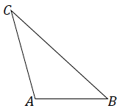

Exercise 1
Use construction tools to create a scale drawing of $△DEF$ with a scale factor of $r=3$. What properties does your scale drawing share with the original figure? Explain how you know.

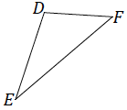

Example 2
Use construction tools to create a scale drawing of $△XYZ$ with a scale factor of $r=\frac{1}{2}$.

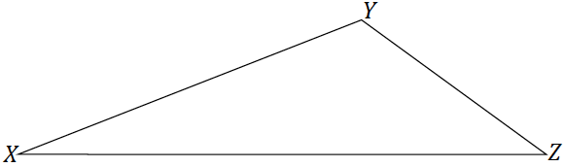

Exercises 2–4
- Use construction tools to create a scale drawing of $△PQR$ with a scale factor of $r=\frac{1}{4}.$ What properties do the scale drawing and the original figure share? Explain how you know.

- Triangle $EFG$ is provided below, and one angle of scale drawing $△E'F'G'$ is also provided. Use construction tools to complete the scale drawing so that the scale factor is $r=3$. What properties do the scale drawing and the original figure share? Explain how you know.

- Triangle $ABC$ is provided below, and one side of scale drawing $△A'B'C'$ is also provided. Use construction tools to complete the scale drawing and determine the scale factor.

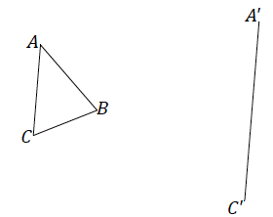

Problem Set
Lesson Summary
There are two properties of a scale drawing of a figure: corresponding angles are equal in measurement, and corresponding lengths are proportional in measurement.

- Use construction tools to create a scale drawing of $△ABC$ with a scale factor of $r=3$.

- Use construction tools to create a scale drawing of $△ABC$ with a scale factor of $r=\frac{1}{2}$.

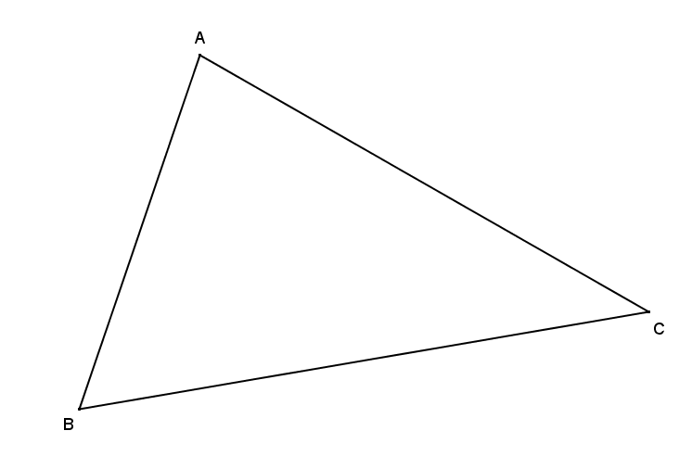

- Triangle $EFG$ is provided below, and one angle of scale drawing $△E'F'G'$ is also provided. Use construction tools to complete a scale drawing so that the scale factor is $r=2$.

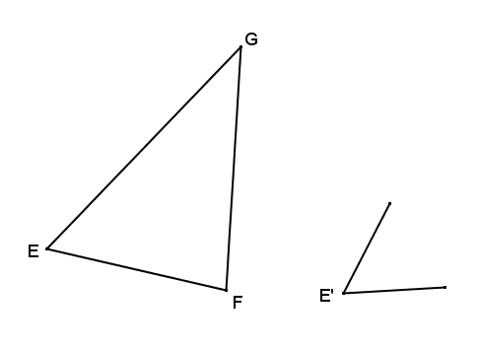

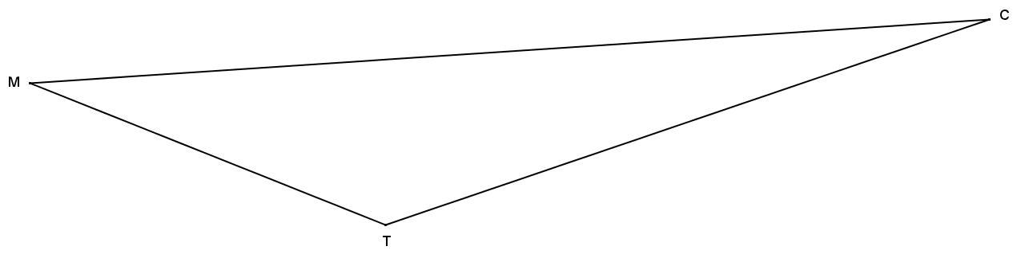
- Triangle $MTC$ is provided below, and one angle of scale drawing $△M'T'C'$ is also provided. Use construction tools to complete a scale drawing so that the scale factor is $\frac{1}{4}$.

- Triangle $ABC$ is provided below, and one side of scale drawing $△A'B'C'$ is also provided. Use construction tools to complete the scale drawing and determine the scale factor.

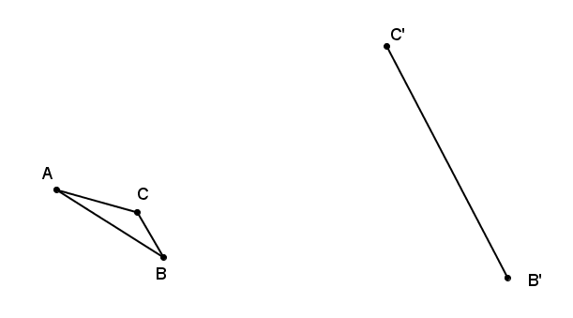

- Triangle $XYZ$ is provided below, and one side of scale drawing $△X'Y'Z'$ is also provided. Use construction tools to complete the scale drawing and determine the scale factor.
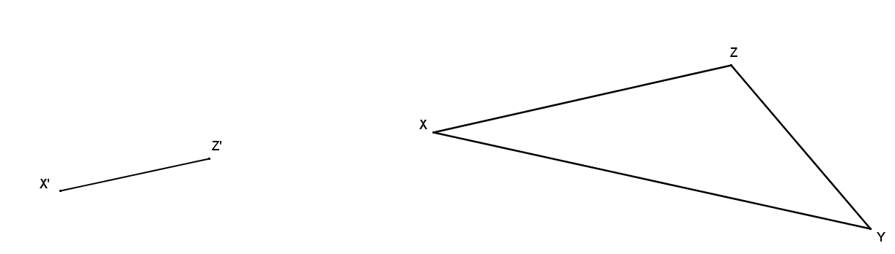

- Quadrilateral $GHIJ$ is a scale drawing of quadrilateral $ABCD$ with scale factor $r$. Describe each of the following statements as always true, sometimes true, or never true, and justify your answer.
  - $AB=GH$
  - $m∠ABC=m∠GHI$
  - $\frac{AB}{GH}=\frac{BC}{HI}$
  - $Perimeter\left(GHIJ\right)=r∙Perimeter(ABCD)$
  - $Area\left(GHIJ\right)=r∙Area\left(ABCD\right)$ where $r≠1$
  - $r<0$

