Lesson 24: Differences Due to Random Assignment Alone

Classwork
Exercises 1–17
Twenty adult drivers were asked the following question:
“What speed is the fastest that you have driven?”
The table below summarizes the fastest speeds driven in miles per hour (mph).
$$70$$ | $$60$$ | $$70$$ | $$95$$ | $$50$$ | $$60$$ | $$80$$ | $$75$$ | $$55$$ | $$90$$
$$110$$ | $$65$$ | $$65$$ | $$65$$ | $$55$$ | $$70$$ | $$75$$ | $$70$$ | $$65$$ | $$40$$

- What is the mean fastest speed driven?

- What is the range of fastest speed driven?

- Imagine that the fastest speeds were randomly divided into two groups. How would the means and ranges compare to one another? To the means and ranges of the whole group? Explain your thinking.

Let’s investigate what happens when the fastest speeds driven are randomly divided into two equal-size groups.

- Following the instructions from your teacher, randomly divide the $20$ values in the table above into two groups of $10$ values each.

Mean
Group 1
Group 2

- Do you expect the means of these two groups to be equal? Why or why not?

- Compute the means of these two groups. Write the means in the chart above.

- How do these two means compare to each other?

- How do these two means compare to the mean fastest speed driven for the entire group (Exercise 1)?

- Use the instructions provided for Exercise 4 to repeat the random division process two more times. Compute the mean of each group for each of the random divisions into two groups. Record your results in the tables below.
Mean
Group 3
Group 4
Group 5
Group 6

- Plot the means of all six groups on a class dot plot.

- Based on the class dot plot, what can you say about the possible values of the group means?

- What is the smallest possible value for a group mean? Largest possible value?

- What is the largest possible range for the distribution of group means?

- How does the largest possible range in the group means compare to the range of the original data set (Exercise 2)? Why is this so?

- What is the shape of the distribution of group means?

- Will your answer to the above question always be true? Explain.

- When a single set of values is randomly divided into two equal groups, explain how the means of these two groups may be very different from each other and may be very different from the mean of the single set of values.

Problem Set
Lesson Summary
When a single set of values is randomly divided into two groups,
- The two group means will tend to differ just by chance.
- The distribution of random groups’ means will be centered at the single set’s mean.
- The range of the distribution of the random groups’ means will be smaller than the range of the data set.
- The shape of the distribution of the random groups’ means will be symmetrical.

In one high school, there are eight math classes during 2nd period. The number of students in each 2nd period math class is recorded below.
$32$ $27$ $26$ $23$ $25$ $22$ $30$ $19$

This data set is randomly divided into two equal size groups, and the group means are computed.
- Will the two groups means be the same? Why or why not?

The random division into two groups process is repeated many times to create a distribution of group mean class size.
- What is the center of the distribution of group mean class size?

- What is the largest possible range of the distribution of group mean class size?

- What possible values for the mean class size are more likely to happen than others? Explain why you chose these values.

There are $3$ different sets of numbers: Set A, Set B, and Set C. Each set contains $10$ numbers. In two of the sets, the $10$ numbers were randomly divided into two groups of $5$ numbers each, and the mean for each group was calculated. These two means are plotted on a dot plot. This procedure was repeated many times, and the dot plots of the group means are shown below.
The third set did not use the above procedure to compute the means.
For each set, the smallest possible group mean and the largest possible group mean were calculated, and these two means are shown in the dot plots below.
Use the dot plots below to answer Problems 5–8.
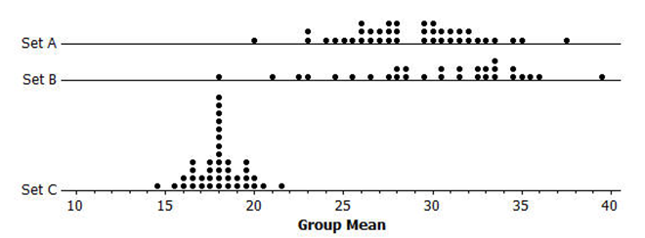

- Which set is NOT one of the two sets that were randomly divided into two groups of $5$ numbers? Explain.

- Estimate the mean of the original values in Set A. Show your work.

- Estimate the range of the group means shown in the dot plot for Set C. Show your work.

- Is the range of the original values in Set C smaller or larger than your answer in Problem 7? Explain.

