Lesson 20: Margin of Error when Estimating a Population Mean

Student Outcomes
- Students use data from a random sample to estimate a population mean.
- Students calculate and interpret margin of error in context.
- Students know the relationship between sample size and margin of error in the context of estimating a population mean.

Lesson Notes
Lessons 16 and 17 introduced the concept of margin of error in the context of estimating a population proportion. The concept of “margin of error” may have been difficult to grasp for those students who see the word “error” and think “mistake.” Lessons 16 and 17 showed that margin of error is interpreted as the farthest away from the value of the population proportion that an estimate is likely to be. The margin of error was also used to calculate an interval of plausible values for the population proportion.
In this lesson, margin of error is first developed visually and then estimated by twice the standard deviation of the sampling distribution of the sample proportion. This, and the next lesson, develops the idea of the margin of error when sample data are used to estimate a population mean.

Classwork
Example 1 (5 minutes): Describing a Population of Numerical Data
Provide each student the page of $100$ numbered rectangles located at the end of this teacher lesson. For this example, let students work in pairs to answer the questions. Use whole class discussion to develop those answers.

Example 1: Describing a Population of Numerical Data
The course project in a computer science class was to create $100$ computer games of various levels of difficulty that had ratings on a scale from $1$(easy) to $20$ (difficult). We will examine a representation of the data resulting from this project. Working in pairs, your teacher will give you a page that contains $100$ rectangles of various sizes.
  - What do you think the rectangles represent in the context of the $100$ computer games?
Each rectangle represents a computer game.

  - What do you think the sizes of the rectangles represent in the context of the $100$ computer games?
The size of the rectangle, or the number of squares that comprise it, represents the difficulty rating of the computer game. The minimum rating is $1$; the maximum is $20$.

  - Why do you think the rectangles are numbered from $00$ to $99$ instead of from $1$ to $100$?
Anticipating that a random sample will be taken later in the lesson, it is easiest if all the labels have the same number of digits. So $100$ is conveniently designated as $00$. The integers from $1$ to $9$ are represented by $01$, $02$, and so on.

Exploratory Challenge 1/Exercises 1–3 (5 minutes): Estimate the Population Mean Rating
Let students work with their partners to answer the questions.
Exploratory Challenge 1/Exercises 1–3: Estimate the Population Mean Rating
- Working with your partner, discuss how you would calculate the mean rating of all $100$ computer games (the population mean).
To find the population mean, all $100$ ratings would have to be added and then divided by $100$. This is not hard, but it can be a tedious calculation to make. If your students don’t think adding $100$ numbers is too bad, suggest that the number of computer games might have been $1000$.

- Discuss how you might select a random sample to estimate the population mean rating of all $100$ computer games.
A good answer would include stating a reasonable sample size, e.g., $10$ or more. It should also state that a random-number table or a calculator with a random-number generator should be used to generate the $10$ random two-digit numbers. The generated numbers identify the rectangles (computer games) that would be chosen for the sample.

- Calculate an estimate of the population mean rating of all $100$ computer games based on a random sample of size $10$. Your estimate is called a sample mean, and it is denoted by $\overline{x}$. Use the following random numbers to select your sample.
$$34 86 80 58 04 43 96 29 44 51$$
The respective ratings for the given random numbers are $12, 5, 2, 4, 1, 4, 18, 10, 1,$and$16$. Based on this sample, the estimate for the population mean rating is $\frac{73}{10}=7.3$.

Exploratory Challenge 2/Exercises 4–6 (10 minutes): Build a Distribution of Sample Means
Let students work with their partners to generate four sets of random numbers. Prepare a number line for the class to post their sample means. Be sure to provide enough room on the number line so the sample means do not overlap.
Exploratory Challenge 2/Exercises 4–6: Build a Distribution of Sample Means
MP.5
- Work in pairs. Using a table of random digits or a calculator with a random-number generator, generate four sets of ten random numbers. Use these sets of random numbers to identify four random samples of size $10$. Calculate the sample mean rating for each of your four random samples.
Answers will vary. To build a distribution, you should have $50$ or more randomly generated sample mean estimates. So, if you have between $25$ and $30$ students in your class, then $12$ to $15$ pairs should generate about four sample mean estimates, which will provide the right number of estimates for the distribution.

- Write your sample means on separate sticky notes, and post them on a number line that your teacher has prepared for your class.
Note: Be sure that you have provided enough length on your number line so that the sticky notes do not overlap.

- The actual population mean rating of all $100$ computer games is $7.5$. Does your class distribution of sample means center at $7.5$? Discuss why it does. Or, if it doesn’t, discuss why it doesn’t.
A possible reason why their sample means don’t center at $7.5$ is that they need more samples. They may suggest that they were very unlucky and got a distribution that centered well above or well below $7.5$. That is possible, but it’s highly unlikely.
Note: There is a theoretical result that says, for random samples, the expected value of the sample mean is the mean value of the population from which the sample was taken. But that theory is not part of your curriculum. However, your students may reason that if a population is divided into samples of equal size, then the mean of sample means is the same as the mean of the whole. They might give an example such as, “Consider four samples each of size three (e.g., $4, 1, 3$; $2, 2, 7$; $5, 9, 6$; $3, 6, 5)$. The respective means are $\frac{8}{3}$, $\frac{11}{3}$, $\frac{20}{3},$ and $\frac{14}{3}$ whose mean is their sum divided by $4$, precisely the same as the sum of the $12$ values divided by $12$.” Students might then argue that this would also apply to random samples and then go on to try to demonstrate conceptually that taking means produces values that tend to congregate or balance around the population mean.

Example 2 (5 minutes): Margin of Error
This example has students visualize the concept of margin of error. Using the dot plot, they will (roughly) determine the number of rating points within which almost all the sample means fall (i.e., within that number of points from the population mean $7.5$).
This example should also clarify the meaning of the word “error” in the phrase “margin of error” insofar as the the word does not imply “mistake” but refers to estimation error (i.e., the error that is made when a sample is used to estimate a population value).
Read through the example as a class, and convey the following:
- Almost all of the sample means are between $4$ and $11$. That is, almost all are roughly within $3.5$ rating points of the population mean $7.5$. The value $3.5$ is a visual estimate of the margin of error. Highlight this description with students.
- Although not a formal definition of margin of error, it is a visual representation that motivates students’ understanding of the term.
- It is not really an error in the sense of “mistake.” Rather, it is how far our estimate for the population mean is likely to be from the actual value of the population mean.
Pose the question presented in the text to the class:
- Based on the class distribution of sample means, is the visual estimate of margin of error close to $3.5$?
  - Discuss this question using the distribution of the sample means from the class. It is anticipated that the margin of error is also close to $3.5$. If it’s very different, examine the results, and possibly examine what values seemed to make this estimate different.

Suppose that $50$ random samples each of size ten produced the sample means displayed in the following dot plot.
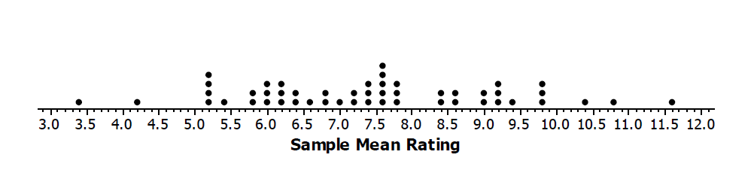
Note that almost all of the sample means are between $4$ and $11$. That is, almost all are roughly within $3.5$ rating points of the population mean $7.5$. The value $3.5$ is a visual estimate of the margin of error. It is not really an “error” in the sense of “mistake.” Rather, it is how far our estimate for the population mean is likely to be from the actual value of the population mean.
Based on the class distribution of sample means, is the visual estimate of margin of error close to $3.5$?

Example 3 (5 minutes): Standard Deviation as a Refinement of Margin of Error
This example refines the concept of margin of error by using the standard deviation as the measure of spread. Students need to calculate the standard deviation of the distribution of sample means and should note that twice the standard deviation is close to their visual estimate of margin of error.
Your students may ask where the doubling came from. Remind them of their lesson on the normal distribution. The standard deviation of the sample mean variable is called standard error. (A formula for standard error follows in the next lesson.) The normal distribution of sample means has $95\%$ of the sample means within two standard deviations of the population mean.
Suppose that the margin of error is $3.5$. The interpretation of this is that plausible values for the population mean rating are within $3.5$ points from their mean estimate of $7.5$ points (i.e., from $4$ to $11$ rating points). Discuss these concepts with students. The following paragraphs summarize these concepts and should provide students with an explanation of margin of error they can use moving forward.

Example 3: Standard Deviation as a Refinement of Margin of Error
Note that the margin of error is measuring how spread out the sample means are relative to the value of the actual population mean. From previous lessons, you know that the standard deviation is a good measure of spread. So, rather than producing a visual estimate for the margin of error from the distribution of sample means, another approach is to use the standard deviation of the sample means as a measure of spread. For example, the standard deviation of the $50$ sample means in the example above is $1.7$. Note that if you double $1.7$, you get a value for margin of error close to the visual estimate of $3.5$.
Another way to estimate margin of error is to use two times the standard deviation of a distribution of sample means. For the above example, the refined margin of error (based on the standard deviation of sample means) is $2\left(1.7\right)=3.4$ rating points.
An interpretation of the margin of error is that plausible values for the population mean rating are from $7.5 –3.4$ to $7.5+3.4$ (i.e., $4.1$ to $10.9$ rating points).

Exploratory Challenge 3/Exercise 7 (8minutes)
It may be somewhat tedious for students to enter approximately $50$ numbers into their calculators, but it will go faster if they work in pairs, with one student reading the entries while the other enters them in a calculator. Provide students an opportunity to summarize the standard deviation of the class distribution and the interpretation of it as a margin of error.
MP.2
&
MP.5

Exploratory Challenge 3/Exercise 7
Calculate and interpret the margin of error for your estimate of the population mean rating of $100$ computer games based on the standard deviation of your class distribution of sample means.
Answers will vary based on the class distribution of sample means.
Sample response: Suppose the sample mean is $7.2$ and the standard deviation is $1.9$. The margin of error is $2(1.9)=3.8$ rating points. This means that the plausible values for the population mean rating are from $7.2-3.8$ to $7.2+3.8,$ or from $3.4$ to $11$ rating points.

Closing (2 minutes)
- Ask students to summarize the main ideas of the lesson in writing or with a neighbor. Use this opportunity to informally assess comprehension of the lesson. The Lesson Summary below offers some important ideas that should be included.
Lesson Summary
This lesson revisited margin of error. Previously, you estimated a population proportion of successes and described the accuracy of the estimate by its margin of error. This lesson also focused on margin of error but in the context of estimating the mean of a population of numerical data.
Margin of error was estimated in two ways:
- The first was through a visual estimation in which you judged the amount of spread in the distribution of sample means.
- The second was more formalized by defining margin of error as twice the standard deviation of the distribution of sample means.

Exit Ticket (5 minutes)

Name Date
Lesson 20: Margin of Error when Estimating a Population Mean

Exit Ticket

At the beginning of the school year, school districts implemented a new physical fitness program. A student project involves monitoring how long it takes eleventh graders to run a mile. The following data were taken mid-year.
  - What is the estimate of the population mean time it currently takes eleventh graders to run a mile based on the following data (minutes) from a random sample of ten students?
$$6.5, 8.4, 8.1, 6.8, 8.4, 7.7, 9.1, 7.1, 9.4, 7.5$$

  - The students doing the project collected $50$ random samples of $10$ students each and calculated the sample means. The standard deviation of their distribution of $50$ sample means was $0.6$ min. Based on this standard deviation, what is the margin of error for their sample mean estimate? Explain your answer.

  - Interpret the margin of error you found in part (b) in the context of this problem.

Exit Ticket Sample Solutions

At the beginning of the school year, school districts implemented a new physical fitness program. A student project involves monitoring how long it takes eleventh graders to run a mile. The following data were taken mid-year.
  - What is the estimate of the population mean time it currently takes eleventh graders to run a mile based on the following data (minutes) from a random sample of ten students?
$$6.5, 8.4, 8.1, 6.8, 8.4, 7.7, 9.1, 7.1, 9.4, 7.5$$
The mean of the ten times is $7.9$ min.

  - The students doing the project collected $50$ random samples of $10$ students each and calculated the sample means. The standard deviation of their distribution of $50$ sample means was $0.6$ min. Based on this standard deviation, what is the margin of error for their sample mean estimate? Explain your answer.
The margin of error is twice the standard deviation of the sampling distribution (i.e., $2(0.6) = 1.2$ min).

  - Interpret the margin of error you found in part (b) in the context of this problem.
$7.9 –1.2=6.7$ and $7.9+1.2=9.1$; plausible values for the population mean time it takes eleventh graders to run the mile mid-year are $6.7$ to $9.1$ min.

Problem Set Sample Solutions

- Suppose you are interested in knowing how many text messages eleventh graders send daily.
Describe the steps that you would take to estimate the mean number of text messages per day sent by all eleventh graders at a school.
If I could not get responses from all eleventh graders, I would base my estimate on the responses from a random sample of students. I would need to find a record or list of all eleventh graders. If I had this list, I would number all of the students on it and use random numbers to generate a random selection of students. For example, if there are $450$ students, I would number all of the students on the list from $1$ to $450$, and generate a selection of students using the random-number generator on my calculator. If my sample is $10$ students, I would generate $10$ random numbers from $1$ to $450$, identify the $10$ students based on the random numbers, and ask the $10$ students how many text messages they send during a school day. I would then find the mean of those $10$ responses. The mean from this sample of students would be my estimate of the mean number of text messages sent by eleventh graders.

- Suppose that $62$ random samples based on ten student responses to the question, “How many text messages do you send per day?” resulted in the $62$ sample means (rounded) shown below.

$$65$$ | $$68$$ | $$76$$ | $$76$$ | $$78$$ | $$82$$ | $$83$$ | $$83$$ | $$85$$ | $$86$$ | $$87$$ | $$88$$ | $$88$$
$$88$$ | $$89$$ | $$89$$ | $$89$$ | $$90$$ | $$91$$ | $$91$$ | $$91$$ | $$91$$ | $$92$$ | $$92$$ | $$92$$ | $$92$$
$$92$$ | $$93$$ | $$93$$ | $$93$$ | $$93$$ | $$93$$ | $$94$$ | $$94$$ | $$94$$ | $$94$$ | $$94$$ | $$94$$ | $$95$$
$$95$$ | $$95$$ | $$95$$ | $$95$$ | $$95$$ | $$95$$ | $$95$$ | $$96$$ | $$96$$ | $$97$$ | $$97$$ | $$97$$ | $$98$$
$$98$$ | $$98$$ | $$98$$ | $$98$$ | $$99$$ | $$100$$ | $$100$$ | $$101$$ | $$104$$ | $$106$$

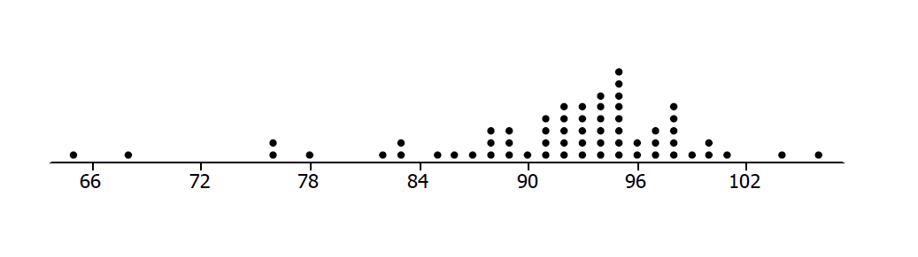
  - Draw a dot plot for the distribution of sample means.
  - Based on your dot plot, would you be surprised if the actual mean number of text messages sent per day for all eleventh graders in the school is $91.7$? Why or why not?
No. The distribution appears to be balanced around $92,$ so $91.7$ is plausible.

- Determine a visual estimate of the margin of error when a random sample of size $10$ is used to estimate the population mean number of text messages sent per day.
Almost all sample means are roughly within $10$ text messages of the population mean $91.7$. So, visually the margin of error is $10$ text messages on average.

- The standard deviation of the above distribution of sample mean number of text messages sent per day is $7.5$. Use this to calculate and interpret the margin of error for an estimate of the population mean number of text messages sent daily by eleventh graders (based on a random sample of size $10$ from this population).
Using the standard deviation of the sampling distribution, the margin of error is $2(7.5)=15$ text messages. Note that the visual estimate is quite a bit smaller than the one using the standard deviation. However, they are the same if the visual estimate were to include all of the sample means from $77$ to $107$.

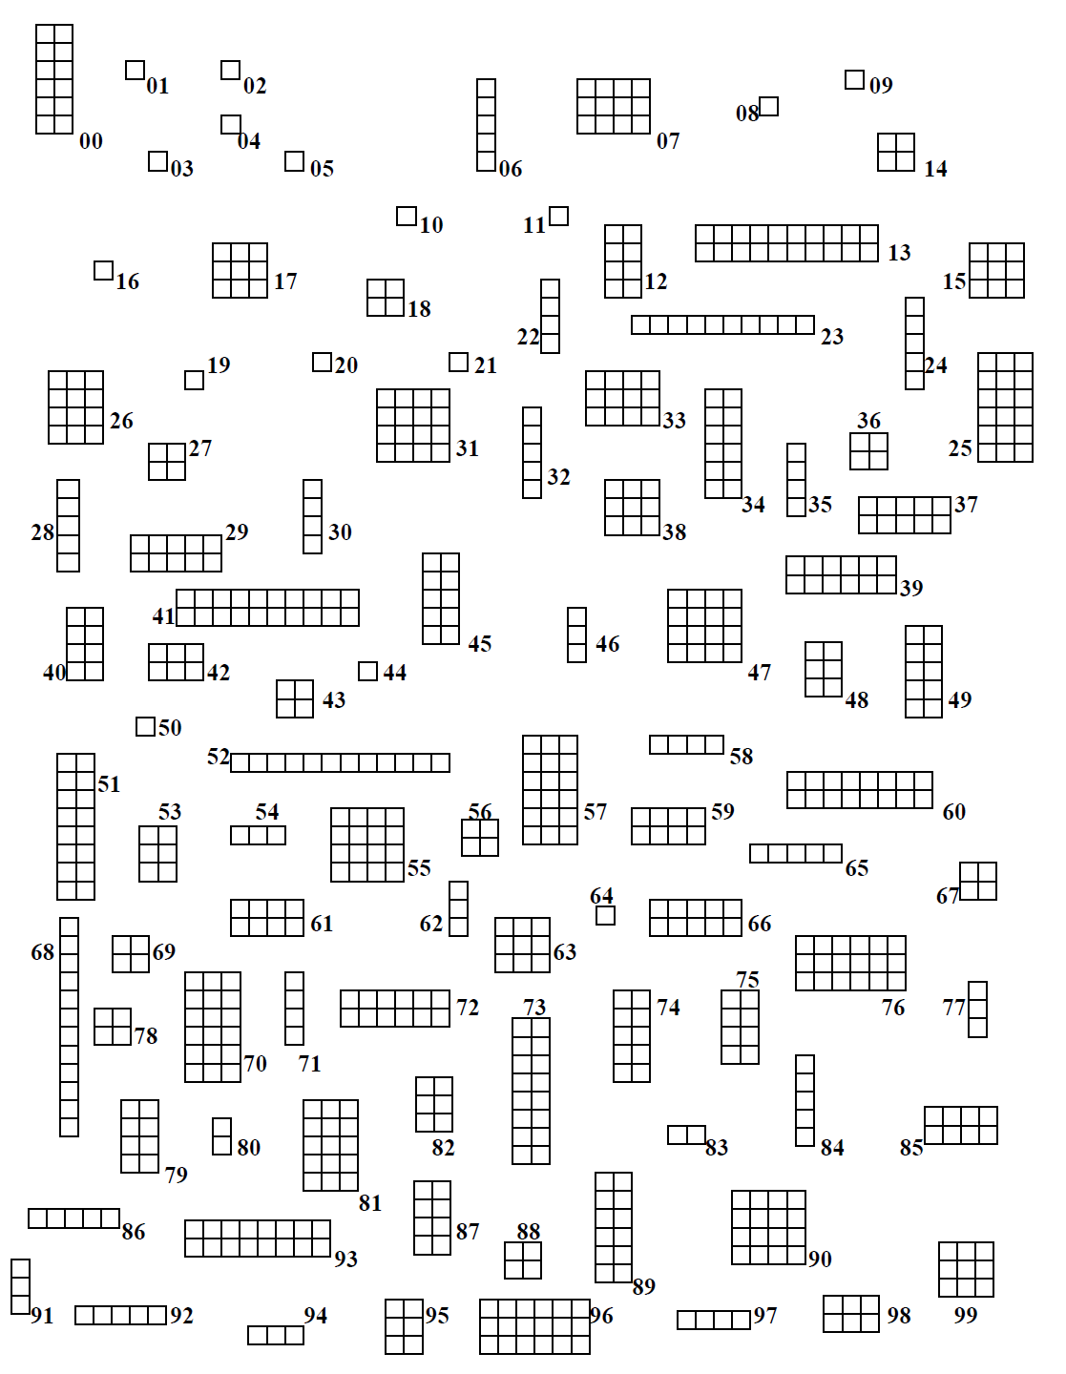
Example 1: Describing a Population of Numerical Data

