Lesson 20: Margin of Error when Estimating a Population Mean

Classwork
Example 1: Describing a Population of Numerical Data
The course project in a computer science class was to create $100$ computer games of various levels of difficulty that had ratings on a scale from $1$(easy) to $20$ (difficult). We will examine a representation of the data resulting from this project. Working in pairs, your teacher will give you a page that contains $100$ rectangles of various sizes.
- What do you think the rectangles represent in the context of the $100$ computer games?

- What do you think the sizes of the rectangles represent in the context of the $100$ computer games?

- Why do you think the rectangles are numbered from $00$ to $99$ instead of from $1$ to $100$?

Exploratory Challenge 1/Exercises 1–3: Estimate the Population Mean Rating
- Working with your partner, discuss how you would calculate the mean rating of all $100$ computer games (the population mean).

- Discuss how you might select a random sample to estimate the population mean rating of all $100$ computer games.

- Calculate an estimate of the population mean rating of all $100$ computer games based on a random sample of size $10$. Your estimate is called a sample mean, and it is denoted by $\overline{x}$. Use the following random numbers to select your sample.
$$34 86 80 58 04 43 96 29 44 51$$

Exploratory Challenge 2/Exercises 4–6: Build a Distribution of Sample Means
- Work in pairs. Using a table of random digits or a calculator with a random-number generator, generate four sets of ten random numbers. Use these sets of random numbers to identify four random samples of size $10$. Calculate the sample mean rating for each of your four random samples.

- Write your sample means on separate sticky notes and post them on a number line that your teacher has prepared for your class.

- The actual population mean rating of all $100$ computer games is $7.5$. Does your class distribution of sample means center at $7.5$? Discuss why it does. Or, if it doesn’t, discuss why it doesn’t.

Example 2: Margin of Error
Suppose that $50$ random samples each of size ten produced the sample means displayed in the following dot plot.
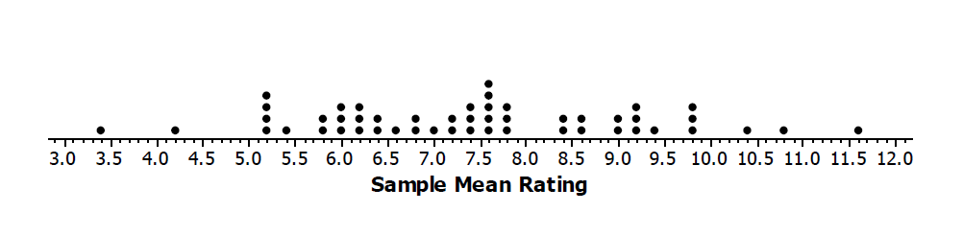
Note that almost all of the sample means are between $4$ and $11$. That is, almost all are roughly within $3.5$ rating points of the population mean $7.5$. The value $3.5$ is a visual estimate of the margin of error. It is not really an “error” in the sense of “mistake.” Rather, it is how far our estimate for the population mean is likely to be from the actual value of the population mean.
Based on the class distribution of sample means, is the visual estimate of margin of error close to $3.5$?

Example 3: Standard Deviation as a Refinement of Margin of Error
Note that the margin of error is measuring how spread out the sample means are relative to the value of the actual population mean. From previous lessons, you know that the standard deviation is a good measure of spread. So, rather than producing a visual estimate for the margin of error from the distribution of sample means, another approach is to use the standard deviation of the sample means as a measure of spread. For example, the standard deviation of the $50$ sample means in the example above is $1.7$. Note that if you double $1.7$, you get a value for margin of error close to the visual estimate of $3.5$.
Another way to estimate margin of error is to use two times the standard deviation of a distribution of sample means. For the above example, the refined margin of error (based on the standard deviation of sample means) is $2\left(1.7\right)=3.4$ rating points.
An interpretation of the margin of error is that plausible values for the population mean rating are from $7.5 –3.4$ to $7.5+3.4$ (i.e., $4.1$ to $10.9$ rating points).

Exploratory Challenge 3/Exercise 7
Calculate and interpret the margin of error for your estimate of the population mean rating of $100$ computer games based on the standard deviation of your class distribution of sample means.

Problem Set
Lesson Summary
This lesson revisited margin of error. Previously, you estimated a population proportion of successes and described the accuracy of the estimate by its margin of error. This lesson also focused on margin of error but in the context of estimating the mean of a population of numerical data.
Margin of error was estimated in two ways:
- The first was through a visual estimation in which you judged the amount of spread in the distribution of sample means.
- The second was more formalized by defining margin of error as twice the standard deviation of the distribution of sample means.

- Suppose you are interested in knowing how many text messages eleventh graders send daily.
Describe the steps that you would take to estimate the mean number of text messages per day sent by all eleventh graders at a school.

- Suppose that $62$ random samples based on ten student responses to the question, “How many text messages do you send per day?” resulted in the $62$ sample means (rounded) shown below.

$$65$$ | $$68$$ | $$76$$ | $$76$$ | $$78$$ | $$82$$ | $$83$$ | $$83$$ | $$85$$ | $$86$$ | $$87$$ | $$88$$ | $$88$$
$$88$$ | $$89$$ | $$89$$ | $$89$$ | $$90$$ | $$91$$ | $$91$$ | $$91$$ | $$91$$ | $$92$$ | $$92$$ | $$92$$ | $$92$$
$$92$$ | $$93$$ | $$93$$ | $$93$$ | $$93$$ | $$93$$ | $$94$$ | $$94$$ | $$94$$ | $$94$$ | $$94$$ | $$94$$ | $$95$$
$$95$$ | $$95$$ | $$95$$ | $$95$$ | $$95$$ | $$95$$ | $$95$$ | $$96$$ | $$96$$ | $$97$$ | $$97$$ | $$97$$ | $$98$$
$$98$$ | $$98$$ | $$98$$ | $$98$$ | $$99$$ | $$100$$ | $$100$$ | $$101$$ | $$104$$ | $$106$$

  - Draw a dot plot for the distribution of sample means.
  - Based on your dot plot, would you be surprised if the actual mean number of text messages sent per day for all eleventh graders in the school is $91.7$? Why or why not?

- Determine a visual estimate of the margin of error when a random sample of size $10$ is used to estimate the population mean number of text messages sent per day.

- The standard deviation of the above distribution of sample mean number of text messages sent per day is $7.5$. Use this to calculate and interpret the margin of error for an estimate of the population mean number of text messages sent daily by eleventh graders (based on a random sample of size $10$ from this population).

